Report on CS4247 Project 2
Edison Tsui Ka Wing
HT086372B

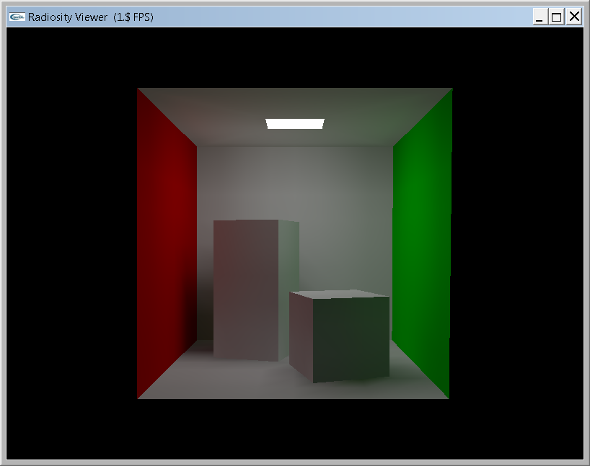 | 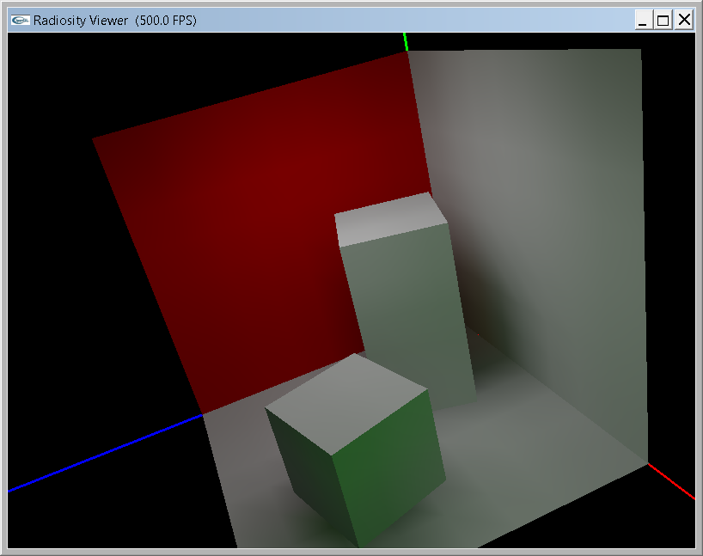
Figure – Scene Render at Total Unshot Power Left = 20% (iteration = 359)

Implementation Issue
In this project, pre-computed delta Form Factor for fixed size hemicube is used instead of dynamic size counterpart. The advantage of pre-computed version is the time saving that we do not need to compute delta Form Factor for new shooter. Three issues are checked before pre-computed hemicube is used
- Delta Form Factor – For correct calculation of delta Form Factor. It is interesting to find that the summation of all delta Form Factor from all five faces will be equal to 1.
- Value of far plane – hemicube is render to screen by glFlush (by setting preprocessor definition ENABLE_RENDERTOSCREEN) and check if scene is properly rendered.
Also, z-buffer precision is avoided by setting the value not too large.
- Side surface – we have set up a 90 degree view frustum for side surface so that upper half of the texture is used for storing hemicube value. Side hemicube is rendered to enable above is correct.

Terminating condition
I define a good terminating condition to be i) linear to degree of refinement, ii) independent of scene. Three metric are investigated and total unshot power is selected as termination condition with threshold = 20%.

Max Unshot Power
Max Unshot Power is not a terminating condition because its value is related to the ratio between shooter and gathers size; also the difference in larger iteration is very small as shown in figure 2. These make us hard to determine a meaning threshold value.
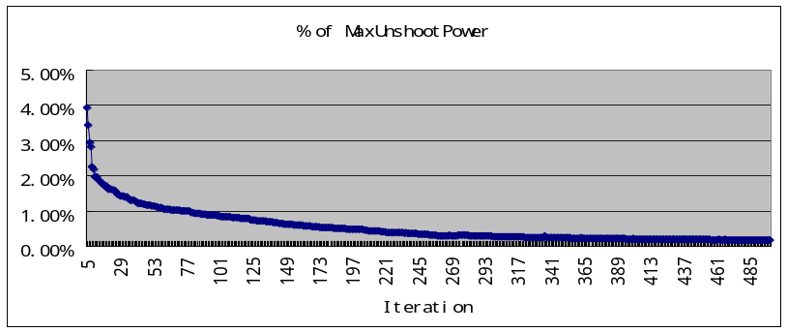
Figure 2 – Max Unshot Power in different iteration (normalized by initial Max Unshot Power)

Rate Change of Total Radiosity
Rate Change of Total Radiosity is computed by (Total Radiosity gained in this iteration) / Total Radiosity. It is the percentage of Radiosity added to the scene by that iteration, data is shown in figure 3. It works if the scene is closed. However, if the scene is open, consider a shooter patch that is near to exit, the Radiosity gained will be minimal, thus giving fault terminating condition. Above shows this metric is scene dependent and hence not suitable for terminating condition.
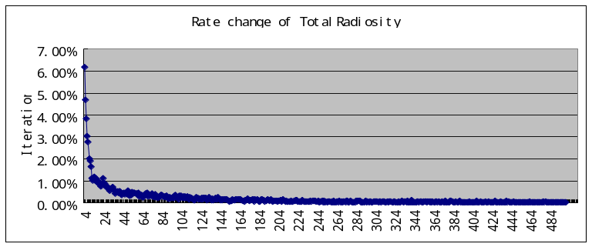
Figure 3 – Rate Change of Total Radiosity in different iteration

Total Unshot Power
Total Unshot Power is the total power left in the scene in that iteration. Due to energy loss from reflectivity, the curve shows a nice decreasing form in figure 4 and most importantly, it is independent of scene and is a meaningful value. We propose two thresholds, 30% and 20% of total Unshot Power left in the scene according to figure 8. It is seen that at 30%, color bleeding start to be obvious and at 20%, color bleeding is nicely shown. So threshold value of 20% is selected. It is noted that the slope of decreasing is related to the reflectivity, i.e. if reflectivity is higher, more energy is remained and the decrease in total unshot power will be smaller and hence take more iteration to complete and vice verse.
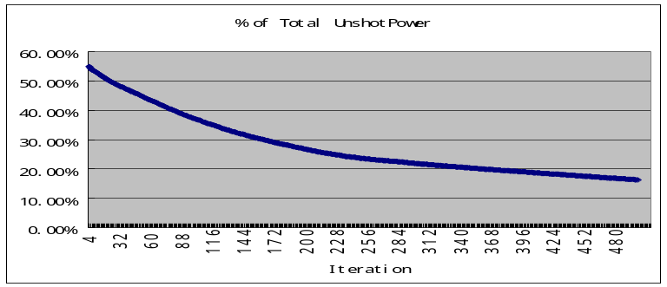
Figure 4 – Total Unshot Power in different iteration (normalize by initial Total Unshot Power)
Limitation and Artifact
As Radiosity only simulates diffuse-diffuse (ideal Lambertian) component, it fail to simulate component with specular part. Also due to the size of receiver, Light Leakage artifact (figure 5) is seen on the floor under the box’s edge. But this artifact can only be reduced but not fully handled even if the size of receiver is reduced. This problem continues, we have light leakage and then due to the hemicube inaccuracy (figure 6), light is shot to box’s surface and “light-dark-light” pattern is shown mistakenly.
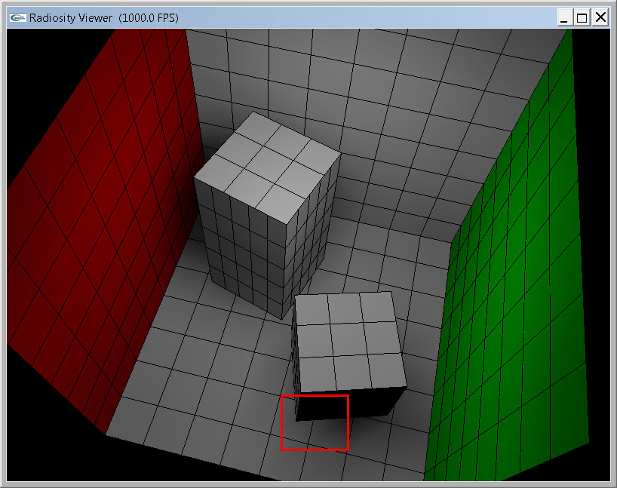  Figure 5 – Light Leakage Artifact | 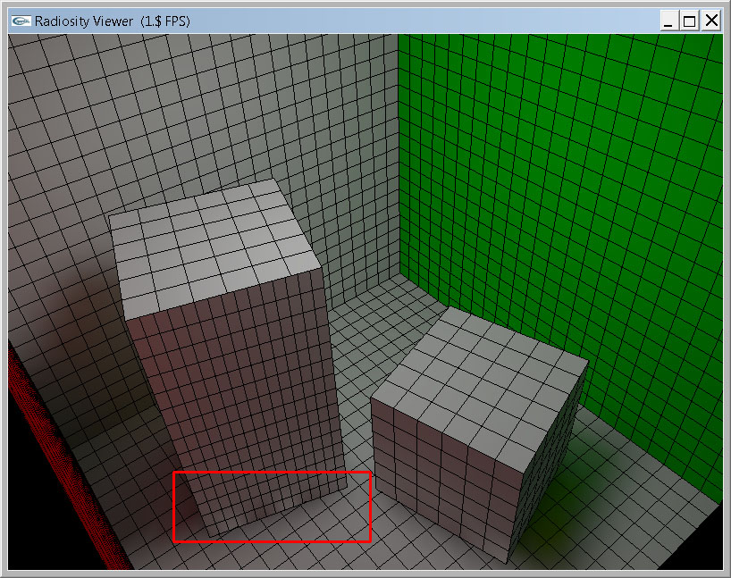  Figure 6 – Hemicube inaccuracy Artifact

New Scene Model
Several Things are added to the scene
- Lights – Windows (yellowish sun light), Lamp (white light)
- Table – with brown material
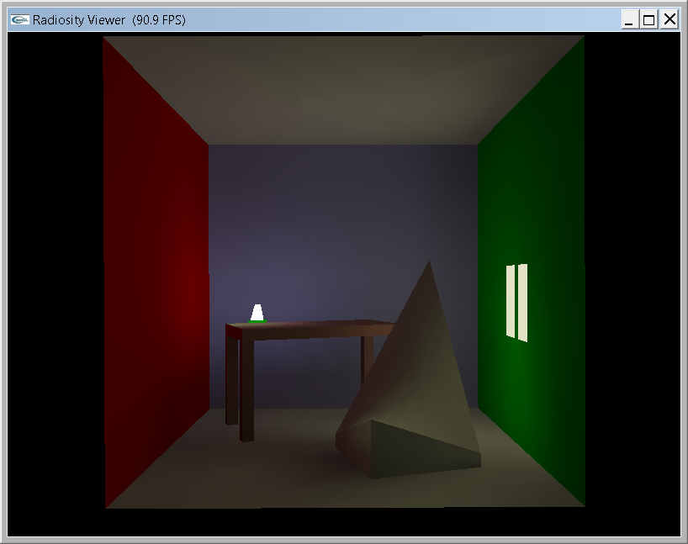
Figure 7 – Render of new scene
Appendix
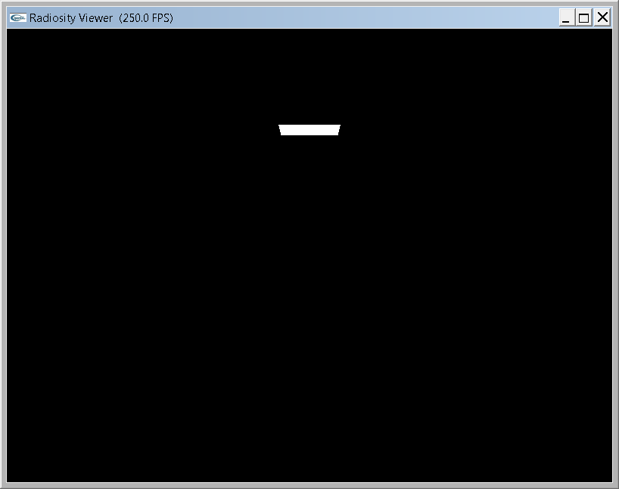  Iteration = 0, Total Unshot Power ~=100% | 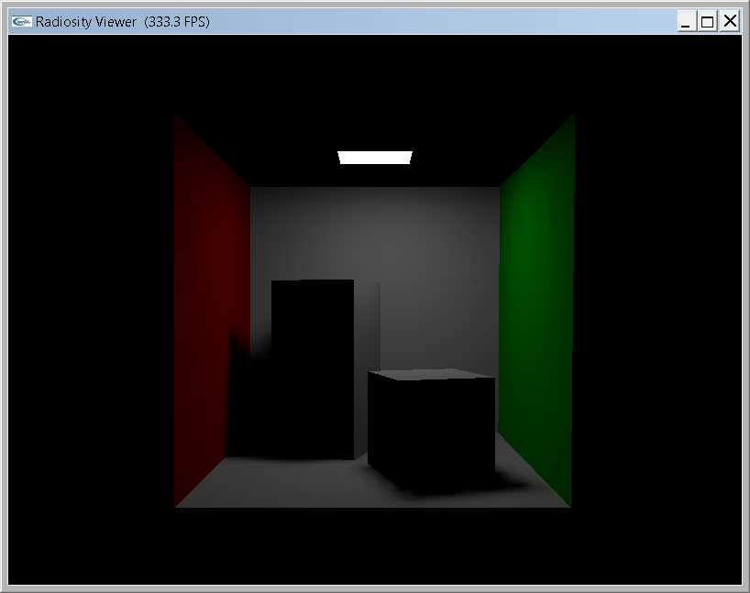  Iteration = 1
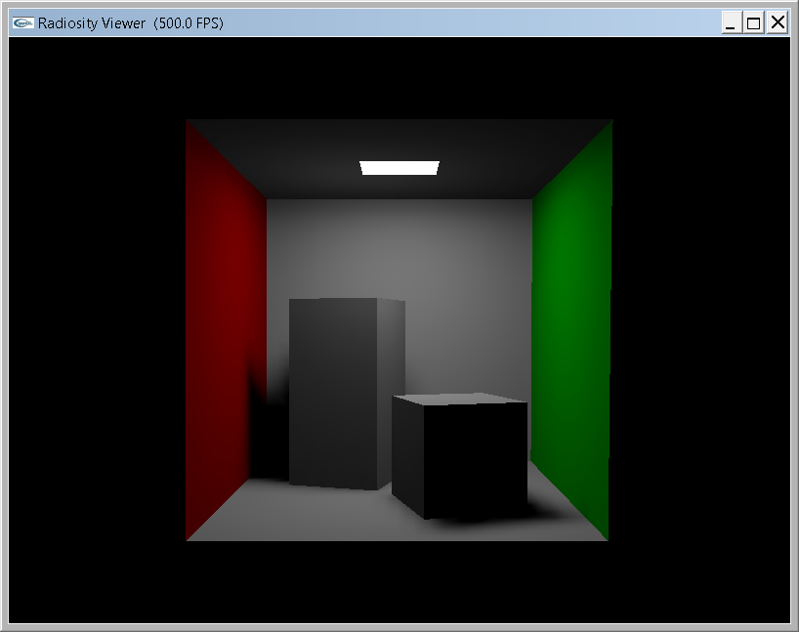  Iteration = 5, Total Unshot Power ~= 55% | 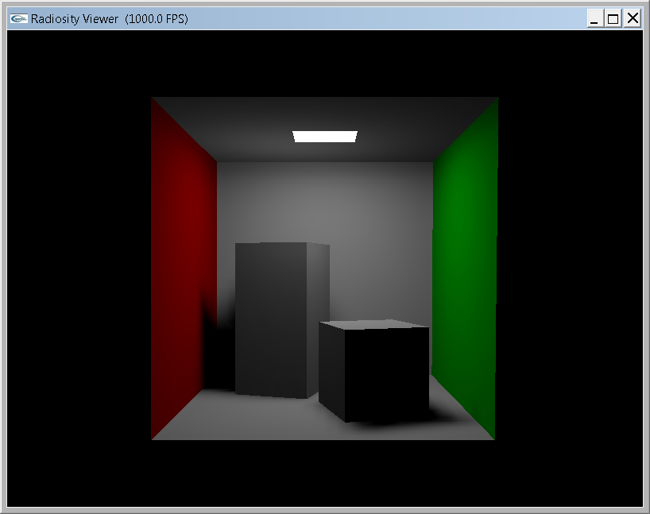  Iteration = 10
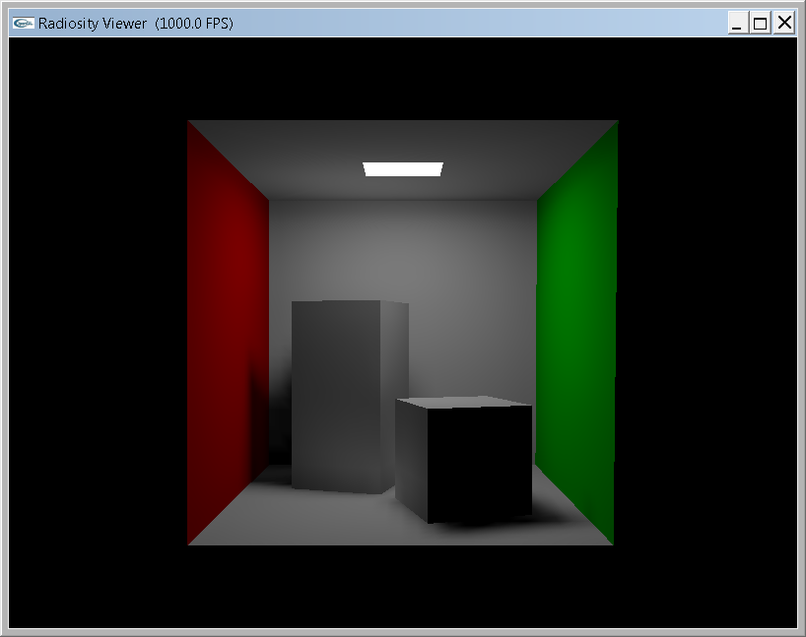  Iteration = 50, Total Unshot Power ~=45% | 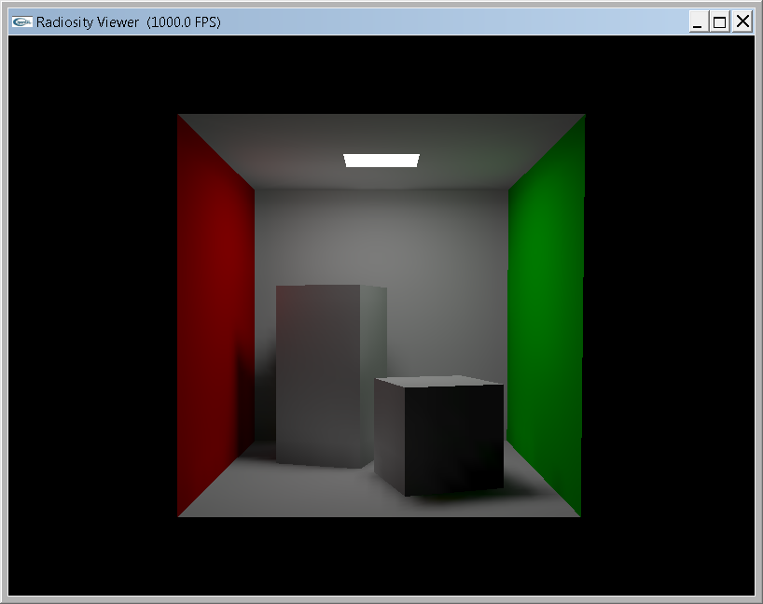  Iteration = 100
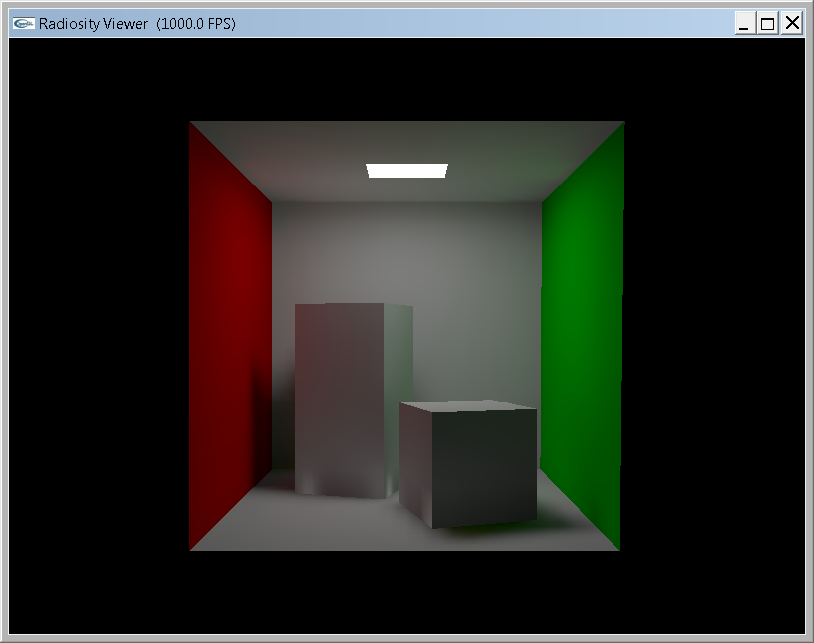  Iteration =200, Total Unshot Power ~=25% | 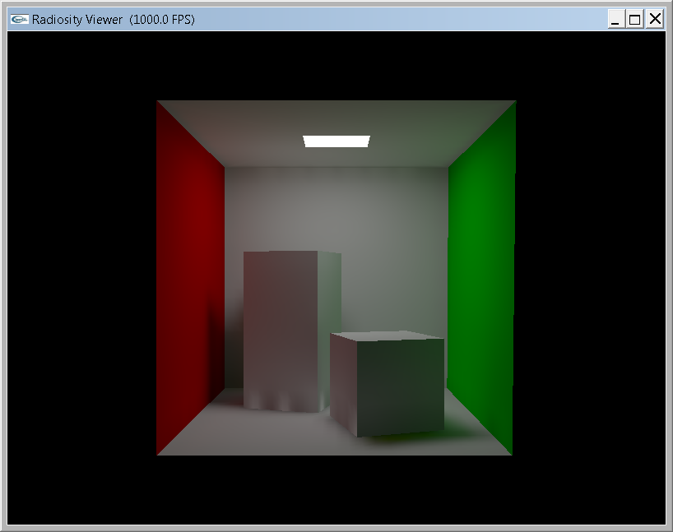  Iteration =500, Total Unshot Power ~=18%
Figure 8 – Scene Rendered in different Total Unshot Power Level and iteration

