Q13. What does the icon in the lower-right corner of the organizational shape indicate?
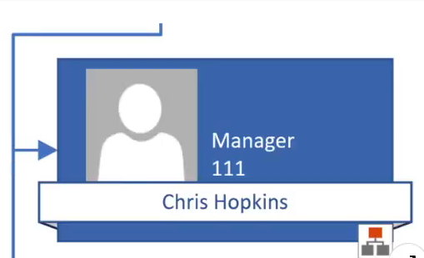
• ☐ Belt shape
• ☒ hidden subordinates
• ☐ synchronized copy
• ☐ executive position

