Q25. Which of these options is available when you select some shapes and then click the arrow on the Position button in the Arrange group on the Home tab?
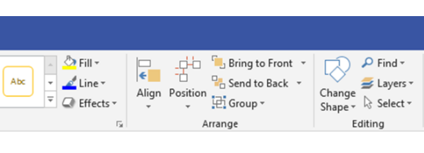
• ☒ Auto Align
• ☐ Auto Space
• ☐ Align Center
• ☐ Align Right

