**_____________________________________________________________________**

**Cheating interactions favor modularity in mutualistic networks**

Lucas A Camacho1, *, Cecilia Siliansky de Andreazzi2, Lucas P Medeiros3, Irina Birskis-Barros4, Carine Emer5, Carolina Reigada6, Paulo R Guimarães Jr7

**_____________________________________________________________________**

**Affiliations**

1 Programa de pós-graduação em ecologia, Departamento de Ecologia - Instituto de Biociências, USP, Rua do Matão, Tv. 14 - Butantã, São Paulo - SP, 05508-090, Brasil. ORCID: 0000-0003-3158-1488 (https://orcid.org/0000-0003-3158-1488)

2 (a) Laboratório de Biologia e Parasitologia de Mamíferos Silvestres Reservatórios, Instituto Oswaldo Cruz, Fundação Oswaldo Cruz, Av. Brasil 4365, Manguinhos, 21045-900, Rio de Janeiro, RJ, Brasil, (b) present address: Centre for Functional Ecology, Department of Life Sciences, University of Coimbra, Calçada Martim de Freitas, 3000-456, Coimbra, Portugal. ORCID: 0000-0002-9817-0635. (https://orcid.org/0000-0002-9817-0635)

3 Department of Civil and Environmental Engineering, MIT, 77 Massachusetts Ave, 02139 Cambridge, MA, USA. ORCID: 0000-0002-0320-5058 (https://orcid.org/0000-0002-0320-5058)

4 School of Natural Sciences, University of California, Merced, EUA. ORCID: **0000-0002-9235-7044 (https://orcid.org/0000-0002-9235-7044)**

5 Laboratório de Interação Planta-Animal, Departamento de Botânica,  
Rua Professor Moraes Rego, s/n. Cidade Universitária, Recife, Pernambuco. Brasil. 50.670-901. ORCID: 0000-0002-1258-2816 (https://orcid.org/0000-0002-1258-2816)

6 Centro de Ciências Biológicas e Saúde, Departamento de Ecologia e Biologia Evolutiva, Universidade Federal de São Carlos, UFSCAR - São Carlos, SP – Brasil. ORCID: 0000-0002-0680-219X (https://orcid.org/0000-0002-0680-219X)

7 Departamento de Ecologia - Instituto de Biociências, USP, Rua do Matão, Tv. 14 - Butantã, São Paulo - SP, 05508-090, Brasil. ORCID: 0000-0001-9161-8305 (https://orcid.org/0000-0001-9161-8305)

**\*Corresponding author: [lucascamacho.bio@gmail.com](mailto:lucascamacho.bio@gmail.com)**

**Abstract**

A fundamental fact about mutualisms is that these mutually beneficial interactions often harbor cheaters that benefit from the use of resources and services without providing any positive feedback to the other players. The role of cheaters on the evolutionary dynamics of mutualisms has long been recognized, yet their broader consequences to the community level, and beyond species they interact with, is still poorly understood. Because mutualisms form networks that often involve dozens to hundreds of species, indirect effects generated by cheaters may cascade through the whole community, reshaping trait evolution. Here, we study how harboring cheating interactions can influence coevolution in mutualistic networks. We combine a coevolutionary model, empirical data on animal-plant mutualistic networks, and numerical simulations and show that a higher frequency of cheating interactions in a network can lead to the formation of groups of species phenotypically similar to each other and distinct from other groups, generating higher trait disparity. The resulting clustered trait patterns, in turn, change the patterns of interaction in simulated networks, fostering the formation of modules of interacting species. Our results indicate that cheaters contribute to generate phenotypic clusters in mutualistic networks, counteracting selection for convergence imposed by mutualists, and favoring the emergence of modules of interacting species. Based on these results, we suggest that cheaters might be a fundamental element for our understanding of the evolution of mutualistic networks.

**Keywords:** Coevolution, Ecological network, Modularity, Mutualism, Network structure

**Introduction**

Selection imposed by ecological interactions is one of the main forces impacting phenotypic patterns observed across levels of biological organization (Thompson 2005). Selection imposed by ecological interactions partially shapes trait matching among interacting individuals (Zhang *et al.* 2012), trait distributions within interacting populations (Bronstein *et al.* 2003), trait variation across populations of the same species (Thompson 2005), and trait patterns at the community level (Strauss & Irwin 2004). At the community level, ecological interactions can be a driving force of selection leading to trait convergence (Wilson *et al.* 2012) and trait disparity (Siepielski & Benkman 2010). In this sense, theory and empirical results indicate that distinct ecological interactions (e.g., mutualistic, antagonistic) may favor different trait outcomes at the community level due to coevolution, *i.e.*, the reciprocal evolutionary change between interacting species (Thompson 1994).

Mutualistic interactions, for example, can favor trait matching, which is the trait similarity between interacting species, *e.g.,* the size of the proboscis of a pollinator matching the flower depth that it pollinates. Although mutualisms may also generate other trait patterns, such as intensification of traits (Anderson & Johnson 2008), trait matching is an observed pattern in a variety of mutualistic systems, such as pollination by flies and bees (Zhang *et al.* 2012, Santamaria & Rodríguez-Gironés 2007), seed dispersal by birds and bats (Galetti *et al.* 2013, Mello *et al.* 2011), and Müllerian rings in velvet ants (Wilson et al 2012). Hence, trait matching is an expected outcome of reciprocal selection that could favor higher interaction efficiency in mutualisms (Thompson 1994, Zhang *et al.* 2012). In contrast, antagonisms, such as parasites and hosts, favor trait mismatching between hosts and parasites (but see Anderson 2005, Anderson and Johnson 2008), leading to several coevolutionary dynamics such as coevolutionary alternation and escalation (Nuismer and Thompson), that favor the maintenance or the increase in trait variation across and within species (Andreazzi *et al.* 2017).

Antagonisms and mutualisms are not isolated in nature but coexist in a variety of ways. Studies have explored the effects of combining mutualisms and antagonisms on population dynamics (e.g., Melián *et al.* 2009), community stability (e.g., Wilson *et al.* 2003), and network structure (e.g., Genini *et al.* 2010), highlighting the importance of considering the multiple outcomes that interactions may have at a single community and assigning the extremes of a gradient between mutualism and antagonism (Fontaine *et al.* 2011, Rodríguez-Rodríguez *et al.* 2017). Individuals of the same species can function as antagonistic or mutualistic partners of the same interacting species, e.g., seed-caching rodents acting as seed predators and seed dispersers of the same plant species (Loayza *et al.* 2014). In other scenarios, individuals may act as antagonisms of some species and as mutualisms of others (Gómez *et al.* 2018, Gómez *et al.* 2014, Montesinos-Navarro *et al.* 2017). Finally, there are species in which individuals are specialized cheaters, exploring mutualistic interactions without providing any benefit in return like some fig wasps (Bronstein 2001). Thus, in mutualistic interactions, selection may favor the evolution of life histories that exploit the resources and services provided by mutualistic partners without providing benefits, hereafter, cheating interactions (Bronstein 2001, Vieira *et al.* 2003).

We are beginning to understand how cheating interactions could drive evolutionary patterns in mutualisms, as species acting as a cheater or mutualist may affect coevolution and local adaptation. For example, the interaction between the plant *Lithophragma parviflorum* (Saxifragaceae) and the floral-parasitic moth *Greya politella* changes from parasitism to mutualism if the legitimate pollinators of *L. parviflorum* are absent in the community, with consequences to the species coevolution in a given site (Thompson & Cunningham 2002). By exploring the role of cheaters on three-species systems we progressed in our understanding on how cheaters fuel novel dynamics (Anderson 2005). A next step in the analyses of the importance of cheaters in affecting mutualisms is to explore what are the evolutionary roles that cheaters play in a rich-species communities. In species-rich communities, networks generate pathways connecting species that do not interact directly to each other, allowing evolutionary cascades to affect how species traits evolve (Guimarães *et al.* 2017). In this sense, within a network, species that are central – have more interactions and interact with other highly connected species – might cause stronger cascade effects, since they play an important role in maintaining the structure of networks and, consequently, the structure of the selection pressures between species in the network (Martín Gonzáles *et al.* 2010). Also, considering a pairwise interaction, cheaters can fuel diversification and complexity when considering a pairwise interaction (Wechsler & Bascompte 2021). Thus, cheaters that are in the center of a mutualistic network may propagate a stronger evolutionary effect in the network.

Here, we use a quantitative trait mathematical model, empirical ecological networks of species interactions, and numerical simulations to investigate how cheating interactions may affect coevolution in mutualistic networks. Specifically, we explore three main questions *i)* How do different frequencies of cheating interactions affect coevolutionary dynamics? Due to the arms race dynamics favored by antagonistic coevolution, we expect a higher trait mismatch in scenarios with elevated frequencies of cheating interactions. *ii)* Do central cheating species amplify the effect of cheating interactions on trait evolution? Because central species can influence the trait evolution of several other species, we expect that central cheating species will amplify the effect of cheating interactions on trait evolution in mutualistic networks. *iii)* What is the effect of cheating interactions on the structure of mutualistic networks? By assuming that cheating interactions may favor arms race dynamics, one can expect higher trait matching only among species involved in arms races, but increased trait mismatch with other partners, leading to the loss of interactions based on phenotypic congruence. Thus, we expect that higher frequencies of cheating interactions will generate higher arms race dynamics and consequently, higher frequency of interaction loss, generating networks with higher modularity (Figure 1b).

**Methods**

*Evolutionary model*

Our discrete-time, evolutionary model describes how the average trait of a species *i*, *Zi*, evolves due to reciprocal selection imposed by ecological interactions and other environmental factors (e.g., abiotic conditions). In our model, the selection differential, *S*, and the additive genetic variance of the trait governs trait change across generations (Lande 1976). We assumed *S* has three components potentially affecting the evolution of the trait *Z*: the selection imposed by (i) mutualisms, (ii) cheating interactions, and (iii) other environmental factors. As a first approximation, we assume that, for a given interaction, species are either mutualistic partners or cheaters, but the same species *i* may behave as a cheater for species *j* but as a mutualistic partner to species *k*.

The mutualism component, $S_{m_{i}}$ is defined as the sum of selective effects caused by all mutualistic partners of species *i*, called *N*. We assume that selection imposed by mutualism favors trait matching among mutualistic partners. We also assume that perfect trait matching between partners *i* and *j* occurs if |*Zj(t)-Zi(t)*| = 0 (Guimarães *et al.* 2011). A given species may have multiple mutualistic partners and each partner may contribute differently to selection, where the contribution of partner *j* to selection on species *i* is described by *mij(t).* The total contribution of mutualistic partners to selection on *Zi* is defined as:

$S_{m_{i}}=\sum_{j}^{N}{m_{ij}^{\left(t\right)}(Z_{j}^{\left(t\right)}-Z_{i}^{\left(t\right)})}$ (1)

In the cheating component $S_{a_{i}}$, selection favors trait matching for the cheater species *j* (as in equation 1) but favors trait mismatch for the victim species *i,* defined asthe species explored by the cheater. As in the mutualism component, the magnitude of the trait change is driven by the evolutionary effect of species *j* on species *i,* *vij(t)*. Selection for trait mismatching between cheater on victim is dictated by $ε_{ij}$*:*

$S_{a_{i}}=\sum_{j}^{N}{{δ_{ij}v}_{ij}^{\left(t\right)}(Z_{j}^{\left(t\right)}±ϵ_{ij}-Z_{i}^{\left(t\right)})}$ (2)

We assume if the trait difference between *i* and *j* is higher or equal to , |*Zj(t)-Zi(t)*| , then *δij*=0, and the cheater species imposes no selection on the victim. Thus, $ε_{ij}$ represents a trait barrier preventing the interaction due to trait dissimilarity (e.g., Santamaria & Rodríguez-Gironés 2007). However, if |*Zj(t)-Zi(t)*|< , then δij=1 and selection on victim *i* will favor the increase or decrease of trait values depending on *Zj(t)-Zi(t)*. If *Zj(t)-Zi(t)* is positive, the signal of $ε_{ij}$ will be positive. Contrarily, if *Zj(t)-Zi(t)* is negative, the signal of $ε_{ij}$ will be negative (Andreazzi *et al.* 2017). Finally, we assumed that the environmental component $S_{e_{i}}$ is the combined effects of all other selective pressures, which in turn favors an optimum environmental trait value for each species, *θi*:

(3)

Combining the three selection components described above (equations 1, 2, and 3), the evolutionary change of Zi in timestep *t+1* is given by:

$Z_{i}^{(t+1)}=Z_{i}^{(t)}+φ_{i}[\left(1-γ_{i}\right)\left(S_{m_{i}}+S_{a_{i}}\right)+γ_{i}S_{e_{i}}]$ (4)

in which, *φi* is a compound parameter formed by additive genetic variance and the slope of the adaptive landscape (Guimarães et al. 2017). The parameter *ϒi* dictates the importance of ecological interactions versus environmental factors as selective pressures. Thus, trait evolution, in our model, is defined as:

$Z_{i}^{(t+1)}=Z_{i}^{(t)}+φ_{i}\{\left(1-γ_{i}\right)[\sum_{j}^{N}{m_{ij}^{\left(t\right)}\left(Z_{j}^{\left(t\right)}-Z_{i}^{\left(t\right)}\right)}+\sum_{j}^{N}{δ_{ij}v_{ij}^{\left(t\right)}\left(Z_{j}^{\left(t\right)}±ε_{ij}-Z_{i}^{\left(t\right)}\right)]}+γ_{i}θ_{i}-Z_{i}^{(t)}\}$ (5)

The evolutionary effects *mij(t)*and *vij(t)* that affect the magnitude of trait change due to the mutualism and cheating interactions, respectively, are defined as the relative effect of species *j* on *i*, such that *mij(t)*=*amijqij(t)* and *vij(t)*=*avijqij(t)*. The terms *amij* and *avij* depict, respectively, the presence of a mutualistic or a cheating interaction between species *i* and *j*. The term *qij(t)* is defined as:

$q_{ij}^{(t)}=\frac{e^{{-α(Z_{j}^{\left(t\right)}-Z_{i}^{(t)}}^{2}}}{\sum_{k, i ≠k}{a_{ik} e^{{-α(Z_{j}^{\left(t\right)}-Z_{i}^{(t)}}^{2}}}}$ (6)

where the parameter $α$ controls the sensitivity of the evolutionary effect due to trait matching between species *i* and *j* and *aik*=1 if there is a mutualistic or a cheating interaction between *i* and *k* and *aik* = 0, otherwise. The values and the description of the model parameters are depicted in Table 1.

*Mutualistic networks*

We use 24 empirical mutualistic networks available at the databases Web of Life (<http://www.web-of-life.es/>) and Interaction Web Database (<http://ecologia.ib.usp.br/iwdb/index.html>). These 24 networks include eight plant-pollinator networks, eight plant-frugivore networks, and eight ant-myrmecophyte networks. Each network is represented by an adjacency matrix (**A**) in which each species is represented by a single row and a single column of the matrix; each element of this matrix represents the presence or absence of the corresponding animal-plant interaction. Ant-myrmecophyte networks are commonly less connected, more modular, and less nested in comparison to seed dispersal and pollination networks, while seed dispersal networks are usually more nested and have a higher connectance than pollination and ant-myrmecophyte networks (Supporting Information).

*Simulations*

Our simulations describe how the mean trait Z*i* evolves in time (Figure 1a). Each simulation ends after 1000 timesteps, an amount of time that is sufficient to generate asymptotic trait values. In most simulations, however, the equilibrium was reached before 1000 timesteps. To reduce computational time, we assumed the equilibrium is achieved if |*Zi(t+1) - Zi(t)*|<10-4 for every species *i*, ending the simulation. We run 72.000 simulations, 3.000 per empirical network, where each simulation tracks how species traits change in time due to coevolution and the selective pressures from the environment (Figure 1a). All the simulations were performed in R v. 3.5.3 (R Core Team 2018). In what follows, we explain how we used this modelling approach to explore each of our three questions.

*i) How do different frequencies of cheating interactions affect coevolutionary dynamics?*

We evaluated the impact of the emergence of cheating interactions on the coevolutionary process. For each simulation, we define a probability *p* that an interaction within a “mutualistic network” is not a mutualism but a cheating interaction. We explored values of *p* ranging from 0.01 to 1 to test how different frequencies of cheating interactions change the outcome of the coevolutionary process. Thus, in this first analysis, we assume that cheating interactions are randomly distributed across all interactions in the mutualism network, whereas the frequency of cheating interactions in the network is fixed in each simulation. This process of defining the outcome of interactions based on *p* generates a network with both positive and negative effects, merging the effect of mutualism and cheaters in a single network (Melián *et al.* 2009). Because we are defining a cheating interaction as interactions with a negative effect on one partner and positive effect on the other one (i.e., an antagonism), we prohibit the occurrence of double-negative effects between two species. For this purpose, we only applied the transformation from positive to negative effect based on *p* in the lower triangle of the adjacency matrix, therefore maintaining cheating interactions as a combination of positive and negative effects. We also assumed that the outcome of the interaction does not change across time. Such an approach does not allow us to explore the effects of conditional outcomes of many interactions, but it is a starting point to unravel how cheating interactions changes the outcome of coevolution. We performed a set of sensitivity analyses in which we relaxed the assumption of fixed outcomes of interactions in time, allowing interactions to shift from positive and negative outcomes during simulations. Our sensitivity analyses suggest that temporal variability on the interaction outcome does not influence our main results (Supporting Information).

We characterized the coevolutionary dynamics by describing patterns in trait distributions across species. We first measured the average trait distance between species as a proxy for trait disparity in the network. We computed the mean pairwise distance (*D*), which is the sum of the Euclidean distances of species traits of all possible pairwise combinations between all species divided by the total number of pairwise combinations (Ciampaglio *et al.* 2001):

$D= \frac{\sum_{i}^{N}{\sum_{j≠i}^{N}{\sqrt{{(Z_{i}^{\left(t\right)}-Z_{j}^{(t)})}^{2}}}}}{N(N-1)}$ (7)

to characterize the trait matching generated by the coevolutionary dynamics. To compute among, we used Ward's hierarchical clustering analysis (Ward 1963) along with the GAP validation index (following Tibshirani *et al.* 2001).

*ii) Do central cheater species amplify the effect of cheating interactions on trait evolution?*

Some species do not provide benefit for any of their interaction partners, relying exclusively upon cheating interactions, hereafter called the exclusive cheaters (Bronstein 2001). We hypothesize that exclusive cheaters species could amplify the effects of cheating interactions, *i.e.*, leading to effects on trait distributions that are higher than observed in simulations with the same number of cheating interactions in the network but randomly distributed across all ecological interactions (see previous set of simulations). We expected that this effect would be even stronger if the exclusive cheaters species are highly connected or perform central roles in the network structure. To explore the role of these exclusive, highly connected cheaters species in affecting the coevolutionary outcome, we selected the most connected species in the network and assumed these species are only involved in cheating interactions. To do so, we calculate the degree centrality (Newman 2018), which is a standardized measure of the number of interactions of a given species on the mutualistic network. The degree centrality *Ci* for a species *i* from a given set (e.g., floral visitors) is:

$C_{i}=\frac{k_{i}}{N_{0}}$ (8)

in which $k_{i}$ is the number of interactions of species *i* and *No* is the species richness from the opposite set of *i (*e.g., if species *i* is a floral visitor, the opposite set is formed by flowering plants). We computed a z-score to detect extreme values of species centrality and identify the most central species,

$S_{i}=\frac{C_{i}-\overline{C}}{σ}$ (9)

where $\overline{C}$ is the average value of degree centrality of the network and $σ$ is the standard deviation of the degree centrality values. To test the effect of central cheaters species on trait evolution, we set all species with Si>1 as exclusive cheaters. Thus, we will have a network with central species as obligate cheaters - the Central scenario.

Finally, we compared the coevolutionary dynamics of the Central scenario with the scenario in which cheating interactions were randomly distributed across the network (the Random scenario). To create the Random scenario, we measure the frequency of negative effects in networks (*fCh)* in the Central scenario, as shown in Equation 10, and used this value of frequency as a *p* in the networks of the Random scenario. We considered n(-+) as the number of cheating interactions and n(++) as the number of mutualistic interactions in the network.

$f_{Ch}=\frac{n_{(-+)}}{n_{(-+)}+n_{(++)}}$ (10)

Thus, in the Random scenario, negative effects are not concentrated in central species but distributed across the network. For each combination of empirical networks (n = 24) and scenarios (Random and Central), we performed 1.500 simulations, leading to a total of 72.000 simulations. We ran all simulations until the equilibrium as described above.

*iii) What is the effect of cheating interactions on the structure of mutualistic networks?*

In our baseline coevolutionary model, the trait barrier $ε_{ij}$ indicates whether the evolutionary effects of a cheater species on a victim becomes negligible. To explore the effect of cheating interactions on the network structure, we changed our baseline coevolutionary model to add an additional trait barrier, *bij*, defining the maximum absolute trait mismatch between two species traits so they can interact:

$\left\{\begin{aligned}\left|Z_{i}^{(t)}-Z_{j}^{(t)}\right|>b_{ij}, a_{ij}=0 \\ \left|Z_{i}^{(t)}-Z_{j}^{(t)}\right|≤b_{ij}, a_{ij}=1\end{aligned}\right.$ (11)

Note that $ε_{ij}$ represents a trait barrier that dictates if there is a selection on a victim by a cheater species. In contrast, *bij* describes that a potential mutualism or cheating interaction cannot occur because of a large trait dissimilarity between partners. By incorporating *bij* in our model we explored how network structure changes through time as an outcome of the coevolutionary process. With this approach, in each simulation timestep, we verified if there were interacting species with differences in trait values higher than *bij* Following equation 11, we disconnected those interactions generating an interaction loss. Since we were focusing on how the network changes due to interaction loss, once the interaction is lost, it remains lost and cannot reconnect during the simulations. Thus, at the end of a simulation, we may have an interaction network with a different structure generated through the removal of links. We then compared the initial and final network structure in each particular simulation.

We characterize the structure of the networks calculating two common measures of network structure: nestedness and modularity (Almeida-Neto *et al.* 2008, Blondel *et al.* 2008). For each simulation, we computed the number of interactions loss generated by the coevolutionary dynamics at the end of the simulation, *F*. We computed indexes based on nestedness and modularity describing structural change between the final and initial network. We used two indexes of network structure change: **Δ**NODF and **Δ**Q. For each network, these measures are calculated as the difference between the network nestedness (NODF, Almeida-Neto *et al.* 2008) and modularity (Q, Blondel *et al.* 2008) at the end and at the beginning of the simulations:

$\left\{\begin{aligned}∆NODF={NODF}_{final}-{NODF}_{initial} \\ ∆Q=Q_{final}-Q_{initial}\end{aligned}\right.$ (12)

Coevolutionary dynamics, in our model, therefore, may reduce the total number of interactions, favoring specialization. We then explored if the removal of interactions by coevolutionary dynamics deviates from random removal of interactions from the initial network. To do so, for each simulation, we created a third network generated by removing *F* interactions from the initial network. This network, therefore, has the same number of interactions than the coevolved network but the set of interactions removed was randomly defined. We then compared how network structure changes with random loss of interactions and loss of interactions due to trait dissimilarity of coevolution outcomes.

**Results**

*i) How do different frequencies of cheating interactions affect coevolutionary dynamics?*

The higher the proportion of cheating interactions, the higher the trait disparity observed across animal species and across plant species in the network (Fig. 2a-c). The effect of cheating interactions is similar for the three types of networks studied here, leading to increased trait disparity (Table 2). Thus, cheating interactions increase the trait disparity across species (Fig. 2), and this effect is not dependent on the structure of the ecological network. Following our results, we develop an analytical approximation which relates the importance of evolutionary effects and the trait disparity of species. Both simulations and analytical approximation points to an increase in trait disparity due to cheating interactions (Supporting Information).

We observed that cheating interactions affect the number of species trait clusters. At low levels of cheating interactions (*p* = 0.01, with *p* being the frequency of cheating interactions in the networks), we found a low number of clusters in simulations (2.43 $±$ 0.62, Fig. 2d-f). At intermediate levels of cheating interactions, the number of trait clusters increased (*p* = 0.5, 3.03 $±$ 0.79). Finally, if most of the network is formed by cheating interactions then, on average, we saw the formation of lower numbers of species trait clusters, similar to when there is low frequency of cheating interactions (2.69 $±$ 0.74, *p* = 0.9, Fig. 2d-f). Thus, increasing the frequency of cheating interactions fuels trait disparity in mutualistic networks by promoting the emergence of trait clusters. However, these trait clusters disappear under higher frequencies of cheating interactions.

*ii) Do central cheater species amplify the effect of cheating interactions on trait evolution?*

Our results do not support the prediction that highly connected species would have a stronger effect on trait evolution in mutualistic networks (Table 3). In fact, there is high variability in mean trait disparity within scenarios and types of interactions across simulations shown by the 0.05 and 0.95 quantiles from our simulation results represented by the vertical bars in Fig. 3a-b. Thus, highly connected cheaters species do not promote higher levels of trait disparity than those promoted by cheating interactions distributed across the network in our simulations (Fig. 3a). Similarly, the number of trait clusters of species between scenarios are also variable (Fig. 3b).

*iii) What is the effect of cheating interactions on the structure of mutualistic networks?*

In our simulations, coevolutionary dynamics assuming *p* = 0 (no cheating interactions) led to almost no change in network structure [**Δ**Q ≅ 0; **Δ**NODF ≅ 0]. As we increase the frequency of cheating interactions, mutualistic networks become more modular and less nested (Fig 4; Table 4). This increasing modularity and reduced nestedness observed was not reproduced by simply randomly removing interactions (colored versus black points in Fig. 4). Moreover, the increase in modularity and reduction in nestedness was not equally distributed across mutualisms. In mutualisms that the empirical network was initially very modular and not nested (e.g., ant-myrmecophyte networks) changes in network structure were weaker than in mutualisms that initially showed higher nestedness (e.g., pollination and seed dispersal). Hence, networks under the effect of cheaters shift its network structure towards high modular and low nested patterns (Table 4).

**Discussion**

We explored the coevolutionary outcomes of cheating interactions in mutualistic networks. Our results show how trait evolution and network structure could change due to cheating lifestyles that emerge in mutualisms systems. Previous studies already explored the effect of mutualisms and cheating interactions on population dynamics (Law *et al.* 2001, Bronstein *et al.* 2003, Wilson *et al.* 2003, Lee 2015) and phenotypic evolution (Ferriere *et al.* 2002). In this context, our work contributes to further our understanding on coevolutionary dynamics of multispecies assemblages in three different ways.

First, we showed that cheating interactions promote higher community-level trait disparity in mutualistic networks. By imposing selection favoring trait mismatching, the presence of cheating interactions leads to an increase in species trait disparity in mutualistic interactions. This arms race dynamics partially offsets selection favoring convergence and trait matching in mutualisms (Guimarães *et al.* 2011, Zhang *et al.* 2012). Therefore, cheating interactions may allow us to understand one of the mechanisms preventing the perfect trait matching in empirical mutualistic communities (Law *et al.* 2001); yet trait disparity cannot increase indefinitely due to factors related to the environmental pressures and distinct selection regimes (Andreazzi *et al.* 2017). For instance, limited genetic variation or limited anatomical and physiological mechanisms restricts fruit sugar content and flower size (Jordano 1995), which could limit the potential for trait change in time and consequently restricts trait matching. Also, annual variation in soil nutrients limit the pulp composition of fleshy fruits and, consequently, represents a restriction for the development of sugar-rich fruits that are be highly attractive to frugivores (Herrera 1998), limiting trait matching in plant-frugivore systems.

Cheating interactions promote, in a certain frequency, trait disparity in mutualistic networks by generating clusters of species traits. In intermediate frequencies of cheating interactions, the joint effect of mutualistic selection favoring trait matching and cheating interactions favoring trait mismatching create clusters of species traits. There is theoretical evidence that the proportion of positive and negative effects between species is close to 1:1 in real communities (Dodds 1997). Thus, our results showing higher trait disparity due to the formation of trait clusters in intermediate levels of cheating interactions could be empirically tested. The presence of cheaters may be underestimated in empirical networks (Genini *et al.* 2010), partially because there is great behavioral plasticity among interacting individuals (Bronstein 2001). Thus, intraspecific variation generating behavioral plasticity may play an important role in individual fitness and lead to occasional cheating. This indicates that trait disparity may be higher than expected in mutualistic interactions and future studies would benefit from trait disparity measurements in empirical communities.

Second, the centrality of a cheater species does not change the trait disparity pattern that results from mutualisms with cheating interactions. Although species centrality is one of the best measures to identify important species in ecological networks (Martín González *et al.* 2010), it is not the only force driving the structure and dynamics of networks. For instance, the distribution of mutualistic and antagonistic interactions between component species within a network has an impact in maintaining the network structure when facing perturbations (Montesinos-Navarro *et al.* 2017). A next step of our work would be to explore how the position of certain cheating interactions could change the coevolutionary dynamics.

Third, the presence of cheating species in mutualistic networks may lead to the reorganization of network patterns due to the increased trait dissimilarity. We found that cheating leads to increased modularity and reduced nestedness in mutualistic networks. The emergence of modularity was also observed as an outcome of coevolutionary dynamics in antagonistic networks and depends on the selection intensity between victim and cheater species (Andreazzi *et al.* 2017). Our results propose an alternative path to the emergence of modularity in mutualistic networks, which depends on how much cheating interactions the mutualistic networks support. The structure of interaction networks is explained by several factors, such as species abundance distribution (Dátillo *et al.* 2014), mismatch between traits of plants and animals (Stang *et al.* 2007) and phylogenetic and phenology-based constraints (Jordano 1995, Jordano *et al.* 2003). Here we show that cheating interactions could also change the structure of mutualistic networks through the coevolutionary process. Future studies could test the influence of cheating interactions in cascading co-extinctions in mutualistic networks.

Our results suggest that the incorporation of the selection imposed by the cheating interactions that naturally emerge from mutualisms is pivotal to a deep understanding of the coevolutionary dynamics in species-rich mutualisms. Cheating interactions change the outcomes of mutualistic coevolution, leading to increased interspecific trait variation and clustering. We provide insights on the effect of multiple interaction types in a network and how it may shape trait diversity by the contrasting selective forces favoring convergence and disparity across interacting species (Sauve *et al.* 2016). The structure of simulated networks significantly changed when we increased the frequency of cheating interactions, and this result opens new questions on which is the balance of positive and negative effects that maintains the structure of empirical networks. Our theoretical predictions may also help us to understand how networks might evolve under a rapidly changing world, in which interactions are changing due to several anthropogenic impacts, with unknown consequences for ecosystem functioning.

**References**

Almeida-Neto, Mário, Paulo Guimarães, Paulo R. Guimarães Jr, Rafael D. Loyola, and Werner Ulrich. “A Consistent Metric for Nestedness Analysis in Ecological Systems: Reconciling Concept and Measurement.” *Oikos* 117, no. 8 (August 1, 2008): 1227–39. https://doi.org/10.1111/j.0030-1299.2008.16644.x.

Anderson, Bruce, and Steven D. Johnson. “The Geographical Mosaic of Coevolution in a Plant–Pollinator Mutualism.” *Evolution* 62, no. 1 (2008): 220–25. https://doi.org/10.1111/j.1558-5646.2007.00275.x.

Anderson, Bruce, Steven Johnson, and Clinton Carbut. “EXPLOITATION OF A SPECIALIZED MUTUALISM BY A DECEPTIVE ORCHID.” *American Journal of Botany* 92, no. 8 (2005): 1342–49.

Andreazzi, Cecilia S., John N. Thompson, and Paulo R. Guimarães. “Network Structure and Selection Asymmetry Drive Coevolution in Species-Rich Antagonistic Interactions.” *The American Naturalist* 190, no. 1 (May 19, 2017): 99–115. https://doi.org/10.1086/692110.

Blondel, Vincent D., Jean-Loup Guillaume, Renaud Lambiotte, and Etienne Lefebvre. “Fast Unfolding of Communities in Large Networks.” *Journal of Statistical Mechanics: Theory and Experiment* 2008, no. 10 (October 9, 2008): P10008. https://doi.org/10.1088/1742-5468/2008/10/P10008.

Bronstein, Judith L. “The Exploitation of Mutualisms.” *Ecology Letters* 4, no. 3 (2001): 277–87. https://doi.org/10.1046/j.1461-0248.2001.00218.x.

Bronstein, Judith L., William G. Wilson, and William F. Morris. “Ecological Dynamics of Mutualist/Antagonist Communities.” *The American Naturalist* 162, no. S4 (October 1, 2003): S24–39. https://doi.org/10.1086/378645.

Ciampaglio, Charles N., Matthieu Kemp, and Daniel W. McShea. “Detecting Changes in Morphospace Occupation Patterns in the Fossil Record: Characterization and Analysis of Measures of Disparity.” *Paleobiology* 27, no. 4 (December 2001): 695–715. https://doi.org/10.1666/0094-8373(2001)027<0695: DCIMOP>2.0.CO;2.

Dáttilo, Wesley, Flavia M. D. Marquitti, Paulo R. Guimarães, and Thiago J. Izzo. “The Structure of Ant–Plant Ecological Networks: Is Abundance Enough?” *Ecology* 95, no. 2 (February 1, 2014): 475–85. https://doi.org/10.1890/12-1647.1.

Dodds, Walter K. “Interspecific Interactions: Constructing a General Neutral Model for Interaction Type.” *Oikos* 78, no. 2 (1997): 377–83. https://doi.org/10.2307/3546305.

Ferriere Régis, Bronstein Judith L., Rinaldi Sergio, Law Richard, and Gauduchon Mathias. “Cheating and the Evolutionary Stability of Mutualisms.” *Proceedings of the Royal Society of London. Series B: Biological Sciences* 269, no. 1493 (April 22, 2002): 773–80. https://doi.org/10.1098/rspb.2001.1900.

Fontaine, Colin, Paulo R. Guimarães, Sonia Kéfi, Nicolas Loeuille, Jane Memmott, Wim H. van der Putten, Frank J. F. van Veen, and Elisa Thébault. “The Ecological and Evolutionary Implications of Merging Different Types of Networks.” *Ecology Letters* 14, no. 11 (November 1, 2011): 1170–81. https://doi.org/10.1111/j.1461-0248.2011.01688.x.

Galetti, Mauro, Roger Guevara, Marina Corrêa Côrtes, Rodrigo Fadini, Sandro Matter, Abraão Leite, Fabio Labecca, et al. “Functional Extinction of Birds Drives Rapid Evolutionary Changes in Seed Size.” *Science (New York, N.Y.)* 340 (May 31, 2013): 1086–90. https://doi.org/10.1126/science.1233774.

Genini Julieta, Morellato L. Patrícia C., Guimarães Paulo R., and Olesen Jens M. “Cheaters in Mutualism Networks.” *Biology Letters* 6, no. 4 (August 23, 2010): 494–97. https://doi.org/10.1098/rsbl.2009.1021.

Gómez José María, Perfectti Francisco and Klingenberg Christian Peter. 2014. The role of pollinator diversity in the evolution of corolla-shape integration in a pollination-generalist plant clade. Phil. Trans. R. Soc. B3692013025720130257http://doi.org/10.1098/rstb.2013.0257

Gómez, José María, Eugene W. Schupp, and Pedro Jordano. “Synzoochory: The Ecological and Evolutionary Relevance of a Dual Interaction.” *Biological Reviews of the Cambridge Philosophical Society*, November 22, 2018. https://doi.org/10.1111/brv.12481.

Guimarães Jr, Paulo R., Pedro Jordano, and John N. Thompson. “Evolution and Coevolution in Mutualistic Networks.” *Ecology Letters* 14, no. 9 (September 1, 2011): 877–85. https://doi.org/10.1111/j.1461-0248.2011.01649.x.

Guimarães Jr, Paulo R., Mathias M. Pires, Pedro Jordano, Jordi Bascompte, and John N. Thompson. “Indirect Effects Drive Coevolution in Mutualistic Networks.” *Nature* 550, no. 7677 (October 2017): 511–14. https://doi.org/10.1038/nature24273.

Guimarães, Paulo R. “The Structure of Ecological Networks Across Levels of Organization.” *Annual Review of Ecology, Evolution, and Systematics* 51, no. 1 (November 2, 2020): 433–60. https://doi.org/10.1146/annurev-ecolsys-012220-120819.

Herrera, Carlos M. “Long-Term Dynamics of Mediterranean Frugivorous Birds and Fleshy Fruits: A 12-Year Study.” *Ecological Monographs* 68, no. 4 (1998): 511–38. https://doi.org/10.2307/2657152.

Jordano, Pedro. “Angiosperm Fleshy Fruits and Seed Dispersers: A Comparative Analysis of Adaptation and Constraints in Plant-Animal Interactions.” *The American Naturalist* 145, no. 2 (1995): 163–91. https://www.jstor.org/stable/2463122.

Jordano, Pedro, Jordi Bascompte, and Jens M. Olesen. “Invariant Properties in Coevolutionary Networks of Plant–Animal Interactions.” *Ecology Letters* 6, no. 1 (2003): 69–81. https://doi.org/10.1046/j.1461-0248.2003.00403.x.

Lande, Russell. “Natural Selection and Random Genetic Drift in Phenotypic Evolution.” *Evolution* 30, no. 2 (1976): 314–34. https://doi.org/10.1111/j.1558-5646.1976.tb00911.x.

Law, R., J. L. Bronstein, and R. Ferrière. “On Mutualists and Exploiters: Plant-Insect Coevolution in Pollinating Seed-Parasite Systems.” *Journal of Theoretical Biology* 212, no. 3 (October 7, 2001): 373–89. https://doi.org/10.1006/jtbi.2001.2383.

Lee, Charlotte T. “Inherent Demographic Stability in Mutualist-Resource-Exploiter Interactions.” *The American Naturalist* 185, no. 4 (April 1, 2015): 551–61. https://doi.org/10.1086/680228.

Loayza, Andrea P., Danny E. Carvajal, Patricio García-Guzmán, Julio R. Gutierrez, and Francisco A. Squeo. “Seed Predation by Rodents Results in Directed Dispersal of Viable Seed Fragments of an Endangered Desert Shrub.” *Ecosphere* 5, no. 4 (2014): art43. https://doi.org/10.1890/ES13-00283.1.

Martín González, Ana M., Bo Dalsgaard, and Jens M. Olesen. “Centrality Measures and the Importance of Generalist Species in Pollination Networks.” *Ecological Complexity* 7, no. 1 (March 2010): 36–43. https://doi.org/10.1016/j.ecocom.2009.03.008.

Melián, Carlos J., Jordi Bascompte, Pedro Jordano, and Vlastimil Krivan. “Diversity in a Complex Ecological Network with Two Interaction Types.” *Oikos* 118, no. 1 (2009): 122–30. https://doi.org/10.1111/j.1600-0706.2008.16751.x.

Mello, Marco Aurelio Ribeiro, Flávia Maria Darcie Marquitti, Paulo R. Guimarães, Elisabeth Klara Viktoria Kalko, Pedro Jordano, and Marcus Aloizio Martinez de Aguiar. “The Modularity of Seed Dispersal: Differences in Structure and Robustness between Bat- and Bird-Fruit Networks.” *Oecologia* 167, no. 1 (September 2011): 131–40. https://doi.org/10.1007/s00442-011-1984-2.

Montesinos-Navarro, Alicia, Fernando Hiraldo, José L. Tella, and Guillermo Blanco. “Network Structure Embracing Mutualism–Antagonism Continuums Increases Community Robustness.” *Nature Ecology & Evolution* 1, no. 11 (November 2017): 1661–69. https://doi.org/10.1038/s41559-017-0320-6.

Newman, Mark. *Networks*. Second Edition, New to this Edition: Oxford, New York: Oxford University Press, 2018.

R Core Team. *R: A Language and Environment for Statistical Computing* (version 3.5.0). MacOS High Sierra v. 10.13.06, 2018. http://www.R-project.org.

Rodríguez‐Rodríguez, María C., Pedro Jordano, and Alfredo Valido. “Functional Consequences of Plant-Animal Interactions along the Mutualism-Antagonism Gradient.” *Ecology* 98, no. 5 (2017): 1266–76. https://doi.org/10.1002/ecy.1756.

Santamaría, Luis, and Miguel A. Rodríguez-Gironés. “Linkage Rules for Plant–Pollinator Networks: Trait Complementarity or Exploitation Barriers?” *PLOS Biology* 5, no. 2 (January 23, 2007): e31. https://doi.org/10.1371/journal.pbio.0050031.

Sauve, Alix M. C., Colin Fontaine, and Elisa Thébault. “Stability of a Diamond-Shaped Module with Multiple Interaction Types.” *Theoretical Ecology* 9, no. 1 (February 1, 2016): 27–37. https://doi.org/10.1007/s12080-015-0260-1.

Siepielski, Adam M., and Craig W. Benkman. “Conflicting Selection from an Antagonist and a Mutualist Enhances Phenotypic Variation in a Plant.” *Evolution* 64, no. 4 (April 1, 2010): 1120–28. https://doi.org/10.1111/j.1558-5646.2009.00867.x.

Stang, Martina, Peter G. L. Klinkhamer, and Eddy van der Meijden. “Asymmetric Specialization and Extinction Risk in Plant-Flower Visitor Webs: A Matter of Morphology or Abundance?” *Oecologia* 151, no. 3 (March 2007): 442–53. https://doi.org/10.1007/s00442-006-0585-y.

Strauss, Sharon Y., and Rebecca E. Irwin. “Ecological and Evolutionary Consequences of Multispecies Plant-Animal Interactions.” *Annual Review of Ecology, Evolution, and Systematics* 35, no. 1 (2004): 435–66. https://doi.org/10.1146/annurev.ecolsys.35.112202.130215.

Thompson, John N. *The Coevolutionary Process*. University of Chicago Press, 1994. http://www.press.uchicago.edu/ucp/books/book/chicago/C/bo3637930.html.

———. *The Geographic Mosaic of Coevolution*. University of Chicago Press, 2005. http://www.press.uchicago.edu/ucp/books/book/chicago/G/bo3533766.html.

Thompson, John N., and Bradley M. Cunningham. “Geographic Structure and Dynamics of Coevolutionary Selection.” *Nature* 417, no. 6890 (June 2002): 735–38. https://doi.org/10.1038/nature00810.

Tibshirani, Robert, Guenther Walther, and Trevor Hastie. “Estimating the Number of Clusters in a Data Set via the Gap Statistic.” *Journal of the Royal Statistical Society: Series B (Statistical Methodology)* 63, no. 2 (2001): 411–23. https://doi.org/10.1111/1467-9868.00293.

Vieira, Emerson, Marco Pizo, and Patrícia Izar. “Fruit and Seed Exploitation by Small Rodents of the Brazilian Atlantic Forest.” *Mammalia* 67 (January 1, 2003). https://doi.org/10.1515/mamm-2003-0407.

Ward, Joe H. Ward. “Hierarchical Grouping to Optimize an Objective Function.” *Journal of the American Statistical Association* 58, no. 301 (March 1, 1963): 236–44. https://doi.org/10.1080/01621459.1963.10500845.

Wechsler, Daniel and Jordi Bascompte. “Cheating in mutualisms promote diversity and complexity”. *The American Naturalist* (2021). *In press*.

Wilson, Joseph S., Kevin A. Williams, Matthew L. Forister, Carol D. von Dohlen, and James P. Pitts. “Repeated Evolution in Overlapping Mimicry Rings among North American Velvet Ants.” *Nature Communications* 3, no. 1 (2012): 1272. https://doi.org/10.1038/ncomms2275.

Wilson, W. G., W. F. Morris, and J. L. Bronstein. “Coexistence of Mutualists and Exploiters on Spatial Landscapes.” *Ecological Monographs* 73, no. 3 (2003): 397–413. https://doi.org/10.1890/02-0297.

Zhang, Feng, Cang Hui, and Anton Pauw. “Adaptive Divergence in Darwin’s Race: How Coevolution Can Generate Trait Diversity in a Pollination System.” *Evolution; International Journal of Organic Evolution* 67, no. 2 (February 2013): 548–60. <https://doi.org/10.1111/j.1558-5646.2012.01796.x>.

**Figures and Tables**

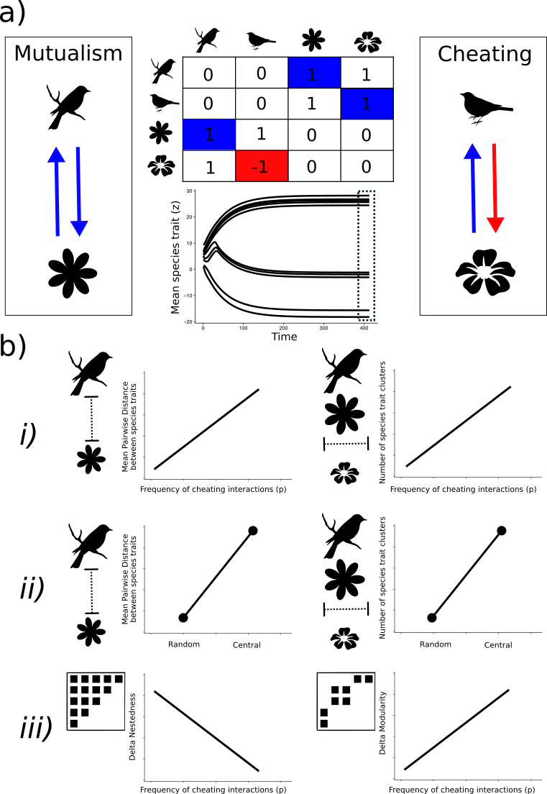

**Figure 1:** Interplay between mutualism and cheating interactions may drive the coevolutionary process in mutualistic networks. (a) Using a binary matrix of interactions, we define two types of interactions: mutualism, as a double positive effect between partner species, and cheating, as a positive effect for the cheater and a negative effect for the victim species. The positive or negative effect occurs from the species in columns to the species in rows (respectively, *i* and *j*) and the effects that define those interactions are the elements of the matrix (*1* or -*1*). Then, we simulate how the species mean trait value *Z* changes in time due to coevolution, as shown in the central plot. (b) We show our expectations for trait matching considering i)the frequency of cheating interactions, ii) species role, and iii) network structure and test these predictions with numerical simulations using a trait-based coevolution model and empirical mutualistic matrices of interactions.

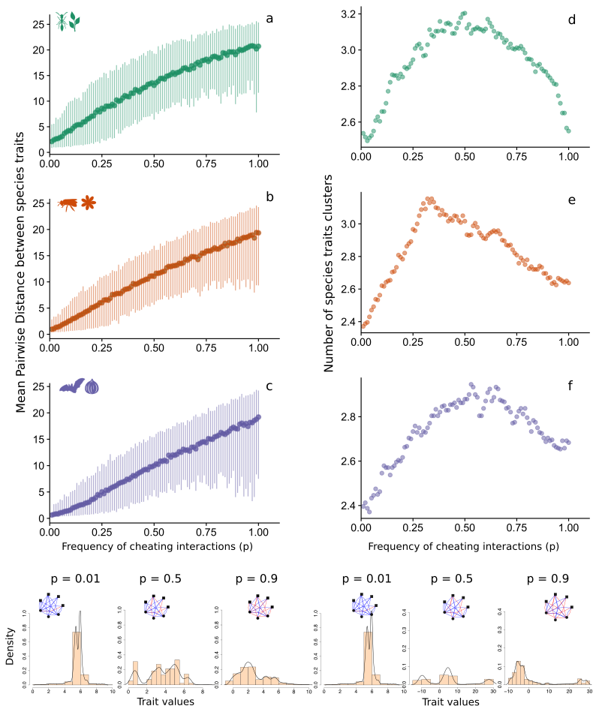

**Figure 2.** How do different frequencies of cheating interactions affect coevolutionary dynamics? Each point in the plot is the average values depicting the D and the number of species trait clusters in different frequencies of cheating interactions (*p*). Each error bar is the 0.05 and 0.95 quantile from our simulation results. Ant-myrmecophyte interactions are represented by the green plots, pollination by orange plots and seed dispersal interactions are represented by purple plots. Each histogram illustrates the distribution of trait values in one simulation with a given frequency of cheating interactions (*p*) where the left histograms show the increased trait disparity, and the right histograms shows the trait group formation.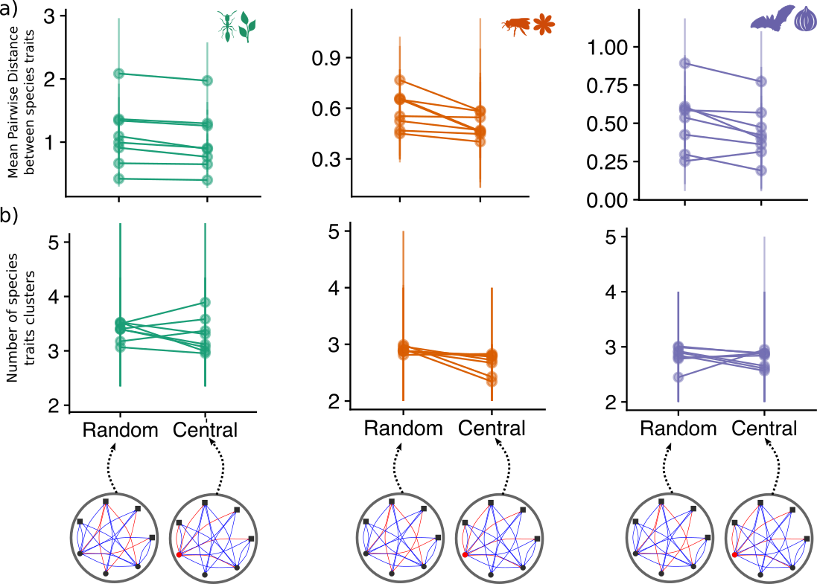

**Figure 3.** Do exclusive cheater species amplify the effect of cheating interactions on trait evolution? Using the species degree centrality, we estimated the frequency of cheating interactions in the Central scenario and used it as a *p* in the Random scenario. Theoretical bipartite networks were used to illustrate both scenarios; cheating interactions concentrated in a single central species and randomly distributed in the network. Two points connected with a line are paired comparisons between scenarios parameterized using the same empirical network and the error bars are the 0.05 and 0.95 quantile from our simulation results. Ant-myrmecophyte interactions are represented by the green plots, pollination by orange plots and seed dispersal interactions are represented by purple plots.

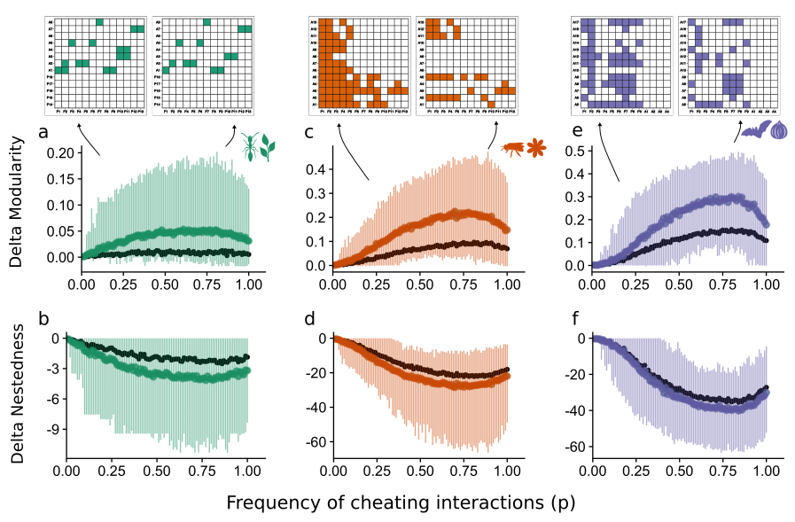

**Figure 4**. What is the effect of cheating interactions on the structure of mutualistic networks? Each point in the plot is the average values of **Δ**Q and **Δ**NODF in different frequencies of cheating interactions (*p*). Each error bar is the 0.05 and 0.95 quantile from our simulation results. The black points are values of ΔQ and **Δ**NODF from networks where we removed interactions randomly. Ant-myrmecophyte interactions are represented by the green plots, pollination by orange plots and seed dispersal interactions are represented by purple plots. The matrices above the graphs are examples of binary adjacency matrices to compare the loss of interactions in simulations from different scenarios.

**Table 1.** Variables and parameters of the model and their baseline values.

|  |  |  |
| --- | --- | --- |
| **Parameter** | **Description** | **Baseline values** |
| *Zi(t)* | Initial mean trait value of specie *i* | *Zi(t)* ~ U (0, 10) |
| *φ*i | Parameter composed of the additive genetic variance and phenotypic variance of *Z* | 0.2 |
| $$ε_{ij}$$ | Trait barrier to happen the cheating interaction between species *i* and *j* | 5 |
| *ϒ*i | Strength of abiotic selection for trait change of species *i* | 0.1 |
| *θi* | Zi optimum value for the environmental selection | *θ*i ~U (0, 10) |
| *Α* | Sensibility of evolutionary effect due to the trait matching between interacting species | 0.2 |
| *p* | Probability of a positive effect become negative in a mutualistic network | 0.01 ≤ *p* ≤ 1 |
| *b* | Trait barrier for any interaction happen between species in the network | 7 |

**Table 2.** Average ± SD values of D and statistical fit of a linear model between D and frequency of cheating interactions in the networks for three types of mutualisms.

|  |  |  |  |
| --- | --- | --- | --- |
| Mutualisms | Average D ± SD | Slope | R2 |
| **Ant-Myrmecophyte (n = 8)** | 12.94 ± 6.68 | 19.12 | 0.68 |
| **Pollination (n = 8)** | 10.86 ± 6.37 | 18.89 | 0.73 |
| **Seed dispersal (n = 8)** | 9.82 ± 6.66 | 19.39 | 0.70 |

**Table 3.** Average difference and paired t-test between Central and Random scenarios in D for three types of mutualisms.

|  |  |  |  |
| --- | --- | --- | --- |
| Mutualisms | Average SD difference from scenarios | t-test value | P |
| **Ant-Myrmecophyte (n = 8)** | -1.40 ± 0.78 | -5.05 | 0.001 |
| **Pollination (n = 8)** | -2.01 ± 1.58 | -3.60 | 0.009 |
| **Seed dispersal (n = 8)** | -1.71 ± 1.71 | -2.83 | <0.025 |

**Table 4.** Average ± SD **Δ**Q and **Δ**NODF for random interaction removal and trait barrier interaction removal for three types of mutualisms

|  |  |  |  |  |
| --- | --- | --- | --- | --- |
|  | **Δ**Q ± SD | | **Δ**NODF ± SD | |
| Mutualisms | Random | Simulations | Random | Simulations |
| **Ant-Myrmecophyte (n = 8)** | 0.007 ± 0.035 | 0.037 ± 0.056 | -1.65 ± 2.52 | -2.96 ± 3.39 |
| **Pollination (n = 8)** | 0.058 ± 0.072 | 0.14 ± 0.12 | -14.9 ± 13.5 | -19.4 ± 15.4 |
| **Seed dispersal (n = 8)** | 0.095 ± 0.081 | 0.18 ± 0.14 | -23.06 ± 17.02 | -26.3 ± 19.0 |