
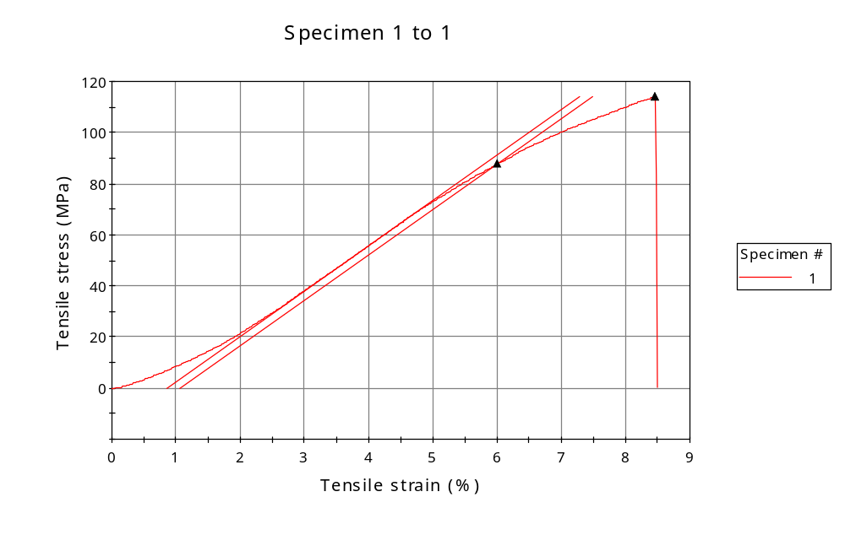
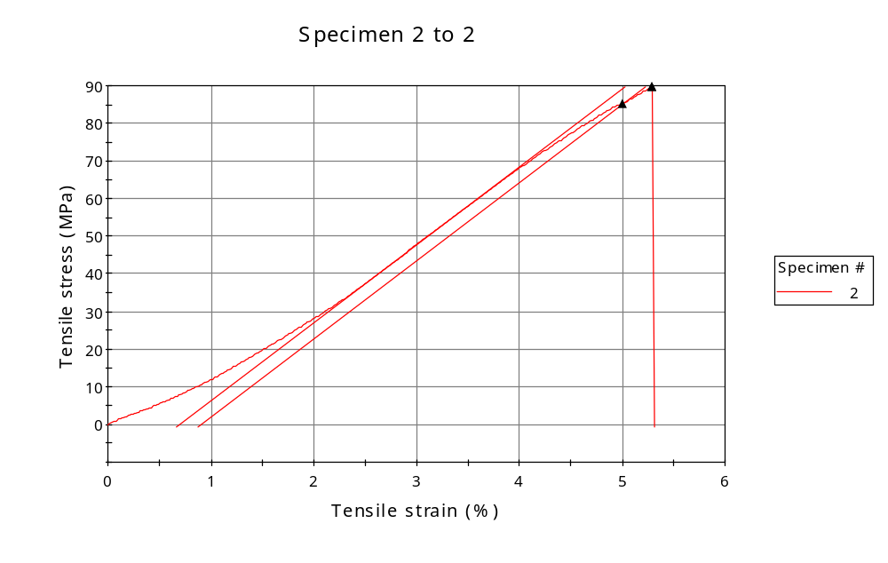
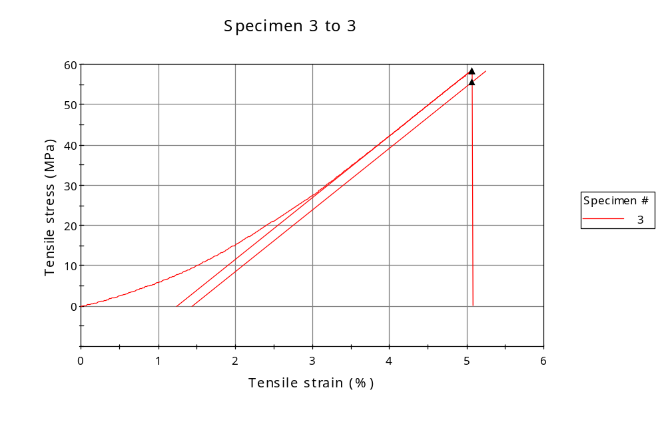
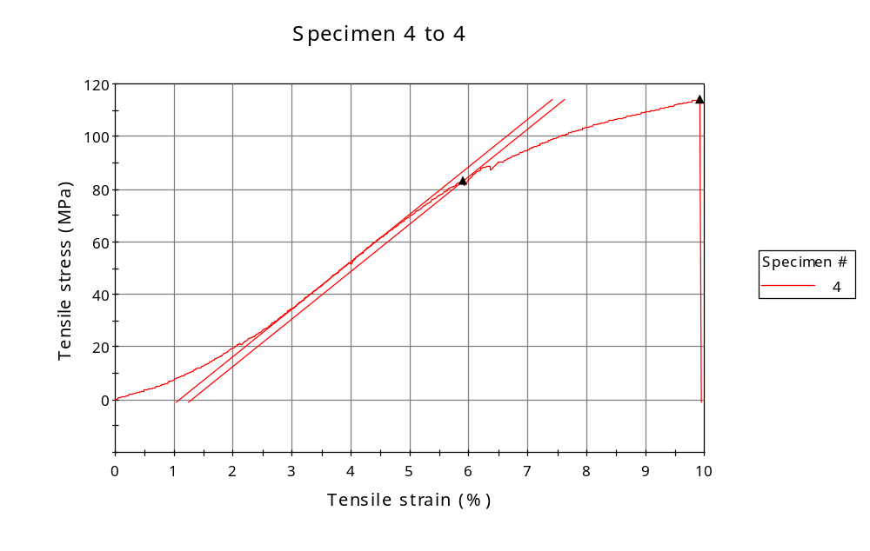
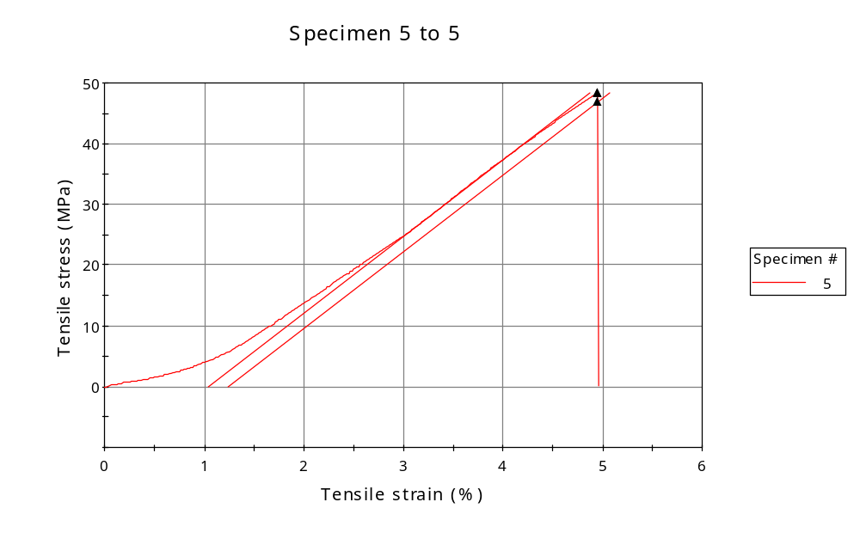
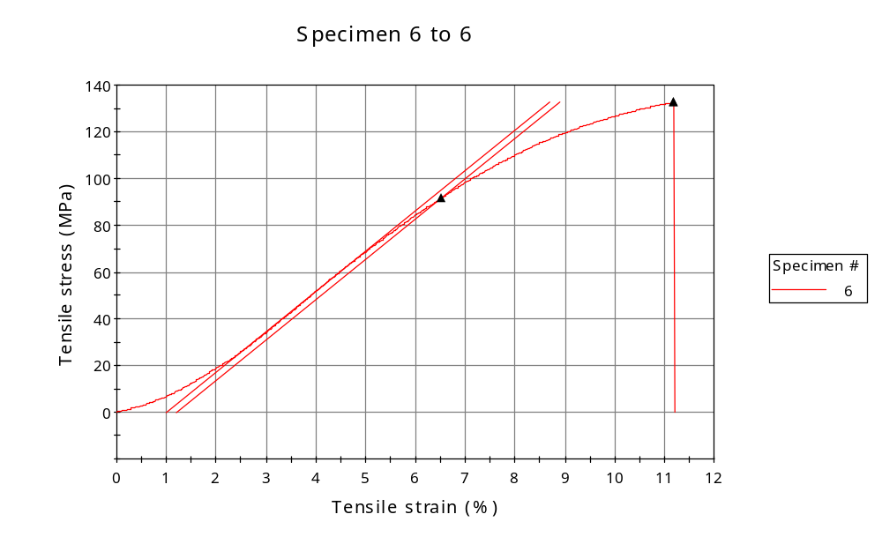
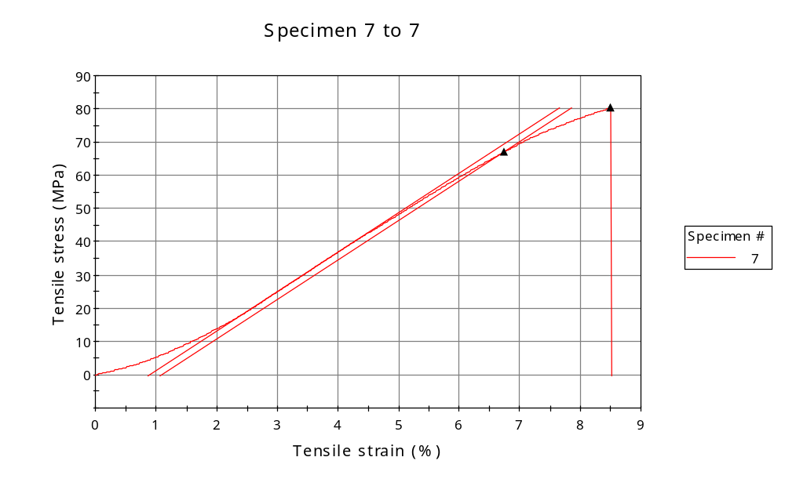
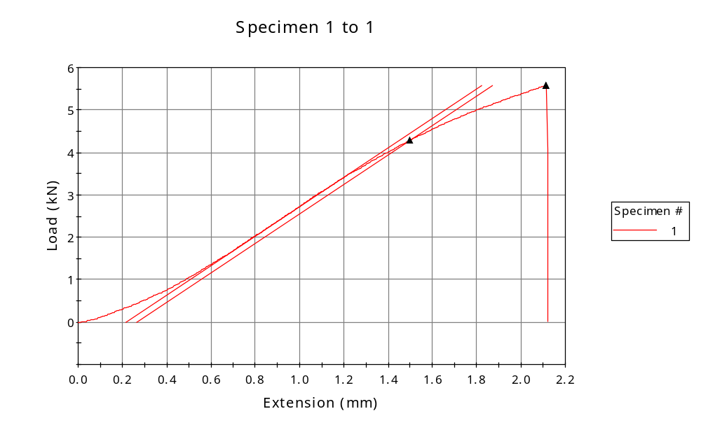
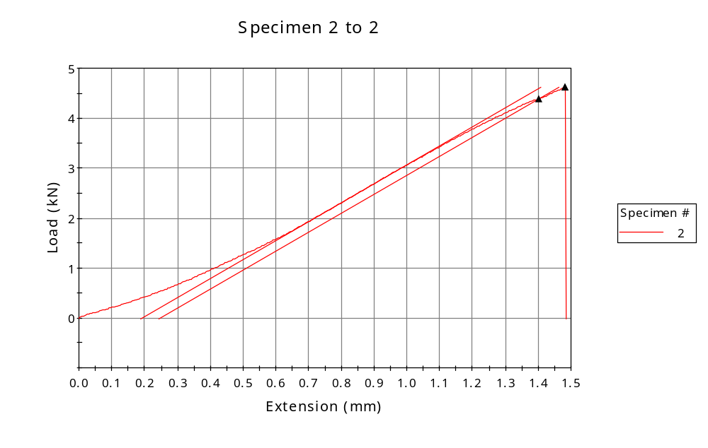
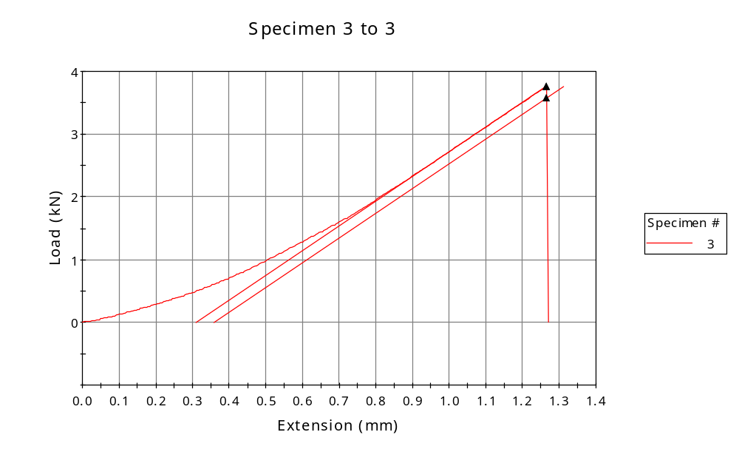
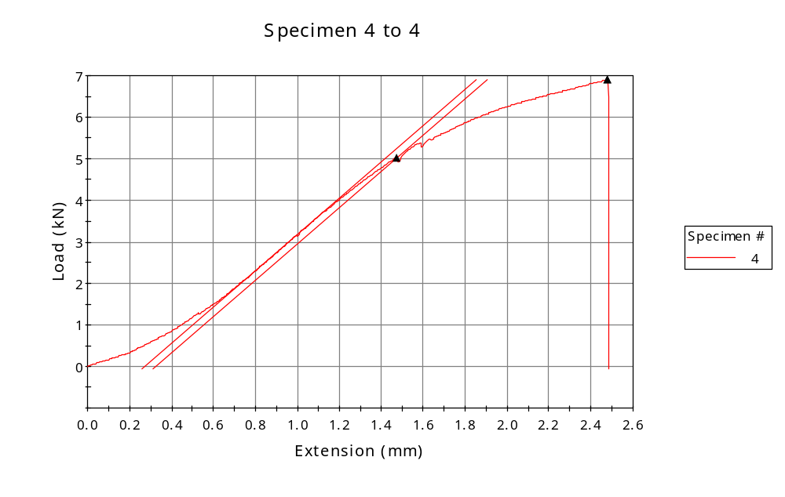
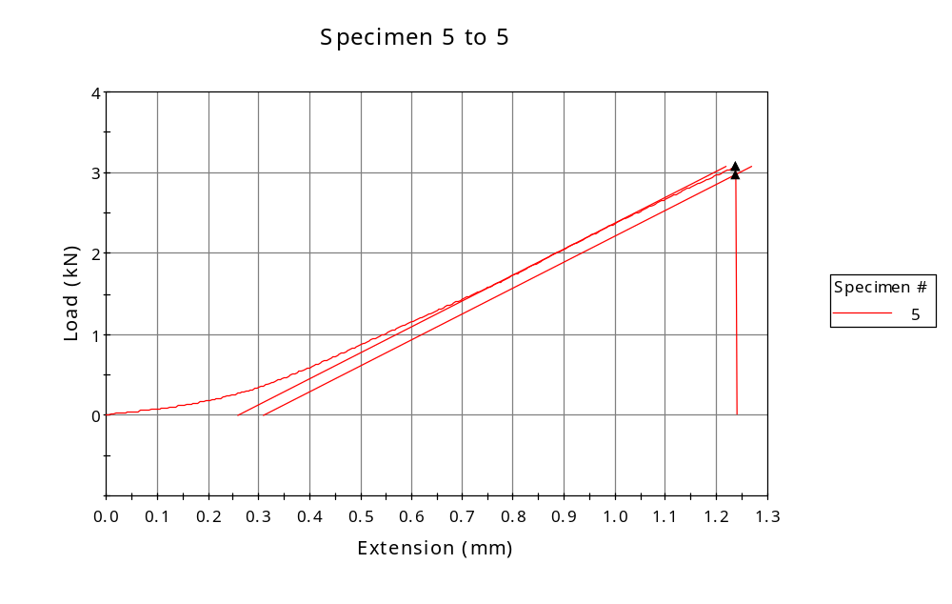
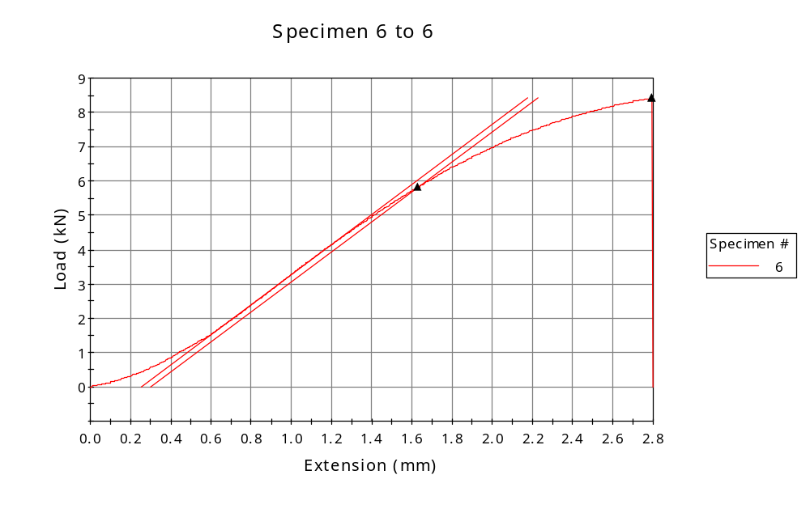
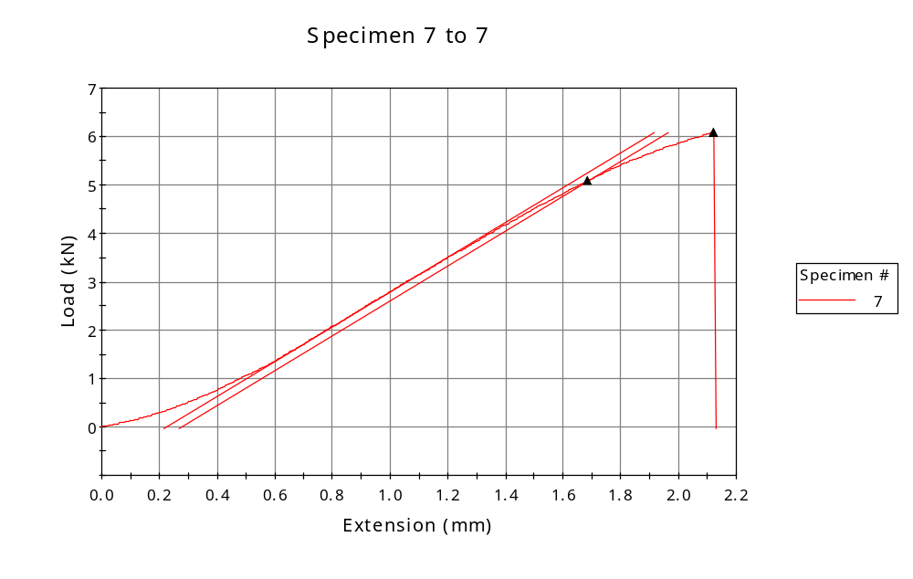

 | CP ID | Length  (mm) | Width  (mm) | Thickness  (mm) | Modulus (Automatic Young's)  (MPa)
1 | CP-01 | 25.00 | 6.00 | 8.15 | 1776
2 | CP-F1_3 | 28.00 | 6.00 | 8.57 | 2071
3 | CP-F1_02 | 25.00 | 6.00 | 10.73 | 1527
4 | CP-F2_1 | 25.00 | 6.00 | 10.08 | 1801
5 | CP-F2_2 | 25.00 | 6.00 | 10.57 | 1263
6 | CP-F2_3 | 25.00 | 6.00 | 10.58 | 1724
7 | CP-F2_4 | 25.00 | 6.00 | 12.65 | 1186
Maximum |  | 28.00 | 6.00 | 12.65 | 2071
Minimum |  | 25.00 | 6.00 | 8.15 | 1186

 | Load at Fy ( 0.2 %) - LE  (kN) | Tensao em Fy ( 0.2 %) - LE  (MPa) | Deformacao em Fy ( 0.2 %) - LE  (%) | Forca Max  (kN) | Tensao na Forca Max - LR  (MPa)
1 | 4.291 | 88 | 6.003 | 5.579 | 114
2 | 4.385 | 85 | 5.010 | 4.617 | 90
3 | 3.572 | 55 | 5.067 | 3.755 | 58
4 | 5.023 | 83 | 5.902 | 6.894 | 114
5 | 2.972 | 47 | 4.950 | 3.073 | 48
6 | 5.819 | 92 | 6.522 | 8.426 | 133
7 | 5.086 | 67 | 6.744 | 6.093 | 80
Maximum | 5.819 | 92 | 6.744 | 8.426 | 133
Minimum | 2.972 | 47 | 4.950 | 3.073 | 48

 | Deformacao na Forca Max - LR  (%) | Forca na Forca na Quebra - LQ  (kN) | Deformacao na Forca na Quebra - LQ  (%) | Final length  (mm) | Final width  (mm)
1 | 8.466 | 5.579 | 8.466 | 119.00 | 6.82
2 | 5.298 | 4.617 | 5.298 | 119.00 | 6.82
3 | 5.066 | 3.755 | 5.066 | 119.00 | 6.82
4 | 9.917 | 6.894 | 9.917 | 119.00 | 6.82
5 | 4.950 | 3.073 | 4.950 | 119.00 | 6.82
6 | 11.184 | 8.426 | 11.184 | 119.00 | 6.82
7 | 8.500 | 6.093 | 8.500 | 119.00 | 6.82
Maximum | 11.184 | 8.426 | 11.184 | 119.00 | 6.82
Minimum | 4.950 | 3.073 | 4.950 | 119.00 | 6.82

 | Alongamento
1 | 3.76
2 | 3.25
3 | 3.76
4 | 3.76
5 | 3.76
6 | 3.76
7 | 3.76
Maximum | 3.76
Minimum | 3.25

