**“21” – FX controller for NI Traktor Pro 2**

Created by Alexey Popoff

**Introduction**

21 is a touchscreen MIDI controller for iPad created using liine Lemur for iOS. It puts 21 of your favorite effects in Traktor at your fingertips. Literally. There are no FX presets. The controller is designed mainly for on-the-fly improvisation and exploration of new FX combinations. The package includes Lemur template and a MIDI mapping to load in Traktor.

**Key Features**

* Full control over all 4 of Traktor’s FX units
* Ability to switch between Single and Group modes for each FX unit
* Deck assignment for each FX unit
* Quick effect selection using a drop-down menu
* Freely assignable touch-sensitive XY pad for each FX unit
* A switch to enable physics for XY Pads to create some extra madness

**Requirements**

* You’ll have to trim down the list of effects in Traktor to exactly 21. This can be done through “Preferences -> Effects -> FX Pre-Selection”
* If your list of effects differs from mine, you’ll need to edit the template.
* The order of effects must be exactly the same both in Traktor preferences and in the Lemur template for drop-down menus to work correctly.

**Features Explained**

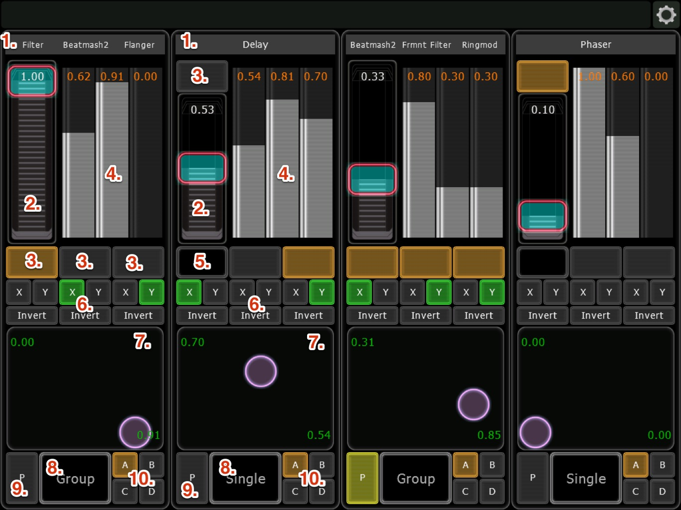

1. Drop-down menu to select FX
2. Dry/Wet fader
3. Effect on/off
4. Three sliders to control effect amount in Group mode or three of the effect parameters in Single mode
5. Reset effect. Single mode only. Touch Dry/Wet fader + this button to store effect preset (standard Traktor function). The other two buttons next to it are button1 and button2 for the selected effect. Again, Single mode only.
6. Three pairs of X/Y switches to assign the sliders to X/Y of the XY Pad below. It’s recommended to assign one slider to only one axis at a time. Selecting both X and Y for the same slider is not very useful and can create unexpected results. If at least one slider is assigned, XY Pad becomes touch-sensitive and will turn the effect on while being touched. This is useful for fast filter sweeps, drum fills, short glitches, etc. Below the X/Y switches are the Invert buttons. They invert the sliders to go from 1 to 0 instead of 0 to 1. This is useful with certain types of effects.
7. XY Pad to control assigned sliders
8. Single/Group mode switch
9. Switch to enable physics for XY Pad. Individual attributes like speed, friction, etc. can’t be controlled from the template. If you want to change those, you’ll need to edit the template using Lemur editor. Enabling physics disables XY Pad touch-sensitivity. Effects will need to be switched on/off using the corresponding buttons. This is because you’ll probably want to change the direction of the ball while it’s bouncing without turning the effects on/off.
10. Deck assignment to assign FX unit to specific decks

**Other Information**

Everything is mapped for two-way communication. Any change in Traktor is promptly reflected on the controller screen and vice versa. Enjoy!