## SWDV 265 project 2: Create an app using FRAMES

### Introduction

In this assignment, create a new app that illustrates concentric Frames in XAML.

### What to Do

The app should display progressively smaller frames, the outer being red, middle is green, and interior is blue. The text should read “<your name> has been Framed! “

1. Create a new solution called IveBeenFramed as a .NET project in Week 2 projects folder.
2. Delete MainPage from the .NET project.
3. Add a new XAML- ContentPage called IveBeenFramedPage.
4. Edit App.xaml.cs, changing the call to MainPage() to IveBeenFramedPage ()
5. Set the padding as outlined in OnPlatform changes.txt
6. Make 3 concentric Frames with the specified colors. HorizontalOptions and VerticalOptions should be set to CenterAndExpand.
7. Put a Label with the specified text in the innermost frame. HorizontalOptions and VerticalOptions should be set to CenterAndExpand.
8. Select IveBeenFramed.UWP as the startup project.
9. Rebuild All
10. Run the program. The result should look like this:
11. . 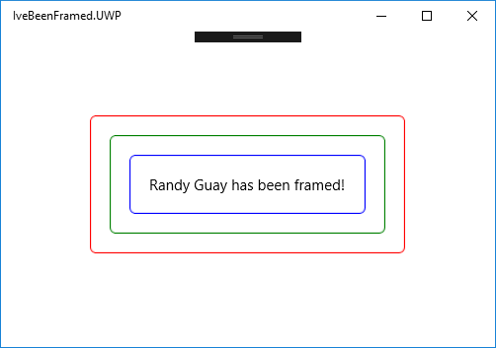
12. The frames and text do not need to resize for different screen sizes.

### Submitting work

Make a screenshot called IveBeenFramed.jpeg. Post it and your IveBeenFramedPage.xaml file to Blackboard.

### Grading

|  |  |  |
| --- | --- | --- |
| Points | Assignment | Requirements |
| 20 | Mobile Apps | Screenshot of UWP program fully functional |
| 20 | Mobile Apps | Photo of Android program running on device |
| 20 | Mobile Apps | Photo of iOS program running on device |
| 80 | Mobile Apps | Submit IveBeenFramed.xaml file |