使用说明：
1、包含有系统菜单文件/ED64P/OS64P.V64的存储卡必须插入SD卡槽
2、连接ED64Plus的USB端口和电脑的USB端口
3、待传输的ROM必须是非BYTE SWAPPED格式
4、在电脑端以命令行方式输入操作指令，回车进行传输
5、传输完成后，ROM自动运行
6、本软件仅供ED64Plus专用
命令行操作指令范例： "X:\>loader64.exe gamename.v64"

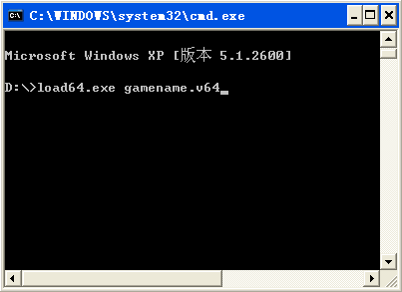

Instructions for use:
1, the system menu file / ED64P/OS64P.V64 the memory card must be inserted into the SD card slot
Connection ED64Plus USB port and the computer's USB port
3, the ROM must be transmitted non BYTE SWAPPED format
4, the command line in the PC input operation instruction, carriage returns, transmission
5, the transfer is complete, the ROM runs automatically
6, this software only ED64Plus

