Model documentation
Name: Lucas Eustáquio Gomes da Silva (Leustagos)
Location: Belo Horizonte – MG, Brazil
Email: lucas.eustaquio@gmail.com
Competition: Global Energy Forecasting Competition 2012 - Wind Forecasting

Summary
The topic for the wind forecasting track is focused on mimicking the operation 48-hour ahead prediction of hourly power generation at 7 wind farms, based on historical measurements and additional wind forecast information.
In order to do so, many features where derived from the dataset. The feature creation had two main guiding principles:
- Model the wind power generation equation, based on constants, wind strength, direction and air density. Windmill behavior.
- Discover the the relationship between wind power generation of T and T±n. The objective here was to reflect the inertia of windmills.
As for the models, the following types types were produced:
- Wind strength and direction components influence on each farm (used GLM)
- Similarity model to detect farm and overall inertia components (used K-Means)
- Wind strength, wind direction influence environment conditions and inertia modeling (used GLM and GBM)
- Ensemble of previous models (used GLM)

Feature Extraction
The first step of features creation was to create instances. The provided dataset did not contain these explicitly. To create these instances, the files “train.csv” and “benchmark.csv” were processed creating one entry for each date and each farm. Also the features “hour”, “month” were created at this point.
The result will a map like this:
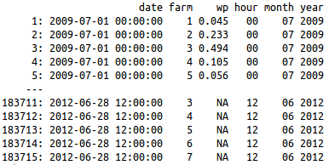
Features:
Name | Type | Description
date | Date and time | This is the date and time of each wind power measurement. It is used mainly to join different tables of features
farm | Categorical (values 1-7) | Represents each farm
wp | Numeric | Wind power – value to be predicted
hour | Categorical (values 01-24) | Hour of each wind power measurement
month | Categorical (values 01-12) | Month of each wind power measurement

The next step was to process the forecasts. Every forecast for each farm were used in this step. So for each date 4 distinct forecasts were obtained (except for the ones in the leaderboard set, which only one was used). Also some other features were derived on this step. The result was the following:
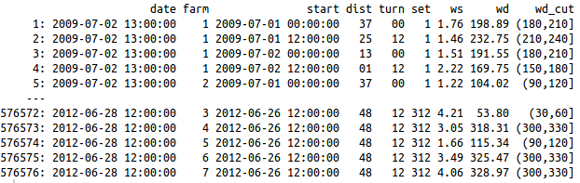
Features:
Name | Type | Description
date | Date and time | Target forecast date
farm | Categorical (values 1-7) | Represents each farm
start | Date and time | Date when the forecast was issued.
dist | Categorical (values 01-48) | Difference in hours of start and date. Distance of the forecasting.
turn | Categorical (00 and 12) | Indicates the starting hour of forecasting.
set | Categorical (1-312) | In order to replicate the same structure of the testing set, this variable was created. Each set represents a period of 36h+48h. The period between “2009-07-02 13:00:00” and “2012-06-28 12:00:00” has exactly 312 consecutive sets of 36h+48h each. This variable was used to do cross-validation training.
ws | Numerical | Predicted wind strength
wd | Numerical | Predicted wind direction
wd_cut | Categorical ( [0,30],(30,60],(60,90]...(330,360] ) | Categorical version of wind direction. Each 30 degrees interval was made into a category. The 30 degree interval was chosen interactively while training.

The next created features were historical ones. For each forecasting the 6 values before the start of the forecast were used. On the test set, many of those values were unknown, and those instances were discarded during some part of training. For validation purposes it would be useful to calculate those previous values for every single instance, even in training set, as in the real situation they would be known. The result is as follows:
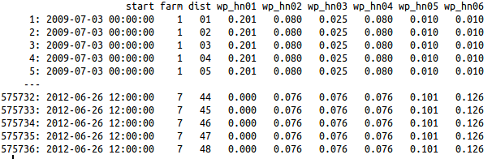
Features:
Name | Type | Description
start | Date and time | Date when the forecast was issued.
farm | Categorical (values 1-7) | Wind farm
dist | Categorical (values 01-48) | Difference in hours of start and date. Distance of the forecasting.
wp_hnXX (XX = [01,06]) | Numerical | X previous known value. 01 is the value for the farm at start date and time, 02 is start – 1 hour and so on.

The next features were made to unify wind strength and wind direction on one single numeric variable. That unification was exploited later to make a similarity model and to correct predictions using moving averages).
For wind power generation, it is expected that not only strength of wind matters, but also direction. The windmills will have different efficiencies for different directions. As can be seen in (1) the wind power conversion is proportional to some constants and ws³. It also depends on air density, but it was dealt later (an attempt to include air density here overfitted and since it was one of the last days of the competition, the causes weren't investigated).
This feature generation consisted on building a gbm model for each farm. To avoid overfiting, 5-fold cross validation were used. A very important issue of this cross validation is that it must use the set feature calculated before. Each set must be either include or excluded as a whole. Doing a instance based sampling overfits, because the model will be able to infer some information related to specifics 36h+48h periods.
The R formula used in this training was “wp ~ wd_cut*(ws + ws2 + ws3)”. ws2 and ws3 are ws² and ws³. wd_cut isn't exactly the same as described previously. For this training it was a categorical value that splited wd in intervals of 8 degrees (this splitting was found iteratively). The result of this training was called “ws.angle”. Another feature map was built with these values. In this map it was also included the 3 previous and 3 next values of “ws.angles”
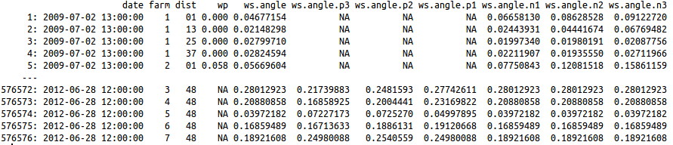
Features:
Name | Type | Description
date | Date and time | Target forecast date
farm | Categorical (values 1-7) | Wind farm
dist | Categorical (values 01-48) | Difference in hours of start and date. Distance of the forecasting.
wp | Numeric | Wind power
ws.angle | Numeric | Numeric value estimating influence of both ws and wd for date
ws.angle.p3 | Numeric | Numeric value estimating influence of both ws and wd for date – 3 hours. If not found defaults to wp of date – 3 hours.
ws.angle.p2 | Numeric | Numeric value estimating influence of both ws and wd for date – 2hours. If not found defaults to wp of date – 2 hours.
ws.angle.p1 | Numeric | Numeric value estimating influence of both ws and wd for date – 1 hours. If not found defaults to wp of date – 1 hours.
ws.angle.n3 | Numeric | Numeric value estimating influence of both ws and wd for date + 3 hours. If not found defaults to ws.angle.n2
ws.angle.n2 | Numeric | Numeric value estimating influence of both ws and wd for date + 2 hours. If not found defaults to ws.angle.n1
ws.angle.n1 | Numeric | Numeric value estimating influence of both ws and wd for date + 1 hours. If not found defaults to ws.angle

Finally, the last features were similarity ones. Since the predicted values are a time series, it is expected to have some inertia between predicted values. There shouldn't have any sudden transitions. One way to deal and let the model learn this was done in the last step. Including previous and next expected values will add make the model learn some dependency between T±n and T. Another way used to do this, is using similarity. See the farm behavior for a set of predictions.
The similarity features were calculated using k-means. For each 12 hour period of forecasting ([1-12],[13-24],[25-36],[37-48]) a instance was built. For each farm, 6 clusters were calculated, and for a dataset including all farms, 24 clusters were calculated. Seeking iteratively for a optimal number of cluster mays lead to performance improvement. After this two maps like this were produced:
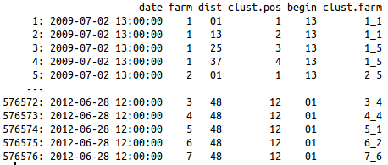
Features:
Name | Type | Description
date | Date and time | Target forecast date
farm | Categorical (values 1-7) | Wind farm
dist | Categorical (values 01-48) | Difference in hours of start and date. Distance of the forecasting.
clust.pos | Categorical (values 1-12) | Position of forecast inside the 12 sequential values. The same as the remainder of the division of (dist-1) by 12.
begin | Categorical | Hour of the first value of the 12 hour sequence.
clust.farm | Categorical (7 farms, 6 values for each = 42 distinct values) | Cluster that the 12 sequential hour got assigned.

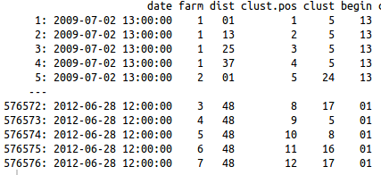
Features:
Name | Type | Description
date | Date and time | Target forecast date
farm | Categorical (values 1-7) | Wind farm
dist | Categorical (values 01-48) | Difference in hours of start and date. Distance of the forecasting.
clust.pos | Categorical (values 1-12) | Position of forecast inside the 12 sequential values. The same as the remainder of the division of (dist-1) by 12.
begin | Categorical | Hour of the first value of the 12 hour sequence.
clust | Categorical (1-24) | General cluster.

The final features were obtained by joined all maps with the forecast map described earlier. To join one map with another simple match the common columns of each.

Modeling techniques and training
All models were trained using the same 5-fold validation scheme. A very important characteristc of this training is that the validation sets were built to either include or remove the 36h+48h hours as a whole. Instance by instance sampling wouldn't reflect neither the real situation or the test set one. By doing this, a consistent validation set was obtained. Significant improvements almost always reflected improvements on the leaderboard.
As stated before, the models were trained aiming two things:
- Model the wind power generation equation, based on constants, wind strength, direction and air density. Windmill behavior.
- Discover the the relationship between wind power generation of T and T±n. The objective here was to reflect the inertia of windmills.
To achieve this the following types of models were trained:
- GBM with gaussian distribution and formula “wp ~ ws + farm + dist + ws.angle + ws.angle.p1 + ws.angle.p2 + ws.angle.p3 + ws.angle.n1 + ws.angle.n2 + ws.angle.n3 + hour + month”: The aim of this model was to learn inertial behavior and something about air density and other ocasional enviroment influences. The inertial behavior was learn through ws.angle(T±3). Ocasional influences were modeled through hour and month categorical variables. Maybe using temperature and or humidity measurements could achieve it better on real world situations. Hour and month models the night/day and seasons relationship. The farm value will deal with any farm specifics and dist with errors due to the distance of forecast (the longer the distance, greater the error)
- GBM with gaussian distribution and formula “wp ~ ws + farm + ws.angle + ws.angle.p1 + ws.angle.p2 + ws.angle.p3 + ws.angle.n1 + ws.angle.n2 + ws.angle.n3 + hour + month + year + dist + wp_hn01”: Same as before including the latest known value of wind power. This value can provide some valuable context information and a starting point for the time series. The reason why both models exists is because many instances of the testing period were discarded to train this one (they lack wp_hn01). In the real situation it wouldn't be necessary, because it would be always available.
- BGM with gaussian distribution and formula “wp ~ farm + dist + wp_hn02 + wp_hn03 + wp_hn04 + hour + month + clust.farm + clust + begin + clust.pos”: This model was built to discover some environment influences. Mixing these features with the previous ones didn't show improvement. Doing separated trainings did. Maybe its because ws and ws.angle are very good predictors and would obfuscate the weaker features. Maybe it was just bad tunning.
All models mentioned before were trained in tree flavors: per farm, per clustered distance ( (0,3],(3,6]...(45,48] ), and one with all.

The final model was a glm ensemble of the previously mentioned (9 models). It was trained using the cross-validated responses for each one. It also used farm and dist as features (because they were used to do the splitting, and would have some meaning to express each models weakness and strengths)
After that yet another model was trained. A smoothing one. It took the result of the ensmble and did a T±n interpolation of the predictions. This model became almost useless when ws.angle(T±n) was included in the previous ones. But it did improve the prediction a tiny bit (useful for competitions).

Code description
The code uses R. All R source files are placed inside “GEFCom2012-Wind-R”. Each R file inside this folder is described as follows:
File | Description
fn.base.R | Utility functions
data.build.R | Builds the features
data.train.farm.R | Trains the models by farm
data.train.dist.R | Trains the models by clustered forecast distance
data.train.misc.R | Trains the overall models
data.train.ens.R | Trains the ensemble model
data.train.all.R | Just call all previous files in order

Generating the solution
The solution was built in a linux environment. Maybe it will also run on windows, but it will rely on the availability of the used libraries. Maybe something will need to be corrected for this, as it wasn't tested on windows.
Step by step guide:
- Put all raw data files (uncompressed) inside data/raw folder.
- Open a R instance with GEFCom2012-Wind-R set as workspace (All scripts must be run with this folder set as the workspace).
- Run data.train.all script. This will build all the features and saves them to the default workspace. The generated prediction will be inside GEFCom2012-Wind-R/data folder.

Additional Comments

- Training all 9 intermediate models didn't improve the final score that much. Ensembling only the ones trained with all instances had almost the same result.

References
- Wind power generation. http://en.wikipedia.org/wiki/Wind_power

