A Feature Engineering Approach to Wind Power Forecasting
GEFCom 2012

Lucas Silva
Software Engineer and Data Scientist
DTI Sistemas
Belo Horizonte, Brazil
lucas.eustaquio@gmail.com

Abstract— this paper describes detailed information about team Leustagos approach to the wind power forecast track of GEFCom 2012. The task was to predict 48-hour ahead hourly power generation at 7 wind farms. The problem was addressed by extracting time and weather related features. These features were used to build gradient boosted decision trees and linear regression models. This approach granted us the 1st place both in the public and private leaderboards.
Keywords— GEFCom, feature engineering, gradient boosted decision trees, linear regression, machine learning, time series

Introduction
The “GEFCom 2012 – Wind Forecast” competition [1] posed the challenge of forecasting the hourly wind power generation for 7 wind farms. A dataset containing historical power measurements for these wind farms, as well as meteorological forecasts of wind components at the level of those wind farms were provided. A detailed description of the dataset can be found in [2].

Challenges
A big challenge in this task was dealing with the time-series nature of the dataset. Since no time-series specific model was used, it had to be kept constantly in mind.
Another difficult part was to create efficient features. Feature creation is one of the most important steps in solving a supervised learning problem. In order to do so, many features where derived from the dataset. The feature creation had two main guiding principles:
- Model the wind power generation equation, based on constants, wind strength, direction and air density (surrogated). These features represent the windmill behavior.
- Discover the relationship between wind power generation of T and T±n. The objective here was to reflect the time-series nature of the dataset, since the modeling techniques aren’t times series specific.

Dataset
As can be seen, the data provided [2] consisted only of a series of hourly wind power generation for each farm, and the forecasted wind strength and direction, issued every 12 hours. It was provided in this way to mimic the real operation conditions and it didn’t have all desired information, like forecasted temperature and air density. So to make it up for this missing information, many surrogate features were created, as it will be explained later. Also, an important step was to build a consistent validation set using only the training period. This validation set allowed to build a model that didn’t overfit the training data.

Techniques
In this work we have used mainly three machine learning techniques, all of them on the R statistical environment. Table 1 gives a brief description of how each algorithm was employed. The rest of this section outlines these algorithms in more detail.
Table 1 - Used Techniques
Technique | Used for
Multiple Linear Regression [3] | Wind strength and direction components influence in each farm.  Ensemble.  Post process to smooth the predictions (high frequency filter).
K-MEANS [4] | Similarity model to detect farm and overall behavior
GBM [5] | Models by farm.  Models by time slot.  Overall models

Linear Regression
The linear regression method was used in this work as a pre-processing step to unify wind strength and direction components in one single feature, to ensemble the models trained with GBM, and finally as a post processing step to smoothen the moving average of the predicted values.
Multiple linear regression attempts to model the relationship between two or more explanatory variables and a response variable by fitting a linear equation to observed data. Every value of the independent variable x is associated with a value of the dependent variable y [12]. The formal definition:
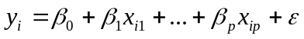 (1)
Where:
- i = 1…n is the training instance index
- 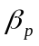 are the regression coeficients
- 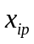are the features
- is the residual error
The linear regression model attempts to find coefficients that make the residual error be as close to zero as possible. In this work we used the Mean Squared Error as the error metric to fit all linear models used.

K-Means
In this work, k-means was used to create some similarity features. The objective of these features was to cluster features that should have similar behavior.
K-Means is a simple learning algorithm for clustering analysis. The goal of K-Means algorithm is to find the best division of n entities in k groups, so that the total distance between the group's members and its corresponding centroid, representative of the group, is minimized [11]. The pseudo-code for the K-Means algorithm is in Figure 1 [11].
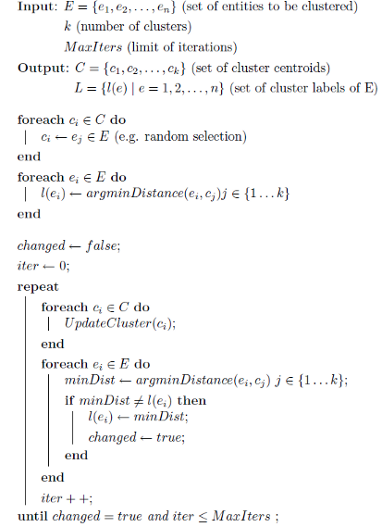
Figure 1 – K-Means Algorithm

GBM – Generalized Boosted Models
GBM was used to train our final submission models. We used the GBM package [8] in the R environment with the Gaussian distribution function [9].
The R GBM package implements boosting for models commonly used in statistics. The GBM algorithm is shown in Figure 2 [10]:
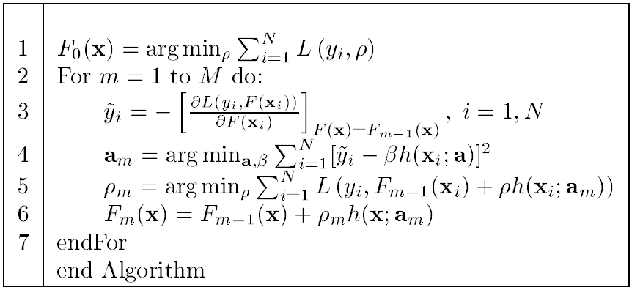
Figure 2 – Boosting Algorithm
Where:
- F(x) is the function we want to minimize
- L(y, p) is the loss function
- y is the output
- p is the prediction
- M is number of trees
- h(x; a) is a “weak learner”or “base learner”, usually trees
The basic framework of the approach is shown in Figure 3. First, in the preprocessing step, features were created. After that three types of models were trained using the processed data:
- Models that were trained for each farm;
- Models that were trained for each predicted time slot (1h-3h ahead, 4h-6h ahead, … 45h-48h ahead);
- Overall models trained without splitting the samples (except for the cross-validation).
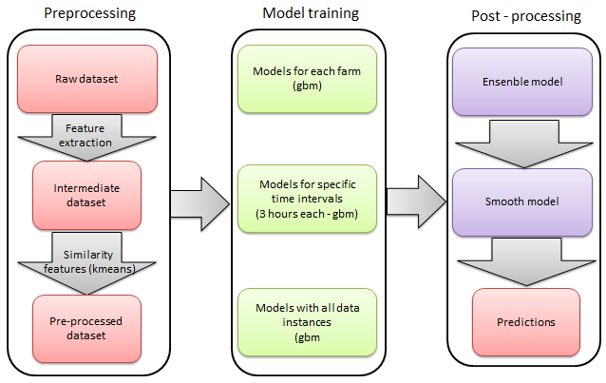
Figure 3 - Basic approach framework

Organization of this paper
In this paper, is described in detail used features and models. Section II briefly describes the dataset and how the data was split for model training. Section III outlines the algorithms used. Section IV shows the performance measurement. Section V is about the chosen approach to this task as it describes the training methods and features. Section VI presents results, section VII discusses some aspects of the solution, and section VIII presents some conclusions.

The Approach

Validation set
The first step of the used approach was to build a consistent validation set. It was built trying to replicate the same structure found in the evaluation period between filled and missing spots. In order to replicate it, the training and evaluation periods were each split in 312 sets of 84 consecutive hours (36+48) and those sets were used to define the 5-fold validation splitting. Each training/validation fold assigned entire 84 hour buckets to either training or validation.
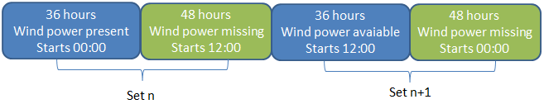
Figure 4 - Training/validation splitting

Figure 4 shows how the set assignment was done. One can notice that odd numbered sets starts at 00:00 and even numbered starts at 12:00. This also happens with the missing spots in the evaluation period. As for the 5-fold splitting, it was done like this:
- Validation folds: Fold 1 contained sets 1, 6, 11 and so on as validation set and the remaining as training set. Fold 2, contained 2, 7, 12, …, as validation, and analogous splitting were done for folds 3, 4 and 5.
- Test fold: Contained all available filled data and was used to build models to predict missing data.
In this scenario, each model needed to be trained six times. One for each validation folds to tune model parameters and also train ensembles, totalizing five and another one with full available data to predict the leaderboard. This procedure allowed us to produce consistent results most of the time, meaning that improvements found in available data almost always generalized to the missing unknown data.
In this problem there is a time component in the data, so random cross-validation tends to overestimate the performance of models as it implicitly gives to the model more information of the surroundings of each 48 hour spot. This was verified in an early step benchmark.

Features creation
The first step of features creation was to create training instances. The provided dataset did not contain these explicitly. To create these instances, the files “train.csv” and “benchmark.csv” were processed creating one entry for each date and each farm. Also the features hour, month and year were created at this point. Figure 5 how the produced data looked like and Table 2 explains each feature.
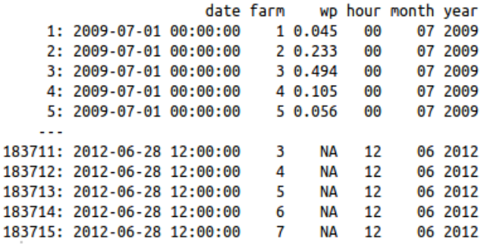
Figure 5 - Instance Creation Step 1

Table 2 – Features created in the first step
Name | Type | Description
Date | Date and time | This is the date and time of each wind power measurement. It is used mainly to join different tables of features
farm | Categorical (1-7) | Represents each farm
wp | Numeric | Wind power – value to be predicted
hour | Categorical (01-24) | Hour of each wind power measurement
month | Categorical (01-12) | Month of each wind power measurement
year | Categorical (2009-2012) | Year of each wind power measurement

The next step was to process the forecasts. Every forecast for each farm was used in this step. Each timestamp had 4 distinct forecasts, except for the ones in the leaderboard set, which had only the one that would be available at the time of forecasting. Also some other features were derived in this step. Figure 6 and Table 3 show the data and the features meaning.
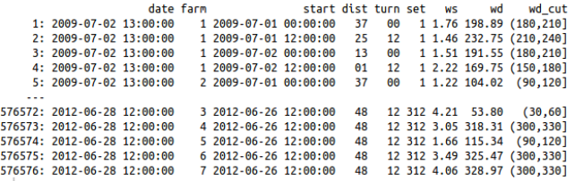
Figure 6 - Features created using forecast
Table 3 - Forecast features
Name | Type | Description
date | Date and time | Target forecast date
farm | Categorical  (values 1-7) | Represents each farm
start | Date and time | Date when the forecast was issued.
dist | Categorical  (values 01-48) | Difference in hours of start and date. Distance of the forecasting.
turn | Categorical  (00 and 12) | Indicates the starting hour of forecasting.
set | Categorical  (1-312) | Each set represents a period of 36h+48h. This variable was used to do cross-validation training.
ws | Numerical | Forecasted wind strength
wd | Numerical | Forecasted wind direction
wd_cut | Categorical  ([0,30]...(330,360]) | Categorical version of wind direction.

The next created features were historical ones. For each forecasting the six values before the start of the forecast were used. In the test set, many of those values were unknown, and those instances were discarded during some part of training. For validation purposes it would be useful to calculate those previous values for every single instance, even in training set, as in the real situation they would be known. The historical features are Table 4.
Table 4 - History features
Name | Type | Description
start | Date and time | Date when the forecast was issued.
farm | Categorical (1-7) | Wind farm
dist | Categorical (01-48) | Difference in hours of start and date. Distance of the forecasting.
wp_hnXX (XX = [01,06]) | Numerical | X previous known value. 01 is the value for the farm at start date and time, 02 is start – 1 hour and so on.

The next features were made to unify wind strength and wind direction in one single numeric variable. That unification was exploited later to make a similarity model and to correct predictions using moving averages.
For wind power generation, it is expected that not only strength of wind matters, but also direction. The windmills will have different efficiencies for different directions. As can be seen in [7] the wind power conversion is proportional to some constants and ws³ (wind strength). It also depends on air density.
This feature generation consisted in building a simple regressive model for each farm. To avoid overfitting, 5-fold cross-validation were used. A very important issue of this cross validation is that it must use the set feature calculated before. Each set must be fully included or fully excluded. Doing an instance based sampling would overfit, because the regression will infer some information related to specifics 36h+48h periods.
The R formula used in this training was “wp ~ wd_cut*(ws + ws2 + ws3)”, ws2 and ws3 are ws² and ws³. wd_cut isn't exactly the same as described previously. For this training it was a categorical value that split wd in intervals of 8 degrees (this splitting was found iteratively). The result of this training was called ws.angle. Another feature map was built with these values. In this map it was also included the three previous and three next values of ws.angles. The result is shown in Table 5.

Table 5 - Features unifying ws and angle
Name | Type | Description
date | Date and time | Target forecast date
farm | Categorical (1-7) | Wind farm
dist | Categorical (01-48) | Difference in hours of start and date.
wp | Numeric | Wind power forecast
ws.angle | Numeric | Influence of both ws and wd for date
ws.angle.p3 | Numeric | ws.angle for date – 3 hours. If not found defaults nearest ws.angle.
ws.angle.p2 | Numeric | ws.angle for date – 2 hours. If not found defaults nearest ws.angle
ws.angle.p1 | Numeric | ws.angle for date – 1 hours. If not found defaults nearest ws.angle
ws.angle.n3 | Numeric | ws.angle for date + 3 hours. If not found defaults nearest ws.angle
ws.angle.n2 | Numeric | ws.angle for date + 2 hours. If not found defaults nearest ws.angle
ws.angle.n1 | Numeric | ws.angle for date + 1 hours. If not found defaults nearest ws.angle

Finally, the last features were similarity ones. Since the predicted values are a time series, it is expected to have some inertia between predicted values. It shouldn't have many sudden variations. One way to deal and let the model learn this was done in the last step. Including previous and next expected values will make the model learn some dependency between T±n and T. Another way used to do this is similarity. Extract the farm behavior for a set of predictions.
The similarity features were calculated using k-means. For each 12 hour period of forecasting ([1h-12h],[13h-24h],[25h-36h],[37h-48h]) a instance was built. For each farm, six clusters were calculated, and for a dataset including all farms, twenty four clusters were calculated. See Table 6 for the results.
Table 6 - Similarity features
Name | Type | Description
date | Date and time | Target forecast date
farm | Categorical (1-7) | Wind farm
dist | Categorical (01-48) | Difference in hours of start and date. Distance of the forecasting.
clust.pos | Categorical (1-12) | Position of forecast inside the 12 sequential values. The same as the remainder of the division of (dist-1) by 12.
begin | Categorical | Hour of the first value of the 12 hour sequence.
clust.farm | Categorical (42 = 7 x 6) | Cluster that the 12 sequential hour got assigned.
clust | Categorical (1-24) | General cluster

The final features were obtained by joining all produced features. To join the features simply match the common columns and do a cartesian product with the remaining. Taking Table 2 and Table 6 as example, we can see that the common features in them are date and farm. To join these tables, match those fields by its values. In this specific case, for each match in Table 2, four records will be found in Table 6, because each wp forecast was issued four times. The joining result will have four records, appending Table 2 features to each match in Table 6 (cartesian product).
Some features refer to values in the future (date + n hours). It is important to point out that those values are the forecasted ones, so the whole feature engineering here only uses data available at the time of forecasting.

Modeling techniques
All models were trained using the same 5-fold validation scheme. A very important characteristic of this training is that the validation sets were built to either include or remove the 36h+48h hours as a whole, as repeatedly said before. Instance by instance sampling wouldn't reflect neither the real situation nor the test set one. By doing this, a consistent validation set was obtained. Significant improvements almost always reflected improvements in the leaderboard.
The models were trained aiming two things, as already mentioned before:
- Model the wind power generation equation, based on constants, wind strength, direction and air density. The last one was surrogated by seasonal features, like time, hour and year. Express the windmill behavior.
- Discover the relationship between wind power generation of T and T±n. The objective here was to add some time-series nature to the models.
To achieve this, the following types of models were trained:
- GBM with gaussian distribution and formula wp ~ ws + farm + dist + ws.angle + ws.angle.p1 + ws.angle.p2 + ws.angle.p3 + ws.angle.n1 + ws.angle.n2 + ws.angle.n3 + hour + month: The aim of this model was to learn inertial behavior and something about air density and other occasional environment influences. The inertial behavior was learned through ws.angle(T±3). Occasional influences were inferred using hour, month and year categorical variables. Maybe using temperature and or humidity measurements could achieve it better on real world situations. Hour and month is related to night/day and seasons relationship. The farm value will deal with any farm specifics and dist with errors due to the distance of forecast (the longer the distance, greater the error)
- GBM with gaussian distribution and formula wp ~ ws + farm + ws.angle + ws.angle.p1 + ws.angle.p2 + ws.angle.p3 + ws.angle.n1 + ws.angle.n2 + ws.angle.n3 + hour + month + year + dist + wp_hn01: Same as before including the latest known value of wind power. This value can provide some valuable context information and a starting point for the time series. The reason why both models exist is because many instances of the testing period were discarded to train this one (they lack wp_hn01). In the real situation it wouldn't be necessary, because it would be always available.
- GBM with gaussian distribution and formula wp ~ farm + dist + wp_hn02 + wp_hn03 + wp_hn04 + hour + month + clust.farm + clust + begin + clust.pos: This model was built to discover some environment influences. Mixing these features with the previous ones didn't show improvement. Doing separated trainings did.
All models mentioned before were trained in tree flavors: per farm, per clustered distance ( (0,3],(3,6]...(45,48] ), and one without distinction (Figure 3).
The final model was a linear ensemble of the previously mentioned models (9 models). To define the ensenbling weights, a simple linear regression optimizing the RMSE was used. It was trained using the cross-validated predictions of the models. It also used farm and dist as features, because they were used to do the splitting, and had a relationship with each models weakness and strengths.
After that yet another model was trained. A smoothing one. It took the result of the ensemble and did a T±n interpolation of the predictions. This model became almost useless when ws.angle(T±n) was included in the previous ones. But it did improve the prediction a bit, which was useful for a competition.

Results and discussion

Results
The evaluation metric was RMSE, shown in Equation 2, rooted mean squared error. This metric goes down as the accuracy of the model goes up.
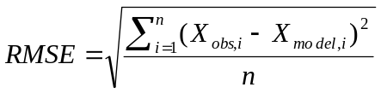 (2)

Figure 7 shows the score improvement of the milestones in this solution. As can be seen, the first model, containing only forecasts and previous known values scored 0.1685. Then by adding some seasonal features (hour, month and year) it went to 0.16393. Next were included in the set the intervals of 36h that were available in the test period and it got better again. After the cross-validation scheme was changed to do the validation splitting using whole 36+48 the score jumped to 0.15315. Then adding the overall model and the smoothing model of final predictions, took it to 0.15103. The last big leap in the score was the inclusion of all combinations of dates and forecasts, with 4 forecasts for each known instance, scoring 0.14779. And finally the unsupervised cluster features were included to get the final and best score of 0.14567.
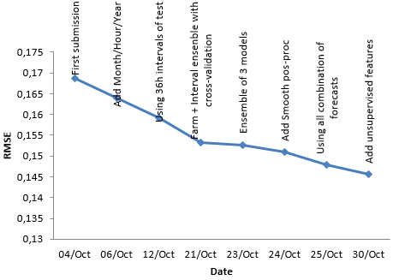
Figure 7 - Score evolution

Looking at the final results in Table 7, we can see that the whole procedure generalizes well, getting consistent results both in public and private leaderboards.

Table 7 - Final Standings
Rank | Team | Public Score | Private Score
1 | Leustagos | 0.14574 | 0.14567
2 | DuckTile | 0.14872 | 0.14720
3 | Gilberto Titericz Jr | 0.14792 | 0.14822
4 | Stefan Henß | 0.14684 | 0.14854
5 | Mz | 0.14804 | 0.14916

Discussion
In this work was provided an efficient approach to predict wind power generation on seven distinct wind farms. The solution was composed by two parts: extracting features and applying distinct aggregation schemes in the data to create models. In the end this approach used many models, more than needed in an actual situation, but that happened because this approach was done to win a competition, when every bit of performance must be considered, disregarding the computation expenses to build it. Also some data that would be known in real operation were hidden, adding complexity to the training process. After the competition, some tests with the models were performed and a simpler version of it was obtained, a version that performed almost as good, but much less complicated. In that approach, only the two overall GBM regressions were used and the features built to merge wind strength and wind direction were discarded. Maybe it would be possible to achieve even better accuracy by including more features, like temperature and humidity forecasts.

Conclusion
We have shown that with some clever combination of well-known algorithms (GBM, linear regression and k-means) it is possible to achieve a high precision for wind power prediction. The most important steps were choosing a reliable scheme of validation for training and creating good features. The key for the result was to never forget the time-series nature of the dataset. Many of the features, some post processing steps and the validation scheme used this characteristic to be designed, and they were the source of this work success. The proposed solution was somewhat complex but accurate. Some tests showed that it could be greatly simplified, with only marginal performance degradation.

References
- Global Energy Forecasting Competition 2012 - Wind Forecasting. http://www.kaggle.com/c/GEF2012-wind-forecasting, 2013.
- Tao Hong, Pierre Pinson and Shu Fan, “Global Energy Forecasting Competition 2012”, GEFCom 2013.
- Charles J. Geyer . Generalized Linear Models. http://www.stat.umn.edu/geyer/5931/mle/glm.pdf
- R Kmeans package, http://stat.ethz.ch/R-manual/R-devel/library/stats/html/kmeans.html, 2013
- Greg Ridgeway. gbm: Generalized Boosted Regression Models. http://cran.r-project.org/web/packages/gbm/index.html, 2013
- Rooted Mean Square Deviation, RMSE, http://en.wikipedia.org/wiki/Root-mean-square_deviation, 2013
- Wind power generation. http://en.wikipedia.org/wiki/Wind_power
- Greg Ridgeway. gbm: Generalized Boosted Regression Models. http://cran.r-project.org/web/packages/gbm/index.html, 2012
- Greg Ridgeway. Generalized Boosted Models: A guide to the gbm package, 2007
- Jerome H. Friedman. Greedy Function Approximation: A Gradient Boosting Machine. Reitz Lecture, 2001
- Data Mining in R. K-Means Clustering. http://en.wikibooks.org/wiki/Data_Mining_Algorithms_In_R/Clustering/K-Means
- Multiple Linear Regression. http://www.stat.yale.edu/Courses/1997-98/101/linmult.htm

