In-class Activity 12: The Hugging Face Ecosystem
AI Driven App Development · 2026 Fall
Name: Lucas Figueroa
Our app is a simple lead qualifier. A person pastes an inbound note. A small Hub model pulls out the person and the company so we can match the note to an account. Deciding whether the lead is actually qualified, and any open-ended reply, stays with a person or with Gemini.

Part 1: Explore the Hub

1. The four main sections

Models
Models is the catalog of pretrained weights, plus the tokenizer, model card, and license that go with them. A developer cares because this is where you check what a model was trained to do, whether it is small enough to run, and whether the license allows the product you are building.

Datasets
Datasets is shared training and evaluation data, with a card that says where the data came from and how it is split. A developer cares because the data is what the model actually learned, and a dataset license can block a use even when the model license looks open.

Spaces
Spaces are hosted apps, usually Gradio or Streamlit, that run a model in the browser on Hugging Face hardware. A developer cares because you can try a model before downloading it, or put a demo up without running your own server.

Docs
Docs is the documentation for the Hub and the libraries, including transformers and pipeline(). A developer cares because that is where the task names, the loading code, and the limits of a model are written down.

2. BAAI/bge-small-en-v1.5
License: MIT.
The model card describes bge-small-en-v1.5 as an English embedding model that turns text into vectors for retrieval, and says version 1.5 has a more reasonable similarity distribution.

Part 2: Licenses

3. A hypothetical GPL 3.0 model (big_finance_predictor)
GPL duties start when you distribute the software. The three cases are different because only the last one hands the program to someone else.
Internal analysis only. Running the model on our own machines, for our own analysis, is not distribution. We could use it that way without publishing our analysis code.
Behind our web app, users only see results. Showing a score or a label over the network is not the same as giving someone the program. GPL 3.0 does not treat that as distribution. The Affero GPL was written to close that gap, and this model is GPL, not AGPL. We could keep the app source private. We should still not ship a copy of the weights to the customer.
Packaged inside software we sell or give to customers. That is distribution. GPL 3.0 is copyleft, so the program we hand over has to be under GPL 3.0, and the people who receive it have to be able to get the source. We can charge money. Those customers can pass the software on, and we cannot keep that product closed.

4. A real finance-model license
I used mrm8488/distilroberta-finetuned-financial-news-sentiment-analysis. It is a text-classification model, a DistilRoBERTa fine-tune on Financial PhraseBank, for sentiment of English financial news. The license tag in the row at the top of the model card says apache-2.0. The Hub listing showed about 271,000 downloads and 479 likes.

5. What that license means
Yes. Apache 2.0 is one of the common permissive licenses: we can use, change, and ship the model inside our own app without open-sourcing that app. What it restricts is mostly notice-keeping: we have to retain the copyright and license notices, and it comes with no warranty.

Part 3: Try a Model

6. Model for the lead qualifier
Name: dslim/bert-base-NER
Task: token-classification (named entity recognition). pipeline() supports this task.
Size: model.safetensors is 433.3 MB, about 108 million parameters. That is under the 2 GB target.
License: MIT. We can use it in the lead app, including commercially, as long as the MIT notice stays with the model.
Popularity: about 1.38 million downloads in the last month, and 739 likes. The card lists 100 Spaces using it.
Feature: when an inbound note arrives, pull out the person and the company so we can match the lead to an account before anyone decides if it is qualified.

7. Model card vs. a Space
On the model card, the panel on the right is Hugging Face’s own widget. It offers one text box and a Generate button, and no choices for which entity types to return. I was logged out. After I entered “Maya Chen from Northwind Logistics asked for a demo of our lead scoring tool.” and clicked Generate, the panel said: “Please login with your Hugging Face account to run the widgets.” The card did not return any entities.
The Space I tried is ashish-soni08/Named-Entity-Recognition, a Gradio app that user built, not the model author and not Hugging Face. It has a text box, Clear, Submit, and two example sentences (“My name is Andrew…” and “My name is Poli…”). The page was already awake. The same Northwind note came back in a couple of seconds, with Maya Chen highlighted as B-PER and Northwind Logistics highlighted as B-ORG, inside the original sentence. It worked. It does not show a confidence score, and it leaves the labels as raw beginning-of-entity tags.
So the card widget is Hugging Face’s, and it did not run without a login. The Space is a third-party Gradio app: more inputs (examples, clear, submit), a highlighted sentence instead of a score, and it worked in a couple of seconds.

8. Why Spaces break or crawl
A free Space goes to sleep when nobody is using it. The next visitor waits while the container starts and the model loads, which feels like the page is hung.
The free machine is a small shared CPU. A model that is quick on a laptop can crawl there, or sit in a queue behind other people using the same Space.
The Space is a separate app from the model. If the owner hits the free-tier quota, a dependency breaks, or the model file moves, the Space pauses or errors on startup even though the model card is still fine.

Part 4: Run It Locally

9. Project setup
uv init hf-explore
cd hf-explore
uv add transformers torch
The project is hf-explore inside the OIM3641_F26 repo. Python is pinned to 3.12 in .python-version. transformers and torch are installed. streamlit was added in Part 5 with uv add streamlit.

10. pipeline() on three lead notes
main.py
"""Pull people and companies out of inbound lead notes."""

import time

from transformers import pipeline

NOTES = [
"Hi, I'm Maya Chen from Northwind Logistics. We need a CRM that can score inbound leads from our website.",
"Please stop emailing me. This is Jordan Patel at Helios and we already have a vendor.",
"Sarah Okonkwo at Brightline Capital asked for pricing on a 50-seat plan.",
]

LABELS = {
"PER": "person",
"ORG": "company",
"LOC": "place",
"MISC": "other",
}

def main() -> None:
started = time.perf_counter()
ner = pipeline(
"token-classification",
model="dslim/bert-base-NER",
aggregation_strategy="simple",
)
load_seconds = time.perf_counter() - started
print(f"model_load_seconds={load_seconds:.1f}")
print()

for note in NOTES:
print(note)
found = ner(note)
if not found:
print(" (no entities)")
for entity in found:
kind = LABELS.get(entity["entity_group"], entity["entity_group"])
print(f" {kind:8} {entity['word']:28} {entity['score']:.0%}")
print()

if __name__ == "__main__":
main()
Command: uv run main.py
First run (download plus load):
model_load_seconds=18.3

Hi, I'm Maya Chen from Northwind Logistics. We need a CRM that can score inbound leads from our website.
person Maya Chen 100%
company Northwind Logistics 100%

Please stop emailing me. This is Jordan Patel at Helios and we already have a vendor.
person Jordan Patel 100%
company Helios 88%

Sarah Okonkwo at Brightline Capital asked for pricing on a 50-seat plan.
person Sarah Okonkwo 99%
company Brightline Capital 100%

real 31.26 seconds (wall clock)
Transformers also printed a load report. bert.pooler.dense.weight and bert.pooler.dense.bias were UNEXPECTED. That checkpoint carries pooler weights this token-classification head does not use. The report says they can be ignored.
Second run (weights already cached):
model_load_seconds=0.3

Hi, I'm Maya Chen from Northwind Logistics. We need a CRM that can score inbound leads from our website.
person Maya Chen 100%
company Northwind Logistics 100%

Please stop emailing me. This is Jordan Patel at Helios and we already have a vendor.
person Jordan Patel 100%
company Helios 88%

Sarah Okonkwo at Brightline Capital asked for pricing on a 50-seat plan.
person Sarah Okonkwo 99%
company Brightline Capital 100%

real 2.08 seconds (wall clock)

11. Reflection
The first run took 31.3 seconds because it downloaded and loaded the weights; the second took 2.1 seconds because those files were already cached. Locally the model returned the same person and company the Space highlighted, plus a confidence score and the full name as one span instead of a B-PER tag. The model card widget never returned a result, because it asked me to log in.

Part 5: Put It in an App

12. Streamlit app
Added with uv add streamlit. Run with uv run streamlit run app.py.
load_ner() is decorated with @st.cache_resource, so the pipeline loads once. The note comes in through st.text_input. The screen shows Person and Company with a confidence percent, not the raw list of dictionaries.

13. Make it robust
An empty note never calls the model. Extract on a blank box shows st.error: “Paste a note first. An empty message has nothing to extract.” The model call is also wrapped in try/except, and a failure is shown with st.error.

14. Screenshot and app.py
Input: “Sarah Okonkwo at Brightline Capital asked for pricing on a 50-seat plan.”
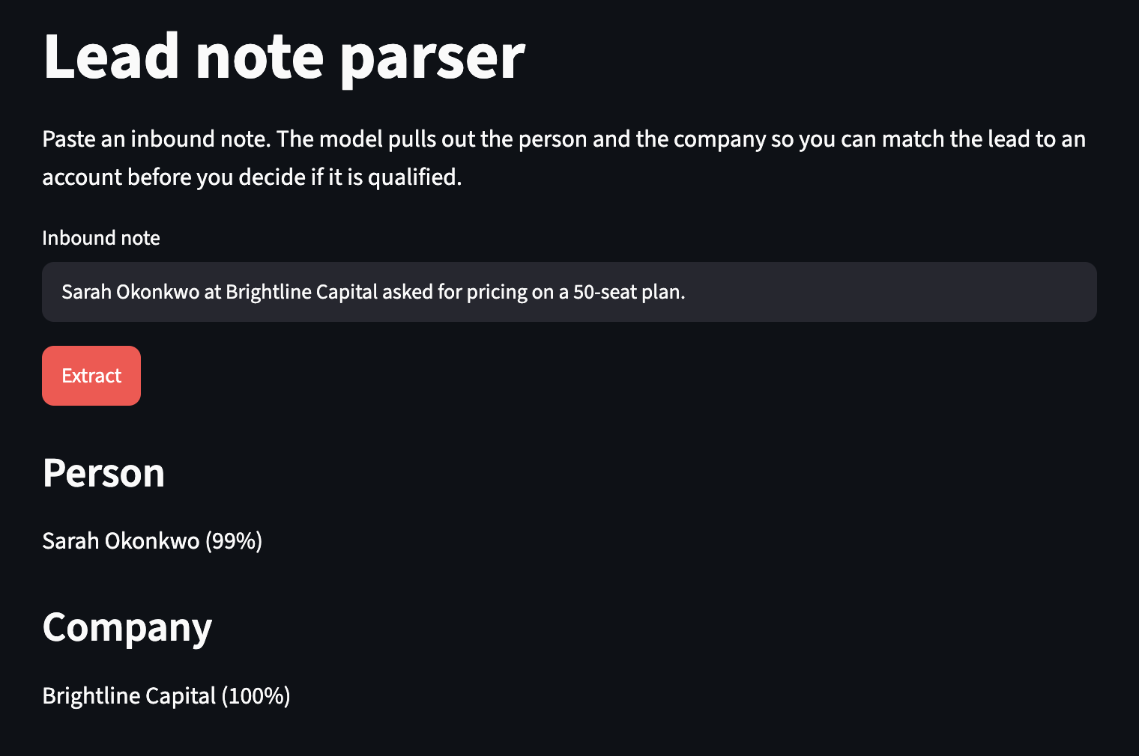
app.py
"""Small lead-note parser. Extracts people and companies from one inbound note."""

import streamlit as st
from transformers import pipeline

st.set_page_config(page_title="Lead note parser", layout="centered")
st.title("Lead note parser")
st.write(
"Paste an inbound note. The model pulls out the person and the company "
"so you can match the lead to an account before you decide if it is qualified."
)

@st.cache_resource
def load_ner():
return pipeline(
"token-classification",
model="dslim/bert-base-NER",
aggregation_strategy="simple",
)

LABELS = {
"PER": "Person",
"ORG": "Company",
"LOC": "Place",
"MISC": "Other",
}

note = st.text_input(
"Inbound note",
placeholder="Maya Chen from Northwind Logistics asked for a demo",
)

if st.button("Extract", type="primary"):
text = note.strip()
if not text:
st.error("Paste a note first. An empty message has nothing to extract.")
else:
try:
entities = load_ner()(text)
except Exception as exc:
st.error(f"The model call failed: {exc}")
else:
grouped: dict[str, list[str]] = {}
for entity in entities:
label = LABELS.get(entity["entity_group"], entity["entity_group"])
grouped.setdefault(label, []).append(
f"{entity['word']} ({entity['score']:.0%})"
)

people = grouped.get("Person", [])
companies = grouped.get("Company", [])
if not people and not companies:
st.warning(
"No person or company found. The note may be too vague to match to an account."
)
if people:
st.subheader("Person")
for item in people:
st.write(item)
if companies:
st.subheader("Company")
for item in companies:
st.write(item)
extras = [
(label, items)
for label, items in grouped.items()
if label not in {"Person", "Company"}
]
for label, items in extras:
st.subheader(label)
for item in items:
st.write(item)

15. Submit
Upload this Word document to Canvas. It has the answers, main.py and its output, app.py, and the screenshot.

