**Spreading holiday joy to migrant workers**

By Sharvin S/O Rajandran

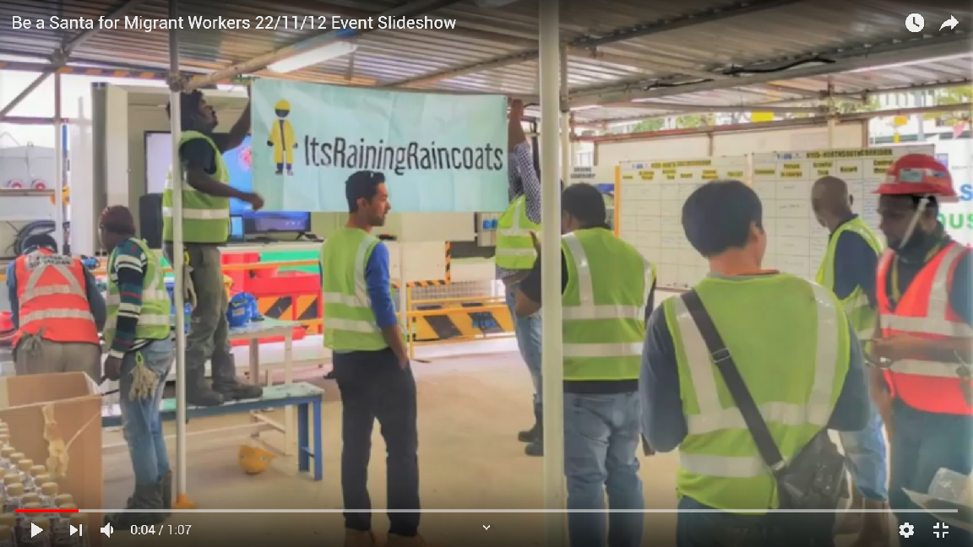

YouTube Link: https://youtu.be/PAirzagHUTM

December is usually the time for gifts and vacations as the holiday mood sets in. Individuals look forward to spending time with their loved ones. A local social initiative group called Its-raining-raincoats has other novel plans for their holiday season.

The group, founded by Dipa Swaminathan back in 2015, plans on spreading the joys of the holiday season to nearly 700 000 migrant workers. It aims to provide a gift to each one of them at their "Be a Santa to migrant workers" initiative.

Its-raining-raincoats specialises in organising donation drives and outreach programmes intending to provide essential items along with gifts to these people to make them feel at home.

Their latest project is a month-long Christmas gift donation drive that began on Nov. 16 to Dec.16 this year.

Its-raining-raincoats volunteer lead Ruchi Trivedi mentions, "this is the second year we're doing the Be a Santa to migrant workers initiative."

She went on to add, "we managed to reach out to out to over 60, 000 migrant workers last year and hope to increase the numbers in the following years to reach our target of 700, 000."

A group of five volunteers headed out to a construction site at Novena on Nov. 22 to hand out gifts to 150 workers. This is in an effort to add holiday festivities to their weekend.

Ruchi who took lead of this distribution event claims, “some of these workers barely get their daily necessities like fresh food and proper mattresses, anything we can do to help them is a worthy effort.”

As the “Be a Santa to migrant workers" initiative is centred around gift-giving, the group encourages members of the public to join the donation drives and drop of gifts at one of their 38 designated drop-off-points across Singapore.

Most of the gifts suggested by the group are practical items, such as toiletries, non-perishable food items, mobile data cards, medicated balms, umbrellas, water bottles and gift vouchers. Things migrant workers can use in their day-to-day lives.

According to Ruchi, the group, “tries to organise an initiative like this every holiday season.”

For Chinese New Year in February this year, they had a donation drive collecting items that were being thrown away for spring cleaning. Similarly for Deepavali they partnered with Pizza Hut to hand out pizzas to foreign workers.

She claims that, “people have been encouraging of out efforts, as many have called in to enquire about our future donation drives.”

It is not just individuals who are intrigued by these efforts as Ruchi went on to add, “many companies [like Starbucks and Pizza Hut] are reaching out to us to help out in any way they can.”

**Tags**: Christmas, donation, foreign worker, gift, Migrant, migrant workers, workers, presents, Santa, Singapore, volunteer