**E-scooter ban raises concerns on food delivery earnings**

**By Sharvin S/O Rajandran**

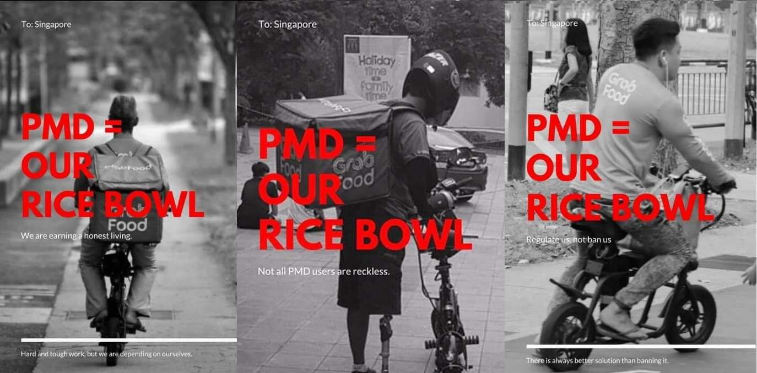

Posters of a social media campaign against the PMD ban by M Siva

SINGAPORE- Bans and fines are nothing new in Singapore. The State has the tendency to impose them when problems arise and this can be seen in the recent ban on the use of electric scooters on walking paths.

The new restrictions have seen a slew of criticisms aimed at the authorities handing out bans as a result of spike in personal mobility device (PMD) related accidents.

In 2018, almost 300 people were injured after accidents involving PMDs. This is according to public data from the National Trauma Registry and was one of the main reasons for implementation of the ban.

A large number of people have raised concerns over this ban, as the Singaporean public have been split on the forming a consensus on the need for the ban.

A large portion of the community, enraged by the fact that their food delivery services would be disrupted, took to social media to express their displeasure.

One of the more public depiction of disagreement with the ban was from a budding social media starlet and PMD rider, Jing, who went on a viral rant on Instagram. She criticised the authorities’ lack in exploring other options before implementing an outright ban.

When contacted she claimed that, “if they were to ban all vehicles causing accidents, cars and motorcycles should have been the first to go as they cause a whole lot more accidents than e-scooters.”

Other displays of discontent can also be seen in the large number of PMD riders who have gathered on three different occasions since the ban to plead with the government through public dialogue sessions.

PMD rider Sunil Singh who was one amongst the 50 e-scooter riders to voice frustrations over the matter with Prime Minister Lee Hsien Loong at a meet-the-people dialogue session held in Ang Mo Kio on Nov 6, vents that the lawmakers “are messing with our livelihoods as a lot of us doing this as our sole source of income.”

He went on to express that the government should be exploring other means to solve this problem like “allowing PMDs but punishing PMD riders harshly when involved in accidents.”

This isn't the first instance of the government resorting to a ban to a perceived problem, in the last half decade.

The authorities have dished out controversial bans on electronic cigarettes, hookah, purchasing alcohol products after 10:30 p.m. and on cats being allowed in residential flats.