**Under-18s football team struggles with World Cup aims**

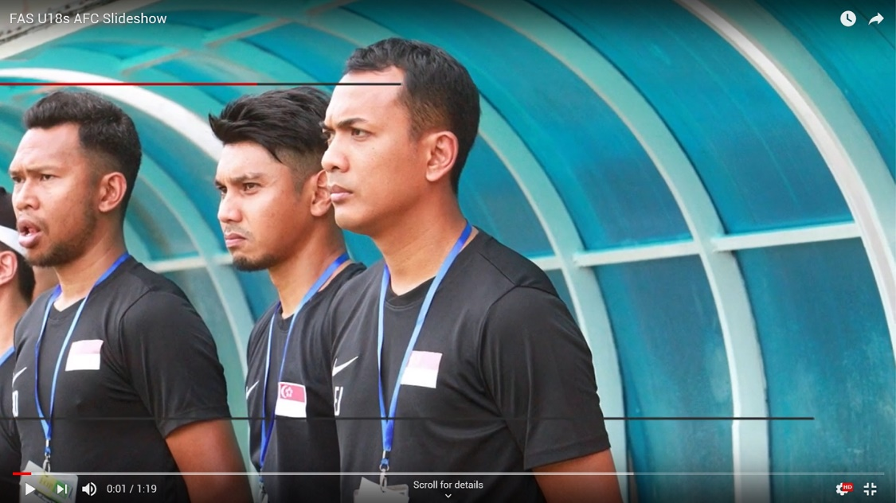

**Embed Code:** <iframe width="560" height="315" src="https://www.youtube.com/embed/ xh4LtHqymuY" frameborder="0" allow="accelerometer; autoplay; encrypted-media; gyroscope; picture-in-picture" allowfullscreen></iframe>

**Direct Link:** https://youtu.be/xh4LtHqymuY

By Sharvin S/O Rajandran

Singapore’s under-18s football team was dealt with a disappointing blow at the Asian Football Confederation (AFC) Under-19 Championship Qualifiers. This dampened the Association’s goal to qualify for the 2034 World Cup.

The team which consists of players from the 13 to 18 age group will be in their prime in the year 2034. They will make up a bulk of the squad for the World Cup qualifiers.

The under-18s football team faced South Korea whom they lost by 0-11, China 0-2 as well as Myanmar 0-8. All the football matches were held in November.

These results meant that Singapore failed to qualify for the AFC U-19 Championship finishing 35th place in a 40-team qualifying group.

The Head Coach of the Under-18’s National Team, F. Juraimi explained, "I was proud of the boys despite the losses since it was a tough challenge to begin with as the group had nations that were record 12-time winners."

He went on to add, “there were encouraging signs with the boys being brave enough to play positive football instead of sitting back and being reserved."

This fearless attitude will hopefully go far for the team who are just short of a few quality additions.

According to Former National Team coach and local football legend, P.N. Sivaji, the local boys could be integrated with foreign talents, “We need to look towards naturalising foreign talent to add quality and experience if we want to go further with the team."

He continued, "Hopefully, this along with funding and resources would be the first step forward in playing positive football and reaching the Goal 2034 target."

Tags: football, youth, national, team, soccer, AFC, under-18s, u18s, Qualifiers, Goal 2034, world cup, tournament, coach, Football Association, China, Myanmar, South Korea, defeat, loss, fail, future, naturalising, foreign talent.