Table 1 Available indicators for SDG 14 in Australia

|  |  |  |
| --- | --- | --- |
| Indicator | Description | Time Range |
| 14.1.1 | Beach litter originating from national land-based sources that ends in the beach (%)1 | 2017-2021 |
| 14.1.1 | Beach litter originating from national land-based sources that ends in the beach (Tonnes)1 | 2017-2022 |
| 14.1.1 | Beach litter originating from national land-based sources that ends in the ocean (%)1 | 2017-2021 |
| 14.1.1 | Beach litter originating from national land-based sources that ends in the ocean (Tonnes)1 | 2017-2021 |
| 14.1.1 | Beach litter per square kilometre (Number) 2 | 2015-2022 |
| 14.1.1 | Chlorophyll-a deviations, remote sensing (%)3 | 2005-2022 |
| 14.1.1 | Exported beach litter originating from national land-based sources (Tonnes)1 | 2017-2022 |
| 14.3.1 | Average marine acidity (pH) measured at agreed suite of representative sampling stations4 | 2010-2021 |
| 14.4.1 | Proportion of fish stocks within biologically sustainable levels (not overexploited) (%)5 | 2018 |
| 14.5.1 | Average proportion of Marine Key Biodiversity Areas (KBAs) covered by protected areas (%)6 | 2000-2023 |
| 14.6.1 | Progress by countries in the degree of implementation of international instruments aiming to combat illegal, unreported and unregulated fishing(level of implementation:1 lowest to 5 highest) 7 | 2018-2022 |
| 14.a.1 | National ocean science expenditure as a share of total research and development funding (%)4 | 2018-2021 |
| 14.c.1 | Score for the implementation of UNCLOS and its two implementing agreements (%)8 | 2023 |
| 14.c.1 | Score for the ratification of and accession to UNCLOS and its two implementing agreements (%)8 | 2023 |
| 1Center for Ocean-Atmospheric Prediction Studies (COAPS) | | |
| 2 Plastic Pollution (MLW, MDMAP, ICC) | | |
| 3World Environment Situation Room | | |
| 4Intergovernmental Oceanographic Commission (IOC) of UNESCO | | |
| 5Department of the Environment and Energy. at https://www.sdgdata.gov.au/goals/life-below-water/14.4.1 | | |
| 6BirdLife International, IUCN and UNEP-WCMC (2021). Based on spatial overlap between polygons for Key Biodiversity Areas from the World Database of Key Biodiveristy Areas (www.keybiodiversityareas.org) and polygons for protected areas from the World Database on Protected Areas and (where available) for Other Effective area-based Conservation Measures and from the World Database on OECMs (www.protectedplanet.net) | | |
| 7Questionnaire on the implementation of the Code of Conduct for Responsible Fisheries - Country self-reporting | | |
| 8Division for Ocean Affairs and the Law of the Sea, Office of Legal Affairs, United Nations Secretariat | | |

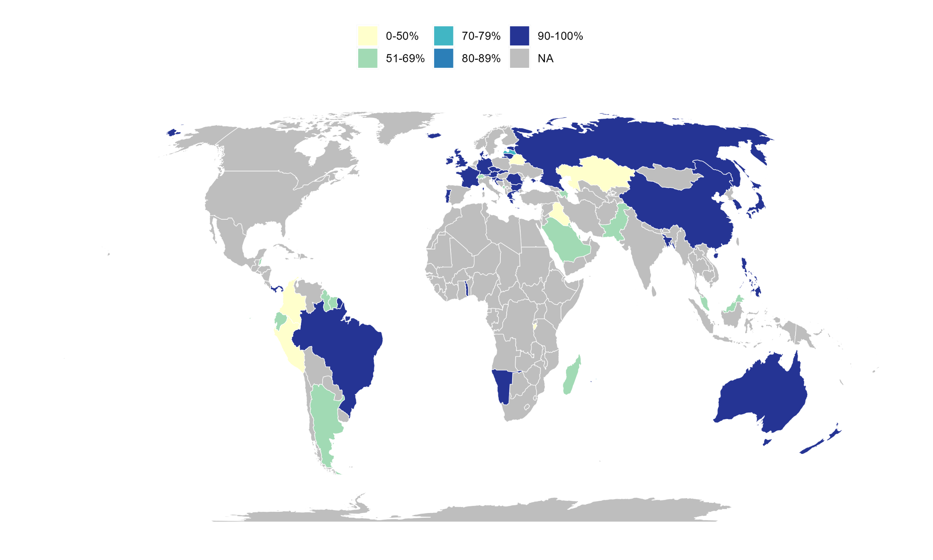

Figure 1 Score for the implementation of UNCLOS and its two implementing agreements (%)

We used R functions from open source code (<https://github.com/lucashertzog/DatSciTrain_SDGs_API>) to interact with the United Nations Statistics Division SDG API (<https://unstats.un.org/sdgapi/swagger/>) and extract relevant indicators from the Global SDG Indicators Database and Metadata Repository (<https://unstats.un.org/sdgs/indicators/SDG_Updateinfo.xlsx>). First, a query was generated in the API, and data was downloaded in R. Then, data cleaning was done using parameters available from the SDMX Global Registry (<https://registry.sdmx.org/data/datastructure.html>) and values without restrictions (blank or observation status A) were selected. In Table 1, all available SDG 14 indicators were selected for Australia, and time periods availability was assessed. Figure 1 was generated using the *rnaturalearth* package using the equal earth projection (CITE) with data from two indicators selecting all countries with data availability. More details on data availability for the indicators are shown in Table S1 (sdg_14_unclos_map.csv).