**Case Study 1: Power Generation**

**Lucas Holliday, Evan Le, Yetayal Tizale**

**May 14, 2025**

### 

### **Background**

The purpose of this analysis is to evaluate the financial viability of installing electricity generating equipment at the West County Landfill near St. Louis and to recommend the alternative with the highest net present value (NPV), considering both “private” and “social” returns. While flaring has proven sufficient to meet the Environmental Protection Agency’s (EPA) regulations requiring large landfills to collect and combust landfill gas, the West County landfill is exploring the generation of additional revenue by installing power-generating equipment and selling the electricity at the wholesale market price. The options in consideration include the internal combustion (IC) engine, gas turbine, and steam turbine. Using a 26-year cash flow model, we conducted an NPV analysis for each equipment type and performed sensitivity analyses on the electricity price, discount rate, and tax rate. The available data is provided in Appendix A. The assumptions used in this analysis are detailed below.

Assumptions:

* Outcome of recommendation is one type of equipment with potentially multiple units.
* Discount rate is 5%.
* The average wholesale price of electricity is 5 cents per kilowatt-hour.
* There are no state or federal tax incentives, renewable energy credits or carbon credits.
* The collected gas that can be turned into energy, known as the capacity factor, is 90%.
* Collection efficiency of the flare and electricity-generating equipment (ɳcol) is 85%.
* The cost of flaring is not included in the equipment NPV calculations. The private NPV of flaring (do nothing alternative) is $0.
* The energy content of LFG is 500 BTU/cf.
* Sulfur dioxide emissions are ignored because the alternatives have identical emissions.

### **Methodology**

### Our spreadsheet in Excel is set up such that West County Landfill can conduct further analysis by changing the assumptions and available data in Appendix A. We first considered the base case of a landfill that only vents the gas into the air and calculated the global warming potential emission savings obtained by installing a flare - savings that would also be obtained by installing electricity generating equipment. We used the following emission assumptions to calculate the total controlled emissions of CO2 and CH4:

*Uncontrolled Carbon Dioxide (UCO2) emission factor in lb/yr is 0.45 x 0.112 x LFG*

*Uncontrolled Methane (UCH4) emission factor in lb/yr is 0.55 x 0.040851 x LFG*

*Controlled Carbon Dioxide (CCO2) emission factor in lb/yr is + (2.75 x ɳcol x UCH4)*

*Controlled Methane (UCH4) emission factor in lb/yr is (1 - ɳcol) x UCH4*

To identify the alternative with the highest private, social, and total NPV, we developed a 26-year cash flow model. Using the average annual landfill gas (LFG) generation, we calculated each option’s maximum energy output (Energymax) and power requirements (Powerrequired) to determine the number of full units needed for each equipment type. For each alternative, annual profit was estimated as:

*alternative total profit = Energymax * (price of electricity [$]*90% - typical O&M Costs [$/kWh])*

To assess the value of partial units, we compared scenarios of rounding up and rounding down the number of units. The value of the partial unit was calculated as the NPV of its profit minus the capital cost of the incremental unit.

*partial unit profit = alternative profit * (partial unit size/# units required) IF the required number of units exceeded the maximum number of fully utilized units*

If this value was positive, the incremental unit was included in the final recommendation for that alternative. This calculation applied only in years where the required number of units exceeded the number of fully utilized units which are highlighted in (Appendix C). Lastly, we detailed the cash flows from Year 0 (capital investment) through Year 26 (final year of profit).

The social NPV for each alternative was calculated as follows:

*emissionspollutant [lb] = LFG [cf] * pollutant emissions [lb/106 cf] / 106*

*social cost [$] = emissionsNOx [lb] * $1.66 + emissionsCO [lb] * $0.31+emissionsPM [lb] * $2.55*

The social NPV was added to the private NPV to determine the total NPV for each equipment.

In cases where we rounded down the number of engines, we accounted for the fact that not all landfill gas was processed since a portion of the gas was flared in some years. We split the LFG between gas captured by the engine(s) and burned by the flare. Gas captured by the engines was found with Goal Seek on LFG that would result in the rounded down whole number of units.

Sensitivity analysis was performed on the price of electricity, discount rate, and tax rate using the Data Table tool in What If analysis.

Energymax =

Powerrequired = Energymax

# of Engines = Powerrequired(average nominal capacity kW)

### **Results**

The emission savings that would be obtained by installing electricity generating equipment is 229,037,601 lb/yr. As shown in Table 1, the optimal number of units to process the landfill gas for the IC engine is 4, for the gas turbine is 2, and the steam turbine is 3. The steam turbine has the lowest social NPV of $2,499,718. The IC Engine has the highest private NPV of $39,562,554, slightly higher than the Steam Turbine by $307,033. The steam turbine has the highest total NPV (including private and social NPV) of $36,755,803. Calculations are detailed in Appendices B, C and D, and 26-year cash flow figures are provided in Appendix E.

Table 1. Summary of optimal units and NPV for flare and equipment alternatives

| Alternatives | Optimal  # of units | Private NPV | Social NPV | Total NPV |
| --- | --- | --- | --- | --- |
| Flare | N/A | $0 | -$10,899,811 | -$10,899,811 |
| IC Engine | 4 | $39,562,554 | -$21,917,686 | $17,644,868 |
| Gas Turbine | 2 | $32,055,396 | -$8,679,533 | $23,375,863 |
| Steam Turbine | 3 | $39,255,521 | -$2,499,718 | $36,755,803 |

### 

### **Recommendations**

Based on our 26-year cash flow analysis of the private NPV of alternative energy-generating equipment, we recommend that West County Landfill process its landfill gas using three steam turbines, the option with the highest total NPV. This recommendation reflects our consideration of social costs, as we believe the landfill should act as a responsible community stakeholder by accounting for the environmental harm caused by its pollutant emissions. However, if West County Landfill chooses to prioritize revenue and exclude social costs from its evaluation, then four internal combustion (IC) engines would yield a higher private NPV, exceeding that of the steam turbine option by $307,033 at the current electricity price of $0.05 per kilowatt-hour.

To test the robustness of our recommendation, we conducted sensitivity analyses on electricity prices, tax rates, and the discount rate. Electricity prices in the U.S. have historically fluctuated, ranging from under $0.10 to over $0.40 per kilowatt-hour.¹ As shown in Appendix F, although steam turbines are initially the preferred option when social costs are included, rising electricity prices make internal combustion engines more favorable. Specifically, at prices above $0.11 per kWh, the increased revenue offsets the higher social costs associated with IC engines.

We also analyzed the impact of tax rates, which are both variable and significant to long-term project profitability. As shown in Figure 1 (Appendix G), IC engines generate higher taxable profits early in the project, initially delivering a higher private NPV. In contrast, steam turbines have lower initial capital costs and more balanced returns over time (Appendix E). Consequently, once the tax rate exceeds approximately 3.6%, steam turbines become the superior option. Furthermore, as seen in Figure 2 (Appendix G), steam turbines deliver the highest total NPV across all tax rates due to their reduced environmental costs.

Lastly, we evaluated how changes in the discount rate affect private NPV and total NPV. As shown in Figure 2 (Appendix H), steam turbines consistently deliver the highest total NPV across all rates, reflecting their lower pollutant emissions. In terms of private NPV, as shown in Figure 1 (Appendix H), IC Engines are favorable at lower discount rates. However, above a 5.4% discount rate, steam turbines become the best option, as IC engines have significantly higher capital costs in Year 0, which are penalized at higher discount rates (Appendix E).

This analysis underscores the dynamic nature of equipment decisions, which are sensitive to changes in economic policy and environmental regulation. For instance, states with aggressive climate initiatives, such as California’s Priority Climate Action Plan (PCAP)², impose stricter emissions standards that would favor steam turbines. Additionally, state or federal incentives, such as renewable energy subsidies or carbon credits, could significantly influence the financial viability of each option. Although under current assumptions, three steam turbines offer the highest total NPV and four IC engines offer the highest private NPV, our sensitivity analysis demonstrates that shifts in regulatory or economic conditions can alter the optimal type of electricity-generating equipment and the number of units required.

**References**

1. “Electricity rates May 2025.” *Electric Choice*. (2025, May 6) <https://www.electricchoice.com/electricity-prices-by-state/>
2. “State climate policy maps.” *Center for Climate and Energy Solutions*. (2025, March 10). <https://www.c2es.org/content/state-climate-policy/>

**Appendix A:**

**Assumptions and Available Data for West County Landfill**

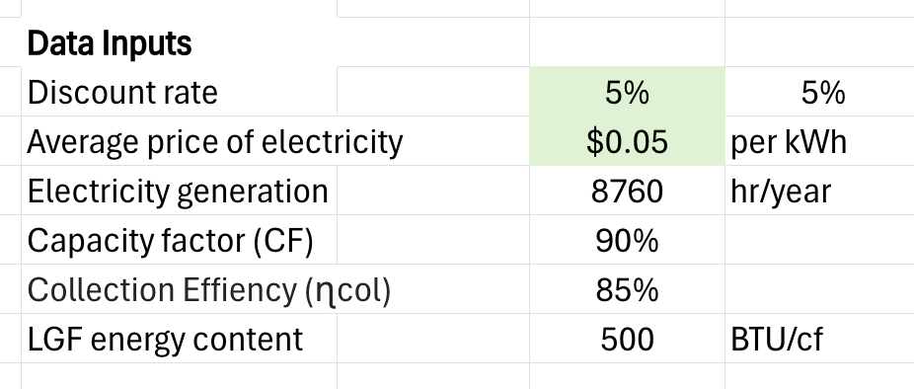

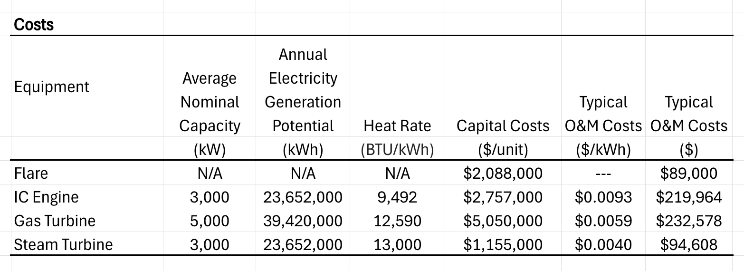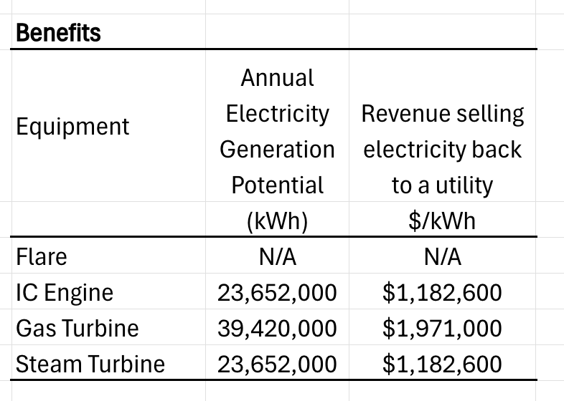

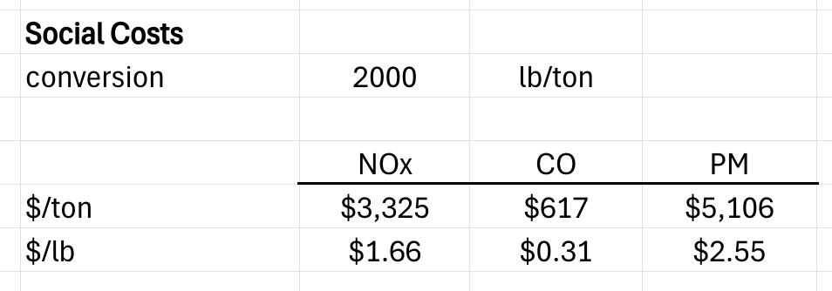

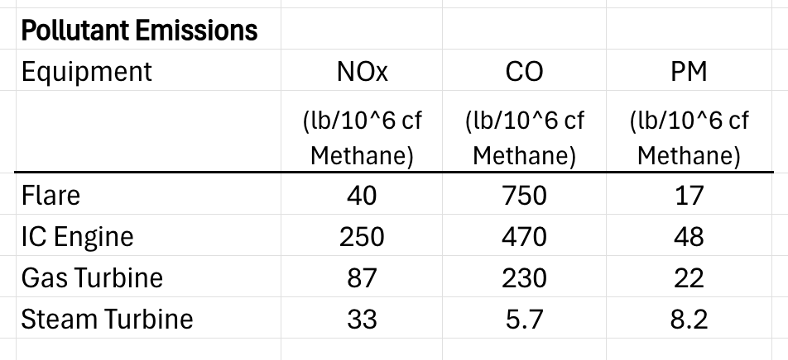

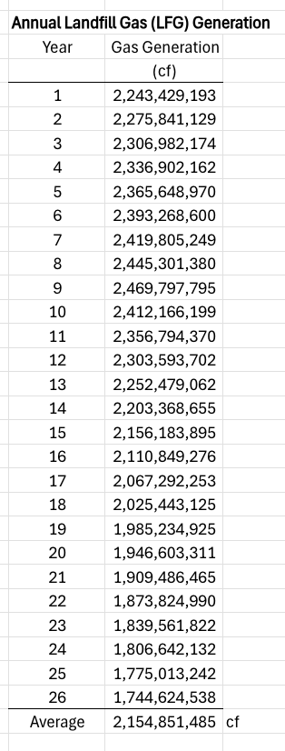

**Appendix B:**

**Emission savings by installing electricity-generating equipment**

|  |
| --- |

**Appendix C:**

**Calculations for alternative with the highest private NPV**

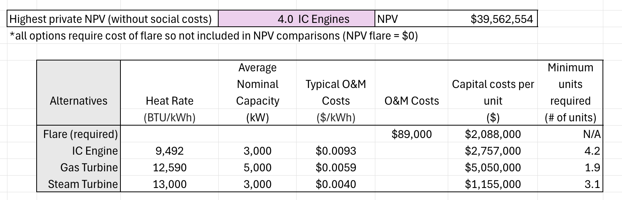

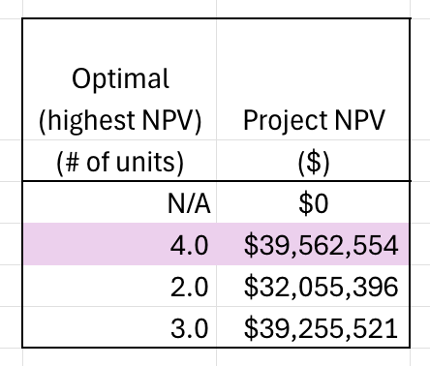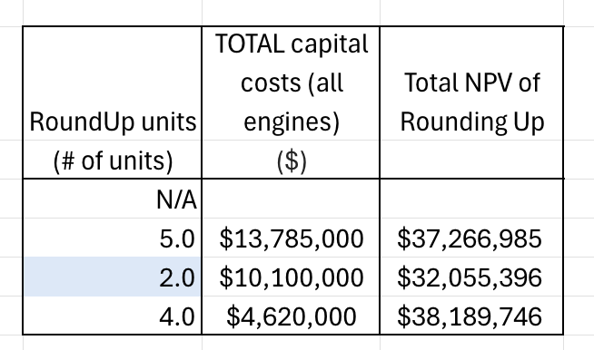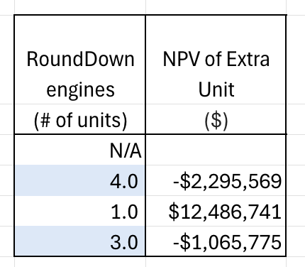

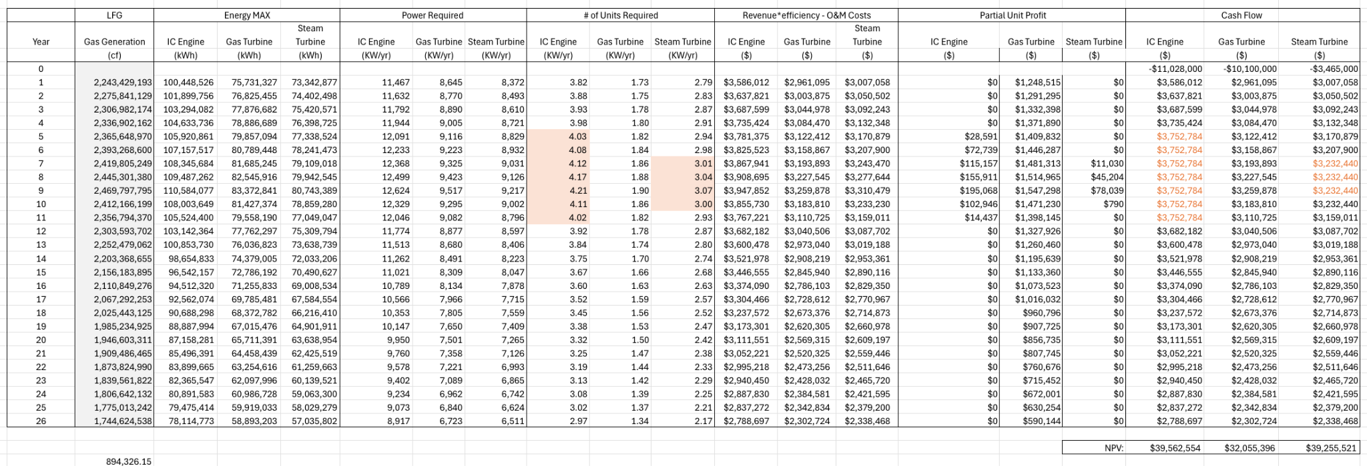

**Appendix D:**

**Calculations for alternative with the highest social and total NPV**

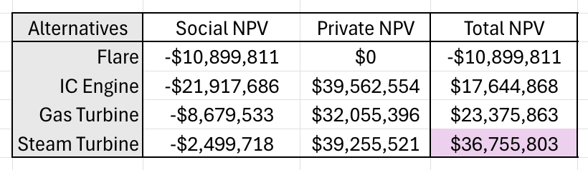

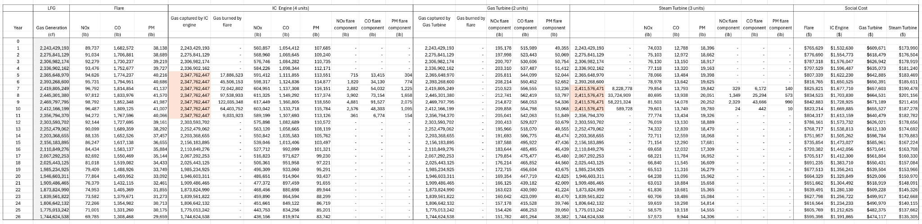

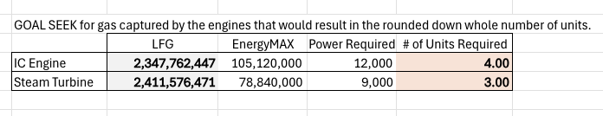

**Appendix E:**

**Figures of Cash Flows for NPV Calculation**

**Private NPV**

IC Engine: NPV = $39,562,554 Gas Turbine: NPV = $32,055,396

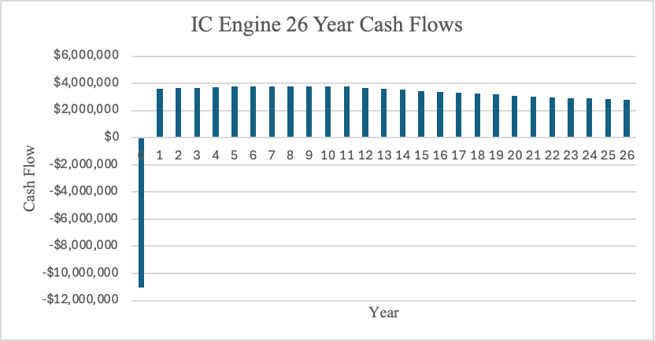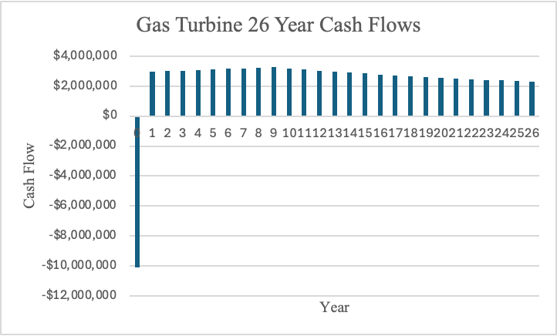

Steam Turbine: NPV = $39,255,521

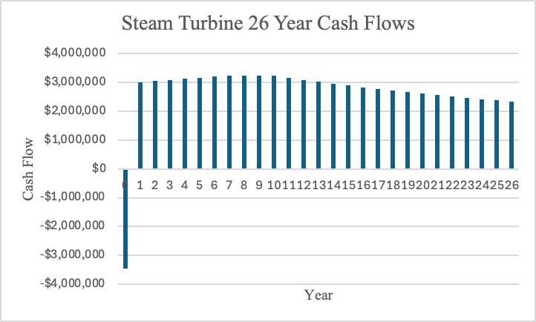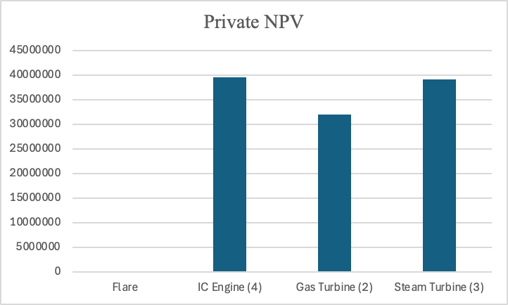

**Total NPV (Private + Social)**

IC Engine: NPV = $17,644,868 Gas Turbine: $23,375,863

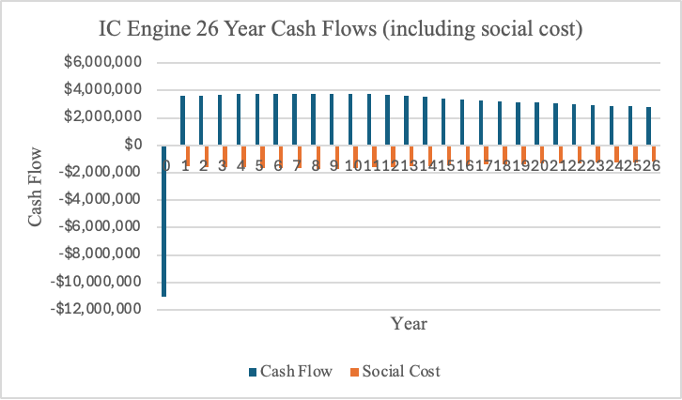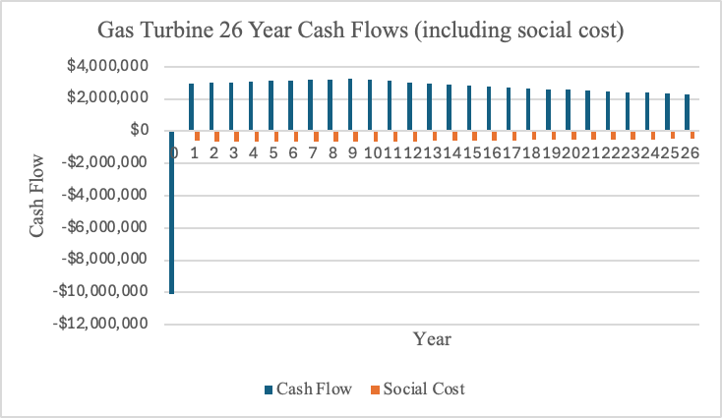

Steam Turbine: NPV = $36,755,803

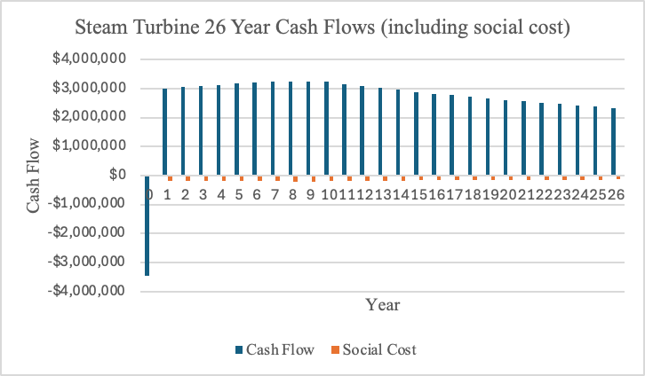 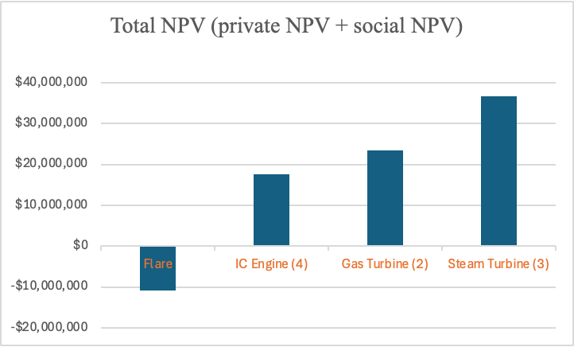

**Extra Unit NPV**

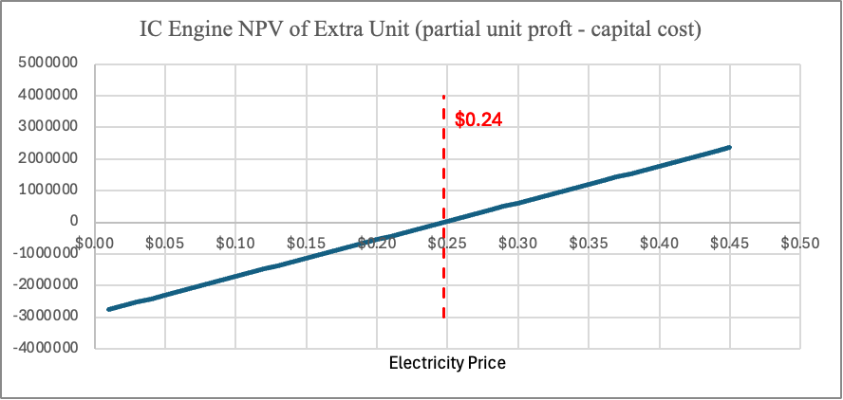

**Appendix F:**

**Sensitivity Analysis - Electricity**

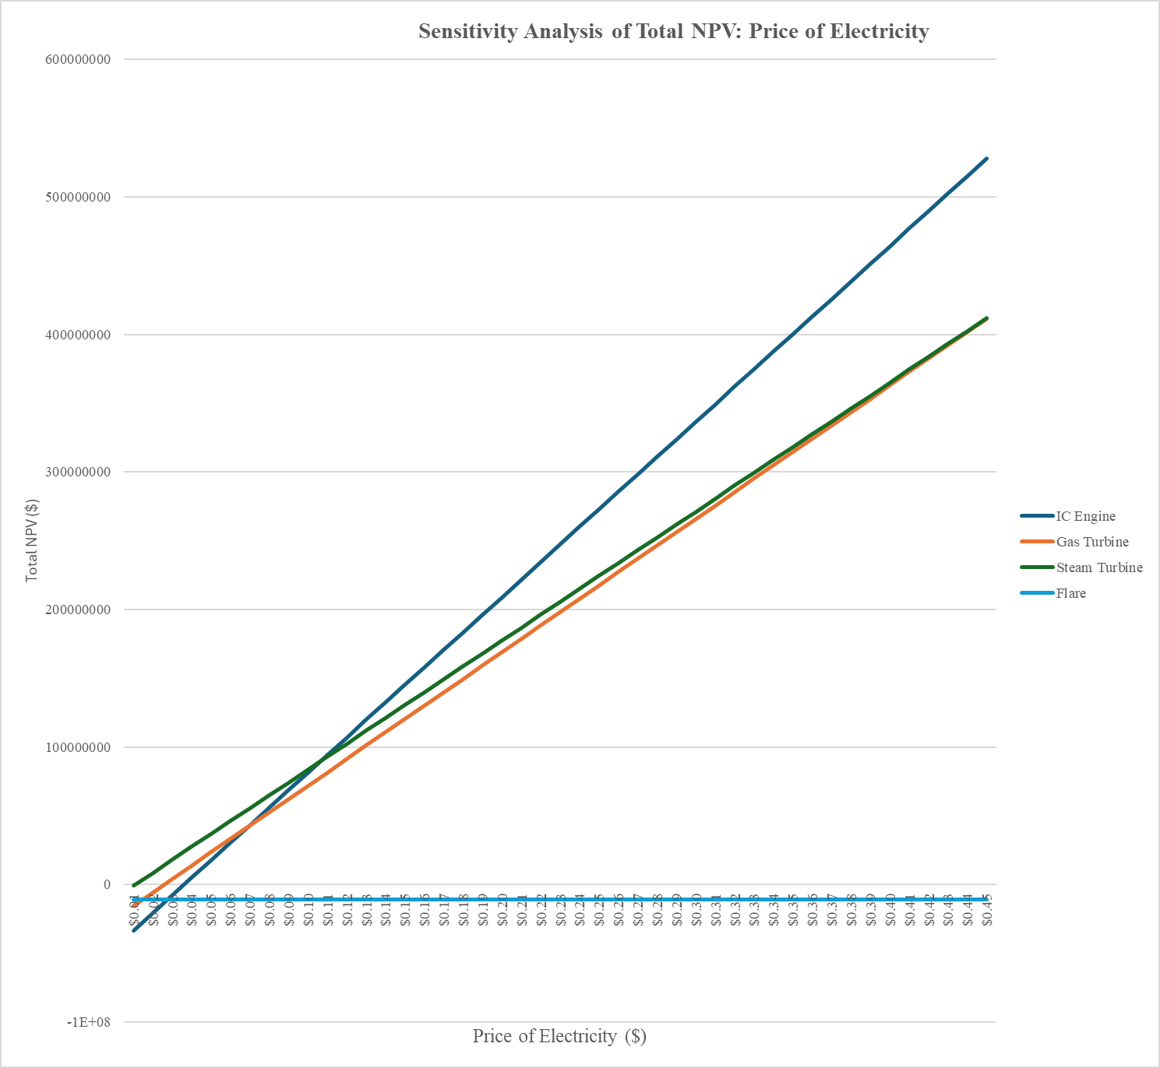

Figure 1 - Electricity Price Sensitivity Analysis on Total NPV

**Appendix G:**

**Sensitivity Analysis - Tax Rate**

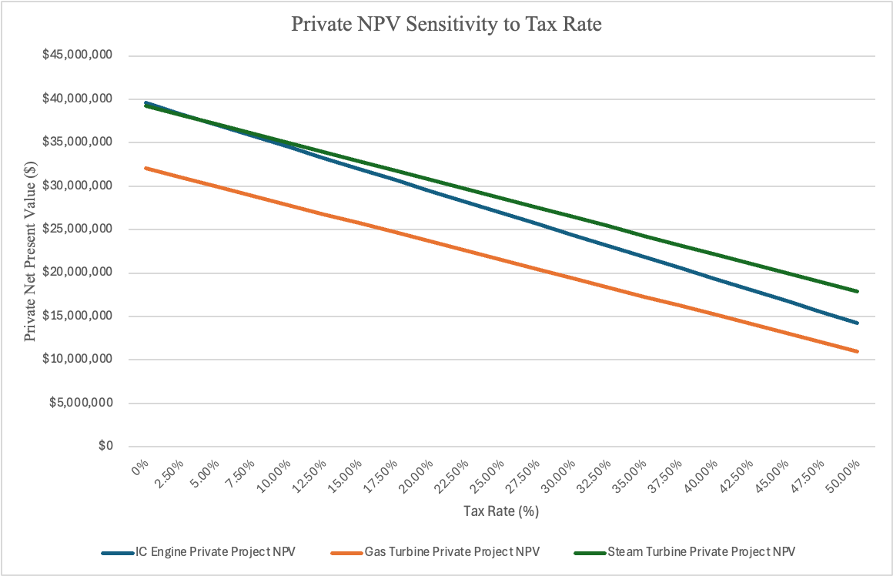

Figure 1 - Tax Rate Sensitivity Analysis on Private NPV

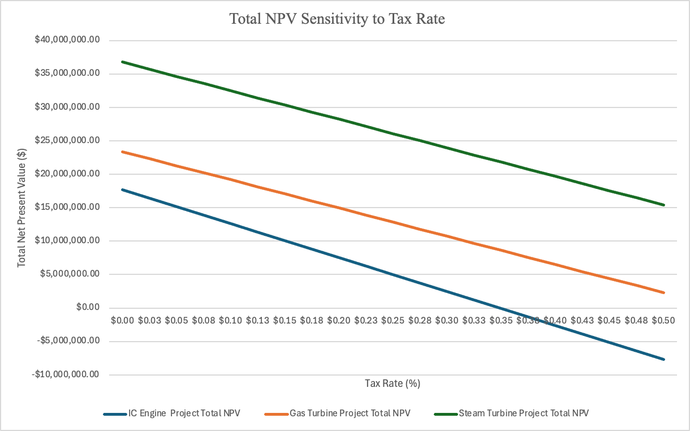

Figure 2 - Tax Rate Sensitivity Analysis on Total NPV

**Appendix H:**

**Sensitivity Analysis - Discount Rate**

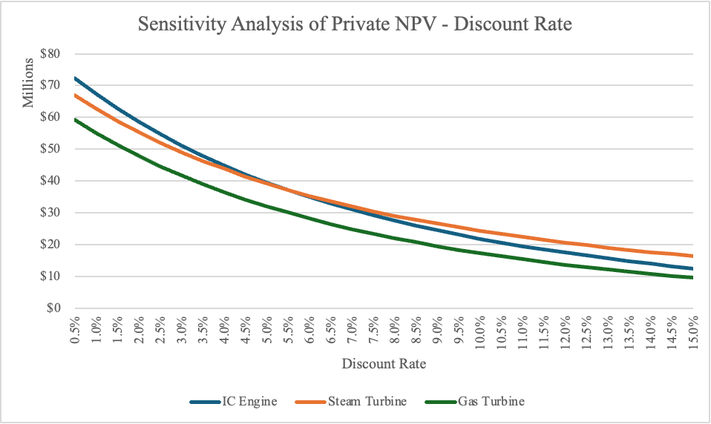

Figure 1 - Discount Rate Sensitivity Analysis on Private NPV

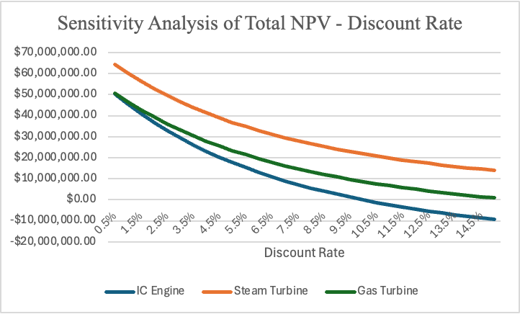

Figure 2 - Discount Rate Sensitivity Analysis on Total NPV