**Case Study 2: Smart Software**

Lucas Holliday, Evan Le, Yetayal Tizale

June 2, 2025

**Background**

Charlotte Rothstein, CEO and founder of Cerebrosoft, a startup for customizable AI applications for multimedia companies, faces a critical strategic decision regarding the launch of the company’s latest product, Brainet. As Cerebrosoft navigates a competitive market, Rothstein must weigh the potential upside of a successful product launch against the financial risks of failure, which could jeopardize the firm’s limited capital given its recent growth and investments.

The purpose of this case study is to apply decision analysis tools to evaluate the optimal decision among two courses of action: (1) proceed with product launch, choosing among three pricing strategies ($30, $40, or $50 per unit), or abandon the product altogether, and (2) evaluate the value of additional market research, which has predictive accuracy only in the high-price scenario. The pricing strategies include a low-price strategy ($30) aimed at maximizing market share, a high-price strategy ($50), focused on maximizing revenue, and a medium-price hybrid strategy ($40) that balances market share and revenue. Available data includes probability distributions for projected unit sales (20,000, 30,000, or 50,000) based on anticipated levels of market competition (high, medium, or low) specific to each pricing level (see Appendix A). Given probabilities for competition scenarios are 20% for high competition, 70% for medium competition, and 10% for low competition. Assumptions made in the analysis are detailed below.

Assumptions:

* Sunk development costs of $800,000 are excluded from the analysis.
* Annual product support costs are $50,000.
* Unit sales forecasts are annual estimates, conditional on pricing and competition.
* The analysis assumes a one-year decision horizon.
* If the product is abandoned, the net financial outcome is $0 with no profit or loss.

**Methodology**

The Excel spreadsheet allows the Cerebrosoft executive team to modify key inputs and update probabilities based on evolving data (see Appendix A). The decision analysis was conducted using a decision tree framework built in Excel with the TreePlan add-in. This allowed dynamic modeling of choices, uncertainties, and expected outcomes. Decision nodes (squares) represent strategic options and chance nodes (circles) represent uncertainties such as market competition and sales volume.

Without market research, TreePlan calculated expected revenues from each pricing strategy based on the probability of different competitive scenarios and sales volumes using backward induction. Expected profits were calculated by subtracting annual support costs from expected revenues. The strategy with the highest expected profit at the root node is the preferred alternative.

With market research, the tree was expanded to incorporate predictions about the competitive environment, expressed as conditional probabilities reliable under the high-price strategy. To reverse the conditional probabilities, the analysis applied Bayes’ Theorem:

$P(A | B) = \frac{P(B | A) P(A)}{P(B)}$

where A is the actual level of competition, B is the predicted competition, *P(B | A)* and *P(A)* were known from company records, and *P(B)* was derived using the Law of Total Probability:

$P(B) =\sum_{i=1}^{n}{}P(B | A_{i})P(A_{i})$

The resulting values of *P(A|B)* were tabulated and used to update the decision tree in the case of purchasing the market research study. In the revised tree, the root node represents the market research prediction (high, medium, or low competition). If a high pricing strategy was chosen, the updated conditional probabilities *P(HC | PHC)*, *P(MC | PHC)*, etc., were used for subsequent branches. If medium or low pricing was selected, the research was disregarded due to lack of predictive reliability, and the original prior probabilities for competition (*P(H)* = 0.2, *P(M)* = 0.7, *P(L)* = 0.1) were applied instead. To simplify the tree, these branches were not expanded. The previously calculated expected revenues were inserted directly at the corresponding terminal nodes. Finally, the Value of Information (VoI) was calculated by subtracting the highest expected profit without market research from the expected profit with market research (net of research cost), helping determine whether the study justifies its $10,000 price tag.

**Results**

Without Market Research

As shown in Table 1, the analysis finds that the $40 pricing strategy yields the highest expected profit of $1,318,000 outperforming the $50 strategy ($1,275,000) and $30 strategy ($1,094,500), and abandoning the project altogether ($0). The $40 option also provides a strong balance of risk and return, making it the preferred standalone strategy. These findings are derived from a decision tree analysis that accounts for the probability of unit sales across different levels of market competition (see Appendix B for full model).

Table 1. Summary of Decision Analysis (Without Marketing Research Study)

| Pricing strategy | Expected Revenue ($/yr) | Costs ($/yr) | Expected profit ($/yr) |
| --- | --- | --- | --- |
| High price ($50) | $1,325,000 | $50,000 | $1,275,000 |
| Medium price ($40) | $1,368,000 | $50,000 | $1,318,000 |
| Low price ($30) | $1,144,500 | $50,000 | $1,094,500 |
| No Brainet launch | $0 | $0 | $0 |

With Market Research

The $10,000 market research improves prediction accuracy for under high product pricing. When incorporated into the decision tree, expected revenue increases to $1,387,695. This yields a Value of Information (VoI) of $19,695, greater than the cost of the marketing study. After incorporating this expense, the expected profit increases to $1,327,695 (see Table 2). The logic and structure of this decision tree are provided in Appendix C.

Table 2. Summary of Decision Analysis (With Marketing Research Study for High Pricing)

| Scenario | Recommended Strategy | Expected Profit ($/yr) |
| --- | --- | --- |
| Predict High/Medium Competition | Medium Price ($40) | $1,318,000 |
| Predict Low Competition | High Price ($50) | $1,463,888 |
| Weighted Average Profit | Mixed | $1,327,695 |

**Recommendations**

In the initial analysis, ignoring the opportunity of obtaining more information by hiring the marketing research company, the alternative actions are to price Brainet high ($50), medium ($40), or low ($30), or abandon the product launch. The possible product demand scenarios are high (50,000 units), medium (30,000 units), or low (20,000 units) which are conditional on pricing and the level of competition. The preferred alternative in this case is to launch Brainet at a medium price of $40 per unit, which delivers the highest expected profit under baseline assumptions while balancing risk of failure against the potential upside of a successful product launch.

Based on the decision analysis, the overall recommended course of action is to launch Brainet at a medium price of $40 per unit. However, Cerebrosoft should invest in the $10,000 market research study to inform whether to adjust its pricing strategy. If the market research predicts medium or high competition, Cerebrosoft should retain the $40 price point, but if the study predicts low competition, the company should consider increasing the Brainet’s price to $50 due to the available market share.

There are several qualitative and sensitivity considerations that could affect these recommendations. The model assumes fixed prior probabilities (20% high, 70% medium, 10% low). If competition, especially low competition, is underestimated, the $50 strategy becomes increasingly favorable. The model also assumes a one-year sales horizon and ignores product lifecycle value, which may undervalue the potential long-term profitability of Brainet, especially if the product sees a successful launch and high product adoption. There are also unknown future opportunities such as licensing, product bundling, or premium software upgrades that could increase Brainet’s profitability over time. Alternatively, if competitors adjust pricing aggressively to counter the release of Brainet, then actual sales may be significantly lower than estimates. A successful launch also depends on Cerebrosoft’s marketing capabilities, post-launch support, and competitive positioning in the AI software market. Since internal resources are stretched given Cerebrosoft’s recent accelerated growth, an aggressive pricing strategy may not be sustainable or worth the risk, which supports going back to the more conservative $40 pricing recommendation. Lastly, the $50,000 annual product support costs also introduces risk in the face of lower sales, as the company’s finances are already tight.

In summary, we recommend that Cerebrosoft launch its new Brainet product at the medium price of $40 per unit and proceed with the proposed market research. Since the value of the research exceeds its $10,000 cost, it represents a worthwhile investment. The insights gained will lead to more informed pricing decisions and could generate long-term value for the company.

**Appendix A: Available Data (Inputs)**

Brainet Product Data

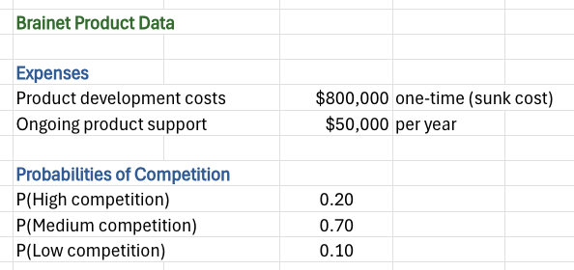

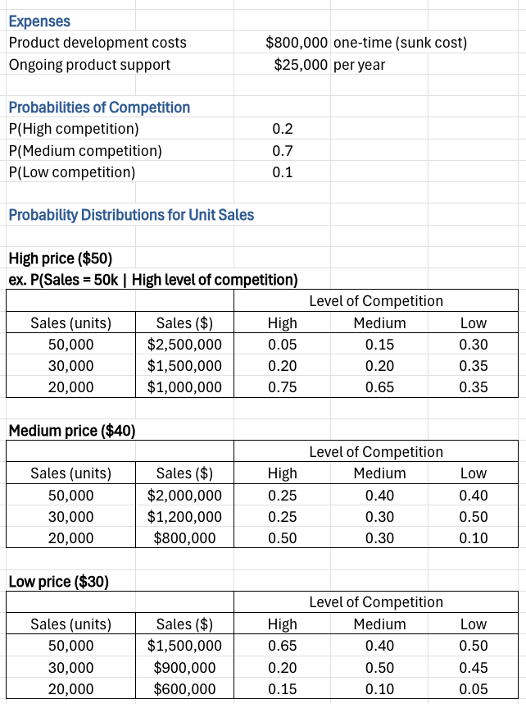

Additional Marketing Research Study Data

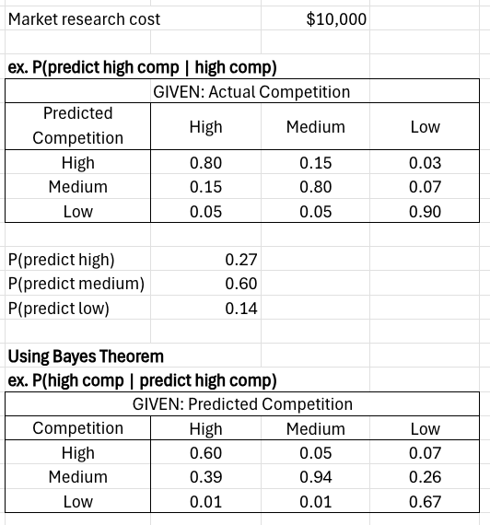

**Appendix B: Decision Analysis without Marketing Research Study**

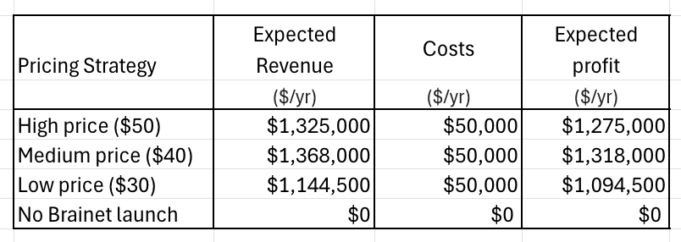

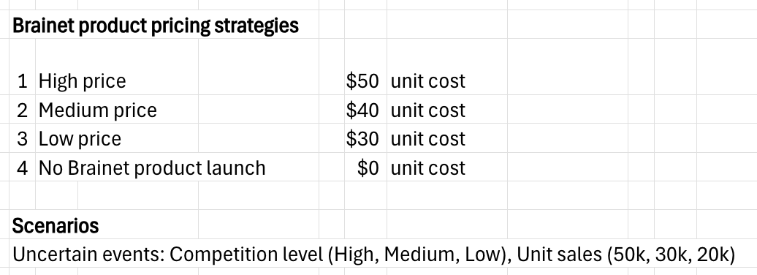

The decision tree for this analysis with the market research study follows (pages 9-10).

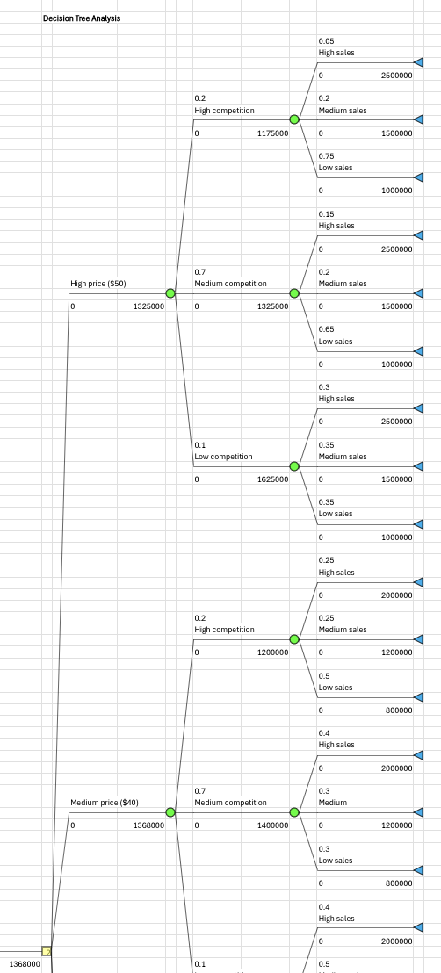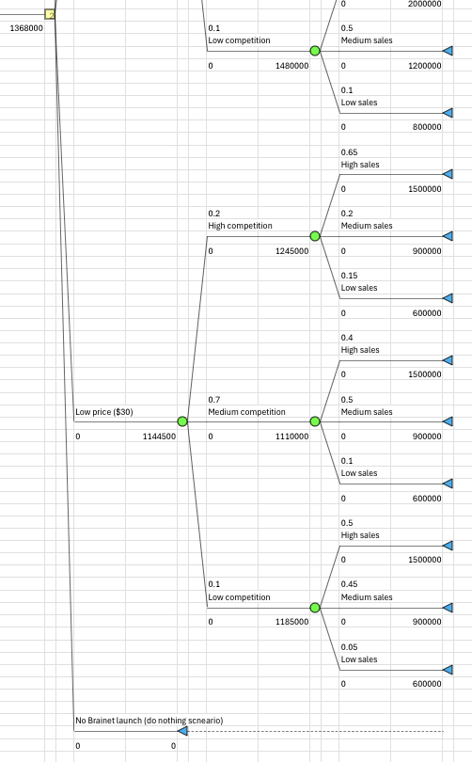

**Appendix C: Decision Analysis with Market Research Study**

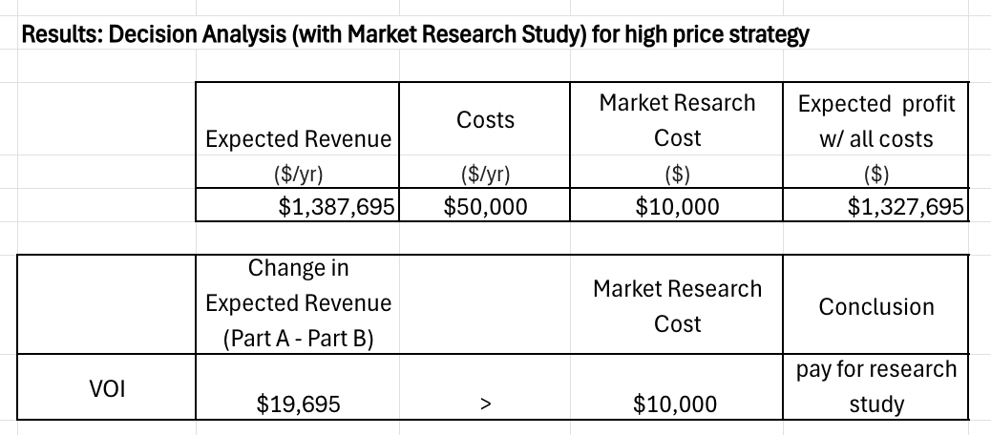

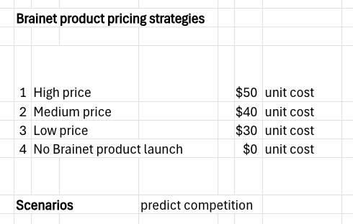

The decision tree for this analysis with the market research study follows (pages 12-14).

