Downloading LibreLane(With VirtualBox downloaded):

Setting Up Ubuntu on VirtualBox

On a Web browser

Go to Ubuntu Download and download the Intel or AMD 64-bit architecture version of Ubuntu 26.04 LTS (takes about 20-30 minutes)

Open Oracle VirtualBox

Click Create a new virtual machine (VM)

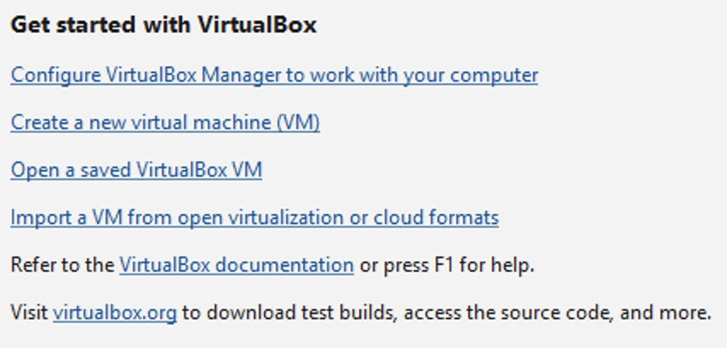

In Virtual machine name and operating system

Name your virtual machine

Select where you want to store it (or leave what is selected)

Select the ISO Image, this is what you downloaded before on the Ubuntu website

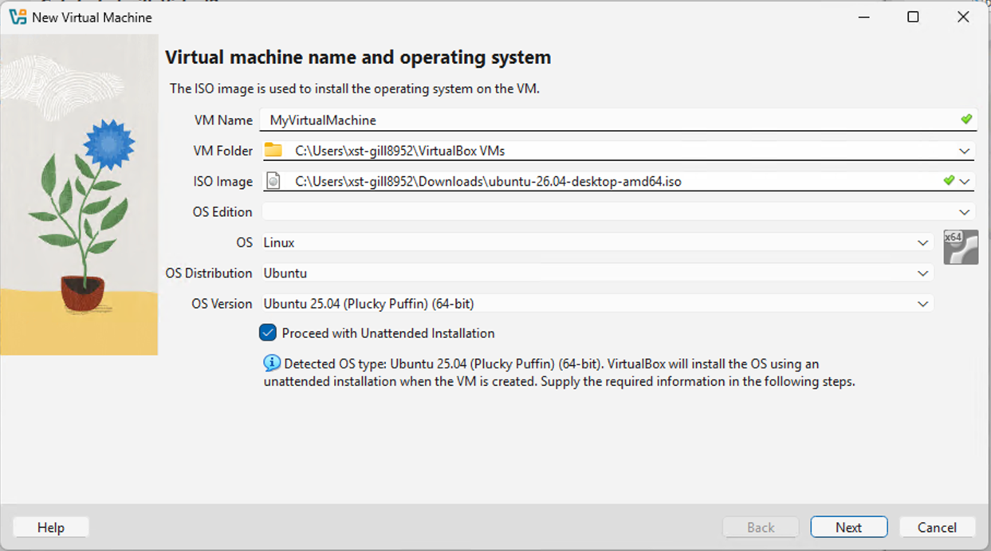

In Set up unattended guest OS installation

Set your username and password for your virtual machine

In Specify virtual hardware

Set the base memory to anything in between 25,000 and 31,000 MB, set number of CPUs to 6, and leave Disk size as is

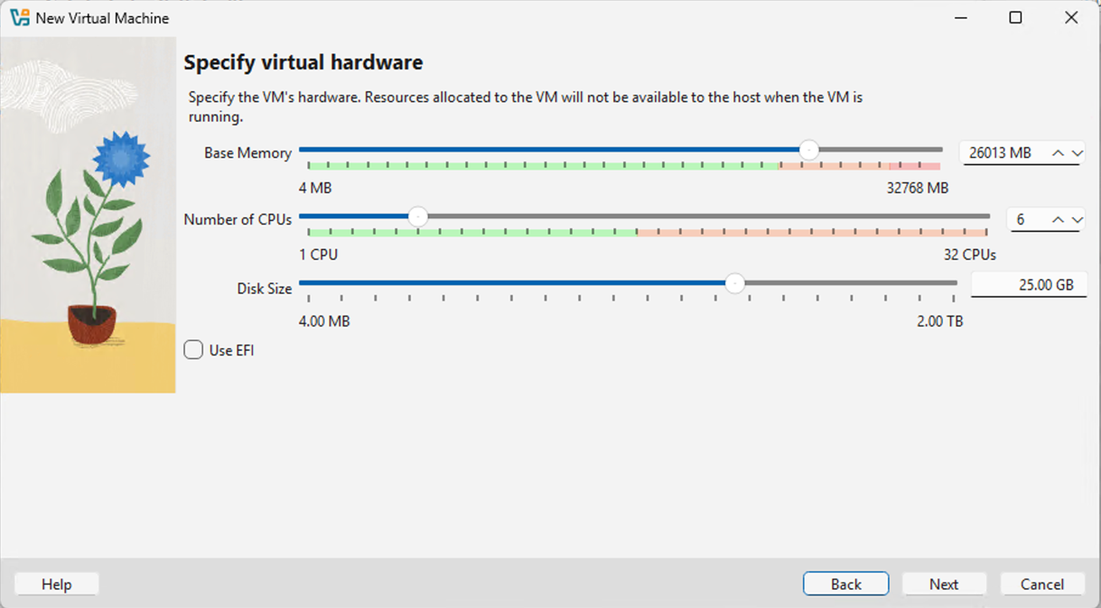

Finish that then open your virtual machine (Takes about 10-15 minutes)

Don’t mess around with Ubuntu as it is loading

Once it loads, log in with your username and password

After logging in the welcome to ubuntu page pops up, set this up as you’d like

I also recommend saving terminal on your dash, you will be using it a lot.

Installing LibreLane

Open terminal in Ubuntu

Type in or copy this command into terminal:

sudo apt-get install -y curl

Once that loads type in or copy this command into terminal:

curl --proto '=https' --tlsv1.2 -fsSL https://artifacts.nixos.org/nix-installer | sh -s -- install --no-confirm --extra-conf "

extra-substituters = https://nix-cache.fossi-foundation.org

extra-trusted-public-keys = nix-cache.fossi-foundation.org:3+K59iFwXqKsL7BNu6Guy0v+uTlwsxYQxjspXzqLYQs=

extra-experimental-features = nix-command flakes

"

Enter your Ubuntu password. This will take a minute to load. After it finishes loading, make sure to close terminal then open it again.

Type or copy this command into terminal:

sudo apt install git

Enter your password if prompted

Enter y if prompted

Type or copy this command into terminal:

git clone https://github.com/librelane/librelane

Now LibreLane is set up on your computer. If you would like to open it, type in this command:

cd ~/librelane

Then open nix by typing in this command:

nix-shell

You will get these errors, but you can just ignore it. They won’t cause any problems for your project.

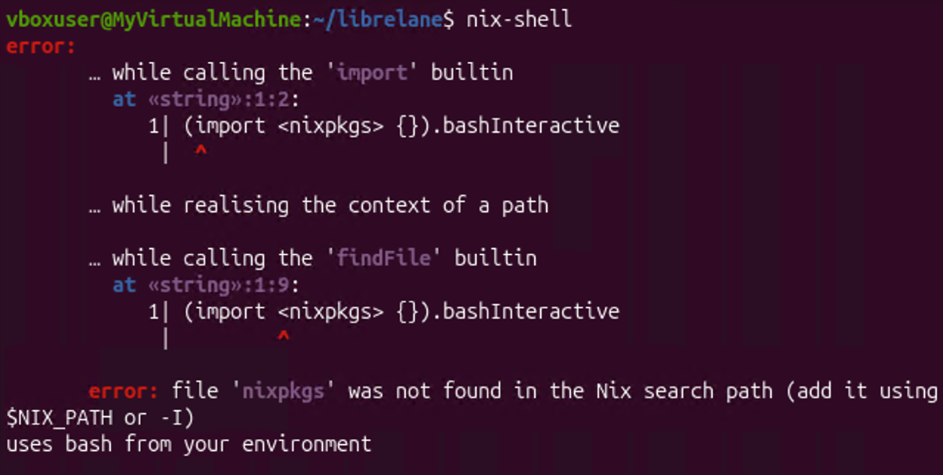

If you get any other error or are not in nix-shell and librelane terminal, go through installing LibreLane again. This is what it should look like:

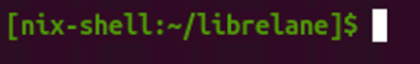

Once these are open you can work on your project.

- Setting Up Your Project
To run your code in LibreLane you will need your source RTL from Vivado and a configuration file that tells LibreLane where to look.
First, you need to make a folder to store all these files in one place, make this folder in the home category of files. Make sure to have no spaces in the names of the folders and files. The example shared will have a folder titled final_proj inside a folder called my_designs, but you can do whatever you prefer. You can use this command in terminal to make the folders:
mkdir -p ~/my_designs/final_proj
Copy all of your .v files from the sources_1 folder made by Vivado for your project. Paste these files into the project folder you just made.
Next, create your config.json file. This is to tell LibreLane exactly how to set up the design. First create the file in your project folder, you can put this command into terminal:
touch ~/my_designs/final_proj/config.json
Once the file is created, write the commands. This is how the config file should be formatted:
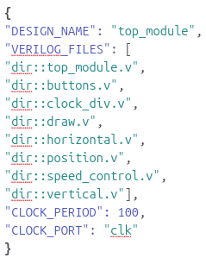
Now that all the files you need are all together, it is time to run them through LibreLane.
- Running Your Design Through LibreLane
To run your project through LibreLane put this command into terminal:
librelane ~/my_designs/final_proj/config.json

LibreLane will run your RTL design through the ASIC design flow. This process converts your design into a physical layout and might take a couple minutes to complete.
If the process completes without errors, LibreLane will generate the files needed to view your design as a GDS layout. You can then open the generated layout in KLayout.
If you get an error, LibreLane will close. Fix the error, then you will need to enter back into LibreLane and run the project again.
cd ~/librelane
nix-shell
librelane ~/my_designs/final_proj/config.json
repeat this until it runs without errors.
- Viewing your GDS Layout
Oonce your design has successfully run through LibreLane without errors, you can open the generated GDS layout in KLayout. Enter this command:
librelane --last-run --flow openinklayout ~/my_designs/final_proj/config.json
Common Issues:
Things to note about errors:
- When doing the command nix-shell you may get some errors but as long as it still says [nix-shell: ~/librelane]$ in your command line you should be able to continue on as usual.
- When getting an error and it says “LibreLane will now quit” you need to write the commands “cd ~/librelane” and “nix-shell” before trying again.
- If you get an error when running your config file and still go on to opening it in klayout it will just give errors about missing required inputs.
- Not having a CLOCK_PERIOD or a CLOCK_PORT will not give you an error but it will cause your GDSII layout to be different.
Possible errors:
Problems in config.json file:
  - Incorrect DESIGN_NAME: If you forget to include DESIGN_NAME, spell it incorrectly, or the name does not match your module name, LibreLane will give an error.
  - Problems with VERILOG_FILES: If you leave VERILOG_FILES empty, forget to include .v at the end of your Verilog file, LibreLane will give an error.
  - Formatting errors: If you forget a comma or quotation marks where they are required, LibreLane will give an error. In Visual Studio Code, a missing comma may also cause the configuration file to show red.
Problems in .v files:
  - Syntax errors: Syntax errors, such as forgetting a semicolon, will cause LibreLane to give an error.

