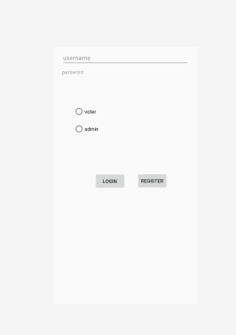

Login pages: Voter can tick to voter and enter username and password to navigate to vote page .

Admin will navigate to admin page

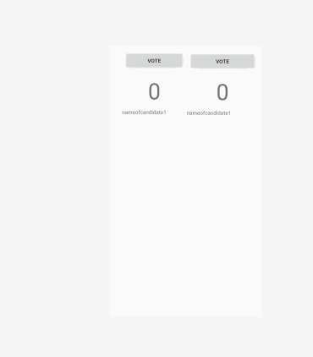

Voting page: user able to press vote button and observe the result display

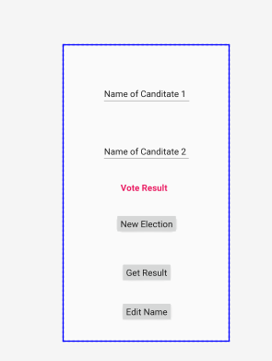

Admin pages: able to edit name of 2 candidate.

Press button edit name to update the name of 2 candidate

Press new election to update the name of 2 candidate and reset the vote result to 0

Get result : show the current vote counts of 2 candidate

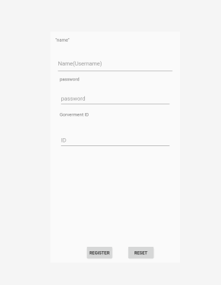

Register page

Enter name (username) password and Government ID to verification account.