Team Inventory  
9/18/2025  
  
REACH  
Dr. Lerner & Dr. Cunha  
Mentor: Bailey Hall  
  
Taylor Davis, Victor Rodriguez, Clayton Ramsey, Lucas Larson

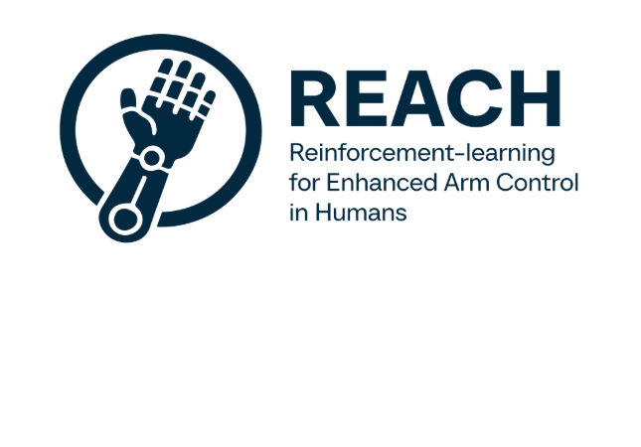

**Overview:**

This team inventory document serves to introduce the members of our team.

It highlights their education, skills, and relevant experience.

Lucas Larson

BS Computer Science | Flagstaff, AZ

**Education**

**Perry High School, Gilbert, AZ July 2018 - May 2022**

**Northern Arizona University, Flagstaff, AZ August 2022 - Present** Bachelor of Science in Computer Science Expected Graduation: May 2026

* CS 386 – Software Engineering
* CS 421 – Algorithms
* CS 470 – Artificial Intelligence

**Work Experience**

* **Research Assistant** | Northern Arizona University  
  Developing a Python package for computing regional hydrologic flow using topological data. Working directly for the USGS under Eric Sjöstedt.
  + Use of high-power compute on campus using MONSOON HPC server
  + Use of USGS APIs to gather and group data for HPC analysis.
* **Research Assistant** | Northern Arizona University  
  Maintain and develop Online Launch Calendar and mobile app for the Grand Canyon River Outfitters Association and National Park Service. Maintain and update remote AWS servers for development and production. Professional communications with clients and sponsors, weekly meetings with deliverable presentations.
  + Database management using PostgreSQL, Ruby on Rails, and AWS.
  + Mobile app development using Ionic, TypeScript, and NPM libraries.

**Skills**

* Linux Terminal – I’ve learned so much about using the linux terminal through classes here on campus and work experience, having to SSH into remote servers.
* Electronics and Circuitry – I am a self-taught electrical engineer from tinkering with electronics, I am proficient enough to design and build basic circuits and repair more difficult ones.
* Full stack development – Working with Dr. Doerry’s lab, I have learned full stack development in multiple different frameworks.
* CAD and Computer Software – Using computer software from a young age, I have learned many different programs like the Adobe suite as well as various CAD and other computer software.

**Other Interests**

* Robotics – I am huge robotics fan, and I was a part of our school’s robotics team in junior high school
* Engineering – I consider myself a multifaceted engineer, I love to design and build physical and digital projects.

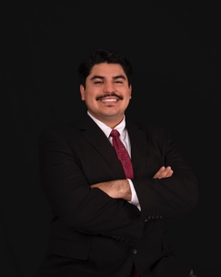Victor Rodriguez

BS Computer Science | Flagstaff, AZ

**Education**

**Grand Prairie High School, Grand Prairie, TX. July 2018 - May 2022**

**Northern Arizona University, Flagstaff, AZ January 2023 - Present** Bachelor of Science in Computer Science Expected Graduation: May 2026

* CS 386 – Software Engineering
* CS 421 – Algorithms
* CS 470 – Artificial Intelligence

**Work Experience**

* **Operating Systems Teaching Assistant | Northern Arizona University**

Supported students in understanding operating system concepts, including process scheduling, memory management, and file systems. Assisted in debugging, lab exercises, and project development for CS480

* + Provided one-on-one and group support to reinforce lecture content and strengthen problem-solving skills
  + Collaborated with the instructor to review lab submissions, answer student questions, and facilitate overall student learning
* **Advanced Programming Teaching Assistant | Northern Arizona University**  
  Assisted students in mastering C programming and algorithm development, providing one-on-one and group guidance. Worked closely with the course instructor to enhance lab sessions and lecture comprehension
  + Supported debugging and code review for student projects
  + Maintained communication channels for answering student queries and ensuring academic success

**Skills**

* Programming: C, Python; debugging, algorithm design, and clean, modular implementation.
* Linux & Tooling: Comfortable with the terminal and SSH to remote machines; Git/GitHub workflows
* Systems Foundations: Processes/threads, memory, and file I/O—good grounding for low-level control and integration
* Data & Analysis: Excel and SQL for quick analysis, logs, and experiment tracking

**Other Interests**

* Human-Centered Technology – Interested in developing tools that enhance quality of life, including assistive devices for mobility and rehabilitation.
* Artificial Intelligence & Robotics – Engaged in applying reinforcement learning to wearable robotic arms, combining AI with real-world impact.
* Systems Programming – Enjoy working with C, Python, and Linux, especially in the context of robotics and embedded systems.

Taylor Davis

BS Computer Science, BS Information Systems Management | Flagstaff, AZ

**Education**

**Snowflake High School, Snowflake, AZ, GPA: 4.0/4.0 August 2016 - May 2020**

**Northern Arizona University, Flagstaff, AZ August 2022 - Present**   
Bachelor of Science in Computer Science

Bachelor of Science in Information Systems Management Expected Graduation: May 2026

1. CS 386 – Software Engineering
2. CS 470 – Artificial Intelligence
3. ISM 370 – Data Analytics in Python

**Work Experience**

1. **Software Developer** | Purple Moon Technologies

Worked on the development of an application to help students in career development. During my time, I worked on search functionalities for browsing job and internship listings.

* + Used Python, Flask, and Django for system development.
  + Learned software engineering practices while collaborating in a team environment.

1. **Webmaster** | Business Information Technology Club Northern Arizona University  
    Led the development and management of BITC’s online presence, ensuring it accurately reflected all up-to-date information and was always functioning correctly.
   * Learned the basics of website management and monitoring
   * Used basic website tools for website updates, HTML, CSS, JavaScript

**Skills**

* Full Stack Web Development – I’ve taken both web programming 1 and 2, as well as created multiple full-stack projects from inception to launch.
* SQL and Databases – Working with database systems such as Oracle and PostgreSQL is something I first learned in database coursework, and I have hands-on experience with it from multiple projects.
* Pandas and Data Analysis – Since my first course in Python, pandas has been a tool I have been using for a long time, and I have produced multiple data analytics projects with Python data analytics packages.
* System Design and UML – From my coursework in ISM and CS, system architecture and diagramming is a skill I have practiced frequently.
* Linux Environments – Computing Tools classes and personal computer experience have given me lots of time to be comfortable in the terminal and in Linux Environments.

**Other Interests**

* Intelligent Systems – I have built a few projects using Artificial Intelligence and Reinforcement Learning, and I am highly interested in this field, hoping to work in the industry after graduation.
* Computer Hardware – Tinkering with hardware is something I love to do and a skill I practice.

Clayton Ramsey

BS Computer Science | Flagstaff, Arizona

**Education**

**Horizon Honors, Phoenix, AZ July 2017 - June 2021**

**Northern Arizona University, Flagstaff, AZ August 2021 - Present**   
Bachelor of Science in Computer Science Expected Graduation: May 2026

1. CS 386 – Software Engineering
2. CS 305 – Computing Tools III
3. CS 345 - Database Systems

**Work Experience**

1. **Teaching Assistant** | Northern Arizona University  
    In Fall of 2023, I worked as the TA for CS305, and I assisted multiple students with the struggles and challenges that come with Linux and Ubuntu web development.
   * Used Ubuntu, HTML, Javascript, and SSH skills

**Skills**

1. Linux Terminal – I’ve learned and worked much with Linux throughout the CS 105, 205, and 305 classes on campus and have done a plethora of SSH material along with that.
2. GitHub – I’ve worked on many projects that have utilized and operated from within the GitHub space.
3. Coding – I have learned and acquired skills with Python, C/C++ and Javascript.
4. Web Development – I’ve done several pieces, adjustments, and full blown mini-websites used with the world of Javascript and HTML.
5. Frequent Project Programmer – Throughout my computer science education I’ve had a mountain of projects, both individually and in groups, so I am accustomed to the workflow and necessities required for projects to operate successfully.

**Other Interests**

1. Robotics – Programming and robotics go hand in hand and my interest in it goes the same way.
2. Hands Ons Work – I’ve always loved seeing things I’ve created work inside and outside of the programming space, this being the biggest opportunity to see it come to fruition.