[1]

Matching the Impedances of Coaxial Transmission Lines by Impedance Matching Calculations

Lucas Le, *Student, IEEE*

*Abstract*—A quantitative, equation based solution is offered for determining the best parameters for ensuring the least amount of reflected signals and least amount of signal distortion. The characteristic impedance equation is used to find the ideal impedance of the RF circuit. The calculated ideal impedance was then used in an online RF simulator to ensure the least amount of signal reflection. The outcome of the simulated circuit is in virtually perfect agreement with well-developed physics ideas and concepts.

*Index Terms*—Impedance, Stripline technology, Ansoft Designer

# INTRODUCTION

A

ntenna impedance matching carry vast importance in today’s modern age where interconnectivity is paramount. Many industries, applications, and security services are dependent on ensuring the proper transfer of data through long distances—for this, matching impedance is essential. For example, millions of people in the United States rely on cable television for news and entertainment, without proper impedance matching, the images projected onto televisions nationwide would be heavily distorted and at points incomprehensible [1]. In instances where transmission cables have vastly differing impedances, the data becomes heavily distorted due to some outputted waves being reflected at the transmission junction back into the receiver [2].

## Impedance Matching

To ensure the maximum power transfer from a source to a load, the load impedance should match the source impedance. When the impedances don’t match, some of the electromagnetic waves get reflected back: this is known as wave reflection.

With these reflected waves, standing waves can also be generated which lead to voltage and current peaks along certain points of the line, potentially damaging the line and leading to energy inefficiencies.

Fig. 1. Example visualization of mismatched impedances. Adapted from [5].

For the least amount of wave reflections to take place, the impedances of the lines should match as closely as possible. One way for measuring how well electromagnetic waves are transmitted between two lines is by measuring the dB loss, which is a metric for measuring the amount of energy lost through transmission. The lower or more negative the dB loss is, the better the impedance match.

## Stripline Technology Process

In this project, one technology that will be employed is Stripline technology. A stripline consists of a conductor sandwiched between two ground/reference planes [3]. A major benefit to striplines is how striplines are shielded from most electromagnetic radiation, reducing signal noise and minimizing the loss of signals [3]. With that benefit, striplines carry another important usage of being an easy way to match impedances between two transmission lines through its physical width, length, and characteristic impedance [3].

The stripline changes its impedance using its physical dimensions because of how electromagnetic fields that are formed by the movement of electrons throughout the stripline’s substrate are shaped by the aforementioned physical dimensions [4].

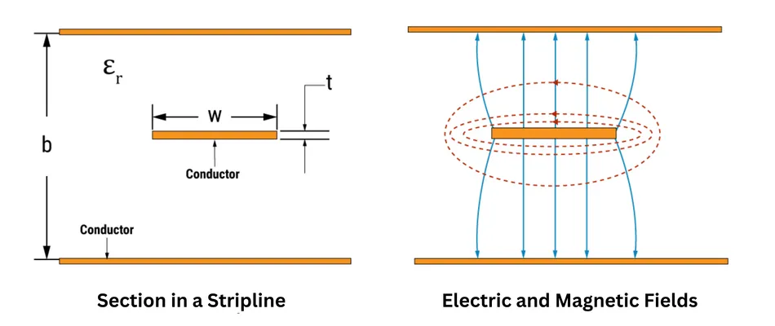

Fig. 2. Electric and Magnetic field diagram of a stripline. Adapted from [6].

# Simulation Software

The simulation software that was employed to simulate and test the effects of different properties and components on signal loss was Ansoft Designer SV (Student Version). From this software, I was able to design and simulate RF circuits and determine the dB loss of different configurations as seen in Fig. 3.

Fig. 3. dB loss chart for a stripline in an example composition.

With Ansoft Designer however, there are some inherent limitations such as how electromagnetic interference and noise are ignored and how ideal component values are used while real-world components have minute differences. Overall though, for the purposes of this project, these limitations don’t pose many problems for the credibility and repeatability of the proposed, simulated circuits.

# Formulation

Let us consider two simple Coaxial transmission lines where line 1 has an impedance of and line 2 has an impedance of . If the ideal impedance of an intermediary transmission line, is being attempted to be equated, (1) can be used to find the value of .

(1)

For the sake of simplicity, we’re assuming that this equation gives the perfect ideal impedance of an intermediary transmission line.

# Numerical Results

For introducing an intermediary Stripline connection between a received 500MHz 200Ω signal and a 2 meter long 50Ω Coaxial cable, I used the formulation developed in Section II. In the following problem we were provided by my ECS 101 instructor, I found that the aforementioned formulation helped substantially in finding the most optimized characteristic impedance. The solution to the problem that I found is presented here.

## Matching Impedances

Here I consider a given situation where the following factors need to be accounted for:

1. I am given a receiver antenna with a 200Ω characteristic impedance, a TV receiver set with a 50Ω impedance, a 2 meter long Coaxial cable with a characteristic impedance of 50Ω, and a black box RF circuit realized in Stripline technology which I need to design (substrate thickness 2×100mil, Rogers 3003, 1/2oz Cu).
2. The RF circuit to be installed in the black box must enable a smooth reception of minimum -30dB return loss for received signals from the antenna into the TV receiver set.

With these factors, I used the 200Ω characteristic impedance of the antenna and the 50Ω impedance of the TV receiver set in the equation formulated in Section II. From that, I calculated to be 100Ω. Following instructions from slides provided by the class instructor, I had E = 90deg and F = 0.5GHz. The reasoning behind these values is still uncertain for me.

Simulating these values, with me setting the parameters of a TRLE intermediary connection to E = 90deg, F = 0.5GHz, and Z = 100, I found that the circuit had a smooth reception where I had a -125dB return loss at the 500MHz input of the TV set.

## Stripline Tolerance Analysis

To more comprehensively understand the effects of different physical dimensions on the dB loss of the aforementioned example, I’ll show different outputs when different parameters of the stripline is changed.

Fig. 4. Optimized stripline integration, where its dB loss is seen in Fig. 3.

Fig. 5. Stripline integration where the conductor width is lowered to 0.6 mm.

Fig. 6. dB loss of Fig. 5. (Red), where W = 0.6mm, compared to dB loss of optimized Fig. 4. (Green) where W = 0.724278mm.

Fig. 7. Stripline integration where the condcutor width is increased to 0.8mm.

# Conclusion

In this paper, I presented a rudimentary mathematically based solution for matching different impedances. My solution is based off concepts that were taught in Lecture 8 of ECS 101 at Syracuse University. While this experimentation was purely conceptual and simulated with software, most studies and real life implementations support my conclusion for finding an optimized impedance between two transmission lines. With that in mind, my solution provides a simple way to ensure the least amount of reflected waves.

References

1. G. Hardesty. (2023, September). VSWR: Impedance Matching in Antennas & Antenna Cables. [Online]. Available email: lle107@syr.edu Message: get DATA-ALLIANCE
2. (2021, November). How Signal Reflection and Impedance Mismatch Are Related. [Online]. Available email: [lle107@syr.edu](mailto:lle107@syr.edu) Message: get CADENCE-ANALYSIS
3. J. C. Rautio, "Chapter 4 - High-Frequency and Microwave Electromagnetic Analysis Calibration and De-embedding," in *Microwave De-embedding*, G. Crupi and D. M. M.-P. Schreurs, Eds. Academic Press, 2014, pp. 151-188. doi: 10.1016/B978-0-12-401700-9.00004-5.
4. L. G. Maloratsky. (2000, March). Reviewing The Basics Of Microstrip Lines. [Online]. Available email: [lle107@syr.edu](mailto:lle107@syr.edu) Message: get DESIGN-FEATURE
5. M. Hasanovic, “Introduction to Microwave Technology” presented in ECS 101, Syracuse University, Syracuse, New York, Oct. 29, 2024.
6. *Reviewing The Basics Of Microstrip Lines*, Sierra Circuits, 2021. [Online]. Available email: [lle107@syr.edu](mailto:lle107@syr.edu) Message: get SIERRA-CIRCUITS

**Lucas Le** was born in Seattle, Washington, in 2006. He is currently pursuing a B.S in Computer Engineering at Syracuse University with an expected graduation date in 2028.

He was a highschooler at Lakeside School in Seattle, Washington from 2020 – 2024 where he was the leader of the Robotics Team, a summer intern with Lakeside’s IT department, and is currently unemployed with an intention to focus on college work. His research interests are currently still developing but he has interests for the fields of robotics, data security, embedded systems, IOT, and various other related subjects.

Mr. Le has received numerous Judge’s awards in various VEX Robotics competitions in 2022 and 2024. He is currently a member of Syracuse’s ASIA club and Cuse’ Baja.

Fig. 8. dB loss of Fig. 7. (Blue), where W = 0.8mm, compared to the dB losses of Fig. 4. (Green) and Fig. 6 (Red).

Looking at these different figures, it’s visible how, to get the lowest dB loss, optimization needs to be calculated. Even with a small physical change of 0.024 from Fig. 4 to Fig. 5, there was a massive change in dB loss.

1. Manuscript has not been sent and therefore not received nor will be revised.

   The author is a student in the College of Engineering and Computer Science, Syracuse University, Syracuse, NY 13244 USA (email: [lle107@syr.edu](mailto:lle107@syr.edu)) ….Digital Object Identifier N/A