Supplementary material 1. Taxonomic changes between the first (2008–2010) and second (2014–2020) cycles of the FlorestaSC inventory.
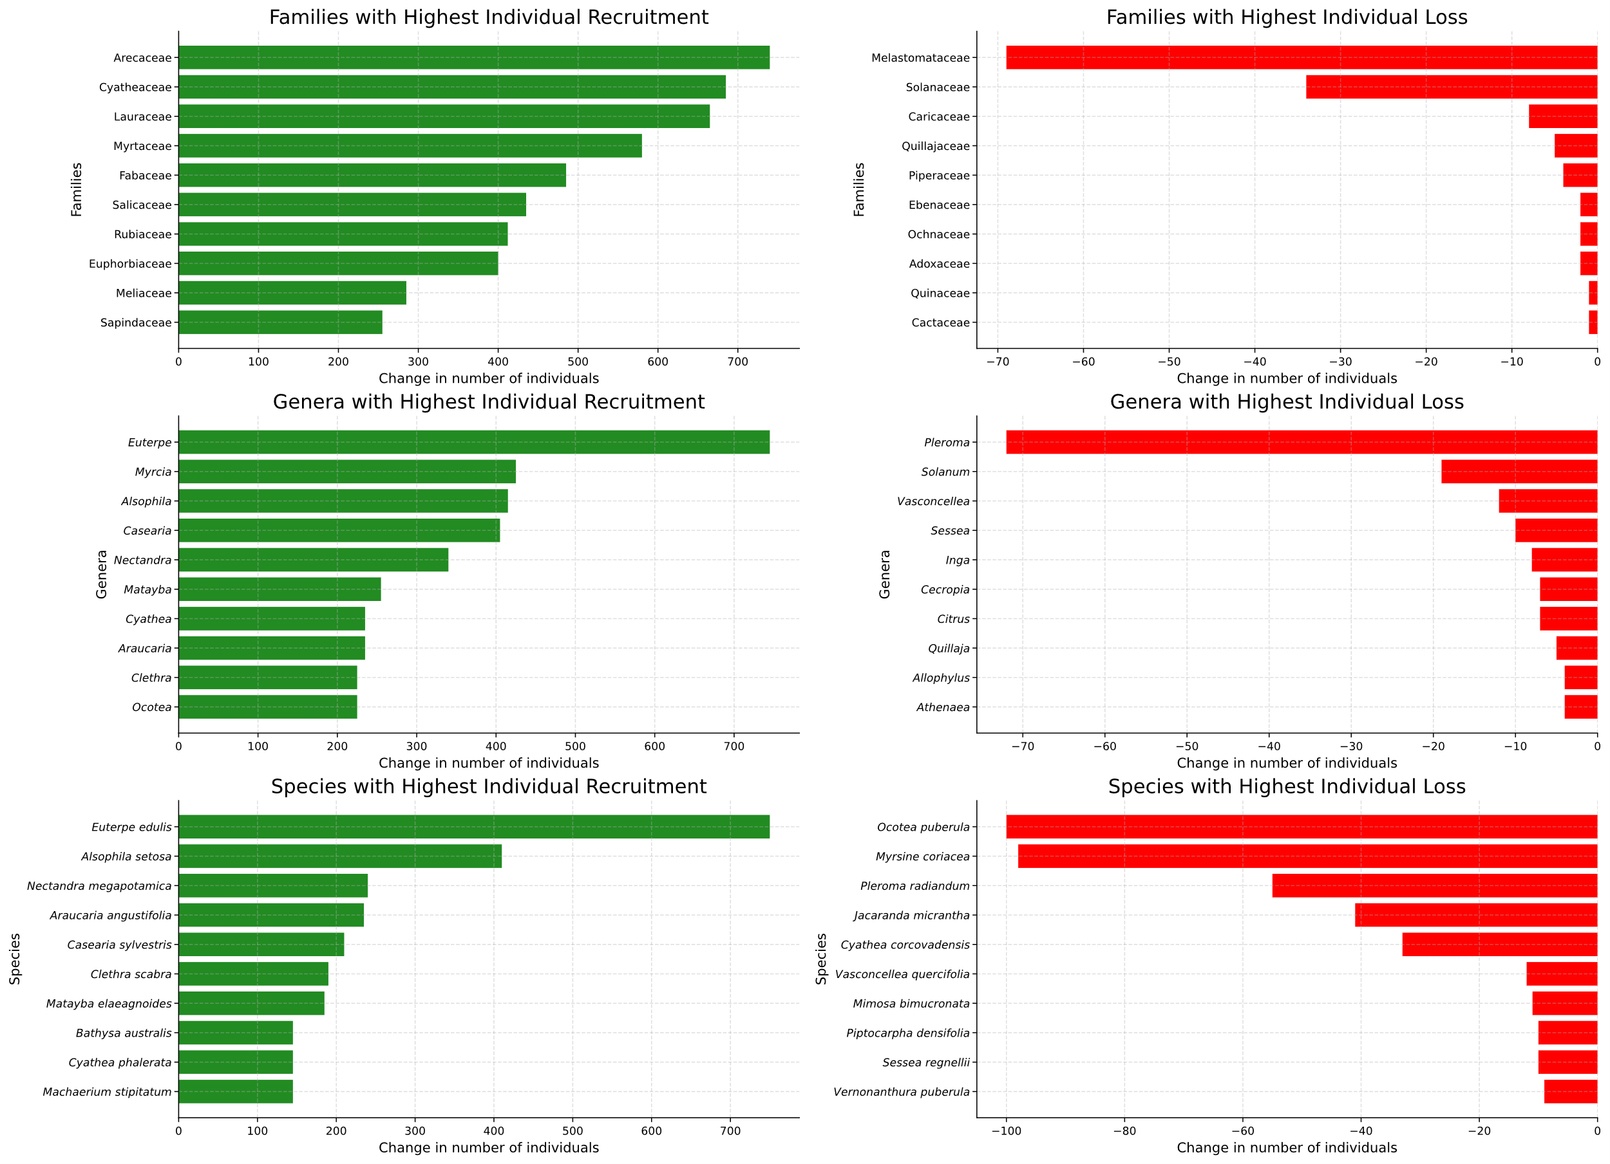
In the first cycle of the FlorestaSC inventory, 54,611 individuals were recorded, representing 581 species, 244 genera, and 81 families. In the second cycle, the total number of individuals increased to 61,717, while species richness slightly decreased to 572, with the number of genera and families remaining unchanged. Overall, approximately 207 genera exhibited compositional change through species ingress or egress, whereas 37 genera remained stable with no variation in individual counts (Supplementary Fig. 1, Supplementary Table 1-3). Across cycles, 23 species were recorded for the first time, including representatives from distinct families such as Capsicum flexuosum Sendtn. (Solanaceae), Pinus taeda L. (Pinaceae), and Eucalyptus grandis W.Hill (Myrtaceae). Conversely, 35 species present in the first cycle were no longer detected in the second (Fig. 2, Supplementary Table 1). Myrtaceae exhibited the strongest recruitment signal, with an increase of 1,137 individuals, followed by Arecaceae (+744), Cyatheaceae (+679), Lauraceae (+673), and Fabaceae (+498). In contrast, Melastomataceae showed the greatest decline (–69 individuals), followed by Solanaceae (–38), Caricaceae (–8), Quillajaceae (–5), and Ochnaceae (–4). At the genus level, Euterpe showed the largest net increase (+741 individuals), followed by Eucalyptus (+506), Myrcia (+450), Alsophila (+417), and Casearia (+404). The genus Pleroma exhibited the greatest decline (–71 individuals), followed by Solanum (–23), Vasconcellea (–12), Sessea (–10), and Cecropia (–7). At the species level, Euterpe edulis Mart.displayed the highest recruitment (+741 individuals), followed by Eucalyptus (+492), Alsophila setosa Kaulf. (+417), Nectandra megapotamica (Spreng.) Mez (+238), and Araucaria angustifolia (Bertol.) Kuntze (+232). The species with the strongest decline was Ocotea puberula (Rich.) Nees (–100 individuals), followed by Myrsine coriacea (Sw.) R.Br. ex Roem. & Schult. (–98), Pleroma raddianum (DC.) Gardner (–56), Jacaranda micrantha Cham. (–41), and Cyathea corcovadensis (Raddi) Domin (–34).

Supplementary Figure 1. Graphs showing, in absolute numbers, the most representative families in terms of species ingress and egress. Genera exhibiting the highest rates of mortality (egress) and those with the highest rates of recruitment (ingress) are also shown (total counts, not weighted by abundance).

Supplementary Table 1. Families with the strongest recruitment and mortality between inventory cycles.
Family | Trend | Δ Individuals | Ecological interpretation
Myrtaceae | Recruitment | +1137 | Evergreen canopy trees in regenerating stands
Arecaceae | Recruitment | +744 | Shade-tolerant palms expanding in understory
Cyatheaceae | Recruitment | +679 | Tree ferns indicative of moist understory recovery
Lauraceae | Recruitment | +673 | Secondary canopy trees tolerant to low light
Fabaceae | Recruitment | +498 | Nitrogen-fixing trees in early- to mid-successional stages
Melastomataceae | Mortality | –69 | Pioneer shrubs losing dominance in mature plots
Solanaceae | Mortality | –38 | Early-successional herbs and shrubs declining with canopy closure

Supplementary Table 2. Genera showing the highest recruitment and mortality.
Genus | Trend | Δ Individuals | Ecological interpretation
Euterpe | Recruitment | +741 | Dominant palm genus in shaded regeneration strata
Eucalyptus | Recruitment | +506 | Exotic canopy tree, expanding in disturbed plots
Myrcia | Recruitment | +450 | Native canopy tree characteristic of humid forests
Alsophila | Recruitment | +417 | Tree fern indicative of microclimatic recovery
Casearia | Recruitment | +404 | Shade-tolerant secondary tree
Pleroma | Mortality | –71 | Early-successional shrub genus losing dominance
Solanum | Mortality | –23 | Short-lived shrubs sensitive to shading
Supplementary Table 3. Species exhibiting the largest changes in abundance.
Species | Trend | Δ Individuals | Ecological interpretation
Euterpe edulis | Recruitment | +741 | Shade-tolerant palm; key species in forest regeneration
Eucalyptus grandis | Recruitment | +492 | Introduced species; expanding in open sites
Alsophila setosa | Recruitment | +417 | Tree fern typical of moist slopes
Nectandra megapotamica | Recruitment | +238 | Secondary Lauraceae tree; resilient under moderate shade
Araucaria angustifolia | Recruitment | +232 | Late-successional conifer increasing in cooler zones
Ocotea puberula | Mortality | –100 | Pioneer canopy tree declining in mature stands
Myrsine coriacea | Mortality | –98 | Mid-successional tree showing demographic thinning
Pleroma raddianum | Mortality | –56 | Early-successional shrub sensitive to shading
Jacaranda micrantha | Mortality | –41 | Light-demanding pioneer tree
Cyathea corcovadensis | Mortality | –34 | Tree fern declining in over-shaded plots

