Operating System Design

Homework:
- Operating System Review 3
Chapter 8 to 12

NAME: DOAN QUOC SY VO

STUDENT ID: 150201133

DATE: June 15, 2015

Questions

- Consider a logical address space of 64 pages of 1024 words each, mapped onto a physical memory of 32 frames.

  - How many bits are there in the logical address?

  - How many bits are there in the physical address?

- What is the purpose of paging the page tables?

- Under what circumstances do page faults occur? Describe the actions taken by the operating system when a page fault occurs.

- Which of the following programming techniques and structures are “good” for a demand-paged environment ? Which are “not good”? Explain your answers.

  - Stack
  - Hashed Symbol Table
  - Sequential Search
  - Pure code
  - Indirection

- Does the working set model of page allocation support global or local replacement of
frames? Explain.

- Consider a demand-paged computer system where the Operating System is expected to support multiprogramming. The system was recently measured to determine utilization of CPU and the paging disk. For the measurements below, which measurement shows thrashing, which measurement shows an increase in multiprogramming is needed, which measurement shows the computer system is being utilized effectively.

  - CPU utilization 13 percent; disk utilization 97 percent
  - CPU utilization 87 percent; disk utilization 3 percent
  - CPU utilization 13 percent; disk utilization 3 percent

- Describe what causes thrashing to occur in an Operating System. What technique can be used to minimize the possibility of thrashing.

- Consider the following page reference string:

1, 2, 3, 4, 2, 1, 5, 6, 2, 1, 2, 3, 7, 6, 3, 2, 1, 2, 3, 6.

Complete the diagram. How many page faults would occur for the LRU replacement algorithms, assuming four frames? Show work, similar to Figure 9.15 in textbook.

1 2 3 4 2 1 5 6 2 1 2 3 7 6 3 2 1 2 3 6
-------------------------------------------------------------------------
1 1 1 1 1 1 1
- 2 2 2 2 2 2
- - 3 3 3 3 5
- - - 4 4 4 4
F F F F F

- The Memory Management techniques for paging and segmentation, was an improvement over requiring the process image to reside in contiguous memory, but paging and segmentation still required the process image to reside in physical memory. With Virtual Memory, the process image no longer has to reside in physical memory, just the pages that are currently used. Explain why the entire process image does not need to reside in physical memory for the process to execute.

- The diagram belows shows the Page Fault Rate in relationship to time in a Working Set Model. What is the significance of the following points in the diagram.

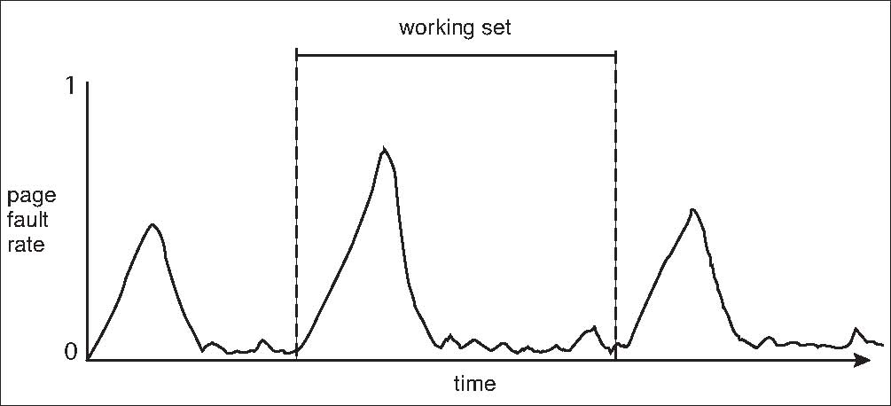
A
B
C
D

A)

B)

C)

D)

- User space and the Linux Kernel space are in different segments in physical memory. What type of memory allocation scheme is used by the Linux Kernel?

- Consider a system that supports the file allocation strategies of contiguous, linked, and indexed allocation. What type of file would be best utilitzed by each of the file allocation strategies?

a) Contiguous Strategy:

b) Linked Strategy:

c) Indexed Strategy:

- Explain how the VFS layer allows an operating system to support multiple
types of file systems easily.

- What are the advantages of the variant of linked allocation that uses a FAT to chain together the blocks of a file?

- None of the disk-scheduling disciplines, except FCFS, is truly fair (starvation may occur).
Explain why this assertion is true for SSTF, SCAN, and CSCAN.

