Operating System Design

Homework:
- Protection
Chapter 14

NAME: VO DOAN QUOC SY

STUDENT ID: 150201133

DATE: Jul 13th 2015

Questions

- What are the main differences between capability lists and access list?

- An Access Matrix can be used to model a protection scheme for an Operating System. In the Access Matrix, the Domain is used for the row and the Object is used for the column. The matrix entry represents the Access Rights for an Object in a Domain. Give an example of how the Access Matrix is used to model the File System of an Operating System.

- Protection can be provided by an application subsystem that must be used to access all resources of the Operating System. Instead of using the Kernel to provide protection, the application subsystem is an abstraction layer that is implemented on top of the Kernel. Describe the merits of using an application subsystem as opposed to having the Kernel provide protection.

- In a Role Based Access Control (RBAC) system, the user is assigned to a role, instead of directly to the object.

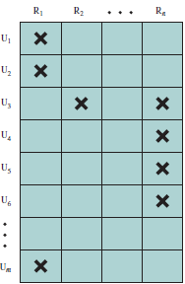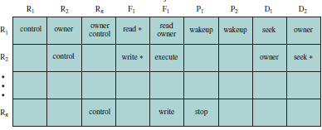
F2

In the RBAC Access Matrix, describe the capability of User U2 and User U3 for the Roles.

- Using the RBAC Matrix in Question (4), describe the capability of User U2 and User U3 for the File F1 and File F2 objects.

Answers

