CS500

Operating System Design
Assignment 3

NAME:

STUDENT ID:

DATE:

Lab Description

In a distributed operating system, users will access remote resources in the same way they access local resources. The operating system has three approaches for handling the remote resource. Data migration transfers the file or portions of the file necessary for the immediate task. Computation migration transfers the computer, rather than the data across. Process migration has the process or parts of the process executed at different sites.

In the case of Computation Migration, consider a job that needs to access various large files that reside at different sites. It would be more efficient to access the files at the sites where they reside and return the desired results to the site that initiated the computation. Generally, if the time to transfer the data is longer than the time to execute the remote command, the remote command should be used.

Such a computation can be carried out in different ways. Suppose that process P wants to access a file at site A. Access to the file is carried out at site A and could be initiated by an RPC. An RPC uses a datagram protocol
(UDP on the Internet) to execute a routine on a remote system. Process P invokes a predefined procedure at site A. The procedure executes appropriately and then returns the results to P.

In this exercise, you will distribute the execution of commands to sort files at the remote system and return the result to the local system. The Raspberry Pi will be the local system where the RPC commands originate.

Turn In:

You will be connected to the Raspberry Pi either through ssh utility (from Linux) or putty (from Windows). Save the output from your session on the Raspberry Pi.

Lab Procedure

- Connect to the Raspberry Pi. From a Linux system, use “ssh” to connect to the Raspberry Pi. From a Windows system, use “putty” to connect to the Raspberry Pi.

$ ssh pi@10.0.1.100 ← HINT: 10.0.1.100 is the IP address in cmdline.txt.

Use vi editor to create local data file:
a) Go into insert mode by typing “i”.
b) Copy and paste text below into file.
c) Exit insert mode with <ESC>.
d) Save the file with the text with “:wq”.

$ vi smallFile
John Doe ECE 3.54 doe@jd.home.org 111.222.3333
James Davis ECE 3.71 davis@jd.work.org 111.222.1111
Al Davis CS 2.63 davis@a.lakers.org 111.222.2222
Ahmad Rashid MBA 3.74 ahmad@mba.org 111.222.4444
Sam Chu ECE 3.68 chu@sam.ab.com 111.222.5555
Arun Roy SS 3.06 roy@ss.arts.edu 111.222.8888
Rick Marsh CS 2.34 marsh@a.b.org 111.222.6666
James Adam CS 2.77 jadam@a.b.org 111.222.7777
Art Pohm ECE 4.00 pohm@ap.a.org 111.222.9999
John Clark ECE 2.68 clark@xyz.ab.com 111.111.5555
Nabeel Ali EE 3.56 ali@ee.eng.edu 111.111.8888
Tom Nelson ECE 3.81 nelson@tn.abc.org 111.111.6666
Pat King SS 2.77 king@pk.xyz.org 111.111.7777
Jake Zulu CS 3.00 zulu@jz.sa.org 111.111.9999
John Lee EE 2.64 jlee@j.lee.com 111.111.2222
Sunil Raj ECE 3.36 raj@sr.cs.edu 111.111.3333
Charles Right EECS 3.31 right@cr.abc.edu 111.111.4444
Diane Rover ECE 3.87 rover@dr.xyz.edu 111.111.5555
Aziz Inan EECS 3.75 ainan@ai.abc.edu 111.111.1111

$ uname -a
Screenshot
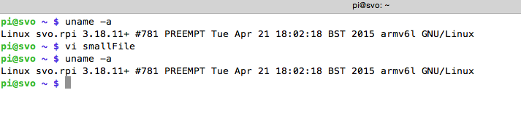

$ cat smallFile
Screenshot:
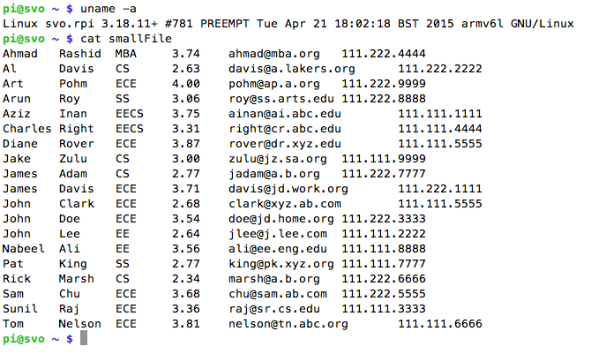

- The “ssh” command is used to login to a remote host. The “ssh” command is also used to execute a command on the remote host (the secure version of the “rlogin” and “rsh” command).

For distributed computing, use “ssh” to distribute the “sort” command to the remote host, 10.0.1.10, on your local network. The input file is smallFile from the local host and the sorted output is placed in file sorted_smallFile on the local host. After executing sort command on the remote host, show the sorted file using “cat” command. Show your work.

$ uname -a

$ ssh cs500in@10.0.1.10 sort < smallFile > sorted_smallFile

$ cat sorted_smallFile ← HINT: The “cat” command will send output of
sorted_smallFile to console.

Screenshot:
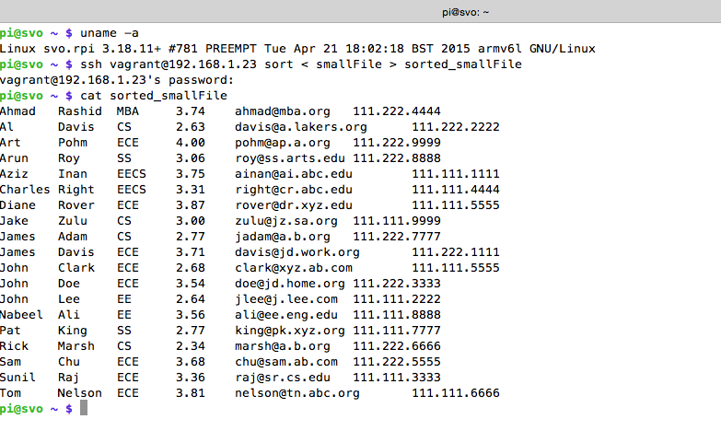

- Execute the “sort” command on the remote host, but instead of saving the sorted file on the local host, save the sorted file on the remote host. Show your work.

$ uname –a

$ ssh cs500in@10.0.1.10 sort < smallFile “> sorted_smallFile_s20”

Login to the remote host using “ssh” and verify the remote host has the sorted file. Show your work.

$ uname -a

$ ssh cs500in@10.0.1.10

$ cat sorted_smallFile_s20

$ exit ← HINT: “exit” command will terminate the “ssh” to remote host and
return you to the Raspberry Pi prompt.
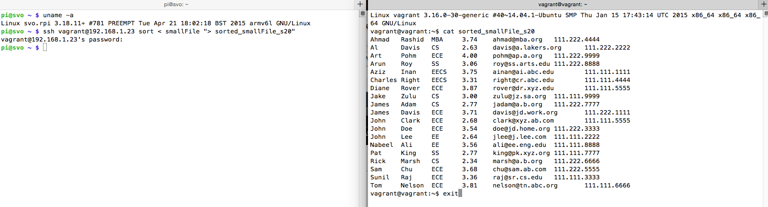

- Execute the “sort” command on the remote host, but use the file on the remote host. This would be the type of activity with a distributed file system. First copy the file, smallFile, to the remote host. Using the smallFile on the remote host as the input file, execute the “sort” command on the remote host, and the sorted output is placed in the file sorted_smallFile_local on the local host. Show your work.

$ scp smallFile cs500in@10.0.1.10:/home/cs500in ← HINT: Places smallFile
on remote host.

$ ssh cs500in@10.0.1.10 sort “< smallFile” > sorted_smallFile_local

$ cat sorted_smallFile_local

