Launcher User Manual

<https://github.com/lucasloss/WinAppLauncher>

Summary

Introduction 3

Terminology 3

Main Window 3

New Project 3

Project Loaded 3

Project Loaded and Apps Running (Monitoring Off) 4

Project Loaded and Apps Running (Monitoring On) 4

File Menu 5

Create a New Project 6

Load an Existing Project 6

The Grid 6

Basic Functions 7

Add/Edit Module 7

Module Context Menu 8

Managing Multiple Instances of a Module 9

Monitoring 10

Recent Projects 11

Settings 11

# Introduction

The Launcher is a Windows application designed to start, stop and monitor Windows applications, Windows services and batch scripts (.bat files).

# Terminology

* **Module**: represents an application, Windows service, or batch script to be controlled by the Launcher.
* **Project**: represents a list of modules. The Launcher saves the project on disk as a JSON file.

# Main Window

## New Project

When you first open the application, the list of modules will be empty.

Notice in the title bar of the application and in its status bar (at the bottom) the text *New Project*. This means the application is ready for you to configure the modules for a new project.

## Project Loaded

In the image below, the main window with *Launcher Project 01.json* loaded.

## Project Loaded and Apps Running (Monitoring Off)

In the image below, the main window with five modules running, but monitoring turned off. When monitoring if off, the CPU and Memory values remain zero. You may start the monitoring by pressing the  button.

## Project Loaded and Apps Running (Monitoring On)

In the image below, the main window with five modules running and monitoring turned on.

While monitoring, the Launcher will refresh the values CPU and Memory every second.

Also notice that you may stop the monitoring by pressing the  button.

# File Menu

The File menu has the following options:

* **New…**: creates a new empty project.
* **Open**…: loads an existing project file.
* **Save**: saves the current project if already existing in disk. Otherwise, opens the Save As dialog form.
* **Save As**…: opens the Save As dialog form which allows you to save a new project or to save an existing project with a different name.
* **Recent Projects**: lists project files previously opened by the Launcher.
* **Exit**: closes the Launcher.

# Create a New Project

To create a new project, take the following steps:

1. Use the menu File/New… to create an empty project.
2. Add modules by clicking the  button.
3. If necessary, select a module on the list and move it up or down by clicking the  and  buttons.
4. Save the project file by clicking the menu File/Save As… or by pressing Ctrl+S.

# Load an Existing Project

To load an existing project, take the following steps:

1. Click the menu File/Open…
2. Select the existing project file.

# The Grid

The image below shows the main grid of the application with a demonstration project loaded.

The application columns:

1. **Run**: it is the first column. When checked, the Launcher will start the application when you press the  button.
2. **Module Type**: it is the second column. Visual representation of the type of module:
   1.  indicates that the module is a batch file.
   2.  indicates that the module is a Windows service.
   3.  indicates that the module is a Windows application.
3. **Module Display Name**: the display name of the module.
4. **Status**: indicates whether the module is running:
   1.  indicates the module is running.
   2.  indicates the module is not running.
5. **CPU**: when monitoring, shows the CPU usage. Updates every second.
6. **Memory**: when monitoring, shows the Memory usage. Updates every second.

Even though three of the columns have the title empty, you may hover the mouse over the title to see the text as a tooltip. This is as design, to save space in the grid. Please refer to the image below.

# Basic Functions

|  |  |
| --- | --- |
|  | Adds a new module to the project. |
|  | Edits the selected module. You may also double click the module on the grid. |
|  | Removes the selected module from the project. |
|  | Moves the selected module up in the list. |
|  | Moves the selected module down in the list. |
|  | Starts monitoring. |
|  | Stops monitoring. |
|  | Starts all modules that are checked to run. |
|  | Stops all modules that are running. |

# Add/Edit Module

To add a new module to your project, click the  button above the grid.

To edit an existing module, select the module on the grid and click the  button. You may also double-click the module on the grid.

To add or edit a module, the application will show the Module Information form. Please refer to the image below.

The Module Information form allows you to configure the following module details:

* **Display Name**: the name of the module that will be displayed in the main grid of the application.
* **Path**: the complete path for the module executable. You may enter the path manually or use the  button to select the file.
* **Arguments**: the arguments that the Launcher should pass on to the executable on module startup.
* **Is Service**: indicates whether the module is a Windows service. This indicates to the Launcher to search for the module in the Windows service list.
* **Allow Multiple Instances**: indicates whether the Launcher will accept to start multiple instances of the same application.
* **Run on ‘Run Checked’**: indicates whether to run the module when the user presses the  button.

# Module Context Menu

The grid in the main window of the Launcher provides a context menu that can be accessed by right-clicking a module in the list.

When a module is not running, the context menu shows the **Start** option enabled and the **Stop** option disabled. Please refer to the image below.

When a module is running, the context menu shows the **Start** option disabled and the **Stop** option enabled. Please refer to the image below.

When a module allows multiple instances running at the same time, the context menu is slightly different. Please refer to chapter Managing Multiple Instances of a Module for more information.

# Managing Multiple Instances of a Module

When a module allows multiple instances to run at the same time, the context menu on the module in the grid will allow the user to start new instances of the module. Please notice the context menu in the image below.

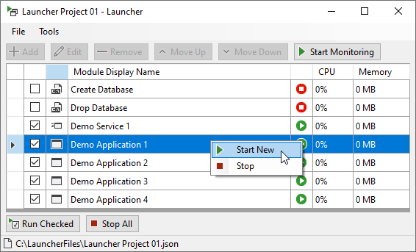

In the image above, the option Start New is enabled and the option Stop is also enabled (because there is only one instance of the module running).

When there are at least two instances of the module running, the context menu will list all processes of the module. Please refer to the image below.

In the image above you will notice the following options:

* **Start New**: start a new instance of the module.
* **Stop All**: stops all processes of the module.
* **Processes**: list the running processes.
  + **Show Window of Process**: brings the window of the module to the front of the screen.
  + **Stop Process**: stops the process. When in doubt about the correct instance to stop, use the function Show Window of Process to be sure of what module to stop.

# Monitoring

When running modules, the monitoring is useful to show when a module stopped running. In this scenario you will notice that the module status icon will change from  to .

Also, when opening the Launcher and loading a project, you may start the monitoring before starting any modules. This makes the Launcher search for running modules and, if any found, change the status icon from  to .

The monitoring also provides:

* The CPU usage of a module.
* The Memory usage of a module.

Notice in the image below that the module Demo Application 1 does not have CPU and Memory information. In the image, the Demo Application 1 has two or more instances running. When there are multiple instances running, the Launcher will not display CPU and Memory information. This is as design.

# Recent Projects

The Launcher saves links to previously opened projects in the menu item File/Recent Projects. Please refer to the image below.

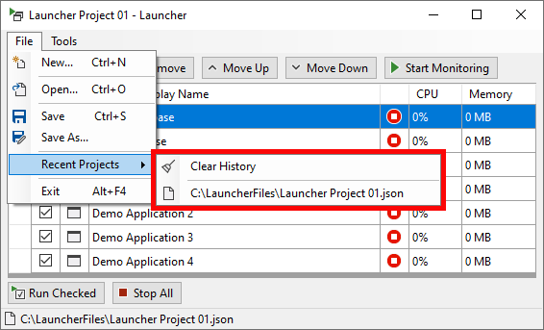

This option provides quick access to previously loaded projects. Click the project in the list to open it.

You may also clear the list of projects by using the **Clear History** menu item.

# Settings

To access the Settings form, click the menu Tools/Settings….

The option **Load the following project on startup** allows the user to select an existing project so the Launcher opens it on startup.