**AUTHOR DECLARATION**

We wish to confirm that there are no known conflicts of interest associated with this  
publication and there has been no significant financial support for this work that could have  
influenced its outcome.

We confirm that the manuscript has been read and approved by all named authors and that  
there are no other persons who satisfied the criteria for authorship but are not listed. We  
further confirm that the order of authors listed in the manuscript has been approved by all of  
us.

We confirm that we have given due consideration to the protection of intellectual property  
associated with this work and that there are no impediments to publication, including the  
timing of publication, with respect to intellectual property. In so doing we confirm that we  
have followed the regulations of our institutions concerning intellectual property.  
  
We understand that the Corresponding Author is the sole contact for the Editorial process  
(including Editorial Manager and direct communications with the office). He/she is  
responsible for communicating with the other authors about progress, submissions of  
revisions and final approval of proofs. We confirm that we have provided a current, correct  
email address which is accessible by the Corresponding Author and which has been  
configured to accept email from thyago.oliveira@penedo.ufal.br.

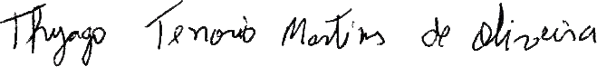  
Singned by correspondente Author: