- train_datagen = ImageDataGenerator(rescale=1./255, rotation_range=10, width_shift_range=0.1, height_shift_range=0.1, zoom_range=0.1, validation_split=0.2)
- batch size: 16
- epocas: 30
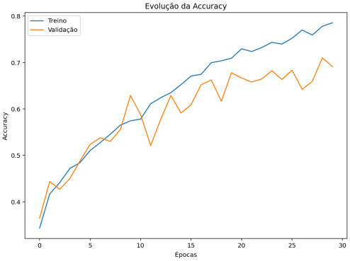
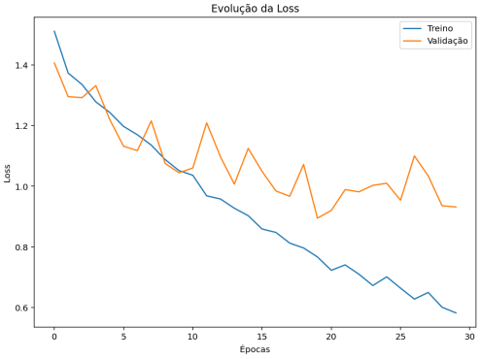
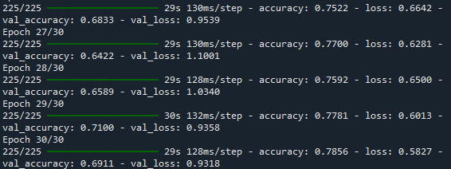
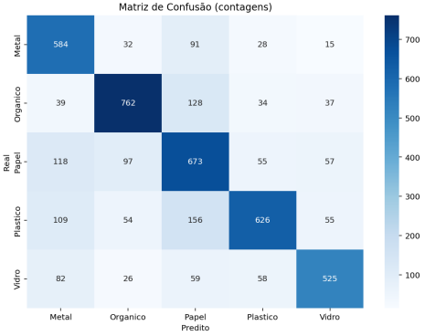
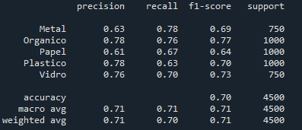

- train_datagen = ImageDataGenerator(rescale=1./255, rotation_range=10, width_shift_range=0.1, height_shift_range=0.1, zoom_range=0.1, validation_split=0.2)
- batch size: 16
- epocas: 5
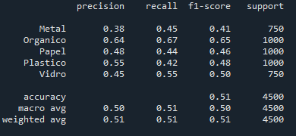

- train_datagen = ImageDataGenerator(rescale=1./255, rotation_range=10, width_shift_range=0.1, height_shift_range=0.1, zoom_range=0.1, validation_split=0.2)
- batch size: 32
- epocas: 5
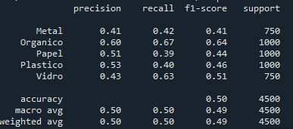

- train_datagen = ImageDataGenerator(rescale=1./255, rotation_range=10, width_shift_range=0.1, height_shift_range=0.1, zoom_range=0.1, validation_split=0.2)
- batch size: 64
- epocas: 5
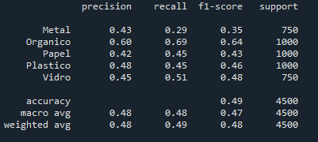
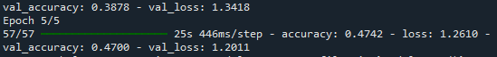

- train_datagen = ImageDataGenerator(rescale=1./255, validation_split=0.2)
- batch size: 16
- epocas: 5
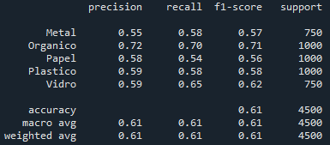

- train_datagen = ImageDataGenerator(rescale=1./255, validation_split=0.2)
- batch size: 16
- epocas: 30
