# YOLO Algorithm

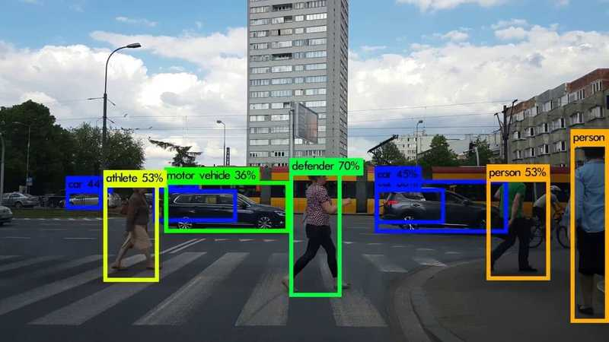In the year 2016 Joseph Redmon et al. proposed YOLO (You Only Look Once); a real-time object detection algorithm. Unlike other region proposal networks, YOLO makes use of a single neural network which outputs object bounding boxes and class probabilities all in one forward pass. The unified architecture is extremely fast allowing to process up to 45 frames per second. YOLO outperforms detection methods like DPM and fast R-CNN by a wide margin making it one of the most popular algorithms for real-time object detection and classification.

YOLO divides the input image in a SxS grid. If the bounding box center of an object falls into a grid cell, that cell is responsible for the detection of that object. Every cell predicts B bounding boxes each of which is defined by four parameters: x, y coordinates of its center, height h and width w. Furthermore, a bounding box is associated with a confidence score which reflects the model’s certainty that there is an object in the box. This amounts to 5 predictions per bounding box. Lastly, the model generates the C class probabilities for every grid cell. Consequently, the output tensor has S x S x (5*B + C) prediction values. To avoid the duplicate detections. YOLO uses non-max suppression.

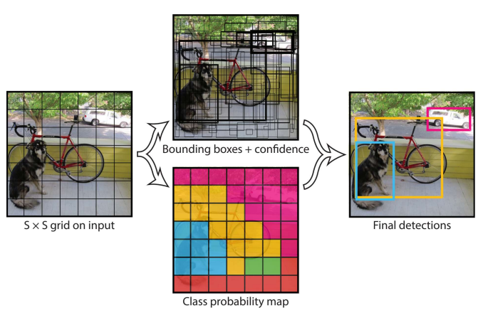

# YOLO Versions

Since its initial release in 2016 different versions and variants of YOLO have been proposed, each providing their own improvements in performance and efficiency. YOLOv1 to YOLOv3 were created by the original authors of YOLO - Joseph Redmon and his advisors. Starting from YOLOv4, the legacy of YOLO was continued by other researchers since Redmon had stopped his work in computer vision. Since then, various companies have published their own models as new YOLO versions such as YOLOv5 and YOLOv6, trying to profit from the YOLO hype. However, most of them they don’t provide any significant benefits. Thus, YOLOv4 remained the state-of-the-art in research and industry for many years.

YOLOv7 is the latest official release from the original authors of the YOLO architecture. Compared to previous versions, YOLOv7 provides a better real-time object detection accuracy, a more robust loss function and increased model training efficiency. As a result, it can be trained much faster on small datasets without any pre-trained weights. YOLOv7-tiny is a more lightweight implementation optimized for edge AI. This makes it suitable for the SoC for wearables used in this project.