Ion Jet Propulsion

**Abstract**

The Ionic Jet Propulsion Project aims to create a cleaner, and more efficient ionic jet engine to be used in commercial, private, and government purposes. Ionic jet engines will primarily exhaust $O^{3}$ (ozone), whereas conventional jet engines exhaust a great deal of ${CO}^{2}$, *CO*, and ${NO}^{2}$, which are known greenhouse gasses. Ionic propulsion was traditionally believed to be a less efficient method of propulsion than the traditional jet engine, however, Massachusetts institute of technology has recently determined that that ion propulsion has the potential to be over 100 times as efficient. Lastly, as a positive side effect of this design, there will be almost no heat signature, which will be of use in military drones or other such aircrafts.

To create significant boost with ionized air molecules via an electrical phenomenon known as the Biefeld-Brown effect in conjunction with Lorentz force. The Biefeld-Brown effect implies that air molecules will lose an electron, thus becoming an ion, when passing near a positively charged electrode. The ion will then be repelled from the positively charged electrode, and attracted to a negatively charged electrode places some distance away. The Lorentz force clams that any charged particle in a magnetic field and electric field will have a perpendicular force applied to it. The Lorentz force is determined by the electric field, magnetic field, and velocity of the particle.

**Abstract Design**

The Ionic Jet will have two circular electrodes on either end of a chamber. The larger diameter electrode will be positively charged and placed at the larger end of the chamber. This will be the intake. The smaller diameter electrode will be negatively charged placed at the smaller end of the chamber. This will be the exhaust. Additionally the smaller electrode will be elongated so it has more tube-like shape. Lastly, a wire will run through the center of the two electrodes with a current running from the intake to the exhaust. This wire will create the magnetic field which will be used to draw the air ions closer to the center which will increase the velocity of the ions as denoted by the Bernulli fluid equation.

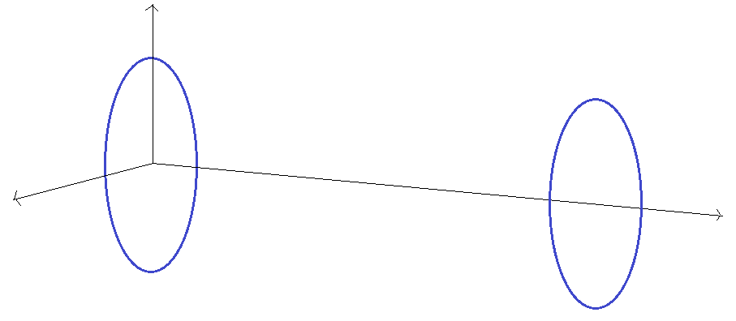

**Mathematical Proof of Concept**

**Calculating $\frac{Q}{A}$**

E = $\frac{Q}{ε_{0}A}$; where A is the area of the two capacitor sides, reffered to here as the positive and negative electrodes.

The electrodes are thin wires with negligible thickness, thus:

A = 2𝝅 $r_{1}$ + 2𝝅 $r_{2}$

A = 2( $r_{1}$ + $r_{2}$)

I don’t really feel like showing all the steps right now.

$\frac{Q}{A}$ = λ = $\frac{Vε_{0}}{2πr_{1}\sqrt{l^{2}+ {(r_{1}- r_{2})}^{2}}}$; where V = volts

**Setup to find the force applied to the air ions by the positive electro**de:

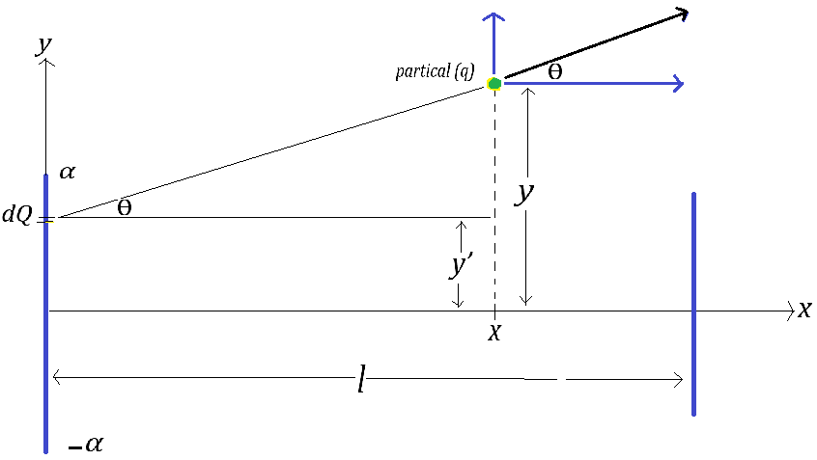

Coulomb’s Law: *Force (F) = $\frac{1}{4πε_{0}}$ $\frac{Q_{1}Q_{2}}{r^{2}}$*

Where:

$Q_{1}$ is the charge of *P*

$Q_{2}$ is the charge of the electrode ring

*r* is the distance from the differential element to *P*

Let:

= *k ≈ 8.99 \**

= *q*

= *Q*

Then: *F = kq*

Law of Vectors:

From Pythagorean:

*r =*

*cosθ = =*

*sinθ = =*

Force in x-direction ()

*= kq cosθ*

Force in y-direction ()

*= kq sinθ*

Substituting *r*, *sinθ,* and *cosθ*

*= kq*

*= kqx*

*= kq*

*= kq*

By definition these ratios are equal

= → *dQ =*  dA

Assuming that the electrode ring is very thin. Thus, dA = dy’ because there is no x component.

Let: = λ Then: dQ = λdy’

Substitute dQ = λdy’ and integrate with respect to y’

Now integrate $F_{x}$ to find the force on the particle, in the x direction, for any point x

$F_{x}$*= λkqx $\int_{-α}^{α}{\frac{1}{{(x^{2}+ {(y-y^{'})}^{2})}^{3/2}}}$ dy’*

Known integration from

$\int{\frac{1}{{(u^{2 }± a^{2)}}^{3/2}}}$ du = $\frac{± u}{a^{2}\sqrt{u^{2} ± a^{2}}}$ + C

Then

Let:

a = x

u = y – y’

-du = dy’

$F_{x}$*= λkqx $\int_{-α}^{α}{\frac{1}{{(x^{2}+ {(y-y^{'})}^{2})}^{3/2}}}$ dy’*

Substitute to u and a

$F_{x}$ = - *λkqa $\int{\frac{1}{{(u^{2 }+ a^{2)}}^{3/2}}}$* du *= $\frac{- λkqau}{a^{2}\sqrt{u^{2}+ a^{2}}}$*  + C

Substitute back to x and y – y’

$F_{x}$ = [ $\frac{- λkqx(y-y^{'})}{x^{2}\sqrt{x^{2}+ {(y-y^{'})}^{2}}}$ + C ]

Evaluating this expression from $–α$ to $α$

$F_{x}$ = - $\frac{ λkqx(y+α)}{x^{2}\sqrt{x^{2}+ {(y+α)}^{2}}}$ + $\frac{ λkqx(y-α)}{x^{2}\sqrt{x^{2}+ {(y-α)}^{2}}}$

**Now integrate $F_{y}$ to find the force of the primary electrode for any point x**

Let:

m = y – y’

dm = -dy’

u = $x^{2}+ m^{2}$

du = 2mdm

$\frac{1}{2}$ du = mdm = -dy’

- $\frac{1}{2}$ du = dy’

$F_{y}$*= λqk $\int_{-α}^{α}{\frac{y-y'}{{(x^{2}+ {(y-y^{'})}^{2})}^{3/2}}}$ dy’*

Substitute to u and - $\frac{1}{2}$ du

$F_{y}$*= - $\frac{1}{2}$ λqk $\int_{-β}^{β}{u^{-\frac{3}{2}}}$ du*

Integrate

$F_{y}$*= - $\frac{1}{2}$ λqk* ( -2) ${( u^{-\frac{1}{2}})}_{-β}^{β}$

Substitute back to y

$F_{y}$ = [ $\frac{λqk}{\sqrt{x^{2}+ {(y-y^{'})}^{2}}}$ + C ]

Evaluating this expression from $–α$ to $α$

$F_{y}$ = $\frac{λqk}{\sqrt{x^{2}+ {(y+α)}^{2}}}$ - $\frac{λqk}{\sqrt{x^{2}+ {(y-α)}^{2}}}$

Therefore, the force for from the positive electrode in the x and y direction at any point x and y are:

$F_{x_{positive}}$*=* - $\frac{ λkqx(y+α)}{x^{2}\sqrt{x^{2}+ {(y+α)}^{2}}}$ + $\frac{ λkqx(y-α)}{x^{2}\sqrt{x^{2}+ {(y-α)}^{2}}}$

$F_{y_{positive}}$*= $\frac{λqk}{\sqrt{x^{2}+ {(y+α)}^{2}}}$*  - $\frac{λqk}{\sqrt{x^{2}+ {(y-α)}^{2}}}$

**Setup to find the force applied to the air ions by the negative electrode.**

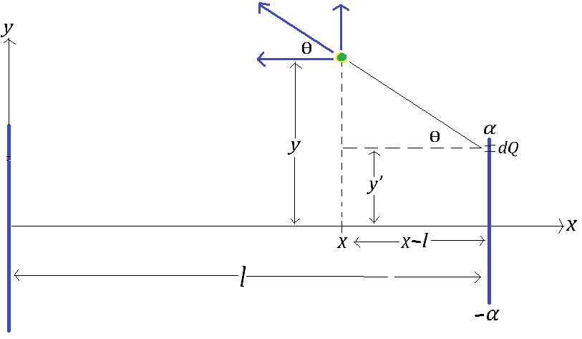

Coulomb’s Law: *Force (F) = $\frac{1}{4πε_{0}}$ $\frac{Q_{1}Q_{2}}{r^{2}}$*

Where:

$Q_{1}$ is the charge of *P*

$Q_{2}$ is the charge of the electrode ring

*r* is the distance from the differential element to *P*

Let:

= *k ≈ 8.99 \**

= *q*

= *Q*

Then: *F = kq*

Law of Vectors:

From Pythagorean:

*r =*

*cosθ = =*

*sinθ = =*

Force in x-direction ()

*= kq cosθ*

Force in y-direction ()

*= kq sinθ*

Substituting *r*, *sinθ,* and *cosθ*

*= kq*

*= kqx*

*= kq*

*= kq*

By definition these ratios are equal

= → *dQ =*  dA

Assuming that the electrode ring is very thin. Thus, dA = dy’ because there is no x component.

Let: = λ Then: dQ = λdy’

Substitute dQ = λdy’ and integrate with respect to y’

Now integrate $F_{x}$ to find the force on the particle, in the x direction, for any point x

$F_{x}$*= λkq(l – x) $\int_{-α}^{α}{\frac{1}{{({(l-x)}^{2}+ {(y-y^{'})}^{2})}^{3/2}}}$ dy’*

Known integration from

$\int{\frac{1}{{(u^{2 }± a^{2)}}^{3/2}}}$ du = $\frac{± u}{a^{2}\sqrt{u^{2} ± a^{2}}}$ + C

Then

Let:

a = l - x

u = y – y’

-du = dy’

$F_{x}$*= λkq(l – x) $\int_{-α}^{α}{\frac{1}{{({(l-x)}^{2}+ {(y-y^{'})}^{2})}^{3/2}}}$ dy’*

Substitute to u and a

$F_{x}$ = - *λkqa $\int{\frac{1}{{(u^{2 }+ a^{2)}}^{3/2}}}$* du *= $\frac{- λkqau}{a^{2}\sqrt{u^{2}+ a^{2}}}$*  + C

Substitute back to x and y – y’

$F_{x}$*= $\frac{- λkq(l-x)(y-y^{'})}{{(l-x)}^{2}\sqrt{{(l-x)}^{2}+ {(y-y^{'})}^{2}}}$*

Evaluating this expression from $–α$ to

*=*  +

**Now $F_{y}$ to find the force of the primary electrode for any point x**

Let:

m = y – y’

dm = -dy’

u = ${(l-x)}^{2}+ m^{2}$

du = 2mdm

$\frac{1}{2}$ du = mdm = -dy’

- $\frac{1}{2}$ du = dy’

$F_{y}$*= λqk $\int_{-α}^{α}{\frac{y-y'}{{({(l-x)}^{2}+ {(y-y^{'})}^{2})}^{3/2}}}$ dy’*

Substitute to u and - $\frac{1}{2}$ du

$F_{y}$*= - $\frac{1}{2}$ λqk $\int_{-β}^{β}{u^{-\frac{3}{2}}}$ du*

Integrate

$F_{y}$*= - $\frac{1}{2}$ λqk* ( -2) ${( u^{-\frac{1}{2}})}_{-β}^{β}$

Substitute back to y

$F_{y}$*= $\frac{λqk}{\sqrt{{(l-x)}^{2}+ {(y-y^{'})}^{2}}}$*

Evaluating this expression from $–α$ to $α$

$F_{y}$*= $\frac{λqk}{\sqrt{{(l-x)}^{2}+ {(y+α)}^{2}}}$*  - $\frac{λqk}{\sqrt{{(l-x)}^{2}+ {(y-α)}^{2}}}$

Therefore, the force for from the positive electrode in the x and y direction at any point x and y are:

=  +

= -

Setup: summing the forces.

Because the force is repelling from the positive electrode, the values of this will be positive.

Because the force is attracting towards the negative electrode, the values of the negative will be negative.

**Thus we have:**

$F_{x_{total}}$ = $F_{x_{positive}}$- $F_{x_{negative}}$

Let:

=

- + +  -

= -

Let:

$H\left(x,y\right)=F_{y_{total}}$ = $\frac{λqk}{\sqrt{x^{2}+ {(y+α)}^{2}}}$ - $\frac{λqk}{\sqrt{x^{2}+ {(y-α)}^{2}}}$ + $\frac{λqk}{\sqrt{{(l-x)}^{2}+ {(y+α)}^{2}}}$ + $\frac{λqk}{\sqrt{{(l-x)}^{2}+ {(y-α)}^{2}}}$

**Finally,**

**The total Force due to the electric field in vector form:**

$F_{E_{total}}$ = *< F(x,y) , H(x,y) >*

**Calculating the force applied to the particle by the magnetic field:**

**Setup:**

The force applied to a moving charged particle in a magnetic field is given by Lorentz force law:

F = q(**E** + **V** x **B**)

Where q is the charged of the particle, **E** is the vector form of the electric field already calculated, **V** is the velocity vector, and **B** is the magnetic field vector

Because we are assuming the ion is not moving in the z-direction, and the magnetic field is only in the z-direction, the force due to the magnetic field will equal:

$F_{B}$ = < $V_{y}$ B, $V_{x}$ B >

Additionally:

B = $\frac{μ_{0}i}{2πr}$ = $\frac{μ_{0}i}{2πy}$

Where:

$μ_{0}$*≈ 4x ${10}^{-7}\frac{Tm}{A}$*

*I = current in amps (A)*

*r = y: the radial distance from the wire*

$V_{y}$*= $\frac{dy}{dt}$*

$V_{x}$*= $\frac{dx}{dt}$*

Substitute B:

$F_{B}$ = < $\frac{μ_{0}i}{2πy}V_{y}$, $\frac{μ_{0}i}{2πy}V_{x}$ >

Substitute $V_{y}$ = $\frac{dy}{dt}$ and $V_{x}$ = $\frac{dx}{dt}$

$F_{B}$ = < $\frac{μ_{0}i}{2πy}\frac{dy}{dt}$, $\frac{μ_{0}i}{2πy}\frac{dx}{dt}$ >

Now sum the forces to get mass times acceleration: **ΣF = ma**

*< F(x,y) , H(x,y) > +* < $\frac{μ_{0}i}{2πy}\frac{dy}{dt}$, $\frac{μ_{0}i}{2πy}\frac{dx}{dt}$ > = m < $a_{x}$, $a_{y}$ >

Substitute $a_{x}$ = $\frac{d^{2}x}{dt^{2}}$ and $a_{y}$ = $\frac{d^{2}y}{dt^{2}}$

m < $\frac{d^{2}x}{dt^{2}}$, $\frac{d^{2}y}{dt^{2}}$ > = *< F(x,y) , H(x,y) >* +< $\frac{μ_{0}i}{2πy}\frac{dy}{dt}$, $\frac{μ_{0}i}{2πy}\frac{dx}{dt}$ >

Factor out d $t^{2}$ from the right hand side, and dt from $F_{B}$ on the left hand side of the equation.

$\frac{m}{dt^{2}}$ < $d^{2}x$, $d^{2}y$ > = *< F(x,y) , H(x,y) >* + $\frac{1}{dt}$ < $\frac{μ_{0}i}{2πy}$ dy , $\frac{μ_{0}i}{2πy}$ dx >

Multiply both sides by $\frac{dt^{2}}{m}$

$d^{2}$ < $x$, $y$ > = *< F(x,y) , H(x,y) > $\frac{dt^{2}}{m}$*  +< $\frac{μ_{0}i}{2πy}$ dy , $\frac{μ_{0}i}{2πy}$ dx > $\frac{dt^{2}}{mdt}$

Reduce $\frac{dt^{2}}{mdt}$ to $\frac{dt}{m}$ and multiply products:

< $d^{2}x$, $d^{2}y$ > = *< $\frac{F(x,y)dt^{2} }{m}$, $\frac{ H(x,y)dt^{2}}{m}$ >* +< $\frac{μ_{0}i}{2πmy}dydt$, $\frac{μ_{0}i}{2πmy}dxdt$ >

Integrate each section

$\int{\frac{μ_{0}i}{2πmy}dy}$ = $\frac{μ_{0}i}{2πm}$ ln|y| + = +

= t dt + $V_{0}$ dt $\int{\frac{H(x,y) }{m}dt^{2}}$ = $\frac{H(x,y) }{m}$ t dt + $V_{0}$ dt

Substitute back into the original equation

**V**(x,y) = < $dx$, $dy$ > = *< $\frac{F(x,y) }{m}t + V_{0}$, $\frac{H(x,y) }{m}$* t + $V_{0}$ *>dt* +< $\frac{μ_{0}i}{2πm}$ ln|y| + , + >dt

Add the vectors

**V**(x,y) = < $dx$, $dy$ > = *< $\frac{F(x,y) }{m}t + V_{0}+\frac{μ_{0}i}{2πm}$* ln|y| + *,* t + $V_{0}$ + $\frac{μ_{0}ix}{2πmy}$ + $C_{2}$ *>dt*

Integrate again to get final x and y equation

**S**(x,y) = <x, y> = *< $\frac{F(x,y) }{2m}t^{2} + {(V}_{0}+\frac{μ_{0}i}{2πm}$* ln|y| + )t + $S_{0}$*, $\frac{H(x,y) }{2m}t^{2}$*  + ( $V_{0}$ + $\frac{μ_{0}ix}{2πmy}$ + $C_{2}$)t + $S_{0}$ *>*

**S**(x,y) = < $\frac{F(x,y) }{2m}t^{2} + {(V}_{0}+\frac{μ_{0}i}{2πm}$ ln|y| + )t + $S_{0}$*, $\frac{H(x,y) }{2m}t^{2}$*  + ( $V_{0}$ + $\frac{μ_{0}ix}{2πmy}$ + $C_{2}$)t + $S_{0}$ >

Work Cited

*Calculus: Early Transcendental Functions.* 4th edition. Appendix B, number 36. Larson, Hostetler, Edwards.

*Average mass of air according to engineeringtoolbox.com = 28.97 g/mol*

$\frac{28.97 g}{mol}$*x $\frac{mol}{6.022x{10}^{23}}$ = 1.74x ${10}^{-21}$ g/molecule*