**Lab Report: Project 11 – Crystal Ball**

Lucas Porter

Spring 2025 TESY 3300

Trevor P. Robinson, PhD

Lab 11 – Crystal Ball

03/23/25

**Abstract**

The purpose of this lab was to build an electronic "crystal ball" using an Arduino Uno, a tilt sensor, and an LCD screen. When the tilt sensor was activated, the Arduino randomly selected and displayed a prediction on the LCD. This project introduced the use of LCD displays, random number generation, switch/case structures in programming, and the use of analog control to adjust LCD contrast.

**Materials**

* Arduino Uno Board
* Breadboard
* Tilt Sensor
* LCD Screen (16x2)
* 10kΩ Potentiometer
* 220Ω Resistor
* Jumper Wires
* USB Cable
* Computer with Arduino IDE

**Procedure**

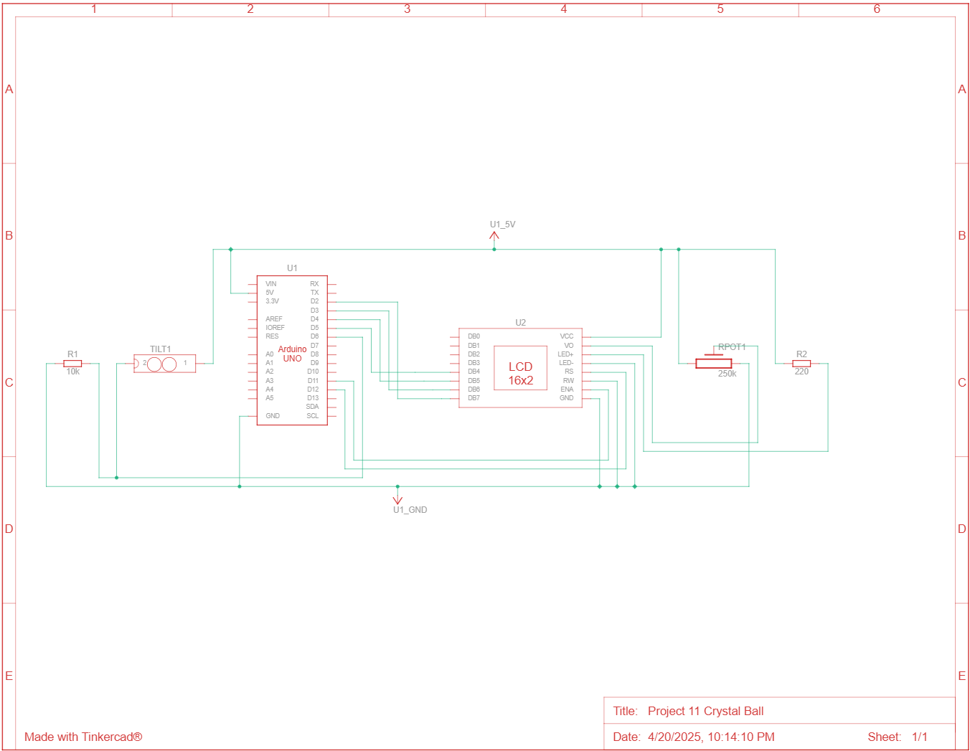*Circuit Diagram*

*Steps*

1. Connected the Arduino’s 5V and GND pins to the power and ground rails of the breadboard.
2. Wired the LCD screen following the standard 16x2 LCD wiring diagram with a potentiometer on the contrast pin (V0).
3. Connected the tilt sensor between ground and a digital input pin with proper pull-up configuration.
4. Uploaded the Arduino sketch and tested the circuit.
5. 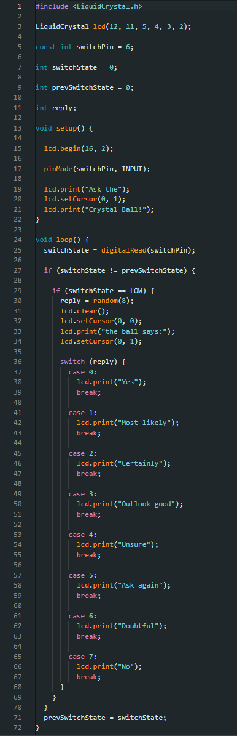Adjusted the potentiometer to set the screen contrast properly.

*Code*

**Discussion**

1. **What does LCD stand for and what is an LCD screen?**  
   LCD stands for Liquid Crystal Display. It is a type of flat-panel display that uses liquid crystals controlled by electrical signals to display characters or images.
2. **How would you change the number of options available in the Random() command?**  
   To add more options, you would change the upper limit in the random() function and add additional case statements in the switch block to match the new options.
3. **How is this circuit setup to adjust the contrast of the LCD screen?**  
   A 10kΩ potentiometer is connected to the V0 pin of the LCD to manually adjust the contrast by varying the voltage.
4. **Is there a limit to the number of switch options available in a case?**  
   Technically, there is no strict limit to the number of case options, but practical limits are based on memory and code clarity.

**Troubleshooting**

1. **Issue:** The tilt sensor kept coming loose from the breadboard, and it was confusing at first which pins to connect since the sensor had multiple legs.  
   **Solution:** Secured the sensor more firmly and verified the correct orientation and connections.
2. **Issue:** The LCD initially showed no text.  
   **Solution:** Adjusted the potentiometer to increase the contrast until the text was visible.

**Conclusion**

I really enjoyed working with the LCD screen in this project. At first, the screen displayed nothing, but after remembering to adjust the potentiometer for contrast, the text appeared clearly. The tilt sensor successfully triggered random predictions, and the base circuit now gives me many ideas for future LCD-based projects. The circuit worked smoothly overall, and no major code adjustments were necessary beyond setting the right contrast for the display.