**Lab Report: Project 12 – Knock Lock**

Lucas Porter

Spring 2025 TESY 3300

Trevor P. Robinson, PhD

Lab 12 – Knock Lock

03/30/25

**Abstract**

The purpose of this lab was to build a knock-activated lock system using an Arduino Uno, a piezo sensor, and an LED to simulate locking and unlocking actions. The system detected knocks of a certain intensity and sequence to "unlock" the device. This project introduced concepts such as analog input handling, threshold detection, Boolean logic, binary numbers, and condition-based programming.

**Materials**

* Arduino Uno Board
* Breadboard
* Piezo Sensor
* 1MΩ Resistor
* Pushbutton
* 220Ω Resistor
* LED
* Jumper Wires
* USB Cable
* Computer with Arduino IDE

**Procedure**

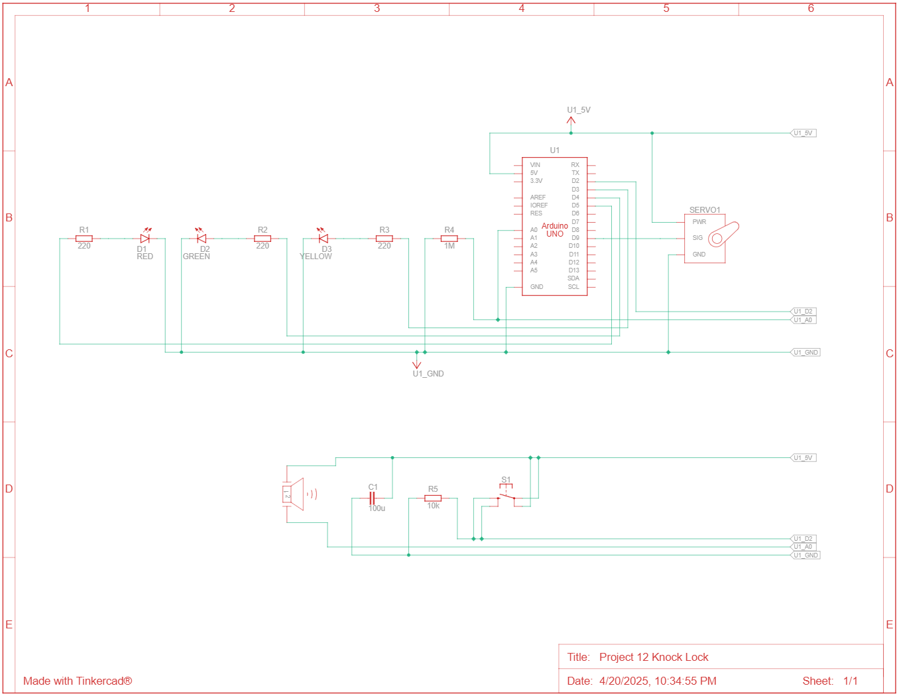*Circuit Diagram*

*Steps*

1. Connected the Arduino’s 5V and GND pins to the power and ground rails of the breadboard.
2. Connected the piezo sensor between an analog input pin and ground with a 1MΩ resistor in parallel.
3. Connected LEDs to a digital output pin with a 220Ω resistor to ground.
4. Connected a pushbutton to another digital input pin with pull-down configuration.
5. 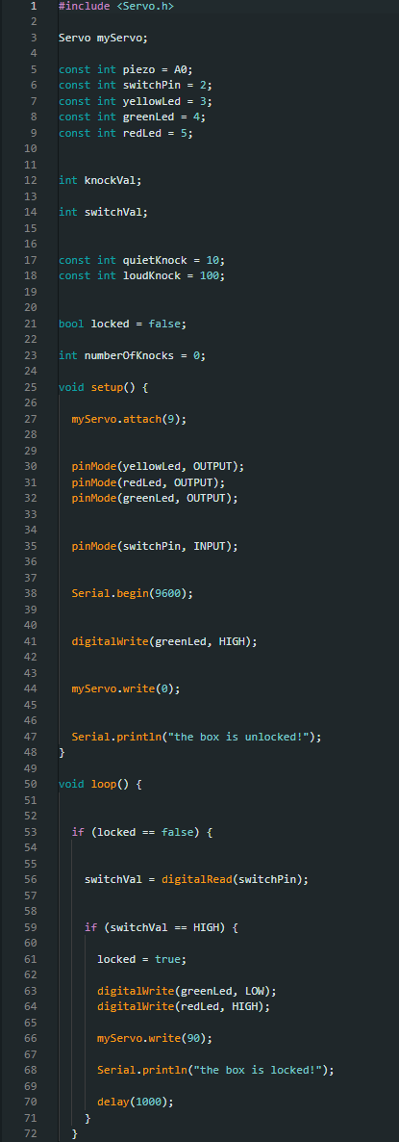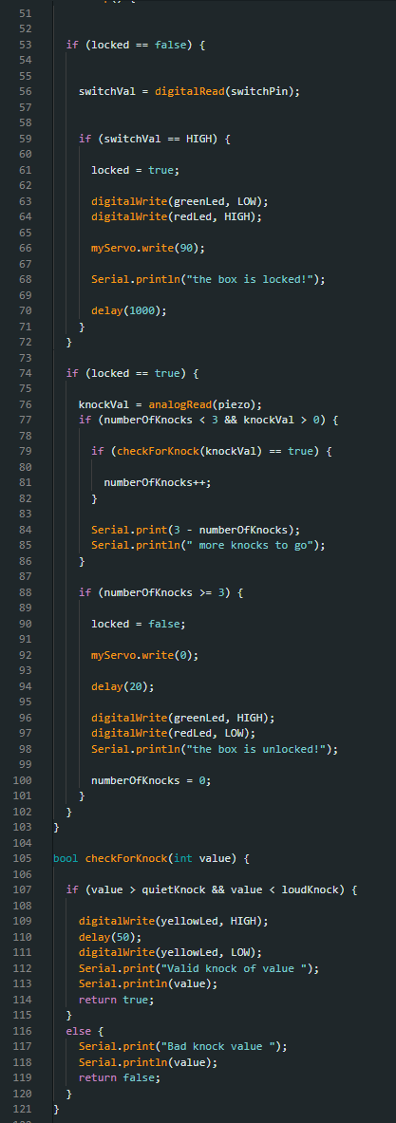Uploaded the Arduino sketch and tested the circuit.

*Code*

**Discussion**

1. **How is the piezo being used as an input device setup different than as an output device?**  
   When used as an input device, the piezo generates a small voltage when it experiences vibrations, which the Arduino reads. When used as an output device, the Arduino sends voltage signals to the piezo to produce sound.
2. **Why was the use of a boolean variable needed in this lab?**  
   A boolean variable was needed to track whether the lock was currently in the locked or unlocked state.
3. **What two digits/symbols are used to represent and count in the binary number system?**  
   0 and 1.
4. **What are the three fundamental operations in Boolean algebra?**  
   AND, OR, and NOT.
5. **Draw the truth/logic table for those three operators.**

|  |  |  |  |  |
| --- | --- | --- | --- | --- |
| A | B | A AND B | A OR B | NOT A |
| 0 | 0 | 0 | 0 | 1 |
| 0 | 1 | 0 | 1 | 1 |
| 1 | 0 | 0 | 1 | 0 |
| 1 | 1 | 1 | 1 | 0 |

1. **Explain a practical example of how each type of operator can be used in the real world.**
   * **AND:** A security system where two keys must be turned at the same time to open a door.
   * **OR:** A house alarm that triggers if either a window or a door sensor is tripped.
   * **NOT:** A toggle light switch where pressing once turns off the light if it was on.
2. **What is the base ten decimal equivalent number to this binary number, 10011111? and 11100011?**
   * 10011111 = 159
   * 11100011 = 227

**Troubleshooting**

1. **Issue 1:** The piezo sensor was not sensitive enough when attached directly to the breadboard and failed to detect knocks.  
   **Solution:** Detached the piezo from the breadboard and placed it directly against the desk surface for better vibration pickup.
2. **Issue 2:** Difficulty maintaining a secure connection to the piezo after detaching it.  
   **Solution:** Twisted jumper wires around the piezo leads to maintain contact. In the future, a more permanent attachment method would be beneficial.

**Conclusion**

The knock lock behaved as expected. It successfully distinguished between knocks above a set intensity threshold and ignored lighter taps. I made a slight adjustment to the code to introduce an upper knock limit, ensuring only medium-strength knocks were accepted. The lock/unlock LED functioned properly, and the reset button worked as intended. Overall, this project was an interesting application of sensor input and logic control, and it demonstrated how simple components can form the basis of an interactive security mechanism.