**Lab Report: Project 13 – Touchy-Feely Lamp**

Lucas Porter

Spring 2025 TESY 3300

Trevor P. Robinson, PhD

Lab 13 – Touchy-Feely Lamp

04/06/2025

**Abstract**

The purpose of this lab was to build a touch-sensitive lamp using an Arduino Uno, a resistor, a wire as a touch sensor, and an LED. The project explored the principle of capacitive sensing, allowing the detection of physical touch without mechanical switches. This lab introduced basic capacitive sensing, resistor-based sensitivity adjustments, and the idea of non-mechanical interaction with electronic circuits.

**Materials**

* Arduino Uno Board
* Breadboard
* LED
* 220Ω Resistor
* 1MΩ Resistor
* Jumper Wires
* Bare Wire (for touch sensor)
* USB Cable
* Computer with Arduino IDE

**Procedure**

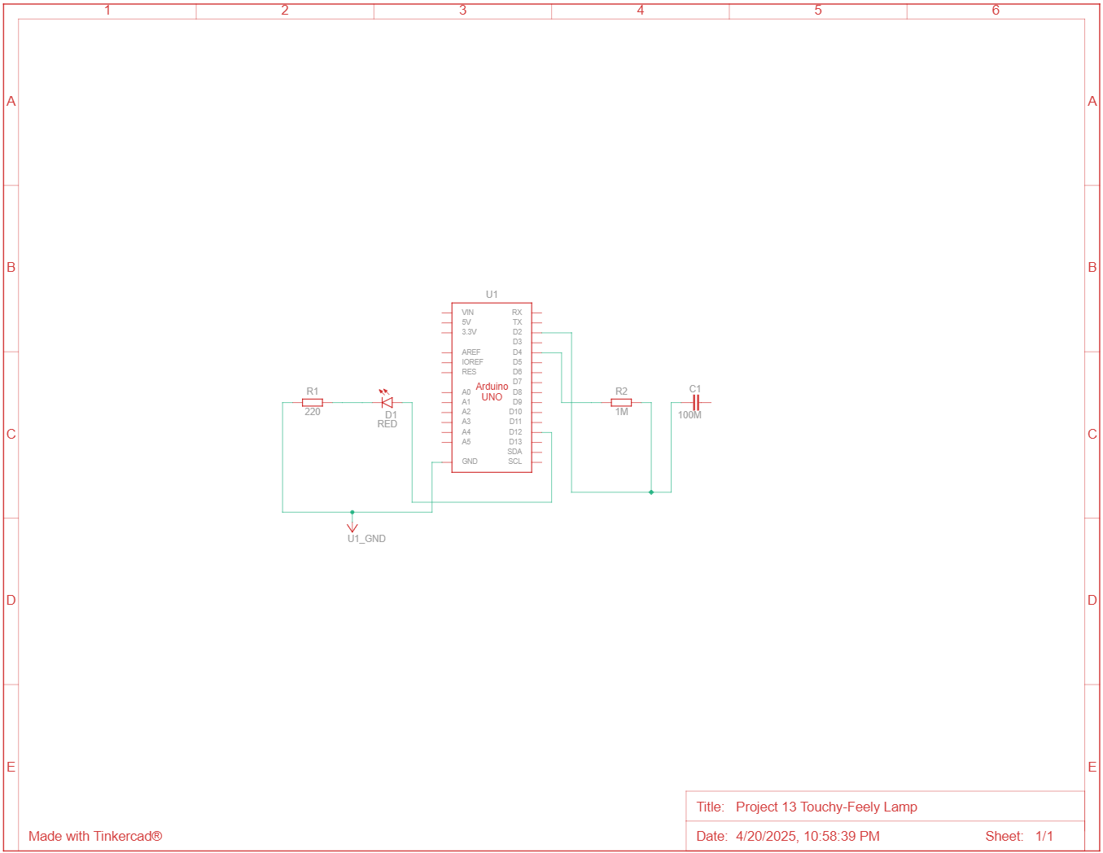*Circuit Diagram*

*Steps*

1. Connected the Arduino’s 5V and GND pins to the power and ground rails of the breadboard.
2. Connected one digital pin to a 1MΩ resistor and then to a bare wire touch sensor.
3. Connected a second digital pin directly to the bare wire to act as a receiver.
4. Connected an LED to a third digital output pin through a 220Ω resistor.
5. Uploaded the Arduino sketch and tested the circuit.

*Code*

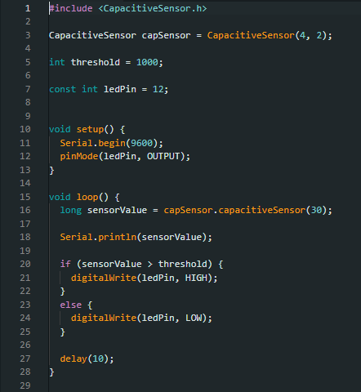

**Discussion**

1. **List three different materials of each a conductor and an insulator.**
   * Conductors: Copper, Aluminum, Gold
   * Insulators: Rubber, Glass, Plastic
2. **What can cause the capacitance/sensor value to increase or decrease in this lab?**  
   The size of the contact area, the moisture of the skin, and environmental electrical noise can affect the capacitance and change the sensor value.
3. **You probably noticed that the values from the sensor changed depending on how much of your finger was touching the conductor. Can you use this to get other interactions with the LED? Explain.**  
   Yes, by measuring how much the capacitance changes (how much surface area touches the wire), the LED brightness could be varied instead of simply turning it on or off.
4. **If you place a different value resistor between pins 2 and 4 it will change the sensitivity? Try it, explain your results.**  
   Using a smaller resistor decreases sensitivity, requiring a stronger touch, while a larger resistor increases sensitivity, allowing even light touches to trigger the LED.
5. **Capacitance can be measured through non-conductive materials like wood and plastic. Why can capacitance still be measured through these materials? Using this knowledge, how can this lab be expanded into something practical in your home?**  
   Capacitance still changes because electric fields can pass through non-conductive materials. This concept could be expanded into hidden touch panels in furniture, like lamps built into a wooden desk.
6. **How does a third party library work compared to an Arduino library? What is the same and what is different?**  
   Both libraries provide pre-written code to extend Arduino functionality. Arduino libraries are officially supported and installed through the IDE, while third-party libraries may need to be manually downloaded and imported. Otherwise, they function similarly once installed.

**Troubleshooting**

1. **Issue:** Accidentally connected the sensor wire to the wrong pin on the breadboard, causing no touch detection.  
   **Solution:** Double-checked connections and moved the wire to the correct location.

**Conclusion**

The Touchy-Feely Lamp worked as expected. The LED lit up when the wire was touched, although a larger contact area was needed for reliable detection. Initially, touching lightly with just the fingertip did not always trigger the LED, but after making small adjustments, the circuit became more sensitive. This lab sparked ideas for other capacitive sensing applications, such as hidden or embedded touch controls in furniture and appliances.