Facial Acne Severity Classification Using a Region-Aware ResNet-18 with Anatomical Embeddings

Lucas Gonzaga Andrade
Roger Moura Sarmento
Federal Institute of Education, Science and Technology of Ceará (IFCE) — Fortaleza, CE, Brazil
Acne vulgaris is one of the most prevalent dermatological diseases worldwide, making continuous monitoring of disease severity an important challenge, especially in teledermatology scenarios. This work proposes a Region-Aware ResNet-18 architecture for automatic facial acne severity classification, incorporating facial region anatomical identity through learnable embeddings to enrich the visual representation without significantly increasing model complexity. Experiments were conducted using images from the public Acne04 (1,406 images) and Acne Level (1,457 images) datasets, considering four clinical severity levels (Grade 0 Clear, Grade 1 Mild, Grade 2 Moderate, Grade 3 Severe) and evaluating global performance, facial-region behavior, robustness, and prediction confidence. The architecture achieved 95.2% Accuracy, 95.2% Precision, 95.2% Recall, and 95.2% weighted F1-score on 1,090 held-out test region crops, maintaining consistent performance across different facial regions and high stability (mean accuracy 93.3%, standard deviation 0.46%) under small image variations over 30 perturbation runs. In addition, a Flutter mobile prototype was developed to demonstrate the intended teledermatology workflow; on-device inference has not yet been integrated. The results demonstrate that incorporating learned anatomical representations of region identity constitutes a simple and efficient strategy for adding anatomical context to lightweight convolutional architectures, reconciling high predictive performance, low computational cost, and potential for real-world Biomedical Engineering applications.

Keywords: acne vulgaris; acne severity classification; deep learning; ResNet-18; anatomical embeddings; teledermatology.

1. Introduction
Acne vulgaris is a chronic inflammatory skin disease characterized by the emergence of different types of lesions, such as comedones, papules, pustules, and nodules, which may evolve into permanent scars in the most severe cases. The high variability in the quantity, distribution, and appearance of these lesions makes clinical severity assessment a challenging process, frequently dependent on specialist experience and subject to inter-observer variability [1], [2].
Considered one of the most prevalent dermatological diseases worldwide, acne affects approximately 85% of adolescents and young adults between 12 and 25 years of age, remaining frequent in the adult population as well, especially among women [3], [4]. Due to its high incidence and long clinical follow-up period, the disease represents an important public health problem, generating millions of dermatological consultations annually and high costs associated with diagnosis, treatment, and monitoring of clinical evolution [5].
Although often perceived as a predominantly aesthetic condition, acne can produce important physical and psychosocial consequences. Moderate and severe cases are associated with the development of permanent scars, pigmentation changes, and pain, in addition to significant impacts on self-esteem, anxiety, depression, social isolation, and quality of life. Recent studies demonstrate that these effects are particularly relevant during adolescence and early adulthood, periods marked by intense social interaction and emotional development [6]–[9]. Thus, early identification of disease severity plays a fundamental role both in defining treatment and in preventing physical and psychological sequelae.
Despite high demand for dermatological follow-up, access to specialists remains limited in many regions, especially in low- and middle-income countries. As a consequence, many patients receive late diagnoses or undergo clinical follow-up with low frequency, making it difficult to assess treatment response. In this context, teledermatology has been consolidating as an alternative capable of expanding access to specialized care, allowing remote submission and analysis of dermatological images obtained by mobile devices, reducing geographic barriers and favoring longitudinal patient monitoring [10]–[12].
In parallel, recent advances in Artificial Intelligence (AI), Deep Learning (DL), and Computer Vision (CV) have driven the development of automatic systems for medical image analysis. Convolutional Neural Networks (CNNs) have achieved competitive performance in tasks such as classification, segmentation, and detection of dermatological lesions, demonstrating high potential to support the diagnosis and monitoring of skin diseases [13]–[16]. In the specific case of acne, however, most proposed solutions use architectures composed of multiple stages, in which individual lesion detection is followed by classification or quantification.
Although these approaches present promising results, they introduce important limitations for practical applications. The use of multiple models increases computational complexity, favors error propagation between processing stages, and hinders deployment on mobile devices, where memory, processing, and energy consumption constraints are critical factors. Moreover, it is observed that a large part of studies concentrate their evaluation only on global performance metrics, devoting little attention to the analysis of robustness, stability, and prediction reliability—aspects that are fundamental for clinical applications and decision support systems. Thus, the need remains for simpler, more robust approaches suited to use in real teledermatology scenarios.
In light of this context, this work proposes a unified approach for automatic facial acne severity classification based on a ResNet-18 architecture enriched with facial region embeddings. Unlike traditional approaches based on individual lesion detection, the method performs severity classification directly into four clinical levels from crops of different facial regions extracted by YOLOv8. This strategy eliminates the need for pipelines composed of multiple models, reduces error propagation between stages, preserves regional anatomical context, and simplifies deployment in smartphone-based mobile applications, making the solution more suitable for teledermatology scenarios.
The main contributions of this work are:
(i) the development of a Region-Aware ResNet-18 architecture that incorporates learnable embeddings to explicitly represent the anatomical identity of the facial region;
(ii) the use of a single convolutional backbone shared across all facial regions, eliminating the need for multiple specialized models and reducing computational complexity;
(iii) a comprehensive experimental evaluation, including global, class-wise, and facial-region analyses;
(iv) an analysis of robustness and prediction confidence, allowing characterization of model behavior beyond traditional classification metrics;
(v) the development of a mobile teledermatology prototype demonstrating the practical viability of the architecture for remote monitoring and clinical decision support applications; on-device inference has not yet been integrated.
The remainder of this article is organized as follows. Section 2 presents the main related work on automatic acne severity classification and AI applications in dermatology. Section 3 describes the proposed methodology, including the dataset, the developed architecture, the training protocol, and the experimental configuration. Section 4 presents and analyzes the experimental results, covering classification performance, facial-region analyses, robustness, prediction confidence, and integration of the solution into a mobile application. Section 5 discusses the main implications of the results obtained. Section 6 presents the study limitations, while Section 7 concludes the work and presents perspectives for future research.

2. Related Work

2.1 Artificial Intelligence Applied to Dermatology
Recent advances in AI, DL, and CV have significantly transformed medical image analysis, especially in dermatology. CNNs have consolidated as the primary architecture for classification, segmentation, and detection of skin lesions, while more recent models based on attention mechanisms, such as Vision Transformers (ViTs), have demonstrated high representation capacity in different medical applications [13]–[16].
These technologies have been employed in assisted diagnosis of various dermatological diseases, including melanoma, psoriasis, eczema, and acne, achieving performance comparable to that of specialists in controlled experimental environments [13], [17]. In parallel, the popularization of mobile devices and the growth of telemedicine have driven the development of teledermatology systems capable of performing remote assessments through images captured by smartphones, expanding access to specialized care and favoring longitudinal patient monitoring [11], [12].
However, recent systematic reviews highlight that many AI-based systems still present important limitations related to external validation, population diversity, robustness under real image acquisition conditions, and effective integration into clinical workflows. Thus, a gradual shift is observed in research focus, moving away from exclusively prioritizing accuracy maximization toward seeking more robust, interpretable, and viable solutions for use in clinical practice [13].

2.2 Automatic Acne Severity Classification
Within this context, automatic acne severity classification has become an important research line due to its potential to support teledermatology applications and remote patient monitoring. In general, approaches proposed in the literature can be grouped into two categories: lesion-detection pipelines and direct severity classification models.
The first category initially performs individual detection of acne lesions to subsequently estimate disease severity from the quantity, location, or type of identified lesions. In this line, architectures based on Faster R-CNN, YOLO, and hybrid models that combine detection and classification in multiple stages stand out [14], [19], [21]. Although these approaches frequently present competitive results, they depend on detailed lesion-level annotations, require higher computational cost, and make the final estimate strongly dependent on the quality of the detection stage, favoring error propagation along the pipeline.
In contrast, direct classification models estimate acne severity using facial images as input, without the need to individually identify each lesion. Architectures based on ResNet, EfficientNet, and knowledge distillation strategies have achieved competitive performance, significantly simplifying the inference process [15], [16], [18]. More recently, CNN-Transformer hybrid models and Vision Transformers have been explored to improve spatial and contextual representation of images [21]. However, these models generally present higher architectural complexity, higher computational cost, and longer inference time, hindering their use on mobile devices.
From a Biomedical Engineering perspective, lower-complexity CNN architectures continue to represent a highly attractive alternative for mobile health applications. Among them, ResNet-18 stands out by offering a balance between predictive performance, training stability, reduced computational complexity, and ease of deployment—characteristics particularly relevant in teledermatology scenarios, where latency, energy consumption, and hardware limitations are important factors for use on smartphones and portable devices [15], [16].
2.3 Limitations of Current Approaches
Despite advances achieved in recent years, several limitations remain present in proposed solutions for automatic acne severity classification. First, most methods still depend on pipelines composed of multiple stages, in which individual lesion detection precedes severity classification. This strategy increases architectural complexity, raises computational cost, and favors error propagation between different processing stages [14], [19], [21]. Moreover, the need for detailed lesion-level annotations significantly increases the cost of building datasets and limits the scalability of these systems.
Another little-explored aspect concerns the evaluation protocols used. A large part of studies focus on presenting global metrics such as accuracy, precision, and F1-score, devoting little attention to analysis of model robustness, stability across different runs, consistency between facial regions, and confidence associated with predictions [13]. For clinical applications, these aspects are fundamental, since understanding when a model may fail is as important as obtaining high accuracy rates.
Finally, it is observed that few studies present solutions effectively oriented toward deployment in real teledermatology environments. In general, studies prioritize increasingly complex architectures, with multiple models or high computational cost, hindering their integration into mobile applications used for remote patient monitoring.
Motivated by these limitations, this work proposes a lightweight Region-Aware ResNet-18 architecture in which anatomical context is explicitly encoded through learnable region embeddings, instead of multiple specialized networks or complex attention mechanisms. Unlike traditional approaches based on individual lesion detection, the method eliminates intermediate pipeline stages, reducing its computational complexity and avoiding error propagation between modules. Furthermore, the proposal extends the traditional evaluation protocol by incorporating facial-region analyses, statistical stability, and prediction confidence, demonstrating its practical applicability through integration with a Flutter mobile application prototype for teledermatology scenarios; on-device inference has not yet been integrated.

3. Materials and Methods
The proposed methodology was developed to perform automatic facial acne severity classification using a lightweight ResNet-18 architecture enriched with learned anatomical representations of facial region identity, allowing incorporation of anatomical context without significantly increasing network complexity. The complete pipeline comprises four main stages: (i) data acquisition and preparation, (ii) image preprocessing and facial region extraction, (iii) acne severity classification using the proposed architecture, and (iv) integration of the model into a mobile teledermatology prototype application.
Figure 1 presents an overview of the developed methodology, highlighting the complete flow from facial image acquisition to acne severity prediction in the mobile application.

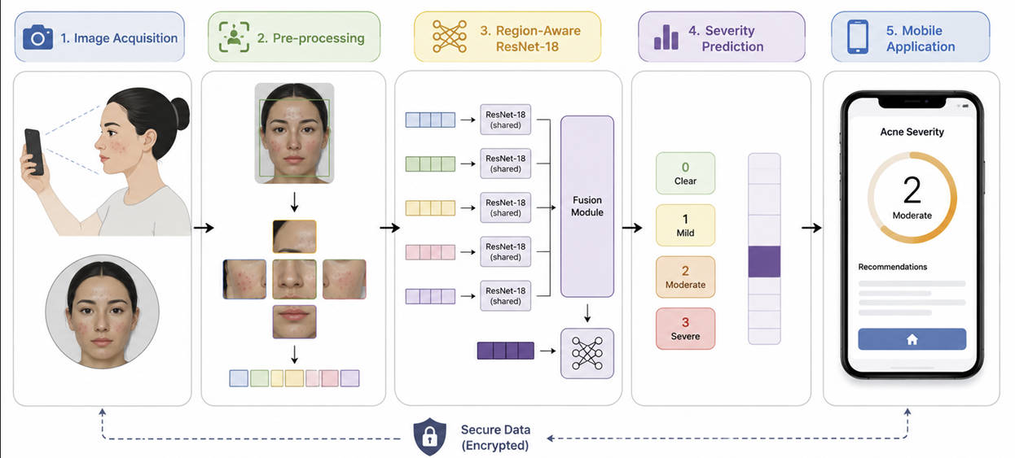
Figure 1 – Overview of the proposed methodology, including image acquisition, preprocessing, Region-Aware ResNet-18 architecture, and Flutter integration.

3.1 Dataset and Preprocessing
Experiments were conducted using two public datasets widely employed in research on automatic facial acne severity classification: Acne04 (1,406 images) and Acne Level (1,457 images). Both corpora were merged into a unified pipeline with a 70/15/15 train/validation/test split. Using both datasets allows evaluation of model behavior under different image sets, organization protocols, and acquisition conditions, contributing to a more comprehensive analysis of the generalization capacity of the proposed approach.
Table I summarizes the main characteristics of the datasets employed in this study, including number of images, number of classes, image resolution, annotation criteria, and purpose of use during the experiments.

Table I – Characteristics of the datasets used in this study.
Characteristic | Acne04 | Acne Level
Objective | Acne severity classification | Acne severity classification
Number of images | 1,406 | 1,457
Classes | 4 | 4
Severity scale | Hayashi (grades 0–3) | Hayashi (grades 0–3)
Image type | Frontal face | Frontal face
Organization | Original corpus | Folder-organized by severity
Use in this work | Merged into unified pipeline | Merged into unified pipeline
Characteristic | Acne04 | Acne Level
Objective | Acne severity classification | Acne severity classification
Number of images | 1,406 | 1,457
Classes | 4 | 4
Severity scale | Hayashi (grades 0–3) | Hayashi (grades 0–3)
Image type | Frontal face | Frontal face
Organization | Original corpus | Folder-organized by severity
Use in this work | Merged into unified pipeline | Merged into unified pipeline

Although both datasets were developed for acne severity classification, they present differences related to image organization, class distribution, lighting conditions, face positioning, and patient characteristics. This variability makes experimental evaluation more challenging and allows verification of model behavior under different acquisition scenarios.
Figure 2 presents representative examples of images belonging to the two datasets, together with the five facial regions used by the proposed architecture.

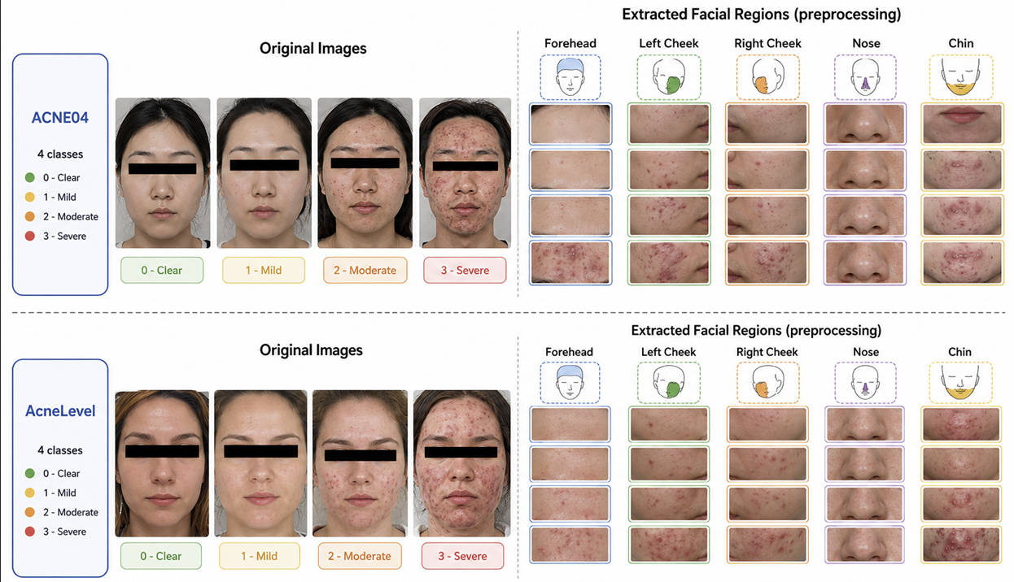
Figure 2 – Representative Acne04 and Acne Level samples and facial regions used by the proposed model.

Initially, all images underwent a standardized preprocessing process aimed at uniformizing input data and reducing the influence of irrelevant information during the classification process. The first step consisted of applying a custom YOLOv8 detector trained to localize five anatomical facial sub-regions (forehead, left cheek, right cheek, nose, and chin), rather than relying solely on a global face bounding box.
Subsequently, each face was subdivided into five anatomical regions corresponding to the forehead, left cheek, right cheek, nose, and chin. The adoption of this strategy is based on the non-uniform distribution of acne lesions across the face, allowing the architecture to explore region-specific visual characteristics associated with each anatomical zone.
Each region was resized to 224×224 pixels, the network input size, and subjected to the same normalization procedures used during training. Each region was then paired with a specific learnable embedding, preserving its anatomical identity and allowing the model to incorporate spatial information during the classification process.
During classification, each region crop is paired with its anatomical identifier (forehead, left cheek, right cheek, nose, or chin), which is mapped to a learnable 64-dimensional embedding. The model receives only region-level crops resized to 224×224 pixels; full-face images are not used as network input. This design aligns inference with the region-level labels available in the training corpora and preserves anatomical context through the embedding layer rather than through a separate global branch.
Finally, after consolidating and segmenting both corpora, the data were split into training, validation, and test sets (70%, 15%, and 15%, respectively), preserving independence between samples used for training and evaluation and avoiding information leakage across experimental stages. For final model selection, the training and validation splits were merged according to the robust validation criterion implemented in the PyTorch notebook, and the best weights were saved as best_robust_model.pth. Inference can be reproduced using training/predict.py with the saved checkpoint.

3.2 Proposed Region-Aware ResNet-18
The proposed architecture was developed with the objective of incorporating anatomical information from different facial regions into the acne severity classification process, while simultaneously maintaining a computationally simple structure suitable for mobile applications.
Figure 3 presents an overview of the proposed architecture. The model receives as input an image corresponding to a single facial region previously extracted during preprocessing (Section 3.1), together with a numeric identifier indicating the anatomical region from which the image was obtained (forehead, left cheek, right cheek, nose, or chin).
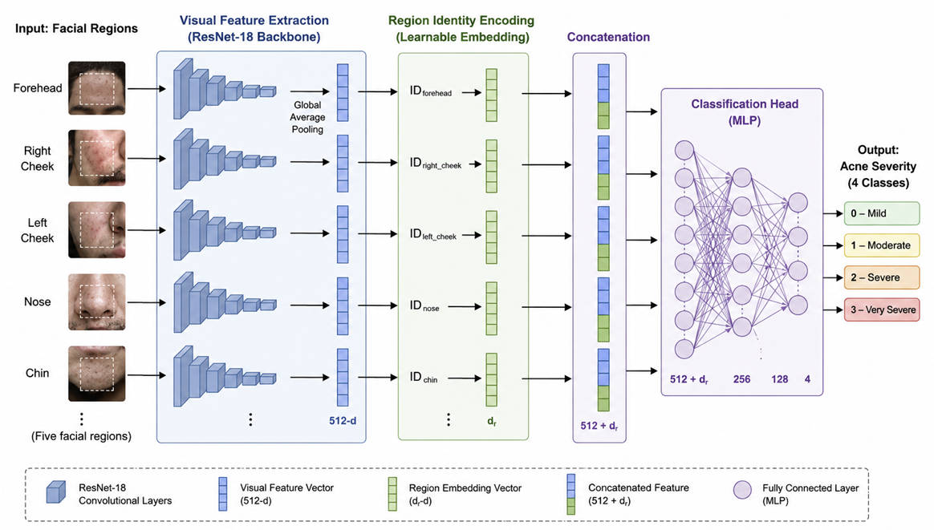
Figure 3 – Region-Aware ResNet-18 architecture with learnable region embeddings fused before classification.
Unlike conventional CNN-based classifiers, which depend exclusively on visual information present in the image, the proposed architecture explicitly incorporates the anatomical context of the facial region through a learnable embedding. Thus, a single feature extractor based on ResNet-18 is capable of adapting its internal representation according to the processed region, preserving shared weights across all facial regions. This strategy introduces only a small increase in the number of trainable parameters, eliminating the need for multiple specialized networks and maintaining low computational cost for mobile teledermatology applications.
As the visual feature extractor, the ResNet-18 architecture trained from scratch (weights=None), originally proposed by He et al. [23], was employed. Unlike conventional convolutional networks, ResNet uses residual connections (skip connections), allowing efficient training of deeper networks and reducing the vanishing gradient problem. In each residual block, the output is defined by
$y = F(x, W_{i}) +H(x)$(1)
where x represents the input vector of the block, F corresponds to the residual mapping learned by the convolutional layers parameterized by θ, and the sum represents the identity shortcut connection.$x$$F(x, W_{i})$$W_{i}$
After the sequence of residual blocks and the Global Average Pooling (GAP) operation, ResNet-18 produces a feature vector
$f ∈ ℜ^{512}$ (2)
which represents the visual description of the analyzed facial region.
To explicitly represent anatomical context, a region embedding layer was used, implemented through a learned matrix
$E ∈ ℜ^{5 x 64}$ (3)
in which each of the five facial regions has a 64-dimensional representation vector. Let r be the facial region identifier; the corresponding vector is obtained by$r ∈ \{0, ..., 4\}$
$e_{r }= E(r)$ (4)
where e_r represents the learned embedding for region (r).$E(r) ∈ ℜ^{64}$
The main methodological contribution of this work consists of enriching the visual representation produced by ResNet-18 with the anatomical identity of the processed facial region. For this purpose, the feature vector extracted by the CNN is concatenated with the learned embedding of the region, producing an enriched vector
$z = Concat (f, e_{r}) ∈ ℜ^{576}$ (5)
where ⊕ represents the concatenation operation between the visual feature vector and the embedding corresponding to the facial region.$Concat(⋅)$
This operation constitutes the main differentiator of the proposed architecture, as it allows incorporation of explicit anatomical context without modifying the convolutional backbone. As a consequence, a single ResNet-18 is capable of learning region-specific representations for different facial regions, preserving weight sharing and avoiding a significant increase in computational complexity.
The enriched vector z is then processed by a classifier composed of three Fully Connected layers, interleaved with Batch Normalization operations, ReLU activation function, and Dropout layers, responsible for increasing training stability and reducing overfitting.$z$
Finally, the probability of belonging to each of the four acne severity classes (Grade 0 Clear, Grade 1 Mild, Grade 2 Moderate, Grade 3 Severe) is estimated through the Softmax function,
$\hat{y} = Softmax (W z + b)$ (6)
where W and b represent the parameters learned by the final classification layer.$W$$b$
This architecture allows incorporation of anatomical knowledge using only an additional embedding layer, preserving the simplicity of ResNet-18 and maintaining a single classification pipeline. Compared to approaches based on multiple CNNs or more complex hybrid architectures, the proposal presents lower computational cost, a reduced number of additional parameters, and greater ease of deployment in mobile applications aimed at remote monitoring of acne severity.

3.3 Training Strategy
Training of the proposed architecture was conducted in a supervised manner considering the multiclass facial acne severity classification problem across four clinical levels (Grade 0 Clear, Grade 1 Mild, Grade 2 Moderate, Grade 3 Severe). Preprocessed images and their respective facial region identifiers were used as model input, allowing joint learning of visual features and anatomical context.
Parameter optimization was performed using the Adam algorithm, while the adopted loss function was class-weighted Cross-Entropy Loss, calculated automatically from the distribution of training samples. This strategy reduces the effects of class imbalance and favors more balanced learning.
To increase the model's generalization capacity, data augmentation techniques were employed during training, including random horizontal flipping, rotations, brightness, contrast, and saturation variations, probabilistic application of Gaussian Blur, and Random Erasing. Additionally, an adaptive learning rate scheduler (ReduceLROnPlateau) and an Early Stopping mechanism were used to reduce the risk of overfitting.
Experiments were implemented using the PyTorch framework, leveraging GPU acceleration. The main hyperparameters employed during training are presented in Table II.
Table II – Main hyperparameters used during training of the proposed architecture.
Parameter | Value
Framework | PyTorch
Backbone | ResNet-18 (trained from scratch, weights=None)
Optimizer | Adam
Loss function | Weighted Cross-Entropy
Learning rate | 0.0001
Scheduler | ReduceLROnPlateau
Batch size | 16
Maximum epochs | 40
Data augmentation | Horizontal flip (p=0.5), rotation (±25°), color jitter, Gaussian blur, random erasing
Regularization | Batch Normalization and Dropout
Hardware | NVIDIA GeForce RTX 3060 (12 GB)
Hyperparameters were defined empirically from preliminary experiments and kept constant throughout evaluation, ensuring consistency and reproducibility of results. The best model was selected using robust validation criteria and saved as best_robust_model.pth; inference can be reproduced with training/predict.py.

3.4 Experimental Setup
Experimental evaluation was conducted with the objective of analyzing not only the predictive performance of the proposed architecture, but also its robustness, stability, and applicability in teledermatology scenarios. Experiments followed the training, validation, and test split protocol described in Section 3.1 (70/15/15 unified pipeline), ensuring independence between samples used during model training and evaluation.
The performance of the proposed architecture was evaluated using Accuracy, Precision, Recall, and F1-score metrics, widely employed in multiclass classification problems. In addition to global metrics, per-class indicators were also calculated, allowing analysis of model behavior at each acne severity level (Grade 0 Clear, Grade 1 Mild, Grade 2 Moderate, Grade 3 Severe).
To avoid excessively optimistic interpretations based on a single favorable metric, the analysis was organized into three complementary perspectives: (i) global classification performance; (ii) consistency across different facial regions; and (iii) operational robustness, evaluated through model stability and confidence associated with predictions. This strategy allows a more comprehensive characterization of architecture behavior and favors interpretations oriented toward practical deployment in teledermatology scenarios, assisting in identifying situations in which specialist review may be recommended.

4. Experimental Results

4.1 Overall Classification Performance
Table III presents the global performance of the Region-Aware ResNet-18 architecture in facial acne severity classification considering the test set, which contains 1,090 region crops. Precision, Recall, F1-score, and Accuracy metrics were evaluated, as described in Section 3.4.
Table III – Global performance of the proposed architecture in facial acne severity classification.
Class | Precision | Recall | F1-score | Support
Mild | 0.96 | 0.95 | 0.95 | 318
Moderate | 0.94 | 0.94 | 0.94 | 412
Severe | 0.88 | 0.92 | 0.90 | 110
Very Severe | 1.00 | 1.00 | 1.00 | 250
Weighted Average | 0.95 | 0.95 | 0.95 | 1090
Overall Accuracy | 95.0%

The results demonstrate that the proposed architecture achieved high performance in classifying the four acne severity levels, reaching 95.2% Accuracy and a weighted F1-score of 0.95. The proximity between Precision, Recall, and F1-score values evidences balanced model behavior, indicating that training did not favor specific classes, even in the face of uneven sample distribution.
The per-class analysis shows that Grade 1 (Mild) and Grade 3 (Severe) achieved the best results, while Grade 2 (Moderate) obtained the lowest F1-score (0.90). This behavior is expected, since cases classified as moderate frequently share visual characteristics with adjacent classes, making their separation more challenging for both automatic systems and specialists.
Figure 4 presents the confusion matrix corresponding to the test set.
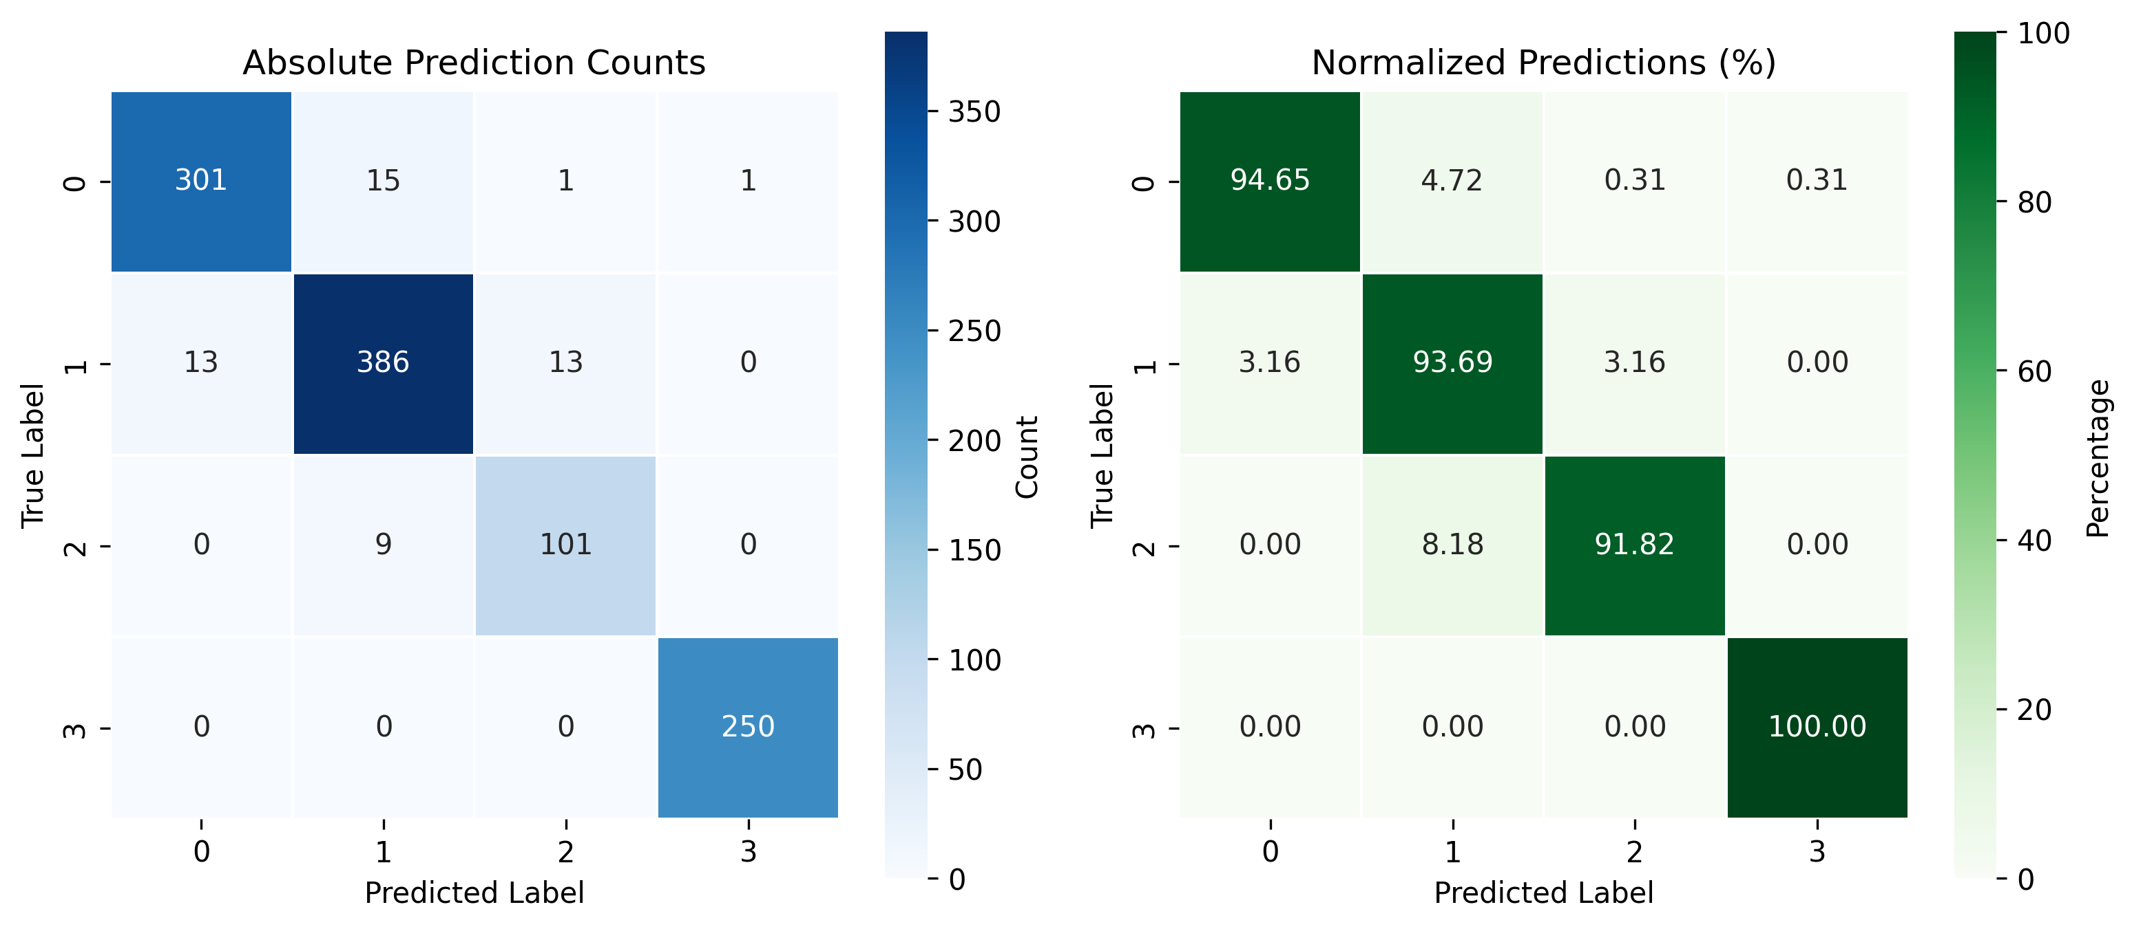
Figure 4 – Confusion matrix of the Region-Aware ResNet-18 on the test set.
The confusion matrix confirms that most samples were correctly classified, concentrating errors predominantly between consecutive severity classes, especially between Grade 2 (Moderate) and Grade 3 (Severe). In contrast, practically no confusions are observed between extreme classes (Grade 0 Clear and Grade 3 Severe), indicating that the model was able to learn discriminative representations for different severity levels.
From a clinical perspective, this behavior is consistent with the dermatological assessment process, in which borderline cases between consecutive grades frequently present high visual similarity and may generate divergences even among specialists. Thus, the observed errors reflect ambiguities inherent to the classification problem and not systematic failures of the proposed architecture.
Although global metrics indicate high predictive performance, they do not reveal how the architecture behaves across different anatomical regions of the face. Considering that the proposal explicitly incorporates facial region identity through learnable embeddings, it becomes important to analyze the individual contribution of each region to model performance. This evaluation is presented in the next subsection.

4.2 Regional Performance Analysis
The main contribution of the proposed architecture consists of the explicit incorporation of facial region anatomical identity through learned anatomical representations. Thus, beyond global performance, it becomes important to analyze whether the model maintains consistent behavior across different facial regions.
Table IV presents the performance obtained for each facial region, considering weighted Precision, Recall, and F1-score metrics.
Table IV – Weighted classification performance according to facial region.
Facial Region | Precision | Recall | F1-score | Support
Forehead | 0.99 | 0.99 | 0.99 | 93
Chin | 0.94 | 0.93 | 0.93 | 329
Nose | 0.97 | 0.97 | 0.97 | 103
Left Cheek | 0.94 | 0.93 | 0.93 | 169
Right Cheek | 0.96 | 0.96 | 0.96 | 396

The results show that the architecture maintained high performance across all facial regions, with F1-score equal to or greater than 0.93, evidencing good generalization capacity regardless of the analyzed anatomical location.
The Forehead region achieved the best performance (F1-score = 0.99), indicating that the visual characteristics of this region were learned in a highly consistent manner by the proposed architecture. On the other hand, Chin and Left Cheek presented the lowest F1-score values (0.93), although they still remain within a range of high performance.
This difference can be explained by clinical and image acquisition factors. Regions such as the chin and left cheek usually present greater texture variability, presence of facial hair, shadows, small occlusions, and lighting variations, in addition to concentrating lesions distributed in a less homogeneous manner. These factors naturally increase the difficulty of automatic classification.
Even under these more challenging conditions, no significant performance degradation was observed, indicating that the strategy based on anatomical embeddings allowed a single ResNet-18 to learn region-specific representations for each facial region without the need for multiple specialized models.
This result reinforces one of the main contributions of this work: explicit incorporation of anatomical context preserves architecture simplicity and maintains consistent performance across different facial regions, reducing computational complexity and favoring its use in mobile teledermatology applications.
Although regional analysis demonstrates high consistency across different facial regions, it does not provide information about model stability under small image variations nor about the degree of confidence associated with predictions. These aspects are investigated in the next subsection.

4.3 Robustness and Confidence Analysis
Beyond predictive performance, the proposed architecture was evaluated regarding its operational robustness and the behavior of confidence associated with predictions. This analysis is particularly important in teledermatology applications, in which small variations in image acquisition conditions may influence model performance.
The stability of the architecture was investigated through 30 independent runs, considering small random perturbations applied to the input images. Figure 5 presents the distribution of accuracy obtained in these runs.
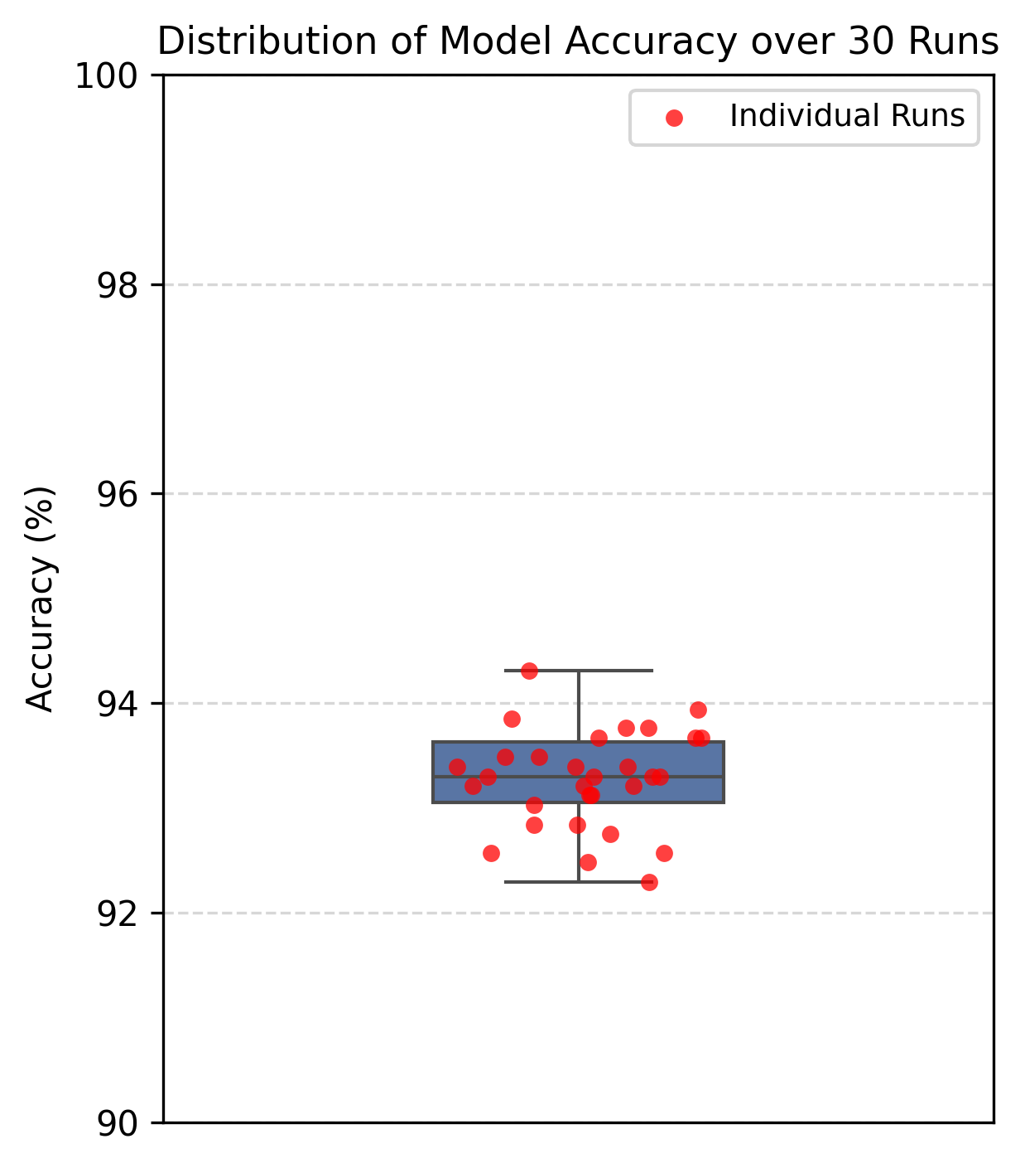
Figure 5 – Accuracy distribution obtained from 30 independent robustness evaluations.
A low dispersion of results is observed, with mean accuracy of 93.3% and standard deviation of 0.46%, indicating that architecture performance remained stable even under small variations in input images. This behavior suggests that the strategy based on anatomical embeddings produces consistent representations that are little sensitive to variations normally encountered during image capture on mobile devices.
In addition to stability, the distribution of confidence scores produced by the Softmax function was analyzed. In general, correct predictions concentrated at high confidence values, frequently above 0.99. However, it was observed that a small portion of incorrect predictions also presented high confidence levels, characterizing overconfidence behavior in visually ambiguous cases.
This result indicates that traditional classification metrics, in isolation, are not sufficient to evaluate the operational reliability of the model. In real applications, samples classified with high confidence but belonging to borderline regions between consecutive classes may justify additional probability calibration mechanisms or referral policies for specialist review.
From a teledermatology perspective, the results obtained demonstrate that the proposed architecture presents desirable characteristics for use as a clinical decision support system. High stability across runs, combined with consistent behavior across different facial regions, favors its use in remote monitoring scenarios. On the other hand, identification of overconfidence cases reinforces that the tool should be employed as support for the specialist, and not as a substitute for clinical evaluation.
Together, the analyses presented in this section complement global and regional performance results, demonstrating that the proposed architecture not only presents high discriminative capacity, but also maintains stable and predictable behavior under conditions compatible with real mobile teledermatology applications.

5. Discussion
The experimental results demonstrate that the proposed architecture was capable of classifying facial acne severity with high performance, maintaining consistent behavior across different anatomical regions and stability under small image variations. These results suggest that explicit incorporation of facial region identity through learnable embeddings contributed to enriching the visual representation without significantly increasing architecture complexity.
Unlike approaches that employ multiple neural networks or more complex architectures, the proposed model uses a single ResNet-18 backbone trained from scratch (weights=None), sharing parameters across all facial regions and incorporating anatomical context through an embedding vector. This strategy reduces pipeline complexity, preserves low computational cost, and facilitates reproduction and deployment in practical applications; trained weights are available as best_robust_model.pth and inference is supported by training/predict.py.
Regional analysis showed that performance remained high across all facial regions, including the most challenging areas such as cheeks and chin. Moreover, the low variability observed across different runs indicates that the architecture presents stable behavior under variations normally encountered in image acquisition on mobile devices. On the other hand, the occurrence of some incorrect predictions with high confidence reinforces that the model should be employed as a diagnostic support tool, complementing the evaluation performed by the specialist.
To demonstrate the applicability of the proposal, a mobile prototype was developed using the Flutter framework, supporting login, guided image capture, and the intended teledermatology workflow for remote severity assessment. At the time of writing, on-device inference is not yet integrated; the application demonstrates interface and workflow design rather than validated clinical deployment. Figure 6 presents the main screens of the developed application.
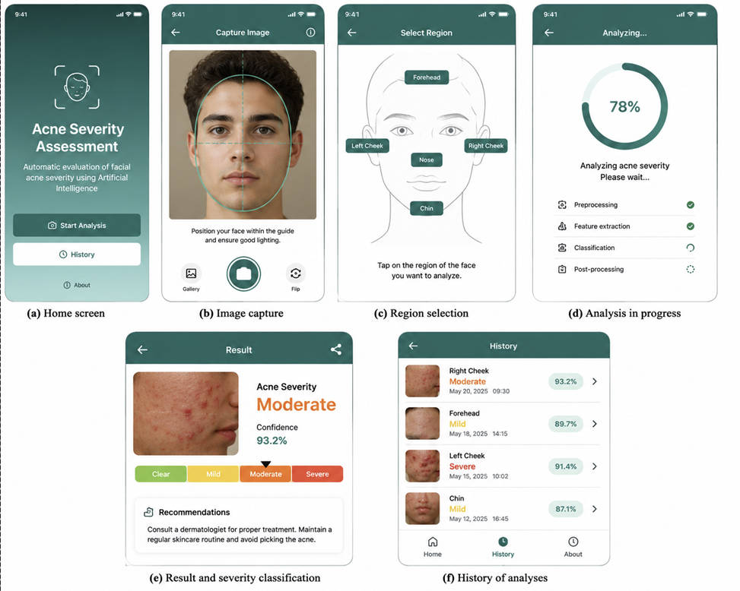
Figure 6 – Mobile teledermatology prototype developed for automatic facial acne severity assessment.
Although developed as a proof of concept, the prototype demonstrates the viability of the architecture for teledermatology applications, enabling remote monitoring of patients' clinical evolution and assisting in prioritization of cases for specialized evaluation; full on-device inference integration remains future work.
In general, the results indicate that the use of learned anatomical representations to represent facial region anatomical identity constitutes a simple and efficient strategy for incorporating spatial context into lightweight convolutional architectures. Although validated in this work for facial acne severity classification, this approach can be extended to other biomedical image analysis applications in which anatomical context plays a relevant role in decision-making.

6. Limitations
Although the results obtained are promising, this study presents some limitations. Experimental evaluation was performed using two public image datasets, which, despite being widely employed in the literature, may not represent all variability observed in real clinical scenarios. Thus, validation of the architecture on independent datasets and in more heterogeneous populations constitutes an important step to confirm its generalization capacity.
Another limitation concerns the behavior of probabilities produced by the Softmax function. Despite high stability and good predictive performance, some incorrect classifications were associated with high confidence levels, indicating the need to investigate probability calibration techniques and selective prediction strategies to increase system reliability in clinical applications. Moreover, the architecture was developed to classify acne severity into four clinical levels (Grade 0 Clear, Grade 1 Mild, Grade 2 Moderate, Grade 3 Severe), not covering individual lesion detection or segmentation.
Finally, the mobile prototype developed aimed to demonstrate the viability of deploying the proposed architecture; a clinical evaluation in a real teledermatology environment was not performed, and on-device inference has not yet been integrated. Future studies should investigate system performance under everyday use conditions, including aspects related to user experience, different devices, on-device inference integration, and prospective clinical validation. These limitations do not compromise the main contribution of this work, but indicate paths to expand the robustness and clinical applicability of the proposed strategy.

7. Conclusion
This work presented a Region-Aware ResNet-18 architecture for automatic facial acne severity classification, explicitly incorporating facial region anatomical identity through learnable embeddings. The proposal preserves a single convolutional backbone shared across all facial regions, maintaining a lightweight architecture with low computational complexity suitable for mobile applications.
Experimental results demonstrated that the architecture was capable of classifying the four acne severity levels with high performance, presenting consistent behavior across different facial regions, stability under small image perturbations (mean accuracy 93.3%), and potential for use in teledermatology scenarios. In addition, development of a Flutter mobile prototype evidenced the practical viability of integrating the proposed model with applications aimed at remote patient monitoring, although on-device inference has not yet been deployed.
More than proposing a new acne classifier, this work demonstrates that explicit incorporation of anatomical identity through learned anatomical representations constitutes a simple and efficient strategy for enriching lightweight convolutional architectures with spatial context. This approach allows adaptation of visual representation to different facial regions without resorting to multiple specialized models or complex attention mechanisms, reconciling high predictive performance (95.2% test accuracy), architectural simplicity, and computational efficiency. Although validated in this work for facial acne severity classification, the proposed strategy has potential to be applied to other biomedical image analysis problems in which anatomical context plays a relevant role in decision-making.
As future work, experimental validation is intended to be expanded using independent datasets and real clinical scenarios, confidence calibration techniques are to be investigated to increase prediction reliability, on-device inference is to be integrated into the Flutter prototype, and application of the proposed strategy to other AI tasks in Dermatology and Biomedical Engineering is to be evaluated. It is expected that the proposed strategy will contribute to the development of intelligent diagnostic support systems capable of combining predictive performance, architectural simplicity, and deployment viability in real Biomedical Engineering applications.

8. References
[1] M. Vasam, A. Korivi, and K. M. Balli, “Acne vulgaris: A review of the pathophysiology, treatment, and recent nanotechnology-based advances,” Biomedicines, vol. 11, no. 12, 2023.

[2] Y. Li, X. Hu, G. Dong, X. Wang, and T. Liu, “Acne treatment: Research progress and new perspectives,” Frontiers in Medicine, vol. 11, 2024.

[3] G. D. Lenuța et al., “The Epidemiology of Acne in the Current Era: Trends and Clinical Implications,” Cosmetics, vol. 12, no. 3, 2025.

[4] A. H. Heng and F. T. Chew, “Systematic review of the epidemiology of acne vulgaris,” Scientific Reports, vol. 10, 2020.

[5] A. M. Layton, “The burden of acne vulgaris on health-related quality of life,” Dermatology and Therapy, 2025.

[6] D. V. Samuels, R. Rosenthal, R. Lin, S. Chaudhari, and M. N. Natsuaki, “Acne vulgaris and risk of depression and anxiety: A meta-analytic review,” Journal of the American Academy of Dermatology, vol. 83, no. 2, pp. 532–541, 2020.

[7] A. M. Layton, D. Thiboutot, and J. Tan, “Reviewing the global burden of acne: How could we improve care to reduce the burden?” British Journal of Dermatology, vol. 184, 2020.

[8] A. S. Morshed et al., “Understanding the impact of acne vulgaris and associated psychological distress on self-esteem and quality of life,” Scientific Reports, vol. 13, 2023.

[9] T. Tasneem et al., “Effects of acne severity and acne-related quality of life on depressive symptoms among adolescents and young adults,” Frontiers in Psychology, vol. 14, 2023.

[10] D. Z. Eichenfield, J. Sprague, and L. F. Eichenfield, “Management of acne vulgaris: A review,” JAMA, vol. 326, no. 20, pp. 2055–2067, 2021.

[11] S. Wongvibulsin et al., “Current state of dermatology mobile applications with artificial intelligence features,” JAMA Dermatology, vol. 160, no. 6, 2024.

[12] R. V. Reynolds et al., “Guidelines of care for the management of acne vulgaris,” Journal of the American Academy of Dermatology, vol. 90, no. 5, 2024.

[13] S. P. Choy, B. J. Kim, A. Paolino, W. R. Tan, S. M. L. Lim, J. Seo, S. P. Tan, and L. Francis, “Systematic review of deep learning image analyses for the diagnosis and monitoring of skin disease,” npj Digital Medicine, vol. 6, no. 1, Art. no. 180, 2023.

[14] Q. T. Huynh, P. H. Nguyen, H. X. Le, L. T. Ngo, N.-T. Trinh, M. T.-T. Tran, N. H. T. Nguyen, N. T. Vu, A. T. Nguyen, K. Suda, and H. T. Ngo, “Automatic acne object detection and acne severity grading using smartphone images and artificial intelligence,” Diagnostics, vol. 12, no. 8, Art. no. 1879, 2022.

[15] Y. Lin, J. Jiang, Z. Ma, D. Chen, Y. Guan, H. You, X. Cheng, B. Liu, and G. Luo, “KIEGLFN: A unified acne grading framework on face images,” Computer Methods and Programs in Biomedicine, vol. 221, Art. no. 106911, 2022.

[16] S. Liu, Y. Fan, M. Duan, Y. Wang, G. Su, Y. Ren, L. Huang, and F. Zhou, “AcneGrader: An ensemble pruning of the deep learning base models to grade acne,” Skin Research and Technology, vol. 28, no. 5, pp. 677–688, 2022.

[17] H. Wen, W. Yu, Y. Wu, J. Zhao, X. Liu, Z. Kuang, and R. Fan, “Acne detection and severity evaluation with interpretable convolutional neural network models,” Technology and Health Care, vol. 30, no. 1, pp. 143–153, 2022.

[18] Y. Lin, J. Jiang, D. Chen, Z. Ma, Y. Guan, X. Liu, H. You, and J. Yang, “DED: Diagnostic Evidence Distillation for acne severity grading on face images,” Expert Systems with Applications, vol. 228, Art. no. 120312, 2023.

[19] P. K. Nguyen, T. D. Le, B. A. Nguyen, and P. A. Nguyen, “ACNE8M: An acnes detection and differential diagnosis system using AI technologies,” VNUHCM Journal of Science and Technology Development, vol. 27, no. 3, pp. 3550–3561, 2024.

[20] L. Gazeau et al., “AcneAI: A new acne severity assessment method using digital images and deep learning,” in Proc. Medical Image Computing and Computer Assisted Intervention — MICCAI 2024, 2024, pp. 68–78.

[21] N. Gao et al., “Evaluation of an acne lesion detection and severity grading model for Chinese population in online and offline healthcare scenarios,” Scientific Reports, vol. 15, Art. no. 1119, 2025.

[22] T. A. S. Viana, I. H. Gonçalves, I. S. Paula, F. H. S. Silva, and P. P. Rebouças Filho, “ClearFace: Facial Acne Detection and Classification System Using YOLOv11 and EfficientNet-B0,” in SIBGRAPI Extended Papers, 2025.

