Facial Acne Severity Classification Using a Region-Aware ResNet-18 with Anatomical Embeddings
Lucas Gonzaga Andrade
Roger Moura Sarmento
IFCE — Fortaleza, CE, Brazil

Abstract
Acne vulgaris is one of the most prevalent dermatological diseases worldwide, making continuous monitoring of disease severity an important challenge, especially in teledermatology scenarios. This work proposes a Region-Aware ResNet-18 architecture for automatic facial acne severity classification, incorporating facial region anatomical identity through learnable embeddings to enrich the visual representation without significantly increasing model complexity. Experiments were conducted using images from the public Acne04 (1,406 images) and Acne Level (1,457 images) datasets, considering four clinical severity levels (Grade 0 Clear, Grade 1 Mild, Grade 2 Moderate, Grade 3 Severe) and evaluating global performance, facial-region behavior, robustness, and prediction confidence. The architecture achieved 95.2% Accuracy, 95.2% Precision, 95.2% Recall, and 95.2% weighted F1-score on 1,090 held-out test region crops, maintaining consistent performance across different facial regions and high stability (mean accuracy 93.3%, standard deviation 0.46%) under small image variations over 30 perturbation runs. In addition, a Flutter mobile prototype was developed to demonstrate the intended teledermatology workflow; on-device inference has not yet been integrated. The results demonstrate that incorporating learned anatomical representations of region identity constitutes a simple and efficient strategy for adding anatomical context to lightweight convolutional architectures, reconciling high predictive performance, low computational cost, and potential for real-world Biomedical Engineering applications.
Keywords: acne vulgaris; acne severity classification; deep learning; ResNet-18; anatomical embeddings; teledermatology.

1. Introduction
Acne vulgaris is a chronic inflammatory skin disease characterized by the emergence of different types of lesions, such as comedones, papules, pustules, and nodules, which may evolve into permanent scars in the most severe cases. The high variability in the quantity, distribution, and appearance of these lesions makes clinical severity assessment a challenging process, frequently dependent on specialist experience and subject to inter-observer variability [1], [2].
Considered one of the most prevalent dermatological diseases worldwide, acne affects approximately 85% of adolescents and young adults between 12 and 25 years of age, remaining frequent in the adult population as well, especially among women [3], [4]. Due to its high incidence and long clinical follow-up period, the disease represents an important public health problem, generating millions of dermatological consultations annually and high costs associated with diagnosis, treatment, and monitoring of clinical evolution [5].
Although these approaches present promising results, they introduce important limitations for practical applications. The use of multiple models increases computational complexity, favors error propagation between processing stages, and hinders deployment on mobile devices, where memory, processing, and energy consumption constraints are critical factors. Moreover, it is observed that a large part of studies concentrate their evaluation only on global performance metrics, devoting little attention to the analysis of robustness, stability, and prediction reliability—aspects that are fundamental for clinical applications and decision support systems. Thus, the need remains for simpler, more robust approaches suited to use in real teledermatology scenarios.
In light of this context, this work proposes a unified approach for automatic facial acne severity classification based on a ResNet-18 architecture enriched with facial region embeddings. Unlike traditional approaches based on individual lesion detection, the method performs severity classification directly into four clinical levels from crops of different facial regions extracted by YOLOv8. This strategy eliminates the need for pipelines composed of multiple models, reduces error propagation between stages, preserves regional anatomical context, and simplifies deployment in smartphone-based mobile applications, making the solution more suitable for teledermatology scenarios.
Contributions: Region-Aware ResNet-18 with 64-D region embeddings; YOLOv8-based five-zone preprocessing; extended evaluation (global, regional, stability, confidence); Flutter teledermatology prototype.

2. Related Work

2.1 Artificial Intelligence Applied to Dermatology
Recent advances in AI, DL, and CV have significantly transformed medical image analysis, especially in dermatology. CNNs have consolidated as the primary architecture for classification, segmentation, and detection of skin lesions, while more recent models based on attention mechanisms, such as Vision Transformers (ViTs), have demonstrated high representation capacity in different medical applications [13]–[16].

2.2 Automatic Acne Severity Classification
Within this context, automatic acne severity classification has become an important research line due to its potential to support teledermatology applications and remote patient monitoring. In general, approaches proposed in the literature can be grouped into two categories: lesion-detection pipelines and direct severity classification models.
In contrast, direct classification models estimate acne severity using facial images as input, without the need to individually identify each lesion. Architectures based on ResNet, EfficientNet, and knowledge distillation strategies have achieved competitive performance, significantly simplifying the inference process [15], [16], [18]. More recently, CNN-Transformer hybrid models and Vision Transformers have been explored to improve spatial and contextual representation of images [21]. However, these models generally present higher architectural complexity, higher computational cost, and longer inference time, hindering their use on mobile devices.

2.3 Limitations of Current Approaches
Motivated by these limitations, this work proposes a lightweight Region-Aware ResNet-18 architecture in which anatomical context is explicitly encoded through learnable region embeddings, instead of multiple specialized networks or complex attention mechanisms. Unlike traditional approaches based on individual lesion detection, the method eliminates intermediate pipeline stages, reducing its computational complexity and avoiding error propagation between modules. Furthermore, the proposal extends the traditional evaluation protocol by incorporating facial-region analyses, statistical stability, and prediction confidence, demonstrating its practical applicability through integration with a Flutter mobile application prototype for teledermatology scenarios; on-device inference has not yet been integrated.

3. Materials and Methods
The proposed methodology was developed to perform automatic facial acne severity classification using a lightweight ResNet-18 architecture enriched with learned anatomical representations of facial region identity, allowing incorporation of anatomical context without significantly increasing network complexity. The complete pipeline comprises four main stages: (i) data acquisition and preparation, (ii) image preprocessing and facial region extraction, (iii) acne severity classification using the proposed architecture, and (iv) integration of the model into a mobile teledermatology prototype application.
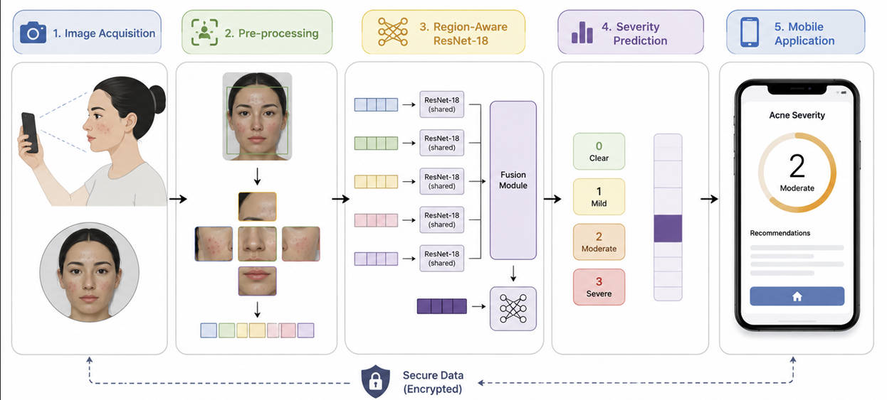
Figure 1 – Proposed methodology from acquisition to mobile reporting.

3.1 Dataset and Preprocessing
Experiments were conducted using two public datasets widely employed in research on automatic facial acne severity classification: Acne04 (1,406 images) and Acne Level (1,457 images). Both corpora were merged into a unified pipeline with a 70/15/15 train/validation/test split. Using both datasets allows evaluation of model behavior under different image sets, organization protocols, and acquisition conditions, contributing to a more comprehensive analysis of the generalization capacity of the proposed approach.
Table I summarizes the main characteristics of the datasets employed in this study, including number of images, number of classes, image resolution, annotation criteria, and purpose of use during the experiments.
Table I – Characteristics of the datasets used in this study.
Characteristic | Acne04 | Acne Level
Images | 1,406 | 1,457
Classes | 4 (Hayashi 0–3) | 4 (Hayashi 0–3)
Use | Merged pipeline (70/15/15) | Merged pipeline (70/15/15)
Although both datasets were developed for acne severity classification, they present differences related to image organization, class distribution, lighting conditions, face positioning, and patient characteristics. This variability makes experimental evaluation more challenging and allows verification of model behavior under different acquisition scenarios.
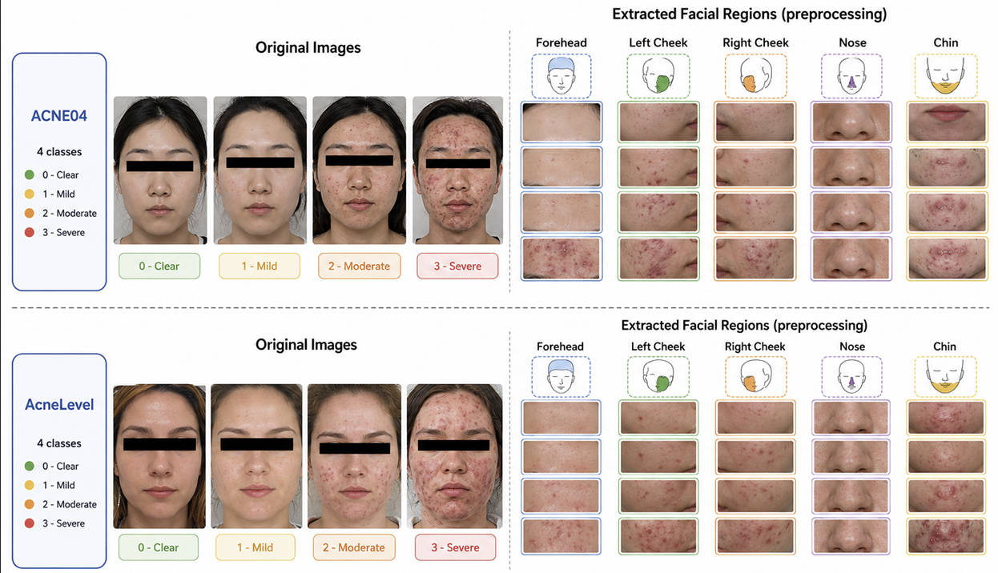
Figure 2 – Acne04 / Acne Level samples and extracted facial regions.
Initially, all images underwent a standardized preprocessing process aimed at uniformizing input data and reducing the influence of irrelevant information during the classification process. The first step consisted of applying a custom YOLOv8 detector trained to localize five anatomical facial sub-regions (forehead, left cheek, right cheek, nose, and chin), rather than relying solely on a global face bounding box.
Subsequently, each face was subdivided into five anatomical regions corresponding to the forehead, left cheek, right cheek, nose, and chin. The adoption of this strategy is based on the non-uniform distribution of acne lesions across the face, allowing the architecture to explore region-specific visual characteristics associated with each anatomical zone.
Each region was resized to 224×224 pixels, the network input size, and subjected to the same normalization procedures used during training. Each region was then paired with a specific learnable embedding, preserving its anatomical identity and allowing the model to incorporate spatial information during the classification process.
Finally, after consolidating and segmenting both corpora, the data were split into training, validation, and test sets (70%, 15%, and 15%, respectively), preserving independence between samples used for training and evaluation and avoiding information leakage across experimental stages. For final model selection, the training and validation splits were merged according to the robust validation criterion implemented in the PyTorch notebook, and the best weights were saved as best_robust_model.pth. Inference can be reproduced using training/predict.py with the saved checkpoint.

3.2 Proposed Region-Aware ResNet-18
The proposed architecture was developed with the objective of incorporating anatomical information from different facial regions into the acne severity classification process, while simultaneously maintaining a computationally simple structure suitable for mobile applications.
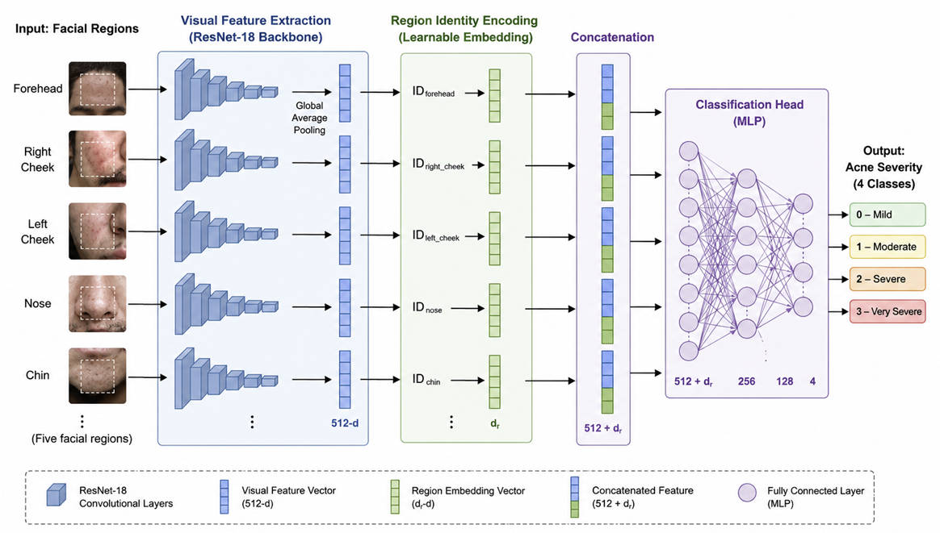
Figure 3 – Region-Aware ResNet-18 with learnable region embeddings.
Unlike conventional CNN-based classifiers, which depend exclusively on visual information present in the image, the proposed architecture explicitly incorporates the anatomical context of the facial region through a learnable embedding. Thus, a single feature extractor based on ResNet-18 is capable of adapting its internal representation according to the processed region, preserving shared weights across all facial regions. This strategy introduces only a small increase in the number of trainable parameters, eliminating the need for multiple specialized networks and maintaining low computational cost for mobile teledermatology applications.
As the visual feature extractor, the ResNet-18 architecture trained from scratch (weights=None), originally proposed by He et al. [23], was employed. Unlike conventional convolutional networks, ResNet uses residual connections (skip connections), allowing efficient training of deeper networks and reducing the vanishing gradient problem. In each residual block, the output is defined by
$y = F(x, W_{i}) +H(x)$(1)
To explicitly represent anatomical context, a region embedding layer was used, implemented through a learned matrix
$E ∈ ℜ^{5 x 64}$ (3)
in which each of the five facial regions has a 64-dimensional representation vector. Let r be the facial region identifier; the corresponding vector is obtained by
$e_{r }= E(r)$ (4)
where e_r represents the learned embedding for region (r).
The main methodological contribution of this work consists of enriching the visual representation produced by ResNet-18 with the anatomical identity of the processed facial region. For this purpose, the feature vector extracted by the CNN is concatenated with the learned embedding of the region, producing an enriched vector
$z = Concat (f, e_{r}) ∈ ℜ^{576}$ (5)
where ⊕ represents the concatenation operation between the visual feature vector and the embedding corresponding to the facial region.
The enriched vector z is then processed by a classifier composed of three Fully Connected layers, interleaved with Batch Normalization operations, ReLU activation function, and Dropout layers, responsible for increasing training stability and reducing overfitting.
Finally, the probability of belonging to each of the four acne severity classes (Grade 0 Clear, Grade 1 Mild, Grade 2 Moderate, Grade 3 Severe) is estimated through the Softmax function,
$\hat{y} = Softmax (W z + b)$ (6)
where W and b represent the parameters learned by the final classification layer.
This architecture allows incorporation of anatomical knowledge using only an additional embedding layer, preserving the simplicity of ResNet-18 and maintaining a single classification pipeline. Compared to approaches based on multiple CNNs or more complex hybrid architectures, the proposal presents lower computational cost, a reduced number of additional parameters, and greater ease of deployment in mobile applications aimed at remote monitoring of acne severity.

3.3 Training Strategy
Training of the proposed architecture was conducted in a supervised manner considering the multiclass facial acne severity classification problem across four clinical levels (Grade 0 Clear, Grade 1 Mild, Grade 2 Moderate, Grade 3 Severe). Preprocessed images and their respective facial region identifiers were used as model input, allowing joint learning of visual features and anatomical context.
Parameter optimization was performed using the Adam algorithm, while the adopted loss function was class-weighted Cross-Entropy Loss, calculated automatically from the distribution of training samples. This strategy reduces the effects of class imbalance and favors more balanced learning.
To increase the model's generalization capacity, data augmentation techniques were employed during training, including random horizontal flipping, rotations, brightness, contrast, and saturation variations, probabilistic application of Gaussian Blur, and Random Erasing. Additionally, an adaptive learning rate scheduler (ReduceLROnPlateau) and an Early Stopping mechanism were used to reduce the risk of overfitting.
Experiments were implemented using the PyTorch framework, leveraging GPU acceleration. The main hyperparameters employed during training are presented in Table II.
Table II – Main hyperparameters used during training of the proposed architecture.
Characteristic | Acne04 | Acne Level
Images | 1,406 | 1,457
Classes | 4 (Hayashi 0–3) | 4 (Hayashi 0–3)
Use | Merged pipeline (70/15/15) | Merged pipeline (70/15/15)
Experimental evaluation was conducted with the objective of analyzing not only the predictive performance of the proposed architecture, but also its robustness, stability, and applicability in teledermatology scenarios. Experiments followed the training, validation, and test split protocol described in Section 3.1 (70/15/15 unified pipeline), ensuring independence between samples used during model training and evaluation.
The performance of the proposed architecture was evaluated using Accuracy, Precision, Recall, and F1-score metrics, widely employed in multiclass classification problems. In addition to global metrics, per-class indicators were also calculated, allowing analysis of model behavior at each acne severity level (Grade 0 Clear, Grade 1 Mild, Grade 2 Moderate, Grade 3 Severe).

4.1 Overall Classification Performance
Table III presents the global performance of the Region-Aware ResNet-18 architecture in facial acne severity classification considering the test set, which contains 1,090 region crops. Precision, Recall, F1-score, and Accuracy metrics were evaluated, as described in Section 3.4.
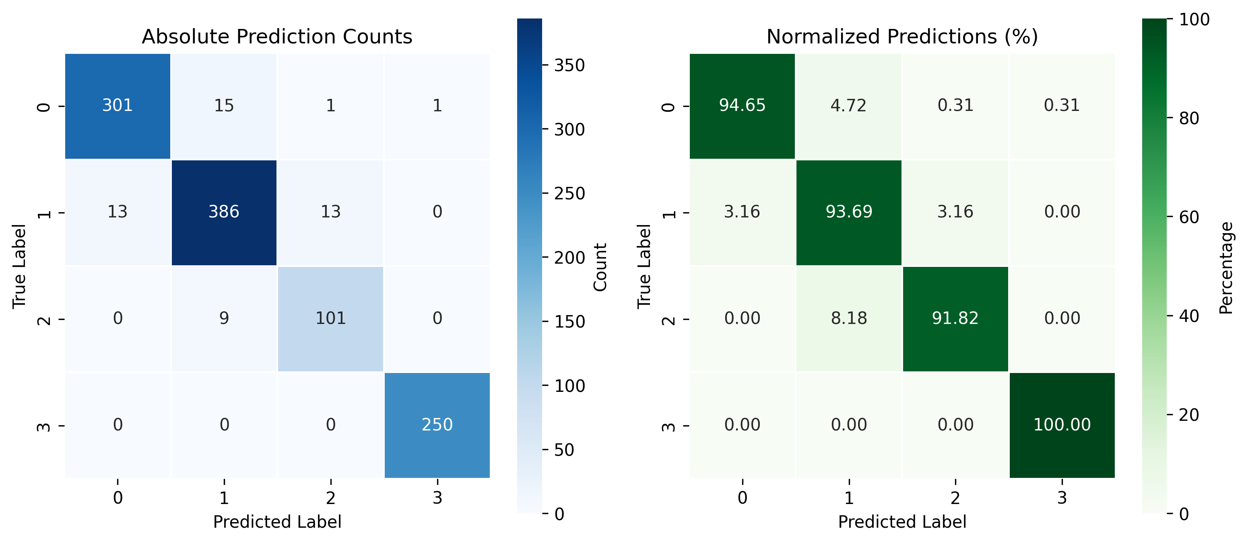
Figure 4 – Confusion matrix on the test set.

5. Discussion
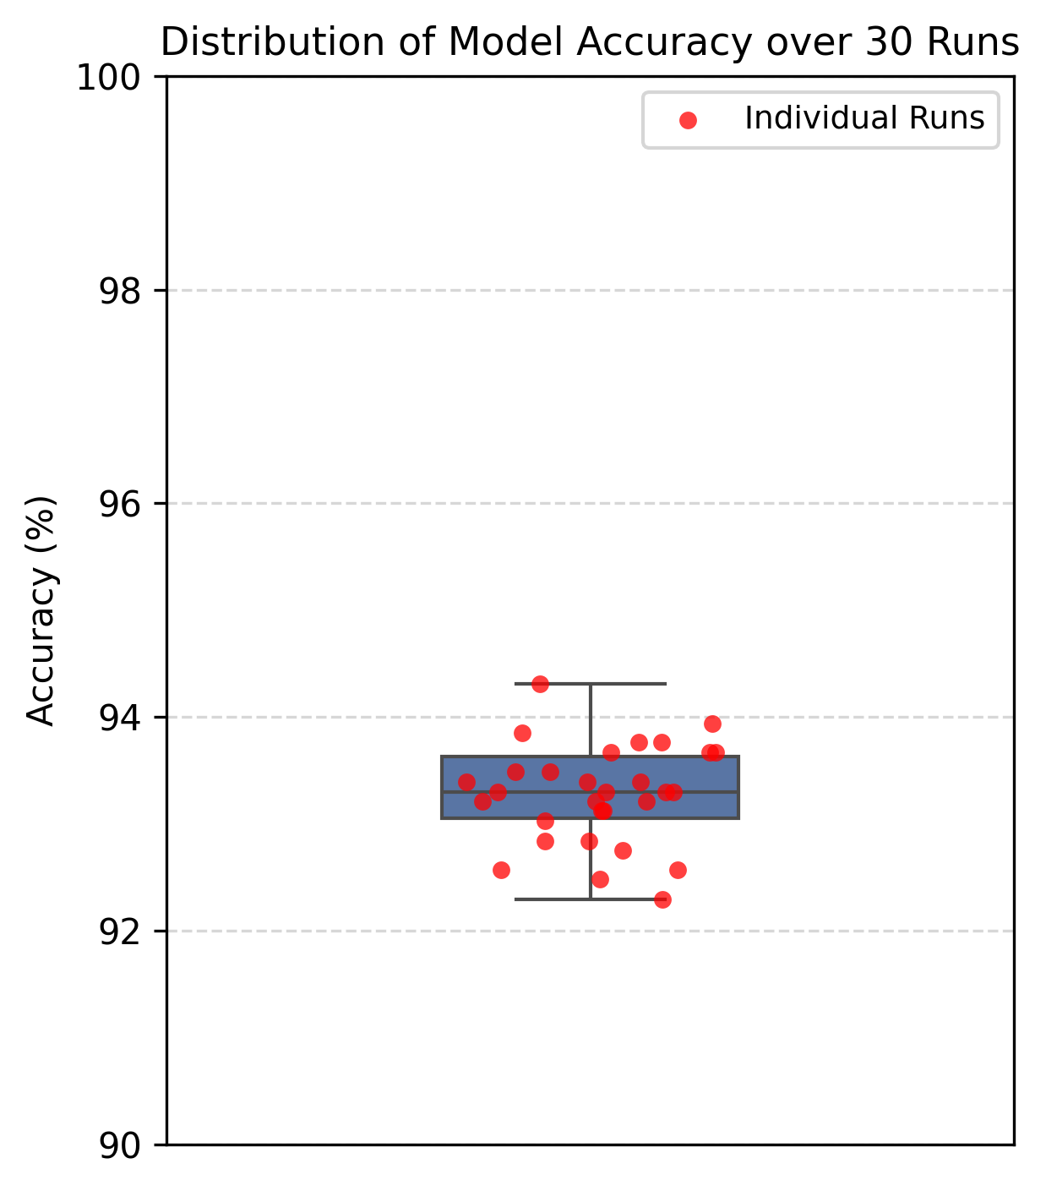
Figure 5 – Accuracy over 30 robustness runs.
The experimental results demonstrate that the proposed architecture was capable of classifying facial acne severity with high performance, maintaining consistent behavior across different anatomical regions and stability under small image variations. These results suggest that explicit incorporation of facial region identity through learnable embeddings contributed to enriching the visual representation without significantly increasing architecture complexity.
To demonstrate the applicability of the proposal, a mobile prototype was developed using the Flutter framework, supporting login, guided image capture, and the intended teledermatology workflow for remote severity assessment. At the time of writing, on-device inference is not yet integrated; the application demonstrates interface and workflow design rather than validated clinical deployment. Figure 6 presents the main screens of the developed application.
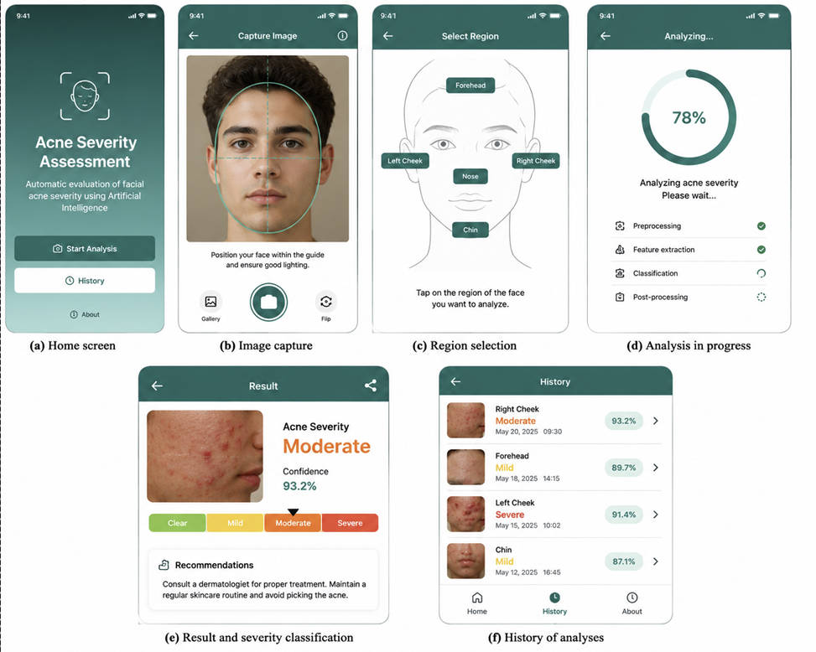
Figure 6 – Flutter teledermatology prototype.
Although developed as a proof of concept, the prototype demonstrates the viability of the architecture for teledermatology applications, enabling remote monitoring of patients' clinical evolution and assisting in prioritization of cases for specialized evaluation; full on-device inference integration remains future work.

6. Limitations
Although the results obtained are promising, this study presents some limitations. Experimental evaluation was performed using two public image datasets, which, despite being widely employed in the literature, may not represent all variability observed in real clinical scenarios. Thus, validation of the architecture on independent datasets and in more heterogeneous populations constitutes an important step to confirm its generalization capacity.

7. Conclusion
This work presented a Region-Aware ResNet-18 architecture for automatic facial acne severity classification, explicitly incorporating facial region anatomical identity through learnable embeddings. The proposal preserves a single convolutional backbone shared across all facial regions, maintaining a lightweight architecture with low computational complexity suitable for mobile applications.

References
[1] M. Vasam et al., Acne vulgaris review, Biomedicines, 2023.
[2] Y. Li et al., Acne treatment perspectives, Front. Medicine, 2024.
[4] A. H. Heng and F. T. Chew, Acne epidemiology review, Sci. Rep., 2020.
[10] D. Z. Eichenfield et al., Management of acne, JAMA, 2021.
[11] S. Wongvibulsin et al., Dermatology mobile AI apps, JAMA Dermatol., 2024.
[13] S. P. Choy et al., DL for skin disease review, npj Digital Medicine, 2023.
[14] Q. T. Huynh et al., Acne detection and grading, Diagnostics, 2022.
[15] Y. Lin et al., KIEGLFN framework, CMPB, 2022.
[16] S. Liu et al., AcneGrader, Skin Res. Technol., 2022.
[23] K. He et al., ResNet, CVPR, 2016.

