README: Grazioso Salvare Interactive Dashboard

Project Overview
This project delivers an interactive dashboard for Grazioso Salvare that connects to an animal shelter database and allows the user to:
- Filter dogs based on predefined rescue categories (Water Rescue, Mountain or Wilderness Rescue, Disaster or Individual Tracking, or None)
- View a filtered list of matching animals in a Dash DataTable
- Visualize the distribution of breeds through a Pie Chart
- Display the selected animal’s location on a map with tooltips and popups
This dashboard supports Grazioso Salvare in identifying potential search-and-rescue dogs more efficiently.

Functionality Achieved
The dashboard meets the following requirements:
- Filtering by Rescue Type using dcc.RadioItems
- Interactive Table that updates dynamically based on MongoDB queries
- Pie Chart visualization showing the breakdown of breeds represented in the current dataset
- Map View with clickable markers showing details about individual dogs
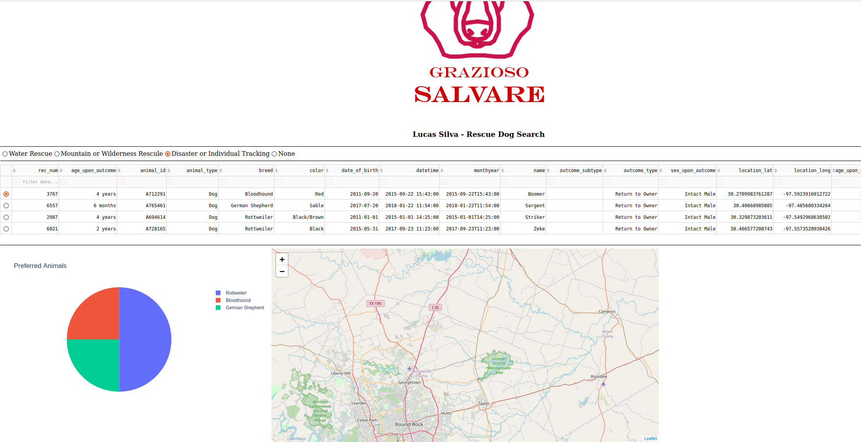
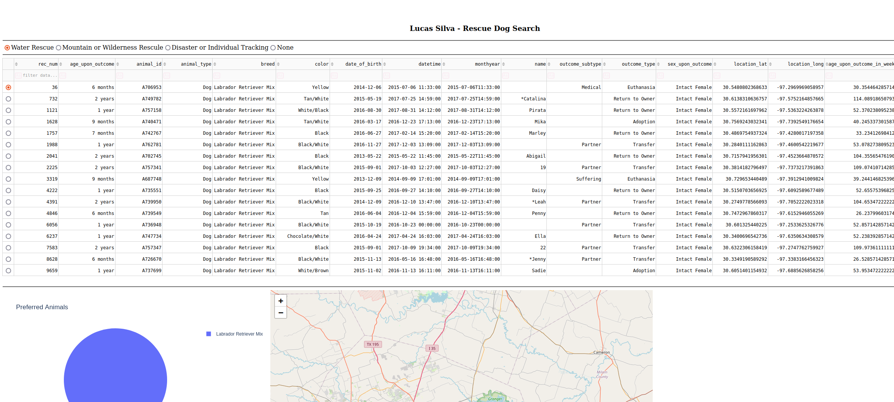
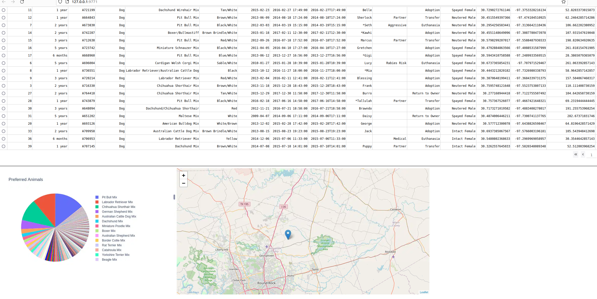

Tools and Rationale
The following tools were used to achieve the functionality of the project:
• MongoDB
Serves as the model component of the project. Stores semi-structured animal data in a flexible document format. Integrates easily with Python through pymongo. Querying with JSON-like syntax allows applying filters for breed, age, and sex efficiently.
• Dash (by Plotly)
Provides both the view and controller. Built on Flask, React, and Plotly, allowing Python-only development of a rich web app. Components such as dcc.RadioItems, dash_table.DataTable, dcc.Graph, and dash_leaflet made it possible to create interactive filters, charts, and maps without custom JavaScript.
• Plotly Express (px)
Used for quick, high-quality visualizations (pie charts, bar charts). Integrated seamlessly into Dash via dcc.Graph.
• Dash Leaflet (dl)
Provides map functionality within Dash. Allowed placing markers with tooltips and popups to visualize dog locations.
Resources and Links:
- Dash documentation: https://dash.plotly.com/
- Plotly Express documentation: https://plotly.com/python/plotly-express/
- MongoDB documentation: https://www.mongodb.com/docs/
- Dash Leaflet: https://dash-leaflet.herokuapp.com/

Steps to Complete the Project
1. Set up MongoDB: Create the Grazioso Salvare database and import animal data.
2. Develop the CRUD module: Implement Python class (AnimalShelter) to query MongoDB.
3. Build dashboard layout: Define DataTable, filter options, graph area, and map container.
4. Implement callbacks:
- Link filter selection to MongoDB queries -> update DataTable.
- Link DataTable rows to Pie Chart -> show breed distribution.
- Link selected rows to Map -> show animal location with tooltip/popup.
5. Test functionality: Verify filtering, chart updates, and map interaction.
6. Deploy and capture screenshots: Run locally with app.run_server() and confirm working UI.

Challenges and Solutions
• Chart Integration
Challenge: Understanding how data was being passed from the DataTable (derived_virtual_data) into Plotly for rendering the pie chart. At first, it was unclear why the chart displayed so many small slices.
Solution: Converted the table data into a Pandas DataFrame, grouped it by breed, and aggregated counts. To improve readability, grouped smaller categories into an 'Other' slice and limited labels.
• Data Consistency
Challenge: MongoDB field names (e.g., age_upon_outcome_in_weeks, sex_upon_outcome) had to match exactly.
Solution: Verified field names in the dataset and adjusted queries accordingly.
• ID and Callback Connections
Challenge: Forgetting to assign IDs (e.g., filter-type) caused callbacks to break.
Solution: Ensured every interactive Dash component had a unique id that matched callback inputs/outputs.

How to Run
1. Clone the repository and install requirements:
pip install dash plotly pandas pymongo dash-leaflet
2. Ensure MongoDB is running and accessible.
3. Run the dashboard:
python app.py
4. Open in your browser:
127.0.01:9771

