Knowledge Graph with Neo4j AuraDB
KMS Dataset - Data Exploration, Graph Schema and Cypher Queries
Lucas Steffenon
Riga Technical University (RTU)
Knowledge Management Systems
October 2026

1. Dataset Exploration
The dataset used in this task was provided in the KMS_Dataset GitHub repository. It contains information about RTU study programmes, study courses, course topics, learning outcomes and study fields. The data is divided into node CSV files and edge CSV files, which makes it suitable for representation as a knowledge graph.
Node type | Identifier | Imported nodes
CourseTopic | topic_id | 640
LearningOutcome | outcome_id | 392
StudyCourse | course_id | 75
StudyProgram | program_id | 2
StudyField | study_field_id | 1
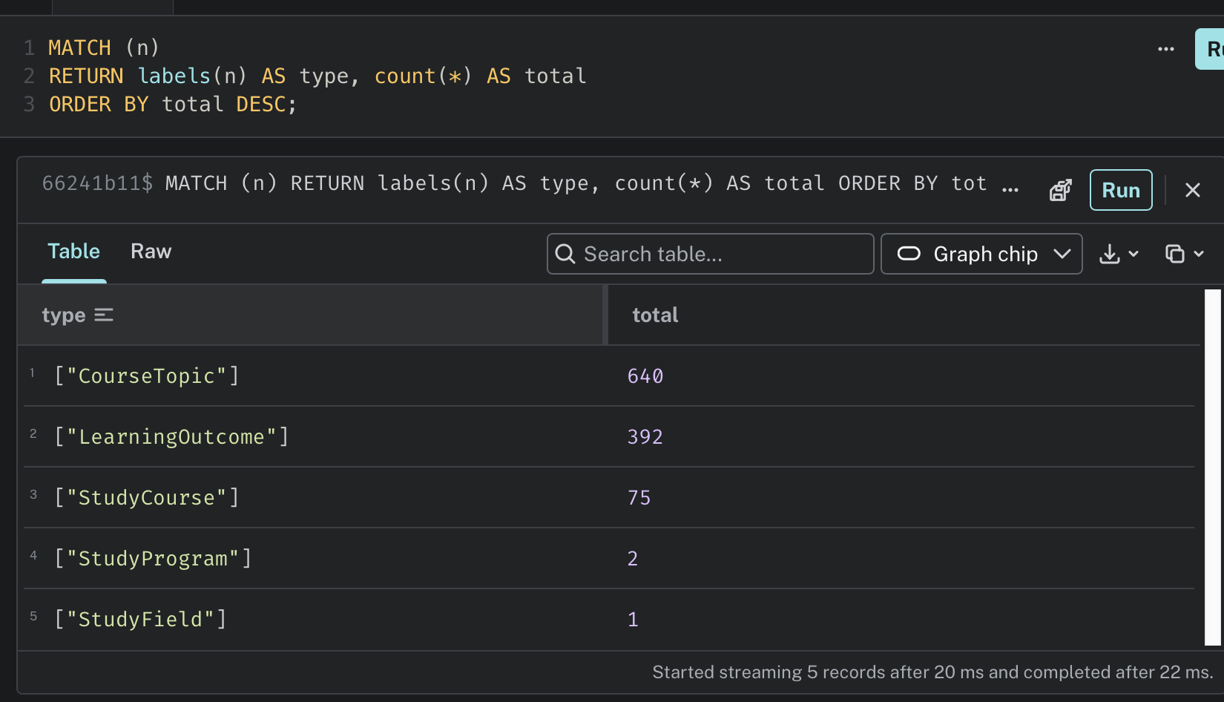
Figure 1. Validation of imported node types and counts.
The import resulted in five node labels. CourseTopic is the largest group with 640 nodes, followed by 392 LearningOutcome nodes and 75 StudyCourse nodes. The graph also contains two StudyProgram nodes and one StudyField node.

2. Knowledge Graph Schema
The graph was modeled around the academic structure of the dataset. Study programmes belong to a study field, programmes contain courses, courses contain topics, and courses are connected to their learning outcomes.
(:StudyProgram)-[:BELONGS_TO_FIELD]->(:StudyField)
(:StudyProgram)-[:HAS_COURSE]->(:StudyCourse)
(:StudyCourse)-[:HAS_TOPIC]->(:CourseTopic)
(:StudyCourse)-[:HAS_OUTCOME]->(:LearningOutcome)
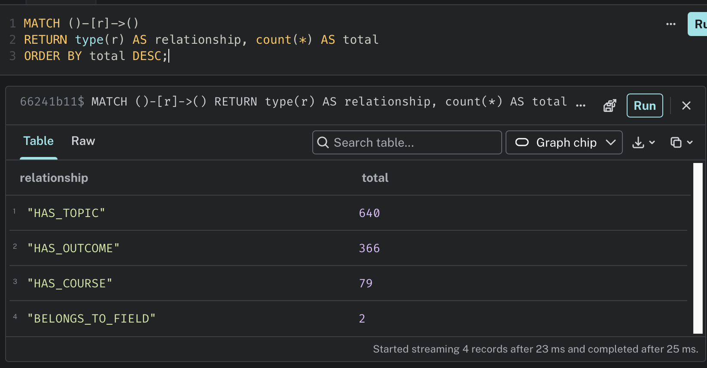
Figure 2. Relationship types and counts after the import.
The database contains 640 HAS_TOPIC relationships, 366 HAS_OUTCOME relationships, 79 HAS_COURSE relationships and two BELONGS_TO_FIELD relationships. The difference between the 392 LearningOutcome nodes and 366 HAS_OUTCOME relationships is expected from the imported edge data: not every learning-outcome node is linked through the course-to-outcome edge file.
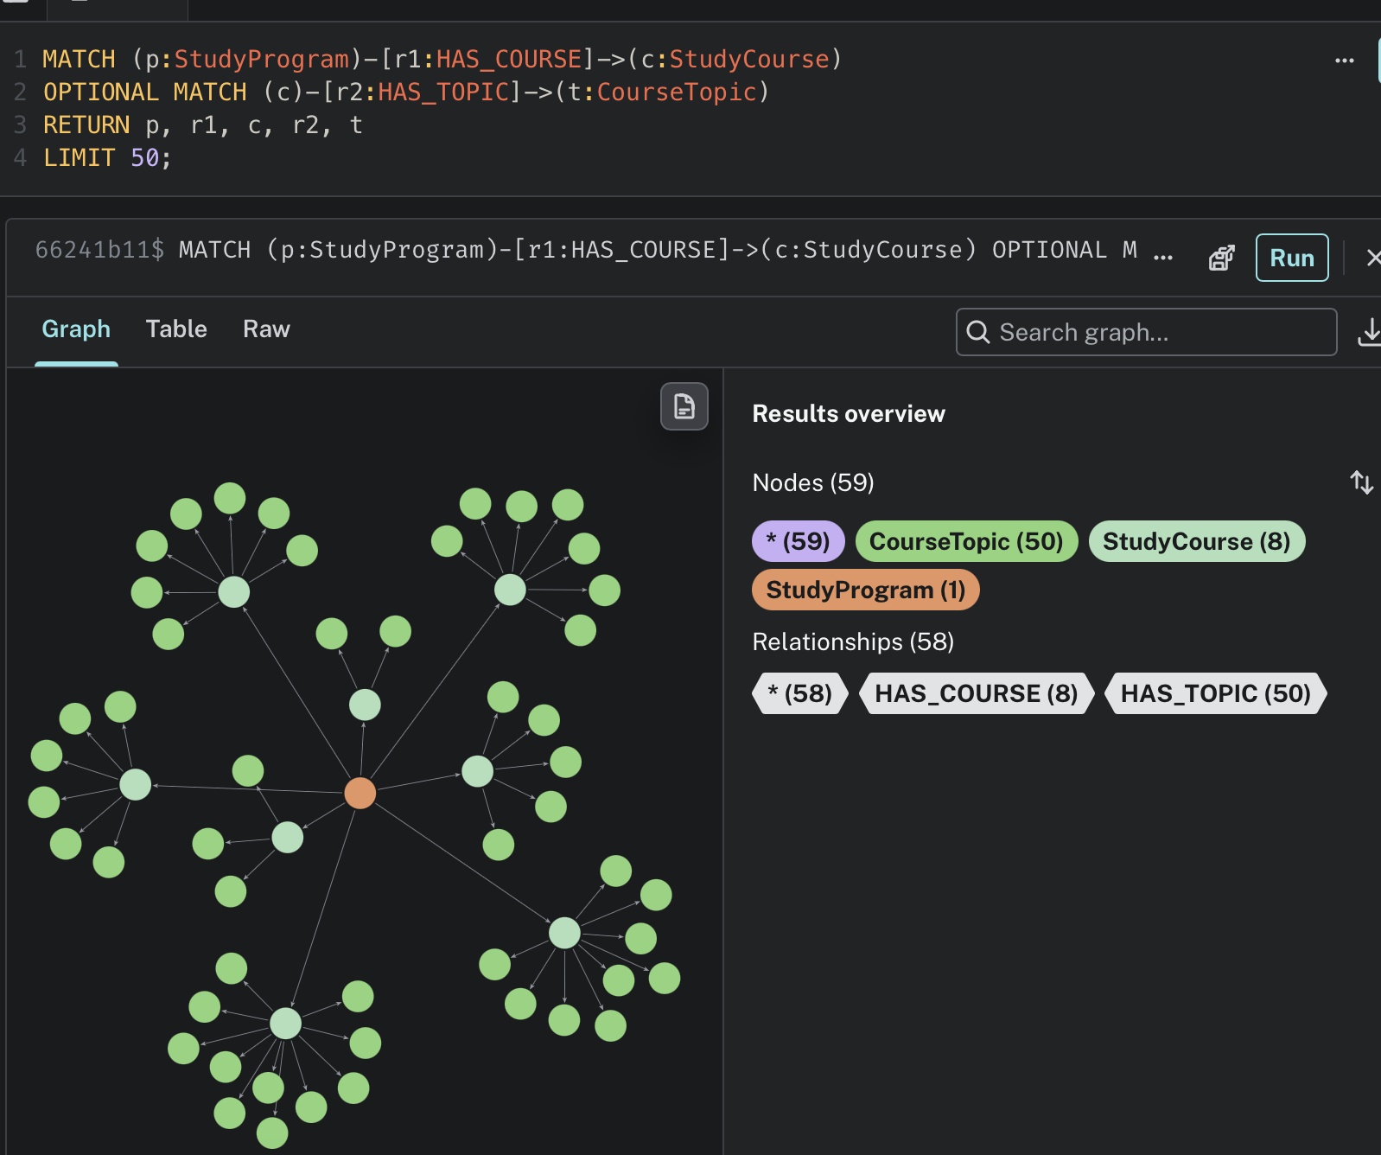
Figure 3. Graph overview showing programmes, courses and course topics.

3. Data Import into AuraDB
The CSV files were imported into Neo4j AuraDB using Cypher. Unique constraints were created for the identifiers of each node type before importing the data. Nodes were then created from the files in the nodes directory, followed by relationships from the files in the edges directory. The validation queries above were used to confirm that the data and relationships were created successfully.
MATCH (n)
RETURN labels(n) AS type, count(*) AS total
ORDER BY total DESC;
MATCH ()-[r]->()
RETURN type(r) AS relationship, count(*) AS total
ORDER BY total DESC;

4. Queries and Results
Five queries were executed to demonstrate how the knowledge graph can be explored. The queries range from simple programme/course navigation to topic and learning-outcome analysis.

4.1 Courses in each study programme
This query lists the courses connected to each study programme and shows the number of credit points stored for each course. The result confirms that programme-to-course relationships can be traversed directly in the graph.
MATCH (p:StudyProgram)-[:HAS_COURSE]->(c:StudyCourse)
RETURN p.title AS Programme, c.title AS Course, c.credit_points AS Credits
ORDER BY Programme, Course;
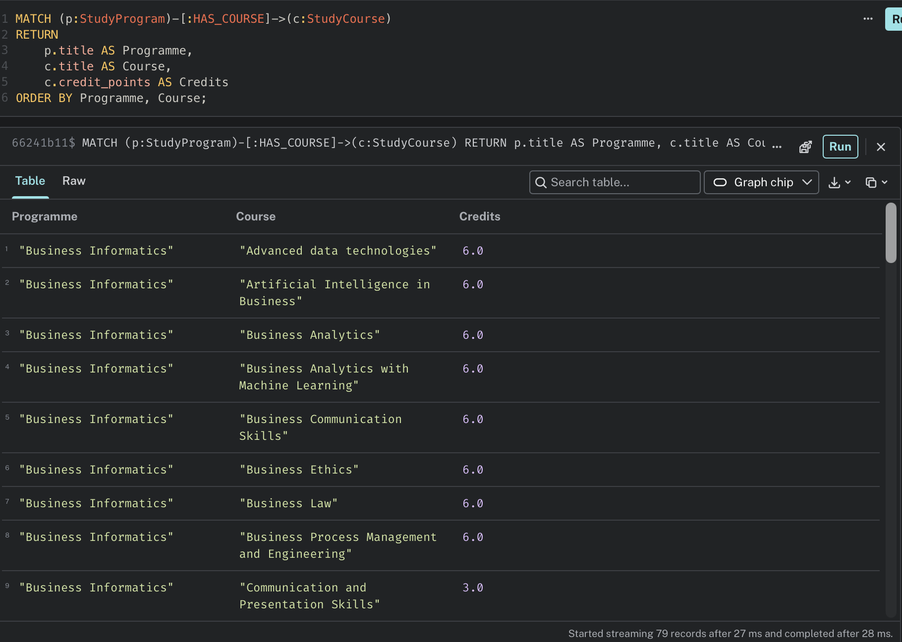
Figure 4. Courses associated with the study programmes.

4.2 Number of courses per programme
This query aggregates the HAS_COURSE relationships. Digital Humanities has 50 course relationships, while Business Informatics has 29.
MATCH (p:StudyProgram)-[:HAS_COURSE]->(c:StudyCourse)
RETURN p.title AS Programme, count(c) AS NumberOfCourses
ORDER BY NumberOfCourses DESC;
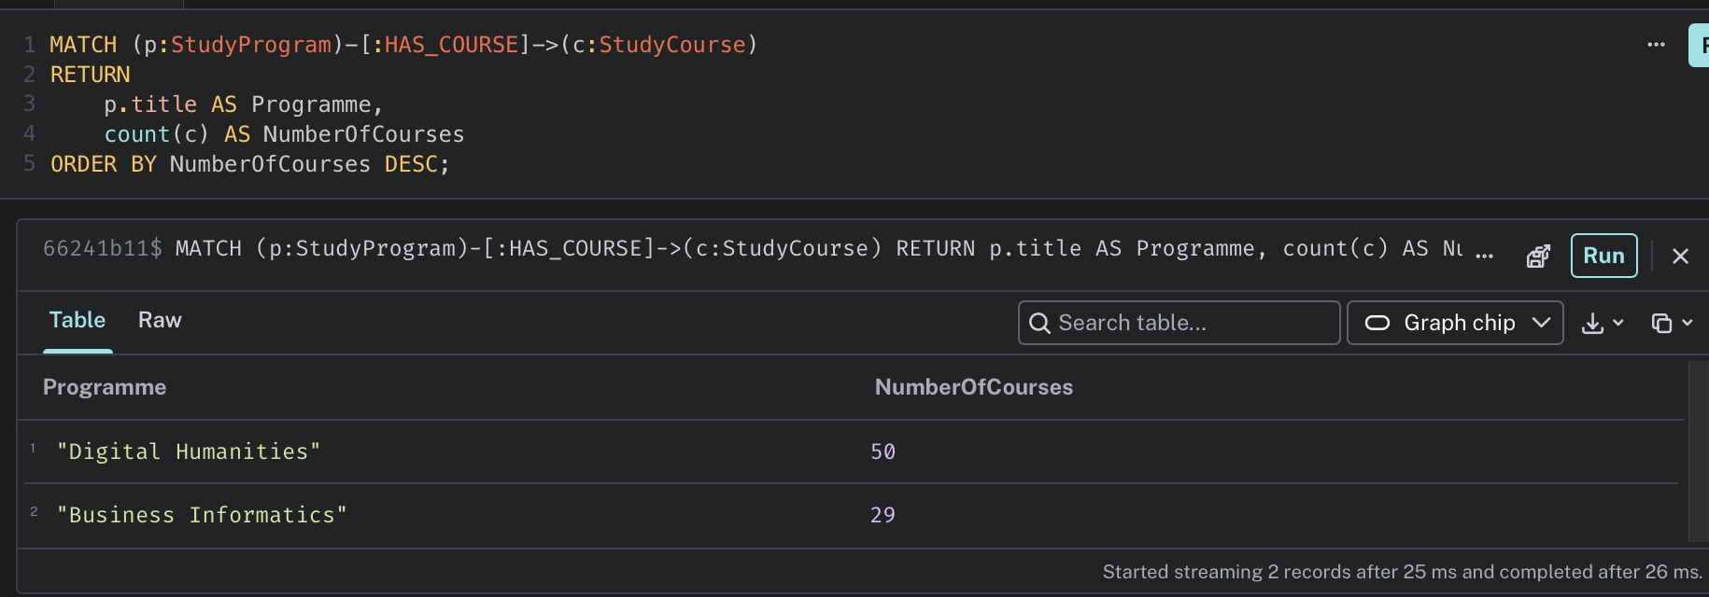
Figure 5. Number of courses connected to each programme.

4.3 Topics of Knowledge Management Systems
This query focuses on the Knowledge Management Systems course and retrieves its topics in their original order. Six topics are returned, covering knowledge management concepts, methods, processes, strategic relations, socio-ethical factors and system blueprint design.
MATCH (c:StudyCourse)-[:HAS_TOPIC]->(t:CourseTopic)
WHERE c.title = 'Knowledge Management Systems'
RETURN c.title AS Course, t.ordinal AS TopicNumber, t.title AS Topic
ORDER BY t.ordinal;
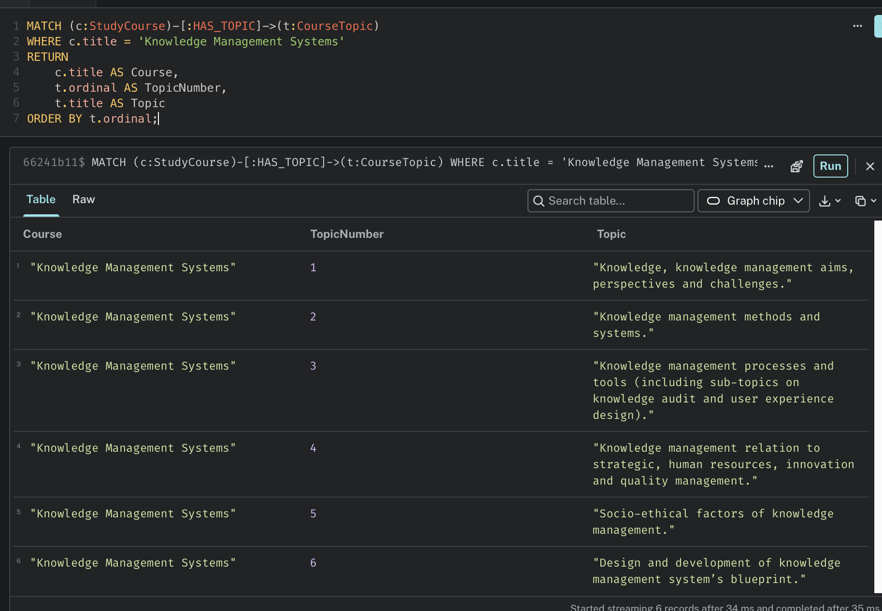
Figure 6. Topics of the Knowledge Management Systems course.

4.4 Learning outcomes by course
This query retrieves learning outcomes linked to courses. The results demonstrate that the graph can connect a course to the competencies or abilities expected from students.
MATCH (c:StudyCourse)-[:HAS_OUTCOME]->(o:LearningOutcome)
RETURN c.title AS Course, o.ordinal AS OutcomeNumber, o.text AS LearningOutcome
ORDER BY Course, OutcomeNumber
LIMIT 30;
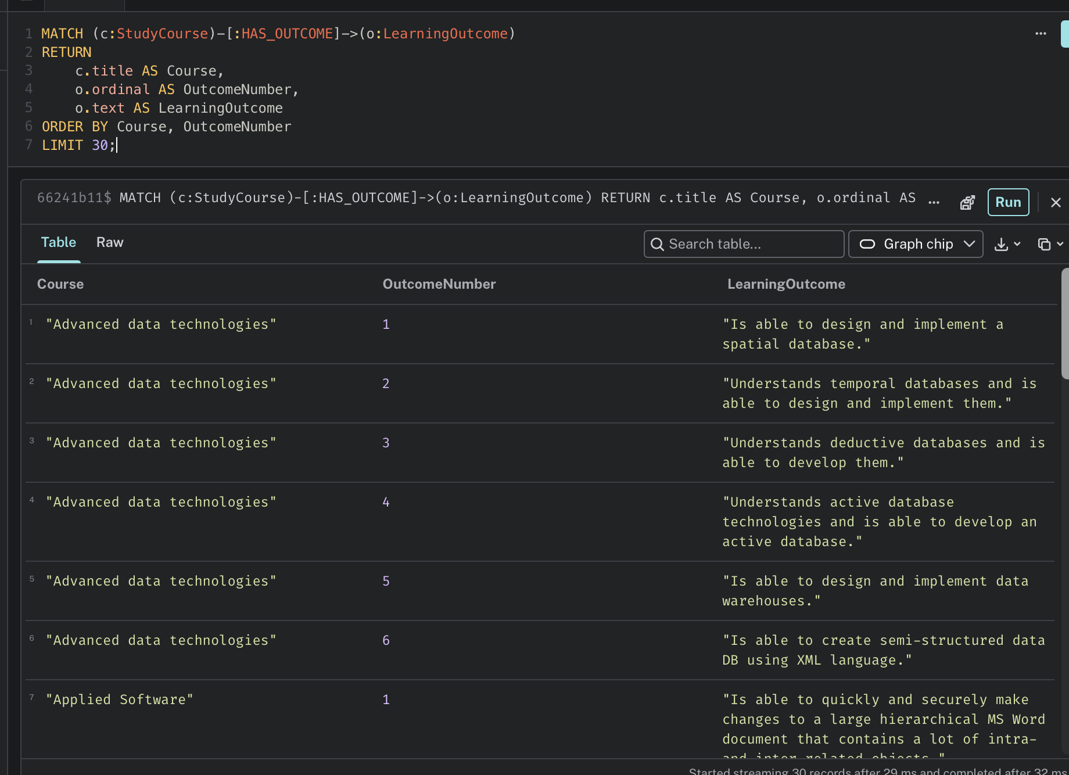
Figure 7. Example learning outcomes linked to courses.

4.5 Courses with the highest number of topics
This query counts the topics connected to every course and returns the ten courses with the largest number. Introduction to Knowledge Society Technology has the highest count in the result with 20 topics, followed by Digital Textuality: Interdisciplinary Approach and Audio and Video Data Processing with 19 each.
MATCH (c:StudyCourse)-[:HAS_TOPIC]->(t:CourseTopic)
RETURN c.title AS Course, count(t) AS NumberOfTopics
ORDER BY NumberOfTopics DESC
LIMIT 10;
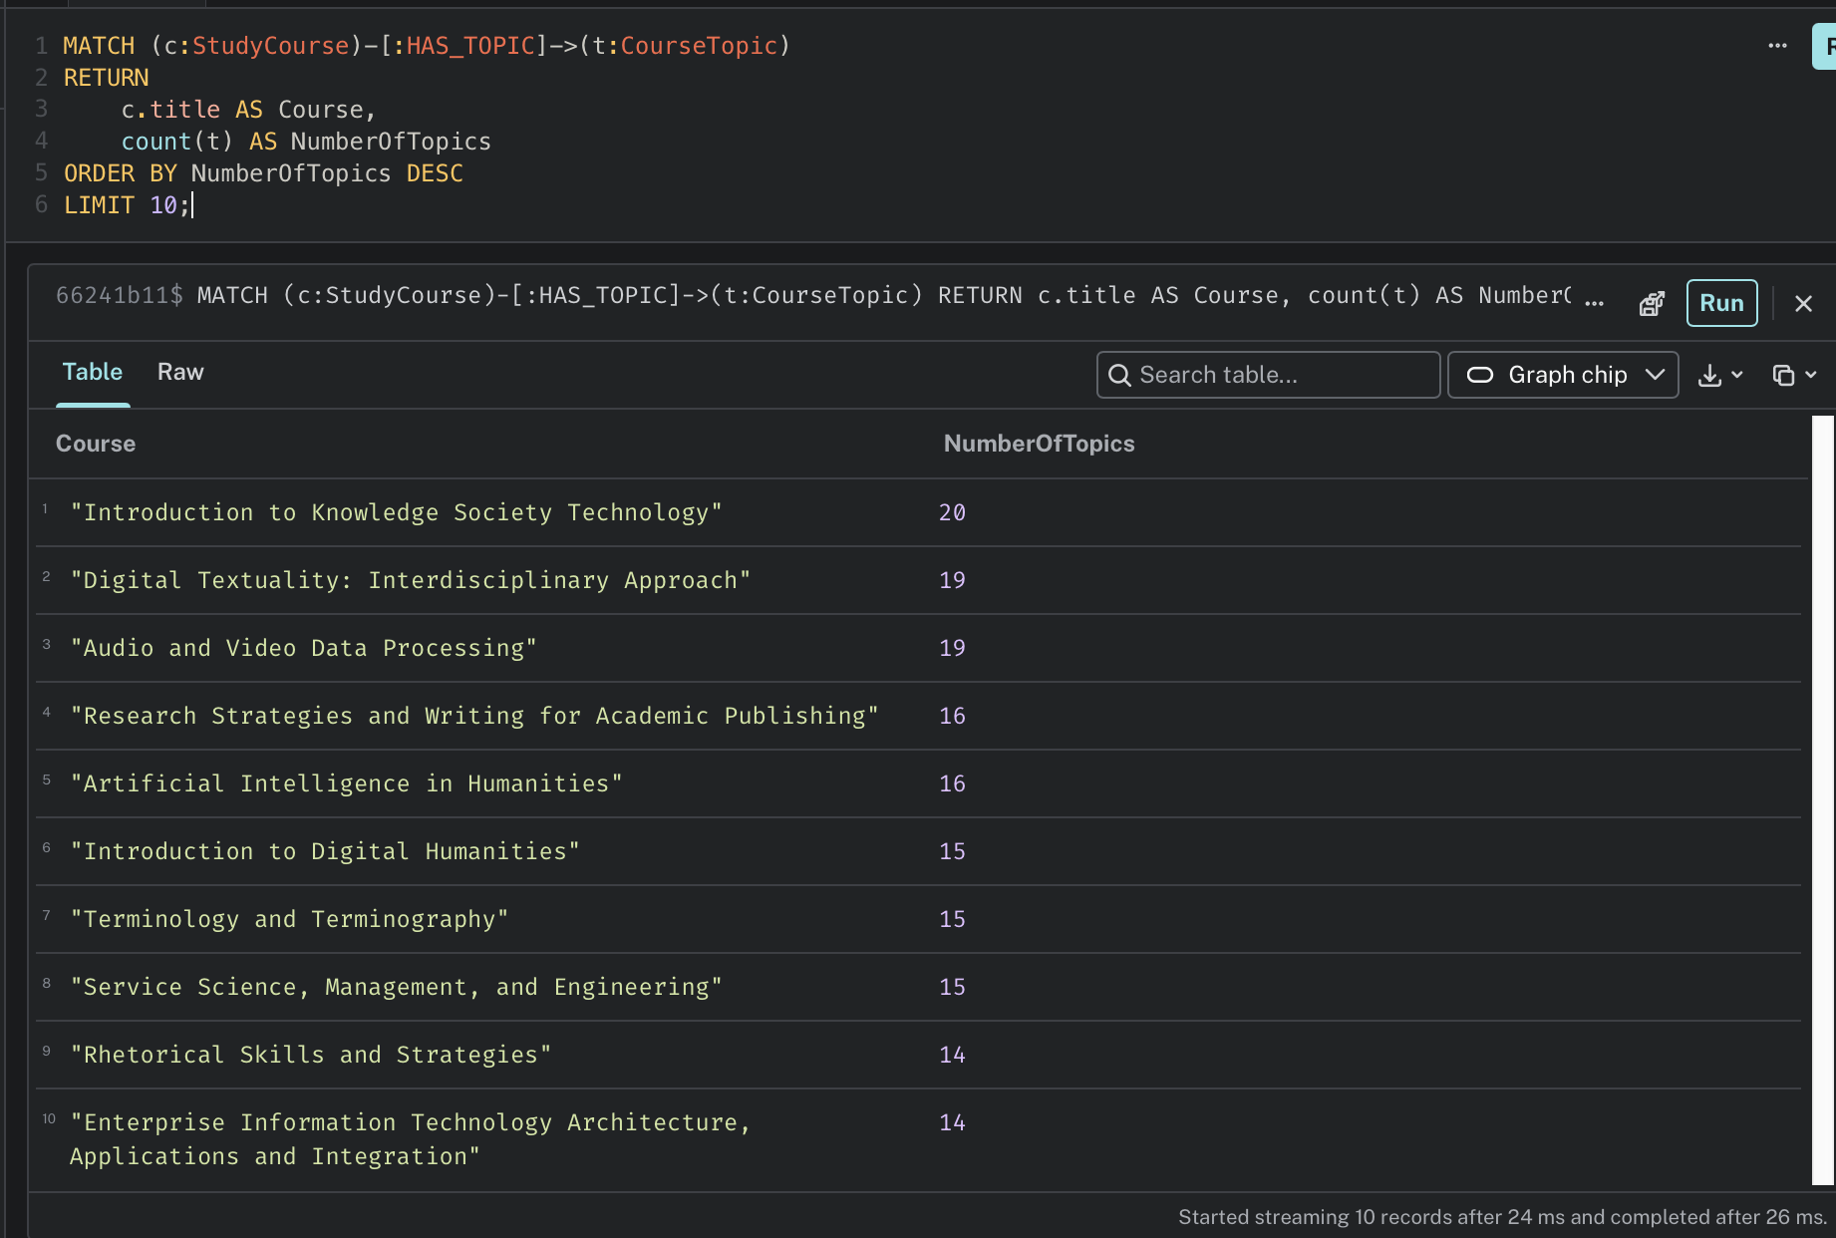
Figure 8. Courses with the highest number of topics.

5. Graph Visualization
A graph view was also generated for the Business Informatics programme (DMB0). The visualization makes the structure easier to understand: the programme node is connected to course nodes, which then branch into their respective topic nodes. This is one of the main advantages of a graph database for this dataset, because relationships can be inspected visually as well as queried with Cypher.
MATCH path =
(p:StudyProgram {program_id: 'DMB0'})-[:HAS_COURSE]->(c:StudyCourse)-[:HAS_TOPIC]->(t:CourseTopic)
RETURN path
LIMIT 50;
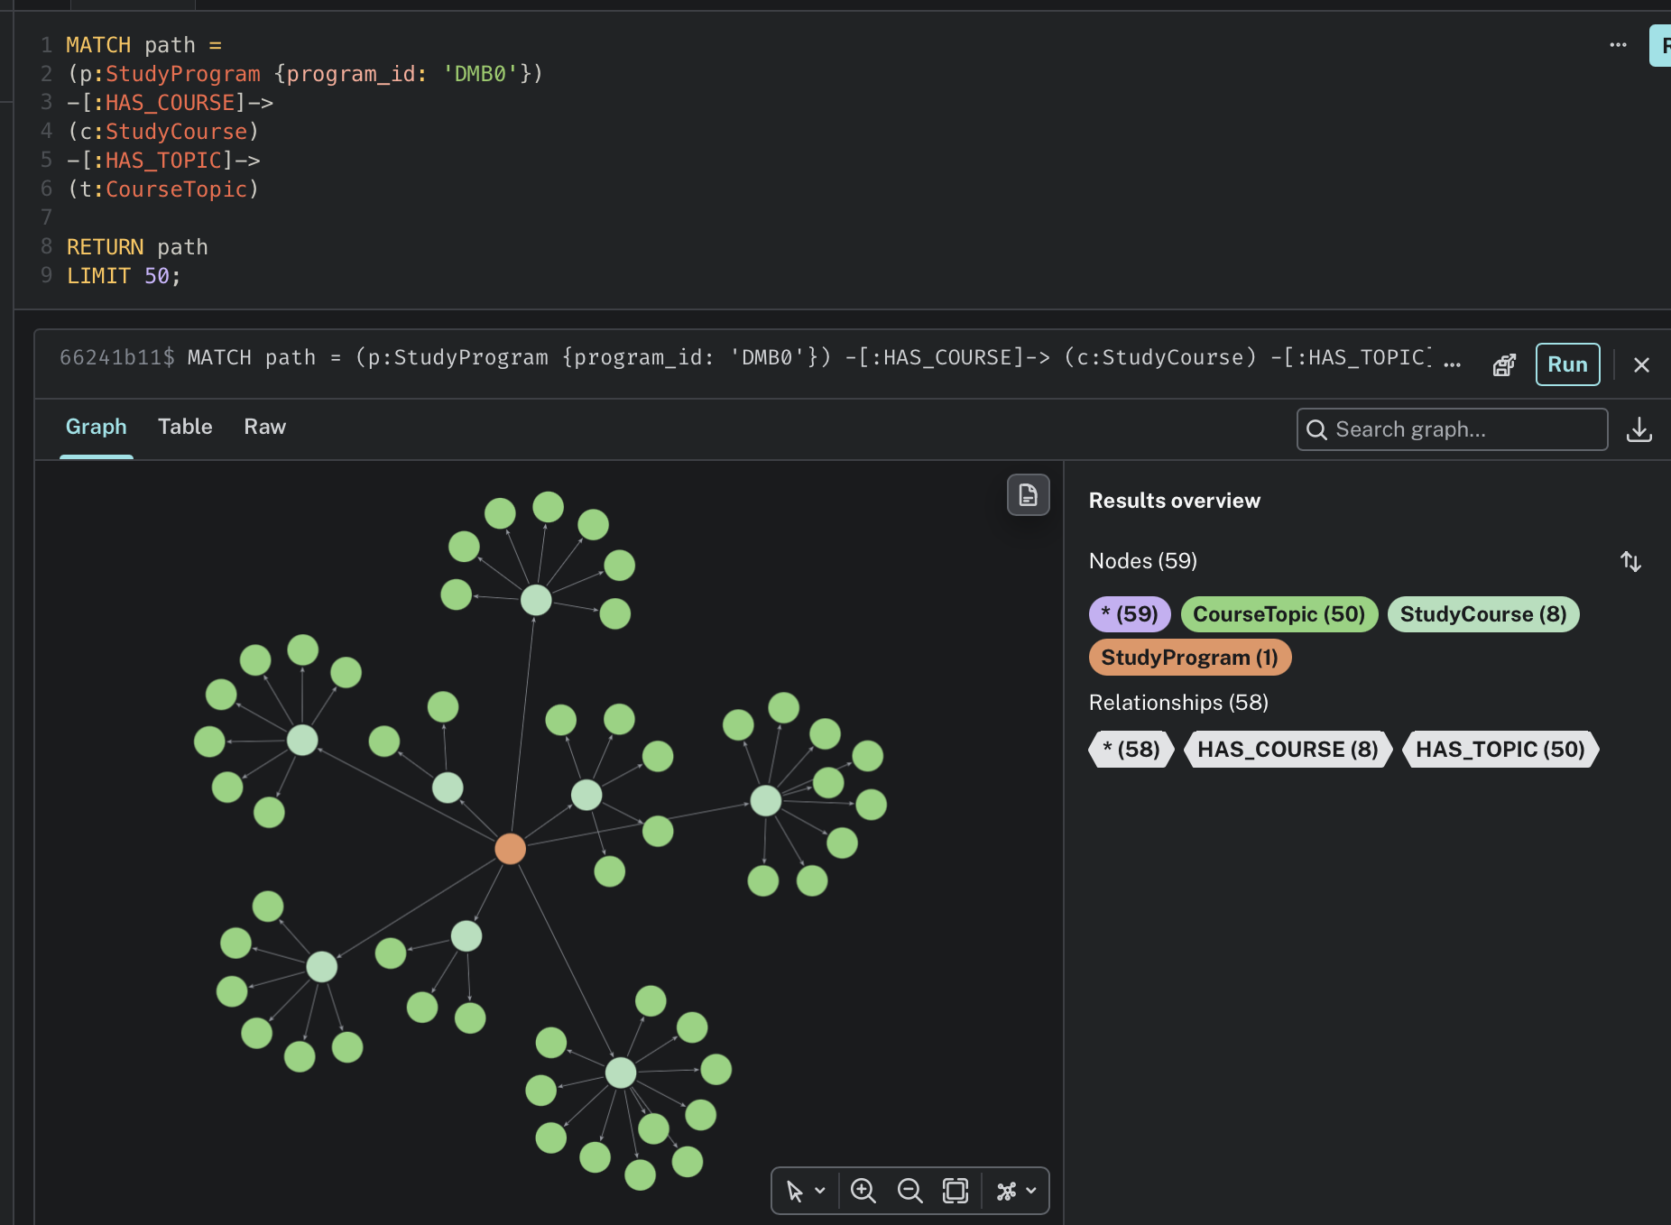
Figure 9. Business Informatics programme, courses and topics visualized as a graph.

6. Conclusion
The KMS dataset was successfully represented as a knowledge graph in Neo4j AuraDB. The final database connects study fields, programmes, courses, topics and learning outcomes through explicit relationships. The queries show that the graph can be used both for straightforward navigation, such as listing the courses in a programme, and for analytical questions, such as identifying courses with the most topics. AuraDB also provides a useful visual representation of the relationships, making the academic structure of the dataset easier to explore.

7. Source
Dataset: ArithaRTU/KMS_Dataset (GitHub)
https://github.com/ArithaRTU/KMS_Dataset

