Quokka: Downside-Aware Multi-Asset Funds with News-Sentiment Analytics
Lucas Sun z5594806
FINS3645 Financial Market Data Design & Analysis - Project Part B (Funds, Sentiment & App, Stations 3-4)

Table of Contents
Table of Contents 1
The funds and the backtest design 2
Out-of-sample results and fund fact sheets 3
The sentiment index 7
Extensions and innovations 9
The minimum-CVaR fund 9
The co-crash stress panel and paired bootstrap 10
The transaction-cost model 11
Sentiment fusion: before and after 12
Extending the finance lexicon 13
The app and the investor journey 13
Critical reflection and three recommendations 15
Appendix 17
Appendix A. Portfolio weights, full book 17
Appendix B. The deployed app 18
Appendix C. Full performance metrics, including the cost grid 19
Appendix D. Covariance estimator study 21
Appendix E. Co-crash panel and bootstrap, in full 21
Appendix F. Current holdings and method separation 23
Appendix G. Sentiment coverage 26
Appendix H. Fusion robustness 26
Appendix I. Lexicon extension 27

The funds and the backtest design
Part A established Quokka as a transparent, comparable, and downside-aware retail product. Part B makes this downside awareness testable: it introduces a tail-objective fund and a crash-day evaluation panel, which verifies whether that objective truly protects investors during market stress. Each of the twelve funds is named by asset family and construction method, for example Combined Min-CVaR, so a fact sheet can state exactly what the fund is without a separate legend.
The funds trade the fixed asset universe established in Part A: 50 US large-cap equities across 10 sectors and 10 cryptocurrencies from 2020 to 2023. This yields an equity panel of 50,300 observations across nine columns and a post-cap crypto panel of 14,610 observations, merging into a combined panel of 60,360 rows. All 60 assets enter the optimiser as the investable universe; the final holdings are an output of the optimisation process, not a predetermined design choice.
Four distinct optimisation methods are applied across each asset family:
- Mean-Variance Tangency maximises the Sharpe ratio. It assumes a zero risk-free rate.
- Global Minimum-Variance minimises portfolio variance. It ignores expected returns.
- Equal Risk Contribution allocates by risk, not by capital. Each asset contributes equally to total portfolio risk.
- Minimum-CVaR solves the Rockafellar-Uryasev formulation as a linear program over historical return scenario. This provides a genuine tail-risk objective rather than a variance-based proxy, the distinction central to this project.
The available data dictates the Min-CVaR confidence level of 0.95, not market-regime assumptions. Higher confidence levels leave too few tail scenarios for a reliable estimate: a 97.5% level leaves just 6.3 scenarios in the initial 252-day window, and a 99% level leaves only 2.5. A 95% level provides 12.6 initial scenarios, expanding to 49.4 by the final window of T = 987. A 90% level is also run as a robustness check.
Position limits reflect standard retail single-issuer concentration practices. The Equity and Combined families use a strict 10% per-asset cap; the Crypto-Only family uses a 25% cap instead. This universe contains exactly 10 assets, so a 10% cap would force every method into an identical equal-weight portfolio. This constraint-saturation failure was caught during verification, proving that these checks are actively executed rather than assumed to pass. The higher cap keeps the general rule intact: the number of assets multiplied by the maximum cap must exceed one.
Covariance inputs for all methods rely on an exponentially weighted moving average (EWMA), a 252-day span with a half-life of 87 days. This geometric weighting covers the full history and is separate from the 252-day backtest burn-in discussed below. It is necessary because equity returns show clear volatility clustering: the autocorrelation of squared returns at lag one is 0.49, against negative 0.18 for raw returns, justifying an estimator that reacts dynamically to recent volatility. Three alternative spans were tested against the chosen 252-day span, using the Combined Min-Variance fund for the comparison (Appendix D):
- A 32-day span increased realised volatility to 13.69% and drove annual two-way turnover to a prohibitive 1,141%. Its calibration suits univariate one-day-ahead forecasting, not this 60-asset multivariate setting.
- A 126-day span underperformed on both metrics, at 12.58% volatility and 496% turnover.
- A static full window covariance yielded 12.79% volatility. The 252-day EWMA consistently beat it across all three out-of-sample years. It lowered volatility by 0.29, 0.12, and 0.72 percentage points respectively. The return edge over the static estimator fluctuated by year. It showed gains of 0.63, and 2.19 percentage points followed by a drop of 1.73 percentage points. This confirms the EWMA provides an advantage in volatility reduction rather than return enhancement.
Every fund rebalances on an expanding window with a 252-day burn-in and a 21-day rebalancing cycle, so weights at any date rely strictly on prior data. An automated standing test enforces this no-look-ahead property: scrambling and inflating future observations leaves historical weights bit-identical across all methods at or before the cutoff, confirming the test is not vacuous.
The first live rebalance occurs on 2021-01-04 for the Combined and Equity-Only families, and on 2020-09-10 for Crypto-Only, giving 36, 36, and 58 rebalances respectively, at a zero risk-free rate throughout. Headline fund performance figures are reported gross of transaction costs; costs are modelled over a 0, 10, 20, and 50 basis-point grid to quantify the drag of trading, with the consequences detailed later. Annualisation uses the precise trading-day counts in the data, 252.1 days for equity and combined funds and 365.5 for crypto-only, rather than standard asset-class assumptions. The next section shows what these four objectives deliver out of sample.

Out-of-sample results and fund fact sheets
Combined Risk Parity delivers the highest Sharpe ratio among the four broad-family methods, at 0.8416. This puts it ahead of Min-CVaR at 0.6180, Min-Variance at 0.5427, and Max-Sharpe at 0.5193 (Figure 1, Table 1). On this single number, Risk Parity looks like the clear fund to recommend. That ranking does not survive closer scrutiny: a later section shows that Sharpe alone hides how each method performs on the market's worst days, the days an investor cares about most, and that comparison changes which fund this report recommends.
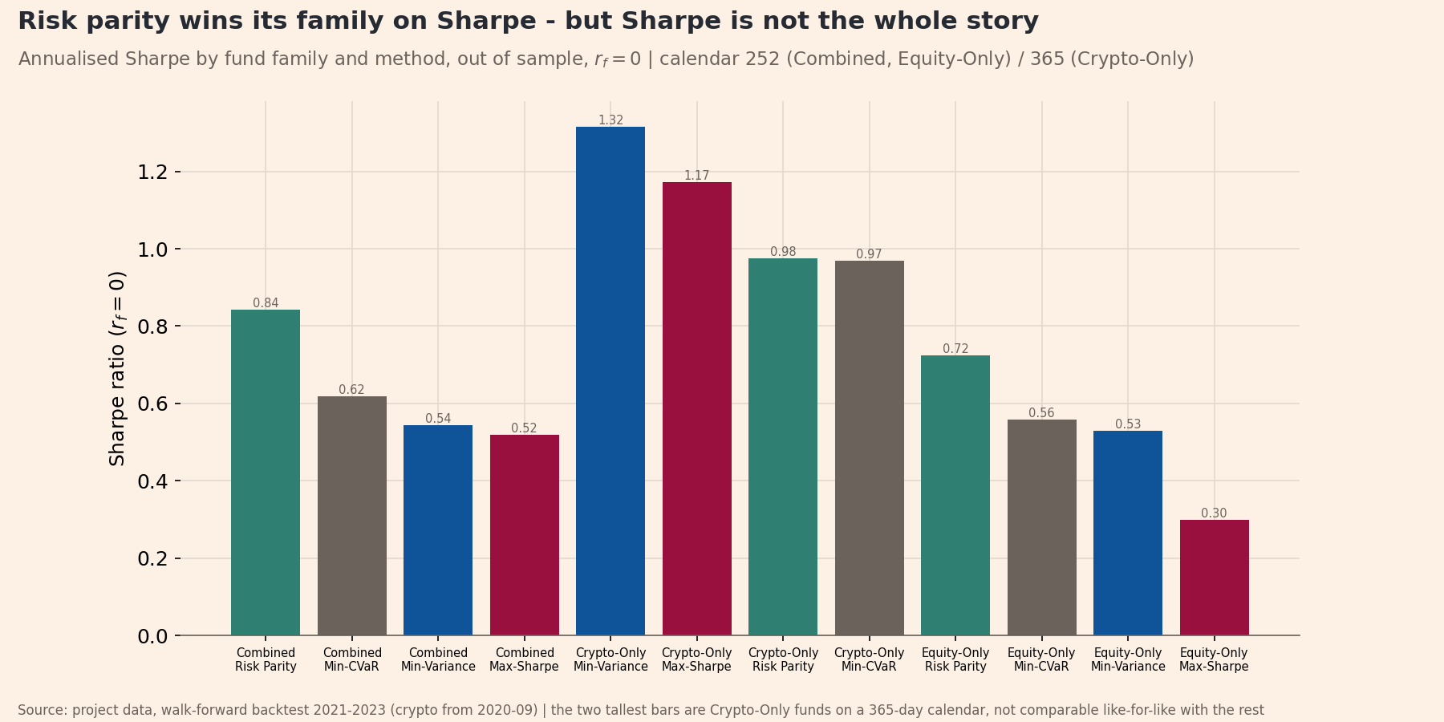
Figure 1. Annualised Sharpe ratio by fund family and construction method, out-of-sample, risk-free rate set to zero. Twelve funds (three asset families x four methods). Combined and Equity-Only funds annualise on a 252-day calendar and Crypto-Only on 365, so Crypto-Only bars are not comparable like-for-like. Sample: walk-forward backtest 2021-01-04 to 2023-12-29 (Crypto-Only from 2020-09-10).
Table 1 tells a more complete story once volatility and drawdown enter alongside return. The Sharpe ranking holds true within the Equity-Only family too: Risk Parity leads at 0.7231, Min-CVaR follows at 0.5590, Min-Variance sits at 0.5291, and Max-Sharpe trails at 0.2996, so the ordering is not a Combined-family artefact. The Crypto-Only family delivers the single sharpest fact in the table: Crypto-Only Min-Variance posts a Sharpe ratio of 1.3160, the highest of all twelve funds, but carries a maximum drawdown of -71.2%. A Sharpe ratio alone would send a retail investor into a fund that lost more than seventy cents on every dollar at its worst point. This is exactly why growth of one dollar, drawdown, and the crash panel sit alongside the Sharpe bar. Risk-adjusted return asks a completely different question than maximum potential loss. A fact sheet answering only the first question misleads by omission.
Fund | Growth of $1 | Ann. return | Ann. volatility | Sharpe | Max drawdown | Holdings | Calendar
Crypto-Only Min-Variance | 10.097 | 97.4% | 74.0% | 1.316 | -71.2% | 7 | 365
Crypto-Only Max-Sharpe | 7.239 | 88.3% | 75.3% | 1.172 | -73.2% | 5 | 365
Crypto-Only Risk Parity | 4.488 | 76.2% | 78.1% | 0.975 | -79.6% | 10 | 365
Crypto-Only Min-CVaR | 4.341 | 72.7% | 75.0% | 0.969 | -75.2% | 6 | 365
Combined Risk Parity | 1.441 | 13.5% | 16.1% | 0.842 | -20.5% | 60 | 252
Equity-Only Risk Parity | 1.328 | 10.6% | 14.6% | 0.723 | -18.5% | 50 | 252
Combined Min-CVaR | 1.246 | 8.3% | 13.4% | 0.618 | -17.2% | 16 | 252
Equity-Only Min-CVaR | 1.213 | 7.3% | 13.1% | 0.559 | -17.3% | 16 | 252
Combined Min-Variance | 1.196 | 6.8% | 12.5% | 0.543 | -16.1% | 20 | 252
Equity-Only Min-Variance | 1.189 | 6.6% | 12.4% | 0.529 | -15.9% | 19 | 252
Combined Max-Sharpe | 1.317 | 11.8% | 22.7% | 0.519 | -34.6% | 12 | 252
Equity-Only Max-Sharpe | 1.114 | 5.0% | 16.8% | 0.300 | -27.9% | 15 | 252
Table 1. Fund performance and fact-sheet elements, all twelve funds, out-of-sample and gross of transaction costs. Columns are the six elements the brief requires per fund: growth of $1 (multiple of the initial dollar), annualised return and volatility (%), Sharpe ratio (risk-free rate zero), maximum drawdown (%), and the number of holdings at the most recent rebalance (names in Appendix F). Calendar is the annualisation basis in days: 252 for Combined and Equity-Only, 365 for Crypto-Only. Sorted by Sharpe. Sample: 2021-01-04 to 2023-12-29 (Crypto-Only from 2020-09-10). Source: performance_metrics.csv joined to current_holdings.csv.
Growth of $1 and the drawdown figure show what that Sharpe ranking costs in practice (Figures 2 and 3). Max-Sharpe pays the steepest price for its returns: a maximum drawdown of -34.6%, more than double Min-Variance's -16.1%. Min-CVaR, the fund this section recommends, grows a dollar to $1.2463 over the same window. The ride matters as much as the endpoint. All four methods track closely through 2021 and separate sharply in 2022. The concentrated bets of Max-Sharpe fall hardest into the drawdown that defines its entire out-of-sample record. Meanwhile, Min-Variance and Min-CVaR give up less ground and recover faster. A fund reporting only the final growth multiple would hide this reality. A retail investor lives through the shape of the drawdown, not just its depth.
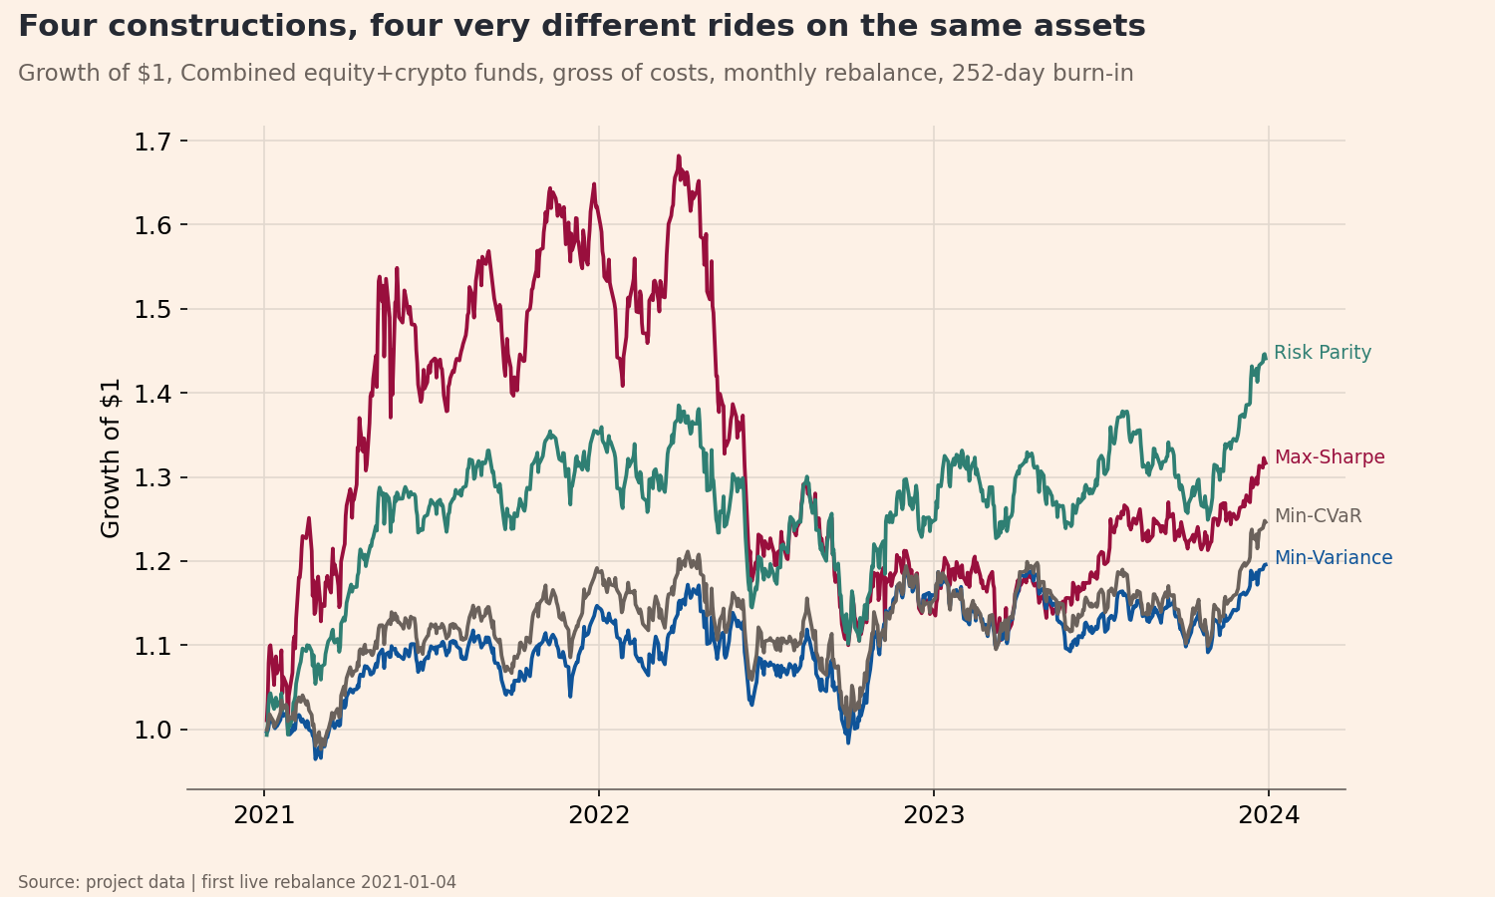
Figure 2. Growth of $1 invested at the first live rebalance, Combined funds across the four construction methods, out-of-sample and gross of costs. Vertical axis is the cumulative value of one dollar (multiple, unitless). Sample: 2021-01-04 to 2023-12-29, 252-day calendar.
Fund weights answer two different questions, and both matter (Appendix A). The first is how a single stock is treated across methods. NVDA is the clearest case: Max-Sharpe holds it in 30 of the 36 Combined rebalances, pinned at the 10% cap in 22 of those, while Min-CVaR never holds it at all, in any of the 36 rebalances. Same asset, same data, opposite verdicts, because one objective rewards NVDA's mean return and the other charges for its tail risk. The second question is what a single fund's whole book looks like over time, shown for the recommended Combined Min-CVaR fund. Holdings counts are an output of each method, not a design choice: across the Combined family's 36 rebalances, Min-CVaR holds 13 to 16 of the 60 assets, Min-Variance 13 to 21, and Max-Sharpe 12 to 18, while Risk Parity holds all 60 by construction (53 to 60 clear the 0.5% reporting threshold in practice). The single-asset families read these same counts against a different denominator: Equity-Only picks from 50 names and Crypto-Only from 10.
Transaction costs do not reorder the podium (Appendix C). Net of costs at every level on the 0, 10, 20, and 50 basis-point grid, Risk Parity always stays ahead of Min-CVaR, which stays ahead of Min-Variance, which stays ahead of Max-Sharpe; Min-Variance and Max-Sharpe converge only at 50 basis points, to Sharpe ratios of 0.427 and 0.424. Turnover explains why: Max-Sharpe trades 409% of the portfolio two-way each year, Min-Variance 263%, Min-CVaR 100%, and Risk Parity just 49%, so the two highest-turnover methods absorb the most cost as the fee grid rises. The full cost treatment, including exactly where each method's advantage breaks even, follows later in the report.
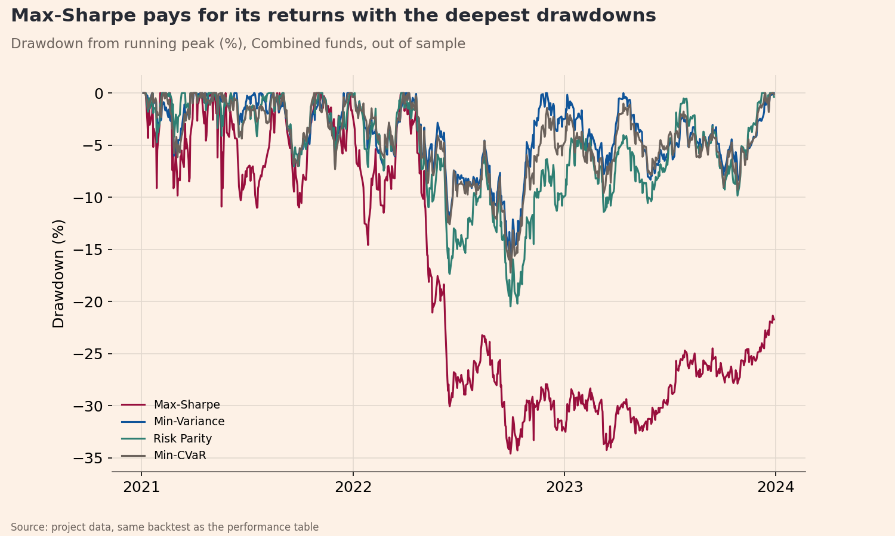
Figure 3. Drawdown from the running maximum, Combined funds, out-of-sample. Vertical axis is the percentage fall from the previous peak of growth of $1, so zero is a new high. Sample: 2021-01-04 to 2023-12-29, 252-day calendar.
All 520 rebalance solves across the twelve funds converge successfully (four methods across 130 dates: 36 Combined, 36 Equity-Only, and 58 Crypto-Only), and the methods produce genuinely different portfolios, not near-duplicates. The closest pair in every family is always Min-Variance against Risk Parity, and even that pair separates by a distinct maximum absolute weight difference: 0.078 in Combined, 0.076 in Equity-Only, and 0.150 in Crypto-Only (Appendix F), the minimum gap found anywhere, not the largest. Combined Min-CVaR holds 16 names on 2023-12-05, five of them pinned at the 10% cap; the full weights sit in Appendix F, distinct from the over-time view in Appendix A.
The evidence points to Combined Min-CVaR as the recommended fund based on three separate arguments. First, a bootstrap test splits the four methods into a protective pair and an exposed pair on the market's worst days. Risk Parity and Max-Sharpe underperform Min-CVaR by 0.94 to 2.22 percentage points on crash days. All four confidence intervals in that comparison exclude zero. Second, Min-CVaR earns more than Min-Variance for indistinguishable protection within the protective pair. It delivers an annualised return of 8.26% against 6.76%. It also produces a Sharpe ratio of 0.6180 against 0.5427. Third, the Min-CVaR objective targets tail loss directly. It does not rely on variance as a proxy for loss. This direct approach perfectly matches a product built on the promise of being downside aware.
The third argument is a judgement call about which objective best matches that promise, not a measured win the way the first two are, and it should be stated as one. This recommendation does not bury Risk Parity's Sharpe ratio: among the four broad-family methods, it remains the strongest choice for an investor who wants return per unit of risk and is willing to accept its weaker protection on the market’s worst days to get it. Appendix F holds per-fund fact-sheet detail for every method.

The sentiment index
Quokka scores headlines with finVADER, a finance-aware extension of VADER. It adds the SentiBigNomics economic lexicon and the Henry financial word list to the general VADER lexicon. The finance lexicon proves its value on this data. The project brief warns that plain VADER scores about half of finance headlines as neutral, and that many of these are false neutrals. This analysis confirms that warning almost exactly. The dataset contains 105,330 distinct headlines. Plain VADER scores 48.09% of them exactly zero, and finVADER reduces this neutral share to 16.0%. Plain VADER produces 50,654 silent headlines. The finance lexicon rescues 34,662 of these silent readings, a 68.4% recovery rate, and grows the working lexicon from 7,502 to 13,324 terms. A compound score of exactly zero means the model found no scored token. It does not indicate balanced news. This recovered signal adds real value rather than smoothing the data.
The sector index construction follows two specific steps. The sentiment scores are first averaged within each ticker-day. An equal-weight mean is then applied across the tickers in each sector. The order of operations matters. Headline counts remain uneven across tickers on any given day, so a flat mean over all headlines would let the most-covered stock dominate the sector reading. Averaging within each ticker first gives every stock an equal voice, regardless of how many headlines it drew. Raw headline text is scored without stripping casing, punctuation, or stopwords. VADER reads capitalisation as emphasis, an exclamation mark as intensity, and negations as sentiment-reversing. Removing these features would discard the exact signal the model expects to read.
Days without headlines are handled using an explicit three-level rule, justifying each level rather than relying on defaults. First, a silent ticker-day is dropped from that day's sector mean, and is never scored as neutral. Even the thinnest sector still averages 2.84 active tickers on a news day, though Appendix G shows that nine of the ten sectors rest on a single ticker on their sparsest days, a limit stated openly rather than hidden. Second, a sector-day with no headlines is left undefined, and data is never invented to fill it; this is rare, as the index is at least 93.4% complete for every sector. Third, for the daily fusion signal only, an undefined value is forward-filled up to five trading days, then set it to neutral zero beyond that gap. The signal constructor lags every signal by at least one trading day, machine-verified so that the signal on day t equals the raw score from day t-1 exactly.
The index is validated against the market's worst days rather than assuming it works (Table 2). Around each of the three crash events verified in Part A, the sector index falls into the bottom quartile of its own 2020-2023 distribution. The OXY collapse on 2020-03-09 sits at the 7th percentile, the BCH-USD fall on 2020-03-12 at the 18th, and the COVID crash week of 2020-03-16 at the 23rd. The test is meaningful because it includes a positive control. The XLM-USD rally of 74.9% on 2021-01-06 sits at the 56th percentile and is correctly not flagged. An index flagging that rally as fear would be reacting to news volume. This one separate volume from sentiment.
Two caveats carry forward. The scores come from headlines rather than full articles, a deliberately noisy proxy inherited from Part A. And the thin sectors, Materials and RealEstate at roughly 2.8 to 3.0 mean tickers per day, carry noisier readings than the broad ones. Figure 4 displays the ten sector indices over time, with Energy's steady climb through 2021 and 2022 the clearest regime shift as the sector's fortunes turned.
Event | Date | Days | Index level | Percentile | Flagged
OXY -52.0% (2020-03-09) | 2020-03-09 | 5 | 0.018 | 7.4% | yes
BCH-USD -43.0% (2020-03-12) | 2020-03-12 | 5 | 0.039 | 18.3% | yes
COVID crash week (2020-03-16) | 2020-03-16 | 5 | 0.047 | 23.5% | yes
XLM-USD +74.9% control (2021-01-06) | 2021-01-06 | 5 | 0.076 | 55.9% | no
Table 2. Event validation of the sector sentiment index. Each row is a verified market event; Index level is the mean compound score across the ten equity sectors over the event window, and Percentile is that level's rank within the index's own 2020-2023 distribution (%). Flagged is true when the level falls in the bottom quartile. The final row is a positive control, a large rally, which the index should not flag. Source: results/tables/sentiment_event_validation.csv.
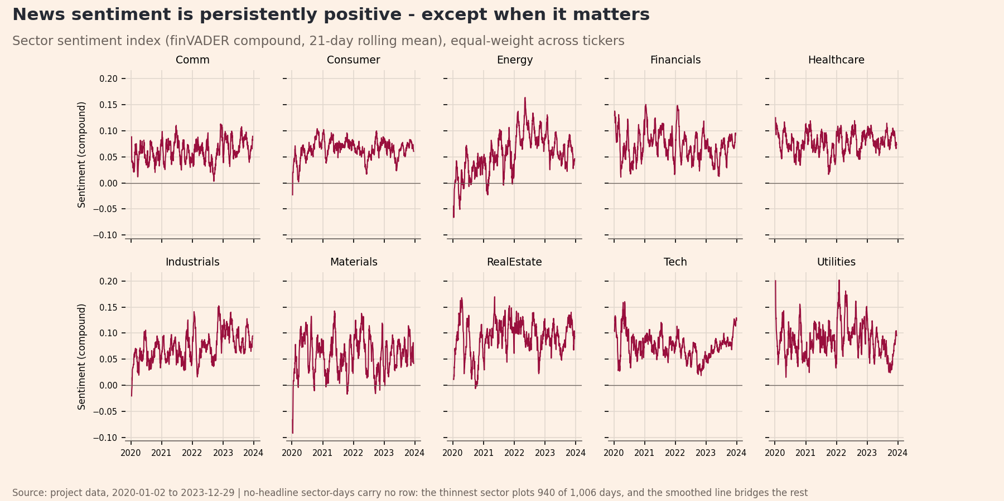
Figure 4. News-sentiment index for the ten equity sectors, daily, 2020-2023. Vertical axis is the finVADER compound score (unitless, bounded -1 to +1), built as a ticker-day mean and then equal-weighted across the tickers in each sector. Sector-days with no headlines are left undefined rather than set to neutral. Sample: 9,832 sector-days from 105,330 distinct headlines.

Extensions and innovations
Part A demonstrated that variance-based risk understates joint downside. Part B transforms this insight into two testable product features. It introduces a tail-objective fund and a crash-day evaluation panel. It also delivers three supporting strands covering transaction costs, sentiment fusion, and lexicon expansion. Every single strand was built and demonstrated with a saved artefact. A sixth strand completes the product offering. The app incorporates a full design system detailed in Section 5 and Appendix B.

The minimum-CVaR fund
The Min-CVaR fund optimises tail loss directly rather than relying on a variance proxy. The objective minimises expected loss beyond a specific threshold. The formulation solves as a linear program.
$$min⁡(α+\frac{1}{T(1-β)}\sum_{t}{u_{t}})$$
It requires the constraints $u_{t}≥-{x_{t}}^{⊤}w-α$ and $u_{t}≥0$. The confidence level$β$ equals 0.95 to target the worst 5% of the fund’s own losses. The variable α represents the solved Value at Risk. The term u_{t} measures the shortfall. The vector $x_{t}$ holds the day-t returns. The backtest runs this using the scipy.optimize.linprog solver. The 0.95 confidence level was established earlier to ensure enough scenarios to estimate a tail average. This formulation creates a sparse linear-programming vertex. This produces behaviour completely different from mean-variance methods. Max-Sharpe pins NVDA to the 10% cap at 22 different rebalances. Min-CVaR holds zero NVDA at every single rebalance. It holds 16 names on 2023-12-05 with the largest positions sitting exactly at the 10% cap.

The co-crash stress panel and paired bootstrap
The crash-day evaluation panel represents the headline innovation of this report. The performance gap is defined as the difference in conditional means.
$$gap=E\left(r | crash days\right)-E\left(r | other days\right)$$
The paired bootstrap resamples these crash dates with replacement. It recomputes the mean difference between two funds 2,000 times. It extracts the 2.5th and 97.5th percentiles to form a confidence interval. Crash days are defined by applying threshold $q$ to each aggregate’s own worst days, taking the equity and crypto aggregates separately, then intersecting the two sets. The out-of-sample period contains 9 crash days at a 5% threshold. It contains 22 days at a 10% threshold for the Combined and Equity-Only families. The crash dates come from the equity and crypto aggregates rather than the fund’s own losses. This ensures the fund is not grading its own homework.
The 5% threshold isolates 9 days. Eight of these falls in a single 2022 market episode. The 10% threshold yields 22 days spread across multiple years. This makes it the better baseline. On these 22 worst days, Min-Variance and Min-CVaR fall 1.44% and 1.52% respectively (Figure 5). Risk Parity drops 2.46%. Max-Sharpe falls 3.21%. A paired bootstrap evaluates these differences. A paired draw is used because fund returns correlate highly. Against Min-Variance, the Min-CVaR deficit of 0.08 percentage points is not distinguishable. The interval spans -0.19 to 0.04. Risk Parity and Max-Sharpe underperform Min-Variance by 1.01 and 1.76 percentage points respectively. Both intervals exclude zero. The single worst day cannot be bootstrapped because resampling cannot beat the observed minimum.
The Sharpe ranking and the crash ranking disagree entirely. The panel exists precisely to reveal this conflict. An investor shopping purely on Sharpe picks Risk Parity and pays a steep price on bad days. The funds are compared directly to the recommended Min-CVaR fund in Table 3. At the 10% threshold, Risk Parity underperforms Min-CVaR by 0.94 percentage points. The interval spans -1.16 to -0.71. At the 5% threshold, Risk Parity trails by 1.32 percentage points. Max-Sharpe trails by 2.22 percentage points. Both intervals exclude zero. This creates a range of 0.94 to 2.22 percentage points of underperformance. One negative finding must also be stated clearly. Minimising the tail and minimising variance provide indistinguishable protection on this specific universe.
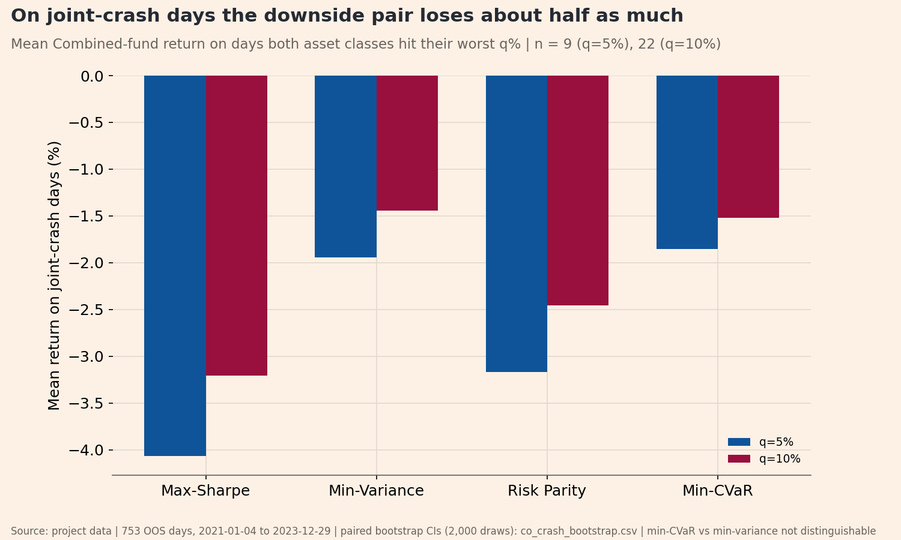
Figure 5. Co-crash stress panel: fund performance on days when the equity and crypto aggregates were both in their own worst q% of daily returns. Vertical axis is the mean daily return in percent on those days. Both thresholds are shown (q = 5%, 9 out-of-sample days; q = 10%, 22 days). Sample: Combined funds, 2021-01-04 to 2023-12-29.
Fund A | Fund B (benchmark) | Crash days | Gap (pp/day) | CI low | CI high
Combined Risk Parity | Combined Min-CVaR | 22 | -0.94 | -1.16 | -0.71
Combined Max-Sharpe | Combined Min-CVaR | 22 | -1.69 | -2.17 | -1.20
Table 3. Paired bootstrap of the co-crash gap at the q = 10% threshold, each fund against the recommended Combined Min-CVaR. Gap is the difference in mean daily return on the 22 joint-crash days, in percentage points per crash day; CI low and CI high are the 95% percentile interval from 2,000 paired resamples of those days. A negative gap means Fund A lost more than the benchmark. Sample: 2021-01-04 to 2023-12-29. The full ten pairings, both thresholds and both benchmarks, are in Appendix E. Source: results/tables/co_crash_bootstrap.csv.

The transaction-cost model
Transaction costs are modelled directly inside the backtest. Treating costs as zero is a quantified simplification rather than a blind hope. Two-way turnover $τ_{t}$ and net return $r_{net}$ are defined mathematically.
$$τ_{t}=\sum_{i}{\left|w_{i,t}-w_{i,t-1}\right|}$$
$$r_{net}=r_{gross}-τ_{t}(\frac{b}{10000})$$
The variable $b$ represents basis points in a grid of 0, 10, 20, and 50. The first rebalance incurs a full turnover of 1. Three findings emerge from this cost model. First, the performance podium never reorders across the fee grid. Risk Parity beats Min-CVaR. Min-CVaR beats Min-Variance. Min-Variance beats Max-Sharpe. Min-Variance and Max-Sharpe finally converge at 50 basis points. They post Sharpe ratios of 0.427 and 0.424 respectively. Second, the breakeven point between the EWMA and static covariance estimators sits near 20 basis points. The EWMA drives 263% annual turnover against just 30% for the static window. Third, the zero-cost headline numbers face strict practical bounds. Appendix C holds the full sensitivity tables.

Sentiment fusion: before and after
The sentiment tilt produces a negligible-to-negative impact net of costs. This represents an honest result. The sentiment signal $z_{i}$ is standardised. It is forward-filled up to five days before setting it to neutral. It is then shifted forward by at least one day. This shift guarantees no look-ahead bias. The tilt adjusts the baseline weights $w_{i}$.
$$\overline{w_{i}}=w_{i}(1+k×max\left(-2,min⁡(z_{i},2\right)))$$
The result is renormalised to the equity budget, and the position caps are reapplied. The scaling factor k is 0.10. This bounds any tilt to 20% of a given name. Equities are the only assets tilted. Missing signals default to a neutral factor of one. Figure 6 and Table 4 show the results, with the full grid in Appendix H. The gross Sharpe ratio changes by 0.0034 for Max-Sharpe, -0.0107 for Min-Variance, 0.0015 for Risk Parity, and 0.0050 for Min-CVaR. At 20 basis points net of costs, the Sharpe impacts fall to 0.0019, -0.0139, -0.0075, and -0.0009 respectively. The gross Sharpe peaks near 0.6347 at a k value of 0.3. However, the maximum tilted drawdown worsens monotonically from -17.2% to -20.2% by a $k$ value of 0.5. Setting $k$ to zero reproduces the base case exactly. This confirms the wiring works properly. The tilt simply trades more than the underlying signal justifies. The factor $k$ was not artificially tuned after the fact.
Fund | Sharpe, base | Sharpe, tilted | Delta, gross | Delta, net 20 bps | Max drawdown, tilted
Combined Max-Sharpe | 0.5193 | 0.5227 | +0.0034 | +0.0019 | -34.8%
Combined Min-Variance | 0.5427 | 0.5321 | -0.0107 | -0.0139 | -16.2%
Combined Risk Parity | 0.8416 | 0.8431 | +0.0015 | -0.0075 | -20.4%
Combined Min-CVaR | 0.6180 | 0.6230 | +0.0050 | -0.0009 | -17.8%
Table 4. Sentiment fusion before and after, per fund. Sharpe ratios use a risk-free rate of zero; Delta is tilted minus base, reported gross and net of 20 basis points per unit of two-way turnover. Tilt strength k = 0.10, clipped at plus or minus two standard deviations, applied to the equity sleeve only and lagged at least one trading day. Maximum drawdown is in percent. Sample: 2021-01-04 to 2023-12-29, 252-day calendar. Source: results/tables/fusion_before_after.csv.
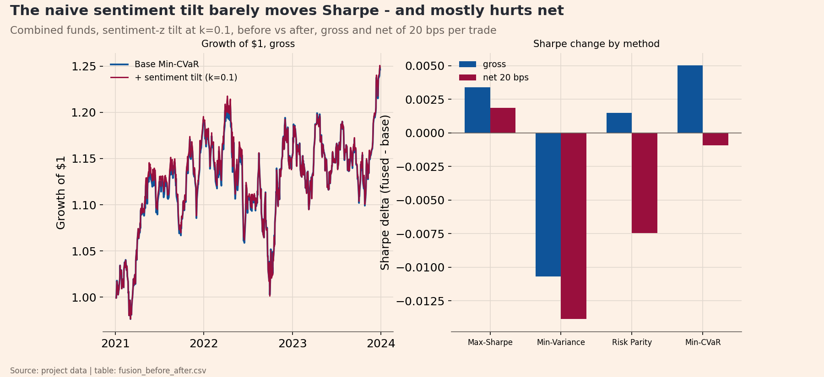
Figure 6. Sentiment fusion, before and after base fund versus the sentiment-tilted fund for each equity-bearing Combined method. Comparison is on the Sharpe ratio (risk-free rate zero), shown gross and net of 20 basis points per unit of two-way turnover. The tilt is a per-ticker sentiment-z tilt on the equity sleeve only, lagged at least one trading day. Sample: 2021-01-04 to 2023-12-29.

Extending the finance lexicon
The lexicon extension acts as a targeted refinement rather than a complete rewrite. It changes just 1.04% of headline scores. The resulting index correlates at 0.990 with the base version. This was pursued to fix inflection gaps and residual false neutrals. AI proposed and rated 32 candidate words. These were first verified to be absent from the existing 13,324-term lexicon. Candidates with a standard deviation above 2.5 or an absolute mean below 0.5 were filtered out. This dropped four planted ambiguous terms including margin, margins, short-squeeze, and stress-test. The 28 passing candidates were manually reviewed and approved (Appendix I).
VADER lacks a stemming feature. This leaves obvious inflection gaps. The base lexicon contained downgrade but missed downgrades and downgraded. Single tokens were installed to fix this. Multi-word concepts entered as hyphenated tokens. Exactly 1,106 headlines contain an installed term. This represents 1.05% of the total. Of these, 1,097 headlines changed score. The update fixed 253 false neutrals. The mean absolute change sits at 0.380. The index was revalidated against the market crash events. Two of the three events sharpen. The OXY drop moves from 0.074 to 0.055. The BCH fall moves from 0.183 to 0.151. One event drifts the wrong way. The COVID week shifts from 0.2346 to 0.2386. It remains safely below the 0.25 threshold. The positive control stays correctly unflagged. It shifts from 0.559 to 0.513.
The co-crash panel with bootstrap confidence intervals stands as the headline innovation. It provides an original evaluation method that changes the fund recommendation a Sharpe ranking would give. The Min-CVaR fund is the specific product this panel evaluates. Finally, the transaction-cost model bounds when this entire construction actually pays off for an investor.

The app and the investor journey
The app makes downside awareness visible rather than just asserted. It serves as the product surface for the risk-conscious retail investor. A clear market gap exists today. Almost nobody sells a single fund holding equities and crypto together. An investor wanting both must buy two products. They must size the crypto sleeve completely blind to how the two behave on the same day. The business model is simple. Quokka charges 0.35% per annum on the balance. It charges nothing on entry or exit. The app hero states both facts clearly. Fee accrual is calculated directly.
$$r_{after}=r-\frac{f}{C}$$
The variable f equals the 0.35% annual fee. The variable C represents the fund calendar of either 252 or 365 days. Charging 252 days everywhere would overcharge a crypto fund by roughly 45%. Gross figures are reported in the results, and this display math is applied in the app.
The investor journey follows the project brief across four core tabs. A fifth tab named About and Data carries the methodology and disclosures. The Compare tab displays all 12 funds. A cost slider applies the precomputed net columns. One line highlights the recommended fund by contrasting the Sharpe ratio against the crash-day trade-off. The Fact Sheet tab opens with a key facts block. It displays fees, inception date, rebalance frequency, holdings, caps, and calendar days. Metric cards follow this block. The page then shows the growth of one dollar both gross and after the 0.35% fee. It also plots drawdown and current holdings at the cap. The fact sheet includes the co-crash panel to make the pitch concrete. A dedicated expander shows weights over time. The Allocation tab provides renormalised sliders. It displays blend metrics and the exact crash-day mean of the blend. A mean is perfectly linear in weights. The Sentiment tab displays the sector index with smoothing. It holds the event validation table including the positive control. It also details coverage and states the fusion verdict honestly. Appendix B holds the app screenshot.
The design system deliberately uses a separate register. The app employs a dark trading-terminal surface. The report keeps its cream FT look. They reconcile perfectly because the app draws its charts live from the same results folder. Restyling the app cannot alter a report exhibit. The system uses two encoding channels. Hue signifies the method. Dash style signifies the asset family. Solid lines mean Combined. Dashed lines mean Equity-Only. Dotted lines mean Crypto-Only. This creates 12 distinct pairs pinned by a test. The user blend draws in white so it never collides with a constituent fund. Colour is explicitly set and never derived. Every panel writes its own foreground and background. The system uses a dark-tile ladder on a true-black floor. It reserves one specific accent colour for interaction. The typography uses a weight ladder of 300, 400, 600, and 700. The 500 weight was deliberately omitted. A documented radius scale reserves the pill shape exclusively for actions. Motion relies on intent. The system honours reduced motion preferences by dropping animations from 0.22 seconds to near zero. The contrast ratio clears WCAG AA standards at 5.6 to 1. The layout is fully responsive. The layout was verified across widths of 390, 430, 768, 1280, and 1600 pixels with zero horizontal overflow. The four-column stat grid steps to two columns below 900 pixels. It steps to a single column below 520 pixels. The tab strip wraps cleanly. This is a dense analytics tool with deliberately tight spacing rather than a loose consumer surface.
The app was deployed from a public GitHub repository on Streamlit Cloud at [paste live URL and repo — Phase 10]. It reads only precomputed results and hosted prices via the course helper. The sentiment model runs strictly at build time. The only live arithmetic is display math. Each tab functions as an isolated fragment. A control redraws only its own tab. The app survives data host downtime by degrading to a stated message. The product intentionally excludes certain features. It offers no point forecasts. It performs no live rebalancing. It runs no live reoptimisation. The About and Data tab carries an explicit coursework and non-investment-advice statement to ensure full transparency.

Critical reflection and three recommendations
Strict discipline shaped the build process rather than intuition. Checking against real data before coding caught a crypto-cap degeneracy early. Ten assets at a 10% cap sum exactly to 1.00. This forces all four methods to collapse into an equal-weight portfolio. The claim ledger ensured the build reproduced every planned number perfectly on the first run. Event validation succeeded by using a positive control. The XLM rally scored 0.559 and was correctly ignored. This proves the index separates sentiment from news volume. The bootstrap testing also overturned two planned claims. The idea that Min-CVaR wins the single worst crash day was retracted because a minimum cannot be bootstrapped. The claim that Min-CVaR loses to Min-Variance at the 10% threshold was also retracted because the confidence interval straddles zero.
Several hypotheses failed against the data and require transparent acknowledgement. First, Min-CVaR provides indistinguishable protection from Min-Variance on crash-day means. The planned story of superior protection did not survive a gap of -0.08 percentage points and an interval spanning -0.19 to 0.04. Second, the sentiment fusion adds roughly zero value net of costs. Third, the EWMA covariance estimator offers a modest edge. It improves full-panel volatility by 0.33 percentage points from 12.79% to 12.45%. This advantage completely vanishes above 20 basis points. Fourth, the crash sample remains thin and episode concentrated. Eight of the nine out-of-sample crash days at the 5% threshold fall within a single 2022 market episode.
The most important failure occurred when automated tests provided false security for the UI render layer. The underlying analysis was completely correct but the product displayed wrong numbers. The app showed 11 of the 12 funds at a 0.1% annual return. The co-crash panel read -0.02% instead of the true -1.85%. A simple formatting error caused this. The column configuration applied a percent string format to a raw decimal fraction. This defect survived automated testing completely. A strict sweep matched the wiring logic perfectly to extreme precision. The test reads the data passed to a widget rather than the output drawn on screen. A real browser screenshot finally revealed the error. Two later manual rounds found more bugs including undefined Sharpe ratios and broken mobile layouts. Ten additional findings came from visual inspection rather than reading code. A test only fails on the specific dimension it observes. Passing checks measures the coverage of the tests rather than the correctness of the product.
Specific limits define the boundaries of these findings. The zero-cost assumption is strictly bounded by the breakeven and podium results. The sentiment scores rely on headlines rather than full articles as a noisy proxy inherited from Part A. The Min-CVaR formulation relies on a 0.95 confidence level across just 12.6 initial tail scenarios. It does not use extreme value theory extrapolation. The EWMA covariance model is evaluated without testing the trade-off against a GARCH model. The sector index carries more noise in thin sectors. These average just 2.84 to 2.97 active tickers. Nine of the ten sectors hit a single-ticker floor on their sparsest days. The sentiment signal applies strictly to equities. Finally, Min-Variance exhibits numerical flatness which indicates that shrinkage methods require future exploration.
Three concrete recommendations are proposed to evolve this product.
First, the construction requires a turnover-penalised rebalance rule. A simple no-trade band offers a practical solution. The EWMA estimator drives 263% annual turnover compared to just 30% for the static window. The calculated 20 basis point breakeven quantifies exactly what a cost model must overcome. This proves the EWMA struggles to pay off outside of highly liquid large-cap assets.
Second, the app should implement a block-bootstrap fan chart. This was deferred by design in the current build. This feature plots percentile bands of future growth while explicitly preserving volatility clustering. It acts as an honest statistical replacement for the deterministic point forecasts that Quokka rightly refuses to show.
Third, the system needs human-labelled headline calibration for the 28 installed lexicon terms. These terms are currently AI-rated and human-approved. Fixing 253 false neutrals clearly shows the coverage upside of this expansion. Formal human labelling provides the only rigorous test to confirm whether the assigned sentiment magnitudes are actually correct.

Appendix

Appendix A. Portfolio weights
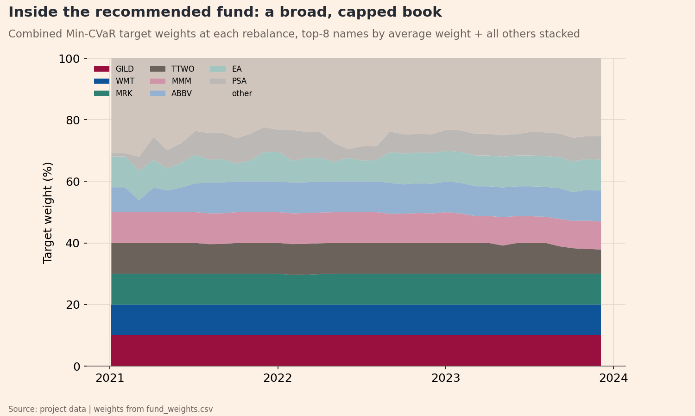
Figure 7. Target weights of the recommended Combined Min-CVaR fund over time, stacked so the bands sum to 100%. Vertical axis is the portfolio weight in percent, set at each 21-trading-day rebalance from data strictly before that date. This is the second reading of the brief's weights-over-time requirement; Figure 4 is the first. Sample: 36 rebalances, 2021-01-04 to 2023-12-29.
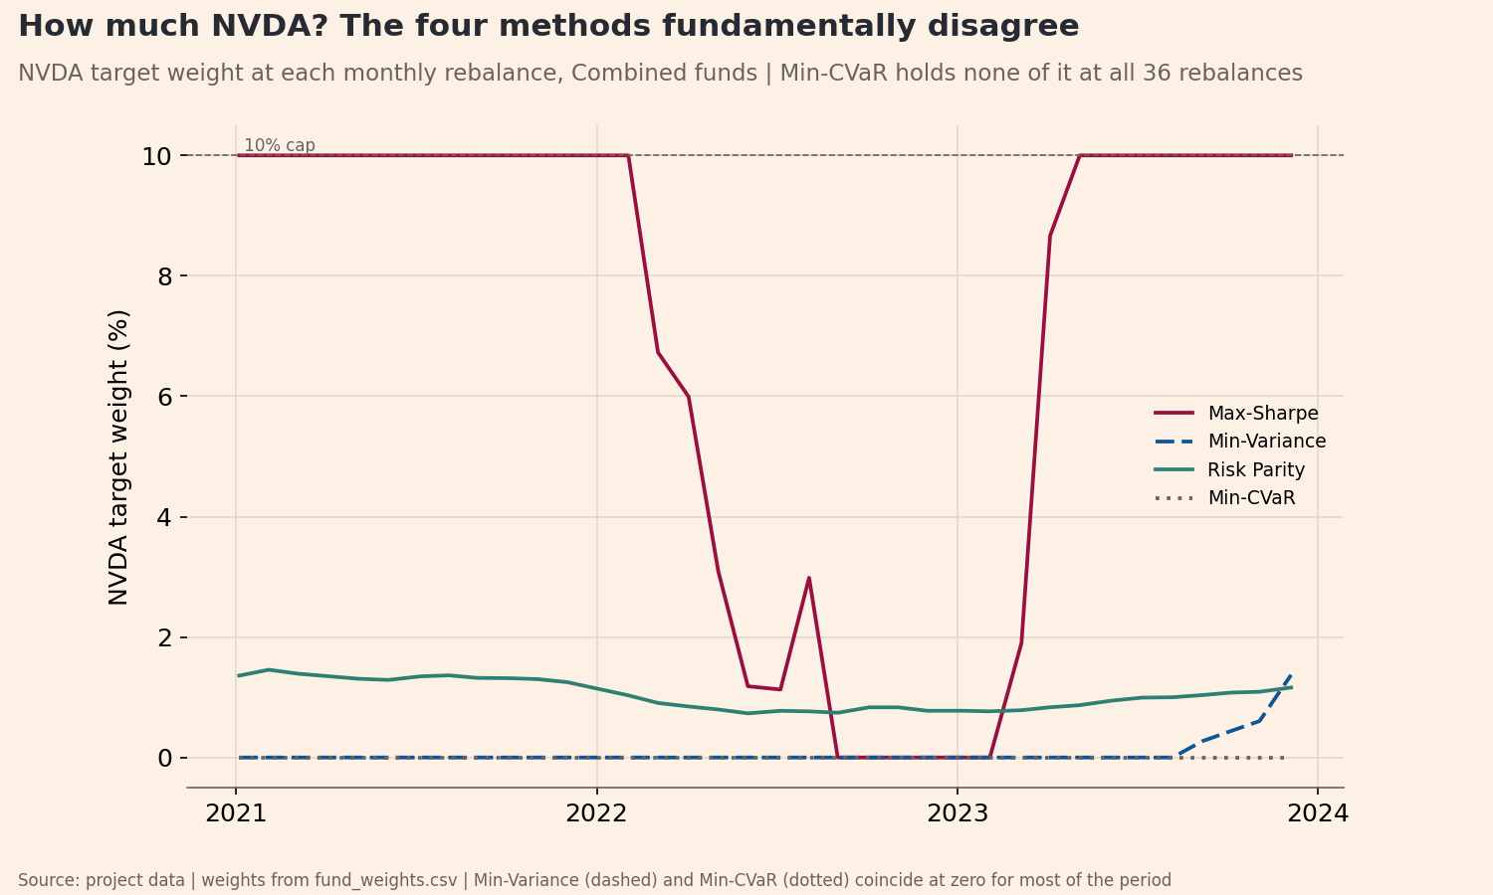
Figure 8. Target portfolio weight on NVDA over time under each of the four construction methods, Combined family. Vertical axis is NVDA's weight in percent of the portfolio, set at each 21-trading-day rebalance from data strictly before that date. Sample: 36 rebalances, 2021-01-04 to 2023-12-29.

Appendix B. The deployed app
[Figure A2 is a screenshot of the deployed app's fact-sheet tab showing the Key facts block (management fee, inception, rebalance, holdings, cap, calendar) AND the co-crash panel - the fee line is the visual proof of the revenue model, so do not crop it out. CAPTURE IT FROM THE LIVE share.streamlit.io URL AFTER PHASE 10, never from localhost. Insert the image above the caption below, then delete this line. DELETE THIS LINE.]
Figure 9. The Quokka fact-sheet tab as deployed, showing the co-crash stress panel for the recommended fund. Captured from the live application at [paste the share.streamlit.io URL here].

Appendix C. Full performance metrics
Fund | Ret | Vol | Shp | MaxDD | G$1 | Cal | Days | Turn | R0 | S0 | R10 | S10 | R20 | S20 | R50 | S50
Combined Max-Sharpe | 11.8% | 22.7% | 0.519 | -34.6% | 1.317 | 252 | 753 | 409% | 11.8% | 0.519 | 11.3% | 0.500 | 10.9% | 0.481 | 9.6% | 0.424
Combined Min-Variance | 6.8% | 12.5% | 0.543 | -16.1% | 1.196 | 252 | 753 | 263% | 6.8% | 0.543 | 6.5% | 0.520 | 6.2% | 0.497 | 5.3% | 0.427
Combined Risk Parity | 13.5% | 16.1% | 0.842 | -20.5% | 1.441 | 252 | 753 | 49% | 13.5% | 0.842 | 13.4% | 0.837 | 13.4% | 0.831 | 13.1% | 0.816
Combined Min-CVaR | 8.3% | 13.4% | 0.618 | -17.2% | 1.246 | 252 | 753 | 100% | 8.3% | 0.618 | 8.1% | 0.608 | 8.0% | 0.599 | 7.6% | 0.569
Equity-Only Max-Sharpe | 5.0% | 16.8% | 0.300 | -27.9% | 1.114 | 252 | 753 | 389% | 5.0% | 0.300 | 4.6% | 0.275 | 4.2% | 0.250 | 3.0% | 0.176
Equity-Only Min-Variance | 6.6% | 12.4% | 0.529 | -15.9% | 1.189 | 252 | 753 | 260% | 6.6% | 0.529 | 6.3% | 0.506 | 6.0% | 0.483 | 5.1% | 0.414
Equity-Only Risk Parity | 10.6% | 14.6% | 0.723 | -18.5% | 1.328 | 252 | 753 | 43% | 10.6% | 0.723 | 10.5% | 0.718 | 10.4% | 0.712 | 10.2% | 0.697
Equity-Only Min-CVaR | 7.3% | 13.1% | 0.559 | -17.3% | 1.213 | 252 | 753 | 110% | 7.3% | 0.559 | 7.2% | 0.548 | 7.1% | 0.537 | 6.6% | 0.505
Crypto-Only Max-Sharpe | 88.3% | 75.3% | 1.172 | -73.2% | 7.239 | 365 | 1208 | 184% | 88.3% | 1.172 | 88.1% | 1.170 | 87.9% | 1.167 | 87.3% | 1.158
Crypto-Only Min-Variance | 97.4% | 74.0% | 1.316 | -71.2% | 10.097 | 365 | 1208 | 285% | 97.4% | 1.316 | 97.1% | 1.312 | 96.7% | 1.308 | 95.8% | 1.295
Crypto-Only Risk Parity | 76.2% | 78.1% | 0.975 | -79.6% | 4.488 | 365 | 1208 | 49% | 76.2% | 0.975 | 76.1% | 0.974 | 76.1% | 0.973 | 75.8% | 0.970
Crypto-Only Min-CVaR | 72.7% | 75.0% | 0.969 | -75.2% | 4.341 | 365 | 1208 | 124% | 72.7% | 0.969 | 72.6% | 0.967 | 72.4% | 0.965 | 71.9% | 0.959
Table 5. Full performance metrics for all twelve funds, including the transaction-cost grid. Ret, Vol, MaxDD and Turn are annualised return, annualised volatility, maximum drawdown and two-way turnover per year, all in percent; Shp is the Sharpe ratio at a zero risk-free rate; G$1 is growth of one dollar as a multiple; Cal is the annualisation basis in days and Days the out-of-sample observation count. R0/S0 through R50/S50 are the annualised return and Sharpe net of 0, 10, 20 and 50 basis points charged on two-way turnover at each rebalance. Sample: 2021-01-04 to 2023-12-29 (Crypto-Only from 2020-09-10). Source: results/tables/performance_metrics.csv.

Appendix D. Covariance estimator study
Estimator | Ann. return | Ann. vol | Sharpe | Max DD | Turnover p.a. | Vol 2021 | Vol 2022 | Vol 2023
ewma_span_252 (locked) | 6.8% | 12.5% | 0.543 | -16.1% | 263% | 10.2% | 15.9% | 10.5%
ewma_span_126 | 6.5% | 12.6% | 0.513 | -17.3% | 496% | 10.2% | 16.1% | 10.5%
ewma_span_32 (RiskMetrics-style) | 7.1% | 13.7% | 0.518 | -16.2% | 1141% | 10.9% | 17.6% | 11.5%
static_full_window | 6.4% | 12.8% | 0.500 | -17.8% | 30% | 10.5% | 16.0% | 11.2%
Table 6. Rival covariance estimators, all evaluated on Combined Min-Variance, the fund whose only input is the covariance matrix. Returns, volatility, drawdown and turnover are in percent per year; Sharpe uses a zero risk-free rate. The three by-year volatility columns show whether the chosen estimator wins in every out-of-sample year or only on average. Sample: 2021-01-04 to 2023-12-29, 252-day calendar. Source: results/tables/parameter_study.csv.

Appendix E. Co-crash panel and bootstrap, in full
Fund | Threshold | Crash days | Mean on crash days | Worst single day | Mean, other days | Gap
Combined Max-Sharpe | q=5% | 9 | -4.07% | -5.53% | 0.10% | -4.16%
Combined Min-Variance | q=5% | 9 | -1.94% | -3.17% | 0.05% | -1.99%
Combined Risk Parity | q=5% | 9 | -3.17% | -4.26% | 0.09% | -3.26%
Combined Min-CVaR | q=5% | 9 | -1.85% | -2.93% | 0.06% | -1.91%
Equity-Only Max-Sharpe | q=5% | 9 | -3.26% | -4.22% | 0.06% | -3.32%
Equity-Only Min-Variance | q=5% | 9 | -1.90% | -3.15% | 0.05% | -1.95%
Equity-Only Risk Parity | q=5% | 9 | -2.68% | -3.71% | 0.07% | -2.76%
Equity-Only Min-CVaR | q=5% | 9 | -1.78% | -2.93% | 0.05% | -1.83%
Crypto-Only Max-Sharpe | q=5% | 9 | -10.10% | -14.58% | 0.32% | -10.42%
Crypto-Only Min-Variance | q=5% | 9 | -9.56% | -15.32% | 0.34% | -9.90%
Crypto-Only Risk Parity | q=5% | 9 | -10.00% | -14.22% | 0.29% | -10.29%
Crypto-Only Min-CVaR | q=5% | 9 | -10.04% | -13.93% | 0.28% | -10.32%
Combined Max-Sharpe | q=10% | 22 | -3.21% | -5.53% | 0.14% | -3.35%
Combined Min-Variance | q=10% | 22 | -1.44% | -3.17% | 0.07% | -1.51%
Combined Risk Parity | q=10% | 22 | -2.46% | -4.26% | 0.13% | -2.59%
Combined Min-CVaR | q=10% | 22 | -1.52% | -2.93% | 0.08% | -1.60%
Equity-Only Max-Sharpe | q=10% | 22 | -2.31% | -4.22% | 0.09% | -2.40%
Equity-Only Min-Variance | q=10% | 22 | -1.42% | -3.15% | 0.07% | -1.49%
Equity-Only Risk Parity | q=10% | 22 | -2.04% | -3.71% | 0.10% | -2.15%
Equity-Only Min-CVaR | q=10% | 22 | -1.42% | -2.93% | 0.07% | -1.49%
Crypto-Only Max-Sharpe | q=10% | 23 | -8.16% | -14.58% | 0.41% | -8.56%
Crypto-Only Min-Variance | q=10% | 23 | -7.85% | -15.32% | 0.42% | -8.28%
Crypto-Only Risk Parity | q=10% | 23 | -8.34% | -17.24% | 0.37% | -8.71%
Crypto-Only Min-CVaR | q=10% | 23 | -8.10% | -13.93% | 0.36% | -8.46%
Table 7. Co-crash stress panel in full: all twelve funds at both thresholds. Crash days are the out-of-sample days on which the equity and crypto aggregates were both in their own worst q% of daily returns. All return columns are daily means in percent; Gap is the crash-day mean minus the other-day mean, in percentage points. Crypto-Only rows carry a different crash-day count because they trade a 365-day calendar. Sample: 2021-01-04 to 2023-12-29. Source: results/tables/co_crash_panel.csv.
Threshold | Fund A | Fund B (benchmark) | Days | Gap (pp/day) | CI low | CI high | Distinguishable
q=5% | Combined Min-CVaR | Combined Min-Variance | 9 | +0.09 | -0.07 | +0.25 | no
q=5% | Combined Risk Parity | Combined Min-Variance | 9 | -1.23 | -1.58 | -0.89 | yes
q=5% | Combined Max-Sharpe | Combined Min-Variance | 9 | -2.13 | -2.82 | -1.43 | yes
q=5% | Combined Risk Parity | Combined Min-CVaR | 9 | -1.32 | -1.66 | -0.97 | yes
q=5% | Combined Max-Sharpe | Combined Min-CVaR | 9 | -2.22 | -2.95 | -1.48 | yes
q=10% | Combined Min-CVaR | Combined Min-Variance | 22 | -0.08 | -0.19 | +0.04 | no
q=10% | Combined Risk Parity | Combined Min-Variance | 22 | -1.01 | -1.20 | -0.82 | yes
q=10% | Combined Max-Sharpe | Combined Min-Variance | 22 | -1.76 | -2.21 | -1.32 | yes
q=10% | Combined Risk Parity | Combined Min-CVaR | 22 | -0.94 | -1.16 | -0.71 | yes
q=10% | Combined Max-Sharpe | Combined Min-CVaR | 22 | -1.69 | -2.17 | -1.20 | yes
Table 8. Paired bootstrap of the co-crash gap, all ten pairings across both thresholds and both benchmark funds. Gap is the difference in mean daily return on the joint-crash days in percentage points per crash day, with a 95% percentile interval from 2,000 paired resamples. Distinguishable is true when the interval excludes zero. The Min-CVaR versus Min-Variance pairings are the ones whose intervals straddle zero. Sample: 2021-01-04 to 2023-12-29. Source: results/tables/co_crash_bootstrap.csv.

Appendix F. Current holdings and method separation
Fund | Rebalance date | Names | Target weights (%)
Combined Max-Sharpe | 2023-12-05 | 12 | ABBV 10.0, NVDA 10.0, OXY 10.0, TMUS 10.0, TRX-USD 10.0, MRK 10.0, SO 8.5, NUE 8.4, ETH-USD 7.5, WMT 6.2, COP 5.5, BTC-USD 3.4
Combined Min-CVaR | 2023-12-05 | 16 | ABBV 10.0, EA 10.0, GILD 10.0, MRK 10.0, WMT 10.0, MMM 9.1, TTWO 7.9, PSA 7.8, T 5.0, NEM 4.2, AMGN 4.1, AEP 3.9, D 2.1, UPS 2.0, SHW 2.0, KO 1.9
Combined Min-Variance | 2023-12-05 | 20 | ABBV 10.0, WMT 10.0, MRK 10.0, KO 10.0, EA 8.9, V 7.7, XOM 7.1, TMUS 5.4, AMGN 5.1, DUK 4.9, ABT 4.7, T 3.8, O 3.4, NEM 2.5, TRX-USD 2.4, NVDA 1.4, SO 0.7, DD 0.7, INTC 0.6, TTWO 0.6
Combined Risk Parity | 2023-12-05 | 60 | MRK 4.1, WMT 3.5, ABBV 3.5, KO 3.1, AMGN 2.6, TMUS 2.5, ABT 2.4, DUK 2.3, T 2.2, GILD 2.2, SO 2.2, EA 2.2, V 2.1, XOM 2.0, O 2.0, CVX 2.0, AEP 2.0, CMCSA 1.8, NEM 1.8, PSA 1.8, TTWO 1.7, D 1.7, OXY 1.6, COP 1.6, GE 1.6, SLB 1.6, SBUX 1.6, SHW 1.6, NEE 1.6, UPS 1.6, DD 1.5, DOW 1.5, DIS 1.5, CCI 1.4, BA 1.4, INTC 1.4, GS 1.4, WFC 1.4, AMT 1.4, MMM 1.4, CAT 1.4, NKE 1.4, TRX-USD 1.3, ADBE 1.3, MS 1.3, NUE 1.3, PLD 1.2, QCOM 1.2, NVDA 1.2, BTC-USD 1.2, AMD 1.1, USB 1.0, ETH-USD 1.0, BCH-USD 0.9, LTC-USD 0.8, EOS-USD 0.8, ETC-USD 0.8, ADA-USD 0.8, XLM-USD 0.7, XRP-USD 0.7
Crypto-Only Max-Sharpe | 2023-12-21 | 5 | TRX-USD 25.0, ETH-USD 25.0, ADA-USD 22.2, BTC-USD 17.0, ETC-USD 10.7
Crypto-Only Min-CVaR | 2023-12-21 | 6 | BTC-USD 25.0, ETH-USD 25.0, TRX-USD 25.0, ADA-USD 15.1, XRP-USD 6.4, XLM-USD 3.4
Crypto-Only Min-Variance | 2023-12-21 | 7 | BTC-USD 25.0, ETH-USD 25.0, TRX-USD 25.0, LTC-USD 12.7, XLM-USD 5.4, BCH-USD 3.6, EOS-USD 3.3
Crypto-Only Risk Parity | 2023-12-21 | 10 | TRX-USD 16.3, BTC-USD 12.7, ETH-USD 11.3, LTC-USD 9.5, BCH-USD 9.1, EOS-USD 8.9, ETC-USD 8.8, ADA-USD 8.0, XLM-USD 7.9, XRP-USD 7.5
Equity-Only Max-Sharpe | 2023-12-05 | 15 | MRK 10.0, NUE 10.0, OXY 10.0, TMUS 10.0, WMT 10.0, ABBV 10.0, NVDA 10.0, COP 9.7, SO 9.5, ABT 3.8, KO 2.2, AMD 1.8, GILD 1.4, AMGN 0.7, GE 0.6
Equity-Only Min-CVaR | 2023-12-05 | 16 | ABBV 10.0, EA 10.0, GILD 10.0, MRK 10.0, WMT 10.0, MMM 9.1, TTWO 7.9, PSA 7.8, T 5.0, NEM 4.2, AMGN 4.1, AEP 3.9, D 2.1, UPS 2.0, SHW 2.0, KO 1.9
Equity-Only Min-Variance | 2023-12-05 | 19 | ABBV 10.0, KO 10.0, MRK 10.0, WMT 10.0, EA 8.9, V 8.2, XOM 7.5, TMUS 5.6, AMGN 5.4, ABT 5.1, DUK 5.0, T 3.7, O 3.0, NEM 2.3, NVDA 1.5, DD 0.9, TTWO 0.9, SO 0.8, INTC 0.8
Equity-Only Risk Parity | 2023-12-05 | 50 | MRK 4.5, WMT 4.1, ABBV 3.7, KO 3.4, TMUS 2.8, AMGN 2.7, ABT 2.6, GILD 2.5, T 2.4, DUK 2.4, EA 2.4, SO 2.3, V 2.3, XOM 2.2, CVX 2.1, O 2.1, AEP 2.1, CMCSA 2.0, TTWO 2.0, NEM 1.9, PSA 1.9, D 1.9, OXY 1.8, GE 1.8, COP 1.8, SLB 1.7, DIS 1.7, SBUX 1.7, SHW 1.7, UPS 1.7, DD 1.7, DOW 1.7, NEE 1.6, BA 1.6, INTC 1.6, GS 1.6, MMM 1.6, WFC 1.5, NKE 1.5, AMT 1.5, CAT 1.5, CCI 1.5, ADBE 1.5, NUE 1.4, MS 1.4, NVDA 1.4, QCOM 1.4, PLD 1.3, AMD 1.3, USB 1.1
Table 9. Current holdings for every fund: the target weights set at the most recent rebalance. Names is the number of assets held; the weights column lists each ticker with its weight in percent, in descending order, and sums to 100 within rounding. The brief requires current holdings for every fund, so all twelve appear. Rebalance date is the date the weights were formed, using data strictly before it. Source: results/tables/current_holdings.csv.
Family | Method A | Method B | Max |weight difference| | Family cap | At cap
Combined | Max-Sharpe | Min-Variance | 10.0% | 10% | yes
Combined | Max-Sharpe | Risk Parity | 9.2% | 10% | no
Combined | Max-Sharpe | Min-CVaR | 10.0% | 10% | yes
Combined | Min-Variance | Risk Parity | 7.8% | 10% | no
Combined | Min-Variance | Min-CVaR | 10.0% | 10% | yes
Combined | Risk Parity | Min-CVaR | 8.4% | 10% | no
Equity-Only | Max-Sharpe | Min-Variance | 10.0% | 10% | yes
Equity-Only | Max-Sharpe | Risk Parity | 9.1% | 10% | no
Equity-Only | Max-Sharpe | Min-CVaR | 10.0% | 10% | yes
Equity-Only | Min-Variance | Risk Parity | 7.6% | 10% | no
Equity-Only | Min-Variance | Min-CVaR | 10.0% | 10% | yes
Equity-Only | Risk Parity | Min-CVaR | 8.3% | 10% | no
Crypto-Only | Max-Sharpe | Min-Variance | 25.0% | 25% | yes
Crypto-Only | Max-Sharpe | Risk Parity | 17.0% | 25% | no
Crypto-Only | Max-Sharpe | Min-CVaR | 25.0% | 25% | yes
Crypto-Only | Min-Variance | Risk Parity | 15.0% | 25% | no
Crypto-Only | Min-Variance | Min-CVaR | 25.0% | 25% | yes
Crypto-Only | Risk Parity | Min-CVaR | 18.6% | 25% | no
Table 10. Method separation: the largest absolute difference in target weight on any single asset between each pair of construction methods, in percentage points, at the most recent rebalance. This is the check that the four optimisers produce genuinely different portfolios rather than silently converging. At cap is true where the difference equals the family weight cap, meaning the pair is separated by the constraint rather than by the objective; quote an unsaturated pair. Source: results/tables/method_separation.csv.

Appendix G. Sentiment coverage
Sector | Days covered | Days covered (%) | Mean tickers | Min tickers | Days on 1 ticker (%)
Materials | 940 | 93.4 | 2.84 | 1 | 15.7
RealEstate | 940 | 93.4 | 2.97 | 1 | 16.2
Utilities | 962 | 95.6 | 3.10 | 1 | 12.7
Energy | 996 | 99.0 | 4.26 | 1 | 1.0
Comm | 997 | 99.1 | 3.82 | 1 | 2.0
Healthcare | 997 | 99.1 | 4.22 | 1 | 0.7
Consumer | 998 | 99.2 | 4.73 | 3 | 0.0
Financials | 998 | 99.2 | 4.41 | 1 | 0.1
Industrials | 998 | 99.2 | 3.79 | 1 | 0.9
Tech | 1006 | 100.0 | 4.32 | 1 | 1.0
Table 11. Sentiment-index coverage by sector. Days covered is the number of trading days on which the sector had at least one headline, with that count as a percentage of all trading days in the sample. Mean tickers is the average number of distinct tickers contributing to the sector mean on a covered day, and the final column is the share of covered days whose sector value rests on a single ticker. Sample: 2020-2023, ten equity sectors. Source: results/tables/sentiment_coverage.csv.

Appendix H. Fusion robustness
k | Ann. return | Ann. volatility | Sharpe | Max drawdown | Turnover per rebalance
base | 8.3% | 13.4% | 0.6180 | -17.2% | 8.3%
0.00 | 8.3% | 13.4% | 0.6180 | -17.2% | 8.3%
0.05 | 8.3% | 13.4% | 0.6203 | -17.5% | 9.9%
0.10 | 8.3% | 13.4% | 0.6230 | -17.8% | 11.7%
0.20 | 8.4% | 13.4% | 0.6307 | -18.3% | 15.8%
0.30 | 8.5% | 13.4% | 0.6347 | -18.8% | 20.5%
0.50 | 8.4% | 13.4% | 0.6280 | -20.2% | 31.7%
Table 12. Sensitivity of the sentiment tilt to its strength parameter k. Each row re-runs the fused backtest at one value of k, the coefficient on the clipped sentiment z-score; k = 0 reproduces the base fund exactly and is the wiring check. Returns, volatility, drawdown and turnover are in percent, Sharpe at a zero risk-free rate. Sample: 2021-01-04 to 2023-12-29, 252-day calendar. Source: results/tables/fusion_k_grid.csv.

Appendix I. Lexicon extension
Term | Mean rating | SD | Passes filters | Final decision | Rationale
downgrades | -2.20 | 0.45 | yes | keep | plural of covered 'downgrade'
downgraded | -2.40 | 0.55 | yes | keep | participle of covered 'downgrade'
upgraded | 2.20 | 0.45 | yes | keep | participle of covered 'upgrade'
headwinds | -1.80 | 0.45 | yes | keep | plural of covered 'headwind'
tailwind | 1.60 | 0.55 | yes | keep | covered 'tailwinds' missing singular? reverse gap
tailwinds | 1.80 | 0.45 | yes | keep | positive outlook idiom
layoffs | -2.60 | 0.55 | yes | keep | plural of covered 'layoff'
defaults | -2.60 | 0.55 | yes | keep | plural of covered 'default'
buybacks | 1.60 | 0.55 | yes | keep | plural of covered 'buyback'
recalls | -1.80 | 0.45 | yes | keep | plural of covered 'recall'
probes | -1.80 | 0.45 | yes | keep | plural of covered 'probe'
halted | -1.60 | 0.55 | yes | keep | participle of covered 'halt'
impaired | -1.80 | 0.45 | yes | keep | participle; writedown context
outperformed | 2.20 | 0.45 | yes | keep | past of covered 'outperform'
underperformed | -2.20 | 0.45 | yes | keep | past of covered 'underperform'
restructuring | -1.20 | 0.45 | yes | keep | distress signal, mildly negative
delisting | -2.80 | 0.45 | yes | keep | exchange removal
delisted | -2.80 | 0.45 | yes | keep | exchange removal, done
oversold | 1.00 | 0.71 | yes | keep | technical: bounce expected
overvalued | -1.80 | 0.45 | yes | keep | valuation warning
dilutive | -1.60 | 0.55 | yes | keep | shareholder dilution
breakout | 2.20 | 0.45 | yes | keep | technical: bullish move
moat | 1.60 | 0.55 | yes | keep | durable competitive advantage
write-down | -2.20 | 0.45 | yes | keep | asset value cut
going-concern | -3.20 | 0.45 | yes | keep | auditor doubt on survival
rate-cut | 1.40 | 0.55 | yes | keep | easing, risk-asset positive
rate-hike | -1.40 | 0.55 | yes | keep | tightening
profit-taking | -0.80 | 0.45 | yes | keep | selling into strength
short-squeeze | 0.20 | 2.59 | no | drop | direction depends on your book
stress-test | -0.40 | 0.55 | no | drop | regulatory routine, mildly negative
margin | 0.00 | 0.71 | no | drop | not sentiment-bearing alone
margins | 0.00 | 0.71 | no | drop | not sentiment-bearing alone
Table 13. Candidate finance terms proposed for the sentiment lexicon, with the ratings behind each decision. Mean rating and SD summarise five independent AI ratings on the VADER valence scale, which runs from -4 to +4; each term was verified absent from the merged lexicon before being proposed. Passes filters is the automatic screen (SD below 2.5 and mean at least 0.5 in absolute value). The final decision is the human review that governs what was installed. This table is also evidence for the AI workflow criterion. Source: results/tables/lexicon_candidates.csv.
Event | Date | Days | Index level | Percentile | Flagged
OXY -52.0% (2020-03-09) | 2020-03-09 | 5 | 0.0118 | 5.5% | yes
BCH-USD -43.0% (2020-03-12) | 2020-03-12 | 5 | 0.0341 | 15.1% | yes
COVID crash week (2020-03-16) | 2020-03-16 | 5 | 0.0470 | 23.9% | yes
XLM-USD +74.9% control (2021-01-06) | 2021-01-06 | 5 | 0.0734 | 51.3% | no
Table 14. Re-validation of the sentiment index after the lexicon extension, on the same four events used in Table 2. Index level is the mean compound score across the ten equity sectors over the event window and Percentile is its rank in the extended index's own distribution (%). Comparing this table against Table 2 shows which event windows move under the extension and by how much. Source: results/tables/lexicon_event_validation.csv.

