LUCAS TARGETT

“An AI-powered strength tracking platform that makes logging workouts effortless using voice while providing advanced analytics and personalised performance insights.”
myProject
Product Requirements Doc

Deliverables 1:
Problem:
Recording workouts is time-consuming and cumbersome, with valuable training data often sitting unused instead of being transformed into meaningful insights.

Vision:
I plan to create an intelligent strength training app that removes the friction from recording workouts while transforming data into meaningful insights that help the users understand monitor and improve their performance.

Goals:
- Simplify Workout logging
Create an intuitive workout logging experience that minimises user effort through voice-assisted data entry and streamlined workflows.

- Provide meaningful Analytics
Transform raw workout data into interactive dashboard and visualisations that help users understand their progress over time.

- Deliver Personalised Insights
Use machine learning and artificial intelligence to provide predictions, recommendations and performance insights tailored to each user.

- Enable Performance Comparison
Allow users to compare their performance against recognised strength standards and, eventually users based on age, sex and bodyweight.

- Develop a Scalable cloud Application
Build a secure, cloud-native application using moder software engineering practices that can support future growth and additional features.

- Demonstrate End-to-End Data Science Skills
Showcase the complete data lifecycle, including data collection, storage, transformation, analysis, machine learning, visualisation and deployment.

Functional Modules:
Authentication
- Login
- Register

Profile
- Name
- Age
- Sex
- Height
- Weight

Exercises (+ variations)
- Bench
  - Fly cable, free weight, incline, decline, bar, dumbbell
- Squat
  - Free, smith machine
- Bicep curl
  - Bar, dumbbell, hammer curl
- Etc.

Workout
- Create workout
- Add exercise
- Add sets
- Finish workout

Dashboard
- Workout history
- Volume
- Estimated 1RM
- Progress graph

User Stories:
Authentication
- As a new user, I want to create an account so that my workout history is stored securely.
- As a returning user, I want to log into my account so that I can access my training data from any device.

User Profile
- As a user, I want to create a profile containing my age, sex, height and weight so that the application can personalise my analytics and comparisons.
- As a user, I want to update my profile information so that my statistics remain accurate over time.

Workout Logging
- As a user, I want to create a workout session so that I can record my training.
- As a user, I want to add exercises to a workout so that I can track each exercise individually.
- As a user, I want to record sets, repetitions and weight so that my performance is accurately stored.
- As a user, I want to edit or delete incorrectly entered sets so that my workout history remains accurate.
- As a user, I want to finish a workout so that it becomes part of my training history.

Voice Logging
- As a user, I want to log exercises using my voice so that I don’t have to manually enter data between sets.
- As a user, I want the application to confirm interpreted voice entries before saving them so that incorrect data is not recorded.

Dashboard
- As a user, I want to view my recent workouts so that I can monitor my consistency.
- As a user, I want to see graphs of my progress over time so that I can identify improvements.
- As a user, I want to view estimated one-repetition maximums (1RM) so that I can monitor my strength progression.

Analytics
- As a user, I want to compare my strength against recognised strength standards so that I understand how I perform relative to others.
- As a user, I want to see training volume trends so that I can manage my workload effectively.

AI Features
- As a user, I want an AI assistant to answer questions about my training so that I can better understand my progress.
- As a user, I want AI-generated recommendations based on my workout history so that I can improve my training decisions.

Machine Learning
- As a user, I want the application to predict my future performance so that I have realistic training goals.
- As a user, I want the application to detect plateaus or unusual training patterns so that I know when to adjust my program.

Future Features
- As a user, I want to compare my results with people of a similar age, sex and bodyweight so that I can benchmark my performance.
- As a user, I want to import data from wearable devices and fitness services so that my workout information is automatically synchronised.

Functional requirements:
Authentication
- FR-1: The system shall allow users to register using an email address and password.
- FR-2: The system shall authenticate registered users before granting access to their account.
- FR-3: The system shall securely store user credentials using password hashing.

User Profile
- FR-4: The system shall allow users to create and update a personal profile including age, sex, height and body weight.
- FR-5: The system shall use profile information when generating personalised analytics and comparisons.

Workout Management
- FR-6: The system shall allow users to create a new workout session.
- FR-7: The system shall allow users to add one or more exercises to a workout.
- FR-8: The system shall allow users to record sets including weight, repetitions and other relevant metrics.
- FR-9: The system shall allow users to edit or delete recorded workout data.
- FR-10: The system shall save completed workouts to the user’s training history.

Voice Logging
- FR-11: The system shall accept spoken workout entries using speech recognition.
- FR-12: The system shall convert spoken workout entries into structured workout data.
- FR-13: The system shall require user confirmation before saving AI-parsed workout entries.

Dashboard & Analytics
- FR-14: The system shall display workout history in chronological order.
- FR-15: The system shall display key performance metrics including training volume, estimated 1RM and exercise progression.
- FR-16: The system shall generate interactive charts and visualisations of workout data.

AI & Machine Learning
- FR-17: The system shall provide AI-generated summaries and insights based on historical workout data.
- FR-18: The system shall predict future performance using machine learning models.
- FR-19: The system shall identify trends, plateaus and significant changes in user performance.

Performance Comparison
- FR-20: The system shall compare user performance against recognised strength standards.
- FR-21: The system shall support demographic comparisons based on age, sex and body weight.

Data Management
- FR-22: The system shall store all workout and profile data within a PostgreSQL database.
- FR-23: The system shall maintain historical workout records for long-term analysis.
- FR-24: The system shall support importing external workout data in future releases.

Administration
- FR-25: The system shall record application events and errors for monitoring and debugging.
- FR-26: The system shall expose a REST API to support frontend and future mobile applications.

Non-functional requirements:
Performance
- NFR-1: The system shall respond to standard user requests within 2 seconds under normal operating conditions.
- NFR-2: Workout logging and dashboard updates shall occur in near real-time.
- NFR-3: Voice entries shall be processed and returned within 5 seconds under normal network conditions.

Availability
- NFR-4: The application shall be accessible through a web browser at all times except during planned maintenance.
- NFR-5: User data shall be automatically backed up to prevent data loss.

Security
- NFR-6: User passwords shall never be stored in plain text and must be securely hashed.
- NFR-7: All communication between the client and server shall be encrypted using HTTPS.
- NFR-8: Users shall only be able to access their own workout data.

Scalability
- NFR-9: The application architecture shall support horizontal scaling through cloud infrastructure.
- NFR-10: The system shall support future expansion to thousands of concurrent users without requiring significant architectural changes.

Reliability
- NFR-11: The application shall gracefully handle unexpected errors without crashing.
- NFR-12: Failed requests shall return meaningful error messages to the user.

Maintainability
- NFR-13: The application shall follow a modular architecture to allow individual components to be updated independently.
- NFR-14: Source code shall follow consistent coding standards and be version controlled using Git.
- NFR-15: The system shall include automated testing for key functionality where practical.
Usability
- NFR-16: The interface shall be intuitive and require minimal training for first-time users.
- NFR-17: Workout logging shall minimise the number of user interactions required to record an exercise.
- NFR-18: The application shall provide clear feedback following user actions such as saving workouts or processing voice commands.

Compatibility
- NFR-19: The application shall support the latest versions of Chrome, Edge, Firefox and Safari.
- NFR-20: The backend shall expose a RESTful API to enable future mobile applications.

Cloud & Deployment
- NFR-21: The application shall be containerised using Docker to ensure consistent deployment.
- NFR-22: The application shall be deployable to AWS cloud infrastructure.
- NFR-23: Continuous Integration and Continuous Deployment (CI/CD) shall be used to automate testing and deployment.

Roadmap:
Phase 1 – Planning & Design
- Finalise Product Requirements Document (PRD) ✅
- Create system architecture diagram ✅
- Design database (ER diagram) ✅
- Develop application wireframes
- Finalise technology stack ✅

Phase 2 – Backend Development
- Develop FastAPI backend
- Design and implement PostgreSQL database
- Create REST API endpoints
- Implement user authentication and profile management

Phase 3 – Frontend Development
- Develop user interface using Next.js
- Implement authentication pages
- Develop workout logging functionality
- Create dashboard and profile pages

Phase 4 – Analytics & Visualisation
- Calculate workout metrics (e.g., volume and estimated 1RM)
- Develop interactive charts and dashboards
- Implement workout history and progress tracking

Phase 5 – AI & Voice Logging
- Integrate speech-to-text functionality
- Convert voice input into structured workout data
- Implement AI-powered workout confirmation and assistance

Phase 6 – Machine Learning
- Develop performance prediction models
- Generate personalised training insights
- Detect trends and performance plateaus
- Implement strength comparison functionality

Phase 7 – Deployment
- Containerise the application using Docker
- Deploy the application to AWS
- Configure CI/CD using GitHub Actions
- Implement monitoring and logging

Phase 8 – Future Enhancements
- Mobile application
- Wearable device integration
- Nutrition tracking
- Community performance comparisons
- Workout program recommendations
- Social features

Deliverables 2:
Architecture Diagram
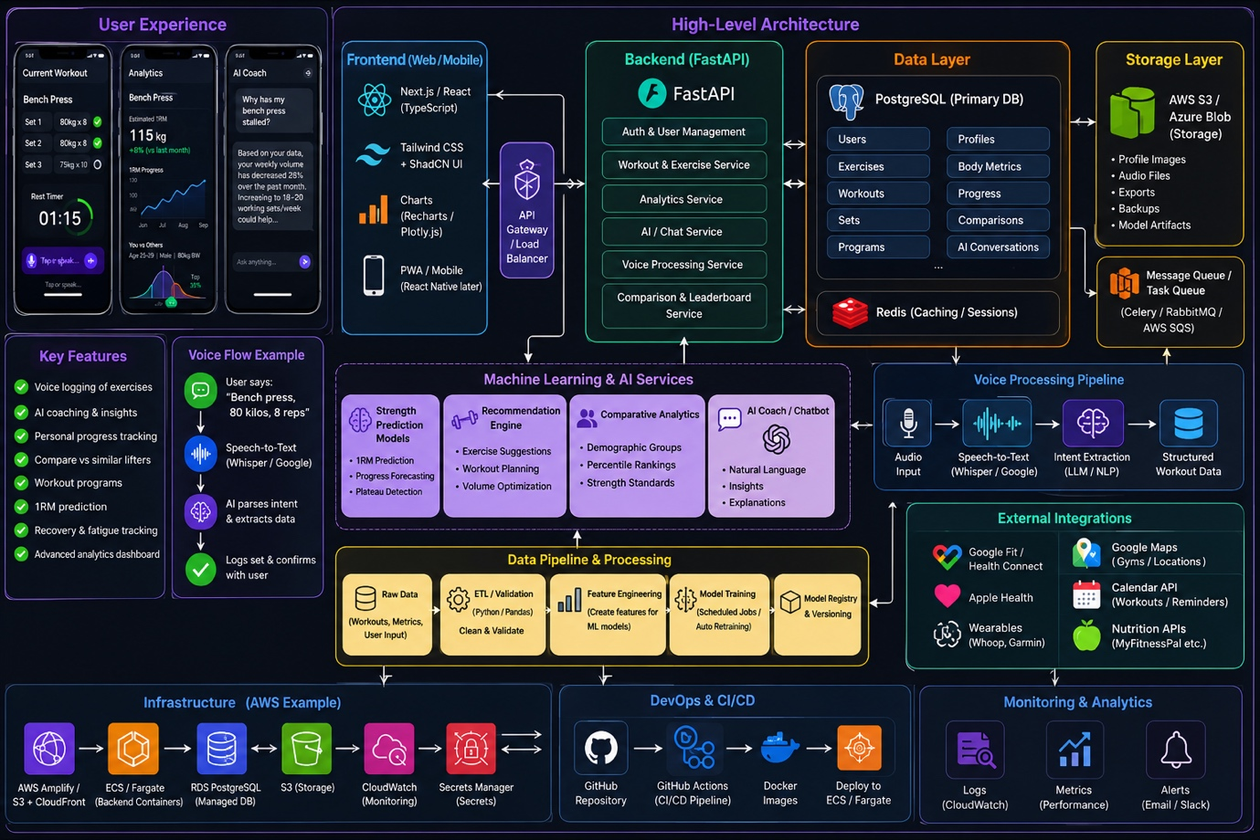

Deliverables 3:
ER Diagram
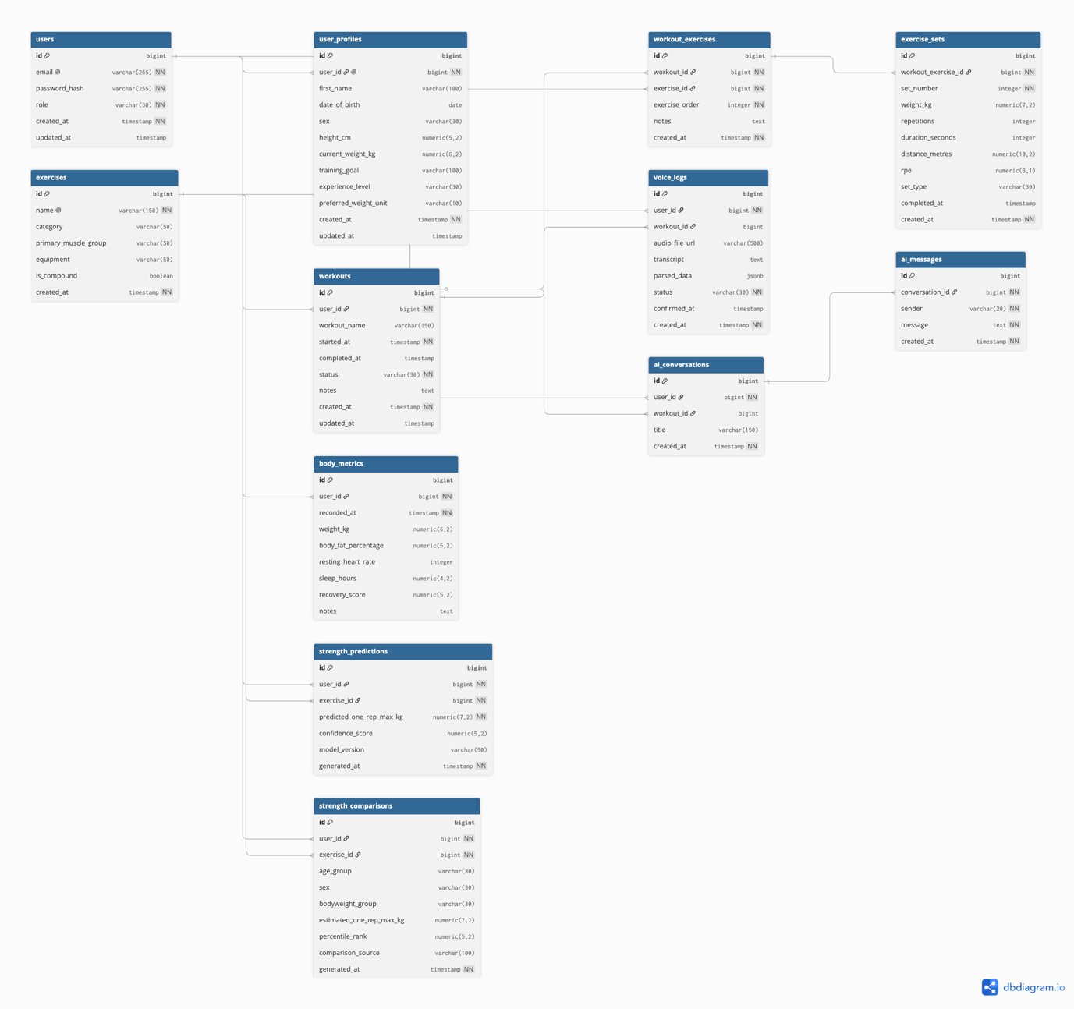

Deliverables 4:
Wireframes
Dashboard
Workout
Analytics
History
Profile
Settings
Login
Register

Deliverables 5:
Tech stack:
Frontend | Next.js (React + TypeScript)
Backend | FastAPI
ORM | SQLAlchemy
Database | PostgreSQL
Cache | Redis
ML | Scikit-learn, XGBoost
AI | OpenAI API (or another LLM)
Speech | Whisper
Charts | Recharts
Cloud | AWS
CI/CD | GitHub Actions
Containers | Docker
Infrastructure | Terraform (later)

