Contents

Model Configurations 2

Erdos-Reyni Network 2

Barabasi-Albert Network 2

Age-bracket Information 3

Results Methodology 4

Section 1 – Random Initial Vaccination 4

Section 1a – Erdos-Reyni Network 4

Section 1b – Barabasi-Albert Network 4

Section 2 – Degree Correlated Initial Vaccination 4

Literature Review – Additional Papers 5

# Age-bracket Information

|  |  |  |  |
| --- | --- | --- | --- |
| Age Bracket | Percentage of Population | Hospitalisation Rate | Mortality Rate |
| 0 – 9 | 11.33% | 0.6x | 0.2x |
| 10 - 19 | 11.75% | 0.2x | 0.1x |
| 20 – 34 | 20.54% | 1x | 1x |
| 35 – 49 | 19.41% | 1.7x | 3x |
| 50 – 64 | 19.45% | 3.5x | 30x |
| 65 – 79 | 13.54% | 6x | 75x |
| 80+ | 4.97% | 15x | 250x |

Hospitalisation/Mortality rates: <https://www.cdc.gov/coronavirus/2019-ncov/covid-data/investigations-discovery/hospitalization-death-by-age.html>

First data source for age distribution (UK): <https://www.statista.com/statistics/281208/population-of-the-england-by-age-group/>

Second data source for age distribution (USA): <https://www.science.org/doi/10.1126/science.abe8372>

# Results Methodology

## Section 1 – Random Initial Vaccination

* Before the epidemic starts and any nodes are infected, vaccinate a portion of the population between 0 and 1, ρ.
* Iterate ρ through 0 to 1, with step size of 0.05
  + Do this 5 times each, and average for a smooth and accurate representation
* Perform this for both the ER (Section 1a) and BA (Section 1b networks for a comparison of effects
  + Therefore end results will be **2 line graphs**

### Section 1a – Erdos-Reyni Network

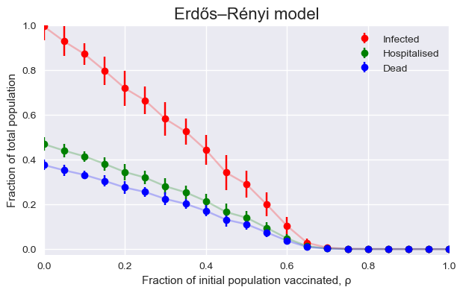

### Section 1b – Barabasi-Albert Network

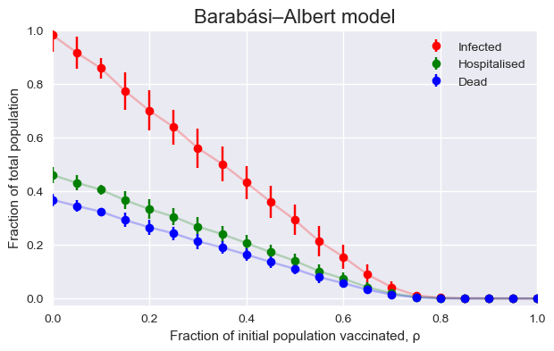

## Section 2 – Degree Correlated Initial Vaccination

* Similar to previous, at t=0 vaccinate a portion of the population, ρ still denotes the portion of nodes being vaccinated, however now it is used to vaccinate either the:
  + Highest N_ ρ degree nodes (Section 2a)
  + Lowest N_ ρ degree nodes (Section 2b)
* This way we will again have **2 line graphs**
* For each of the 2 scenarios, again iterate ρ through 0 and 1 with a step size of 0.05

### Section 2a – Highest Degree First

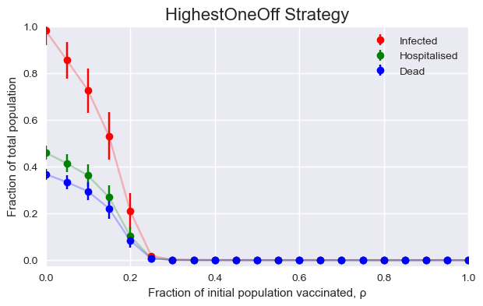

### Section 2b – Lowest Degree First

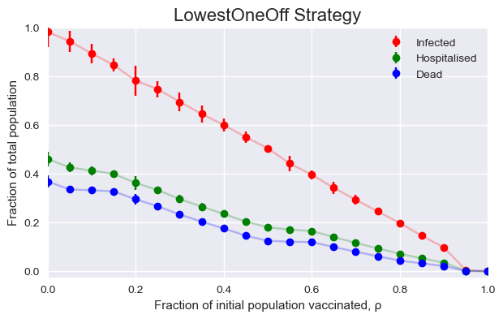

## Section 3 – Age Correlated Initial Vaccination

* Building off of the previous section once again, with this section focusing on vaccinating the individuals based off of their assigned age bracket.
  + Age brackets are correlated to a node’s degree. NOT YET WRITTEN UP
* This section once again will result in 2 line graphs being:
  + Oldest first
  + Youngest first

### Section 3a – Oldest Age First

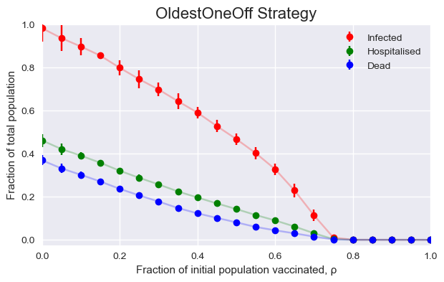

### Section 3b – Youngest Age First

### 

# Literature Review – Additional Papers