Two Objective Optimization of Longitudinal Navigation Along the Minimum Time curve

Ali, Ali Mohamed Ali Hassan  
Dept. of Computer, Control and Management Engineering  
Sapienza University of Rome  
 Rome, Italy.  
ali.1936023@studenti.uniroma1.it

Luca Tirel   
Dept. of Computer, Control and Management Engineering  
Sapienza University of Rome  
 Rome, Italy.  
tirel.1702631@studenti.uniroma1.it

Daniela Iacoviello   
Dept. of Computer, Control and Management Engineering  
Sapienza University of Rome  
 Rome, Italy.  
daniela.iacoviello@uniroma1.it

***Abstract—******The aim of this report is to study the dynamics and navigation of an F-16 jet fighter in a windy condition and design a control system for the pitch angle in the linearized longitudinal dynamic. We will consider only the elevator deflection as control input. First, we will solve a simplified navigation problem, also known as ‘Zermelo’s Problem’, in a constant upwind condition by finding the best flight path angle theta, which must be optimized with respect to time. Then, we will design two different controllers for the longitudinal dynamics of the aircraft in order to solve the optimal tracking problem for the theta we have found previously and compare the results. Finally we will consider the same problem with constraints. To achieve the desired performance, the controllers will be designed with Pole Placement and LQR methods to satisfy the first performance objective, and with LQR only for the second one. The simulation’s results will prove that the required performance specifications are obtained through LQR method.***

***Keywords — Zermelo, Linear Quadratic Regulator (LQR), Pole Placement, State Space Linearization, Overshoot, Navigation, and Guidance.***

**INTRODUCTION**

In the first part of our investigation, we will consider an optimal control problem with free final time by taking into consideration an aircraft flying from an initial state in $t_{0}$ to a final state, both fixed. The problem will be solved only analytically, as shown in article [2]. We are interested in minimizing the flight duration by using the Pontryagin maximum principle to find the best control law, considering constant wind along $X_{2}$. Is important to note that the first problem will be a kinematical translational problem that will be solved in the outer slower loop.

Once we solved the first problem, the theta will be the input for the second problem since we will have a constant optimal pitch angle in the considered case, that need to be tracked. In The second problem We will consider only the longitudinal dynamics of the plane, under the assumptions of constant mass, upcoming wind and considering the jet as a rigid body. This problem will consist in a dynamical trimming problem, that will be solved in the inner faster loop. Several linear and nonlinear longitudinal control strategies have been developed among the years, from PID control to Pole Placement; however, their settling time seems higher compared to the LQR method. In article [1], the LQR control is performed with a fighter aircraft, and the resulting performances are analyzed. In the last case is necessary to have zero overshoot and a fast settling time. The aircraft parameters for the AFTI F-16 and the trimming conditions of the aircraft are taken from [3].

# **Zermelo’s Problem**

## The optimal control problem

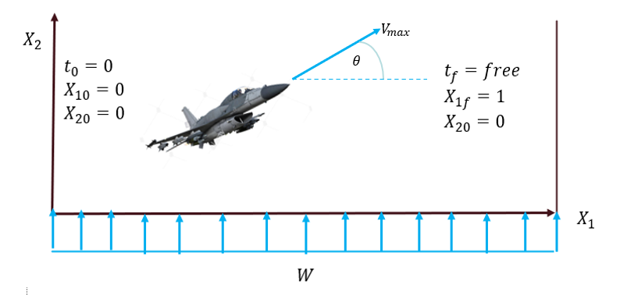 The optimal control problem aims at finding the best pitch angle for an aircraft flying crosswind from a point to another, both fixed. This must be done by minimizing the flight time and considering the aircraft as a point in a planar space. Since the initial and final positions are fixed, we will not have any transversality conditions. The convexity of the problem respect to the control will be checked below.

Figure Navigation Problem

In the figure above $V_{max}$ is the maximum speed of the aircraft along its longitudinal axis, $W$ is the windspeed and $θ$ is the angle between velocity vector and the earth horizontal horizon, which is the Pitch angle, and we consider it as a control variable.

The control is $θ\left(t\right)$ and it should minimize the following cost index:

$$Mⅈn J\left(θ\right)=t_{f} (1)$$

Subject to the dynamical constraints:

$${\dot{x}}_{1}=V\cos\left(θ\right) . (2)$$

$${\dot{ x}}_{2}=V\sin\left(θ\right)+w. (3)$$

With the following boundary conditions:

$$t_{0}=0 x_{1f}=1$$

$$x_{10}=0 { x}_{2f}=0$$

$$x_{20}=0$$

The Hamiltonian is given by:

$$H=P_{1}\left(Vcos\right)+P_{2}\left(V\sin{θ}+w\right)-1 (4)$$

The Euler lagrangian equations are the followings:

${\dot{x}}_{1}=Hp_{1}=V\cos{θ}$ (5)

${\dot{x}}_{2}=H_{p_{2}}=V\sin{θ}+w (6)$

${\dot{p}}_{1}=-H_{x_{1}}=0 \left(7\right)$

$${\dot{P}}_{2}=-H_{x2}=0 \left(8\right)$$

$0=H_{θ}=-p_{1}V\sin{θ}+p_{2}V\cos{θ}$ (9)

From which we can deduce:

$p_{1}=$ constant, $p_{2}=$ constant

So $θ$ will be constant and we can get $\left\{x_{1},x_{2}\right\}$ as follows:

$$x_{1}=\left(V\cos{θ}\right)t (10)$$

${ x}_{2}=\left(V\sin{θ}+w\right)$ t (11)

And by using the prescribed final conditions:

$x_{1f}=1$, $x_{2f}=0$ (12)

We will finally get the following expression:

$$t_{F}=\frac{1}{V\cos{θ}} , \sin{θ}=\frac{-w}{V} (13)$$

And we can get our final solution as following:

$$θ=-\arcsin\left(\frac{w}{V}\right) , t_{f}=\frac{1}{V^{2}-w^{2}} (14)$$

Before we start the simulations, we should check the convexity of the problem using the optimal values for the multipliers. We obtain:

$$H_{θθ}=\frac{V^{2}}{V^{2}-w^{2}} >0$$

The condition above is true for V $>>$ w , that is a reasonable assumption. Is interesting to note that, in the optimal case, the aircraft will point upwind but will move directly toward the final point, therefore, the height will be constant.

A Numerical Example: $$V=600\frac{m}{s}$$

$w=60$ $\frac{m}{s}$

In this way, we obtain our optimal Pitch angle:

$$θ=-0.1002 radians$$

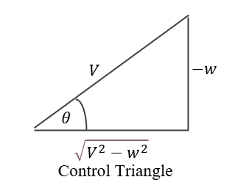

Figure 2 Control Triangle

The longitudinal and vertical position of the aircraft during time are shown in figure 3 and 4, respectively.

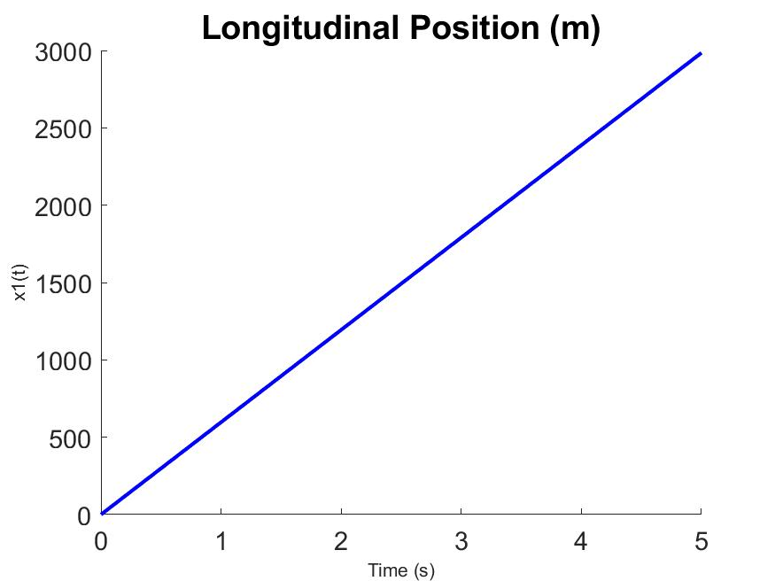

Figure 3 Longitudinal Position vs Time

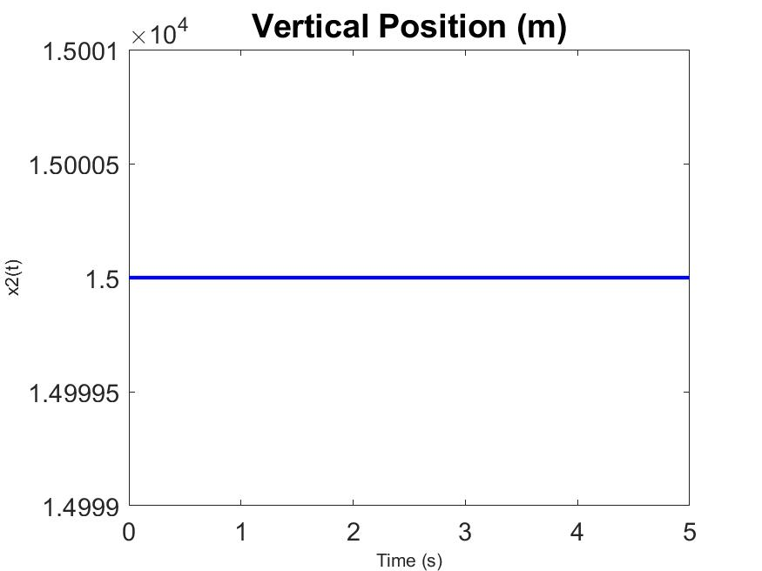

Figure 4 Vertical Position vs Time

The results are consistent with assumptions and output an optimal reference for the second problem. Is important to highlight that we will not care about the optimal final time, since we only needed the optimal angle, and since the two problems are not linked in a dynamical sense.

## The General Solution of Zermelo’s Problem

Here, we can check our logical flow by considering the general Zermelo’s Problem as in figure 5.

$$\dot{x}=V\cos{θ}+u\left(x,y\right). (15)$$

$$\dot{y}=V\sin{θ}+ν\left(x,y\right). (16)$$

Where $u\left(x,y\right)$ and $v(x,y)$ are the wind from both directions X and Y respectively.

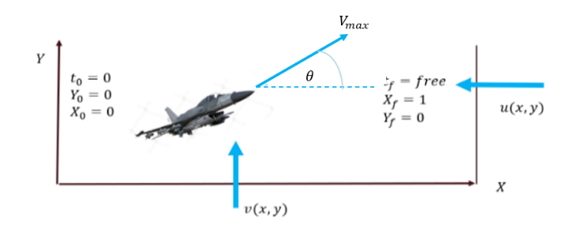

$X-my\sin\left(θ\right)=m\left(\dot{u}+qw-rv\right)$*. $Y+mg\cos\left(θ\right)\sin\left(ϕ\right)=m\left(\dot{v}+ru-pω\right)$ 
.*

$Z+mg\cos\left(θ\right)\cos\left(ϕ\right)=m\left(\dot{w}+pv-qω\right)$*.*

$L=I_{x}\dot{p}-I_{xz}\dot{r}+qr\left(I_{z}-I_{y}\right)-I_{xz}pq$*.*

$$M=I_{y}\dot{q}+rp\left(I_{x}-I_{z}\right)+I_{xz}\left(P^{2}-r^{2}\right).$$ $N=-I_{xz}\dot{p}+I_{z}\dot{r}+pq\left(I_{y}-I_{x}\right)+$ $I_{xz}qr.$

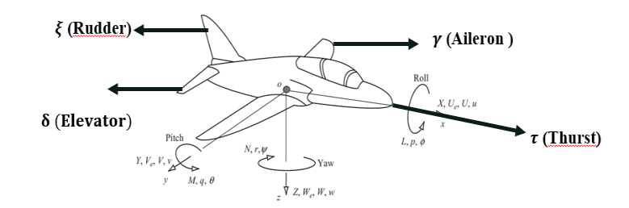

Figure 5 General Zermelo’s Navigation Problem

We set the objective function as:

Figure 7 Connecting control inputs to forces

$Mⅈn J\left(θ\right)=t_{f}$ (17)

The Hamiltonian System is:

$H=λ_{x}\left(V\cos{θ}+u\right)+λ_{y}\left(Vsinθ+ν\right)+1.$ (18)

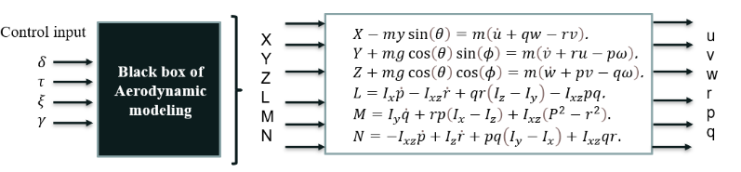The Euler Lagrange equations are the followings:

${\dot{λ}}_{y}=-\frac{∂H}{∂y}=-λ_{x}\frac{2u}{∂y}-λ_{y}\frac{∂u}{∂y}$*(19)*

${\dot{λ}}_{x}=-\frac{∂H}{∂x}=-λ_{x}\frac{∂u}{∂x}-λ_{y}\frac{∂ν}{∂x}$ (20)

$0=\frac{∂H}{∂θ}=v\left(-λ_{x}\sin{θ}+λ_{y}\cos{θ}\right)$ (21)

In the previous problem, where the Hamiltonian is not   
an explicit function of time, H = constant = Zero, which is   
the integral curve of the system and since we are minimizing  
 with respect to time:

$$H\left[t_{F}\right]→H=0 (22)$$

We can get the following equations:

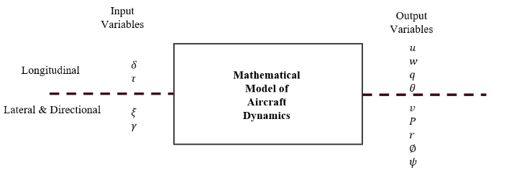

$$λ_{x}=\frac{-\cos{θ}}{V+u\cos{θ}+ν\sin{θ}} (23)$$

$λ_{y}=\frac{-\sin{θ}}{V+u\cos{θ}+ν\sin{θ}}$ (24)

$$\dot{θ}=\sin^{2}{\frac{∂v}{∂x}}+\sin{θ\cos\left(\frac{∂u}{∂x}-\frac{∂γ}{∂y}\right)}-\cos^{2}{θ\frac{∂u}{∂y}} (25)$$

Thus, we deduce that the pitch angle is strongly dependent on the wind magnitude and direction and we can easily check that in our case considering only constant wind along $y$ we obtain a constant pitch angle as we found before.

# **II. longitudinal dynamics modelling**

## The Nonlinear equation of Motions

First, we are considering Newton laws of motion applied to the aircraft as a rigid body with 6 degrees of freedom moving in the space, as shown in Figure 6, we will get the following equation of motions:

(26)

The role of the Blackbox of Aerodynamic model is to connect the standard control input of the aircrafts (Elevator, Aileron, Thrust) to produce forces and moments (X, Y, Z, LM, N) as shown in Figure 7.

Figure 6 Aircraft Forces and Moments

By using the Dynamic Decoupling Principle and considering the wind directions for the computation of the aerodynamic forces for the dynamics [4], we can study longitudinal motions independently of the lateral and directional motions, as shown in figure 8.

Figure 8 Dynamics decoupling

Then, by linearizing our longitudinal equations of motion around the equilibrium point, neglecting any change in thrust input, and assuming we are keeping the same $V_{max}$ of the previous problem, we will get the following linear time invariant model:

$\left[\begin{matrix}\dot{θ} \\ \dot{α} \\ \dot{q}\end{matrix}\right]=\left[\begin{matrix}0 & 0 & 1 \\ -1.1714*{10}^{-13} & -0.76788 & 0.9396 \\ 0 & -2.251 & -1.0462\end{matrix}\right]\left[\begin{matrix}θ \\ α \\ q\end{matrix}\right]+\left[\begin{matrix}0 \\ -0.0016222 \\ -0.16416\end{matrix}\right]δ_{ε}$. (27)

$θ=\left[1 0 0\right]*\left[\begin{aligned}θ \\ α \\ q\end{aligned}\right]+\left[0\right]δ_{ε}$ (28)

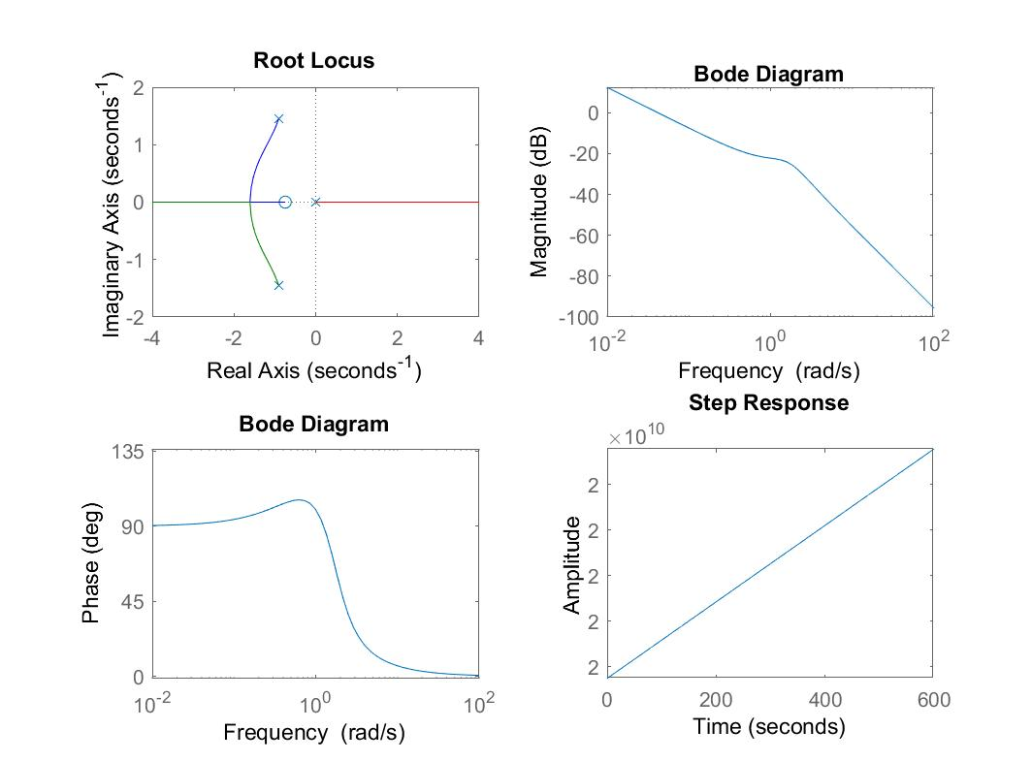

Where $θ$, $α,$ and q are respectively the pitch angle, the angle of attack and pitch rate, and the equilibrium point is the trimmed flight conditions of the aircraft indicated below:

Table I Trimming Conditions

|  |  |
| --- | --- |
| **State Variable** | **Trimming Value** |
| Pitch Angle $θ$ | 0.046492 deg |
| Angle of Attack $α$ | 0.046492 deg |
| Pitch Rate q | 0 m/ $s$ |
| Longitudinal Speed V | 600 m/s |

## Open Loop Response of the Linear Model

Figure 9 Open Loop Response

The main goal is to design two controllers for the airplane to satisfy the following performance specifications:

Table II Performance Objectives

|  |  |  |
| --- | --- | --- |
| **Objective** | **Overshoot** (less than) | **Settling Time** (less than) |
| Fast Maneuver | 10 % | 0.5 s |
| Slow Maneuver | 0 % | 2.0 s |

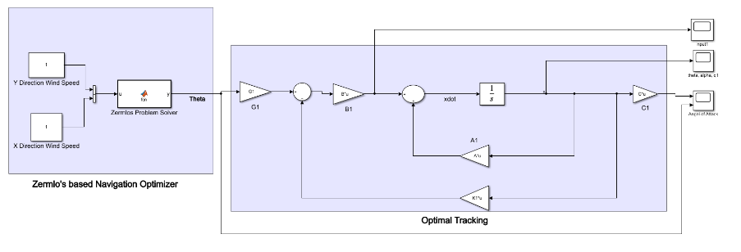Besides, we have also to stabilize the system since the open loop system is unstable.

The transfer function of the open loop system is the following:

(29)

$$T\left(s\right)=\frac{-0.1642 S-0.1224}{S^{3}+1.8414 S^{2}}$$

The poles of the system are the following:

Figure 10 Proposed Scheme

$$P_{1,2}=-0.9070±1.4476j \\ P_{2}=0$$

The open loop system is unable to track the step input shown in figure 9 because the designers of the F16 jet Fighter prefer to design the aircraft to be at relaxed static stability (slightly unstable) to gain high maneuverability rate during missions. So, we will use a full state feedback method to stabilize the system. To perform these control schemes, it is important that the system is controllable and that we can access to all the state variables. We will also need a pre-compensator gain $G_{i}$ to eliminate steady state error. In our schemes, the gain vector K can be deduced with Pole Placement / LQR methods.

Figure 9 Root locus, Bode Plot, and the Step Response of the open loop transfer function

.

# **III. GENERIC FEEDBACK CONTROL**

## Proposed Control Scheme

Considered that we get the optimal required pitch angle when solving the Zermelo’s navigation problem to find the minimum time curve, we should now consider the second objective that aims at tracking this path optimally using the pervious linear model of the longitudinal dynamics. The following proposed scheme provides the general idea:

In the scheme above, the regulator control law is tracking the optimal pitch angle, that is founded to minimize the time of flight across the wind vector field. The regulator is considered an inner loop, for this reason we don’t consider the final time of the first problem. In this model the final equilibrium condition considering wind, will be the following:

|  |  |
| --- | --- |
| $$Θ$$ | $$θ_{opt}<0$$ |
| $$α$$ | 0˚ |
| q | 0 $\frac{m}{s}$ |

Table III Final Equilibrium

## Pole Placement Method

The idea behind this method is to determine the value of the gain K in order to place the poles of the closed loop system in specific locations.

We have chosen these values for the poles as in [1]:

$$p_{1}=-2+0.4j$$

$$p_{2}=-2-0.4j$$

$$p_{3}=-6$$

These are the respective gains:

$${K'}_{1}=\left(\begin{aligned}203.9156 \\ 92.6561 \\ -50.7811\end{aligned}\right)$$

$$G_{1}=-203.9156$$

And we get the following design specifications shown in Table IV and figure 11.

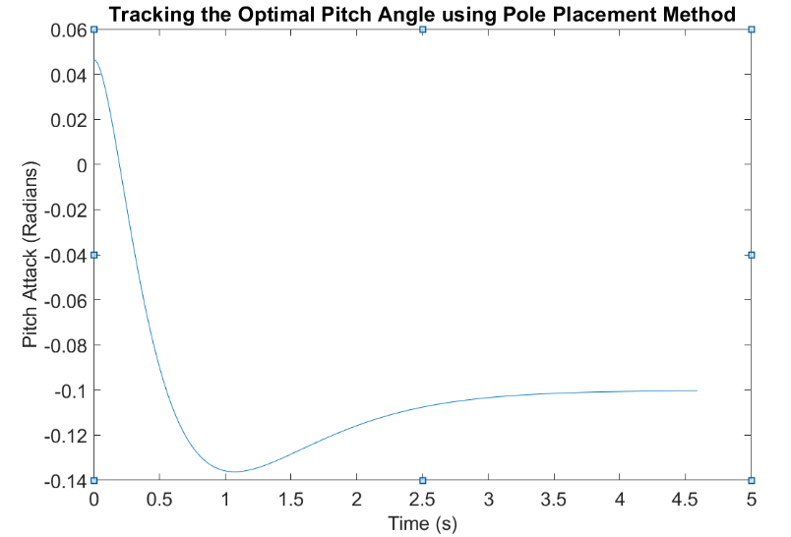

Table III Design specifications of pole placement Method

Figure 11 Tracking of Optimal Pitch Angle using Pole Placement`

Table IV Design Specifications with Pole Placement

|  |  |
| --- | --- |
| **Performance Specifications** | **Values** |
| Rise Time | 0.3335 s |
| Overshoot | 34.6232 % |
| Settling Time | 3.1880 s |
| Peak Time | 0.9978 s |

As shown above, is clear that the performance objective is not met with this control scheme.

## Linear Quadratic Regulator

LQR design is an optimal pole placement method that optimize the control input with respect to the weight we assign to the states and inputs in Q and R matrices by minimizing the quadratic cost index shown in equation (31), satisfying the dynamical system constraints shown in equations (30), and meeting the initial conditions. The bigger the weights are, more important will be their minimizations. At the same time, we will track a reference input which will consist in the solution of the Zermelo’s problem (Pitch Angle), $r\left(t\right)={\overline{C}}^{1}[t_{i},t_{f}]$, which is found to be constant.

So, considering the following linear time invariant system:

(30)

$$\dot{x}\left(t\right)=A x\left(t\right)+B u(t)$$

$$y\left(t\right)=C x(t)$$

with initial conditions $x\left(t_{i}\right)=x^{i}$, representing the trimming conditions of the aircraft, and where A, B, C are constant matrices of dimensions $3×3$, $3×1$, and $1×3$ respectively and depending only on the aircraft geometry.  
The quadratic cost function is:

(31)

$J\left(x,u\right)=\frac{1}{2}\int_{t_{o}}^{t_{f}}{\left( {\left(r\left(t\right)-x\left(t\right)\right)}^{T}Q \left(r\left(t\right)-x\left(t\right)\right)+u^{T}Ru\right)dt} (31$)

Where:

* Q is non-negative and symmetric matrix, in which the values of the diagonal elements represent the weight of each state.
* R is a positive definite matrix representing the weight of the control input.

To find the optimal gain $u^{0}ϵ {\overline{C}}^{1}[t_{i},t_{f}]$, we need to solve the Algebraic Riccati’s Equation, as shown in the following: $$0=KBR^{-1}B^{T}-KA-A^{T}KP-Q.$$

(32)

This admits a unique solution in the form of a linear feedback law, as the following:

(33)

$u^{0}\left(t\right)=-R^{-1}B^{T}Kx^{0}$ (t)

The Q and R matrices will be tuned differently to satisfy the two performance specifications. In the first case, we will increase in Q matrix only the component relative to the pitch angle. In the second case, we will weight the pitch angle and the pitch rate minimization to obtain a slower but more precise maneuver. R will remain the same in the two case of study.

Considering the following Values for $Q_{1} \& R_{1}$:

$$Q_{1}=\left(\begin{matrix}90 & 0 & 0 \\ 0 & 0 & 0 \\ 0 & 0 & 0\end{matrix}\right)$$

$$R_{1}=0.0001$$

We obtain:

${K'}_{2}=\left(\begin{aligned}-948.6833 \\ 13.5169 \\ -100.6071\end{aligned}\right)$

$$G_{2}=-948.6833$$

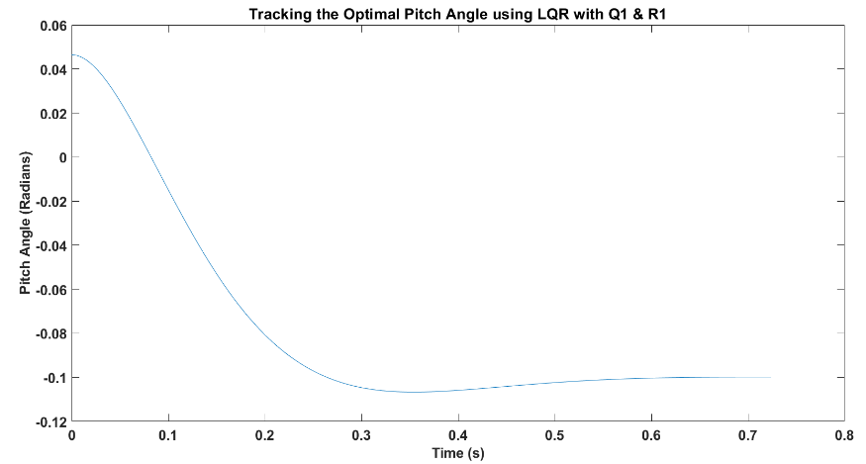

Figure 12 Tracking of Optimal Pitch Angle using LQR with Q1 and R1

Table V Design specifications of LQR Method using Q1 & R1

|  |  |
| --- | --- |
| **Performance Specifications** | **Values** |
| Rise Time | 0.1714 s |
| Overshoot | 4.4374 % |
| Settling Time | 0.4777 s |
| Peak Time | 0.3566 s |

From this result, it is clear that the performance objective for the fast maneuver is met with a small overshoot and a fast-settling time. We conclude that the linear regulator managed the optimal tracking in the first case.

And then, considering the following values for $Q_{2} \& R_{2}$:

$$Q_{2}=\left(\begin{matrix}90 & 0 & o \\ 0 & 0 & 0 \\ 0 & 0 & 15\end{matrix}\right)$$

$$R_{2}=0.0001$$

We Obtain:

$$K_{3}^{'}=\left(\begin{aligned}-948.6833 \\ 13.5512 \\ -395.4273\end{aligned}\right)$$

$G_{3}=-948.6833$

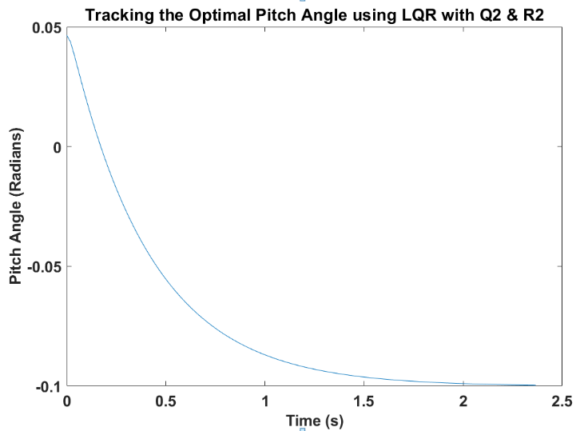

Figure 13 Tracking of Optimal Pitch Angle Using LQR with Q2 & R2

Table VI Design specifications of LQR Method Using Q2& R2

|  |  |
| --- | --- |
| **Performance Specifications** | **Values** |
| Rise Time | 0.8968 s |
| Overshoot | 0 % |
| Settling Time | 1.6129 s |
| Peak Time | 2.9852 s |

Finally, we can conclude that the LQR controller managed the optimal tracking of the desired theta and met the required performance for the slow maneuver minimizing also the pitch rate.

The figures below show the plots of the optimal state variable evolutions to highlight the role of the Q matrix in the control scheme (in green).

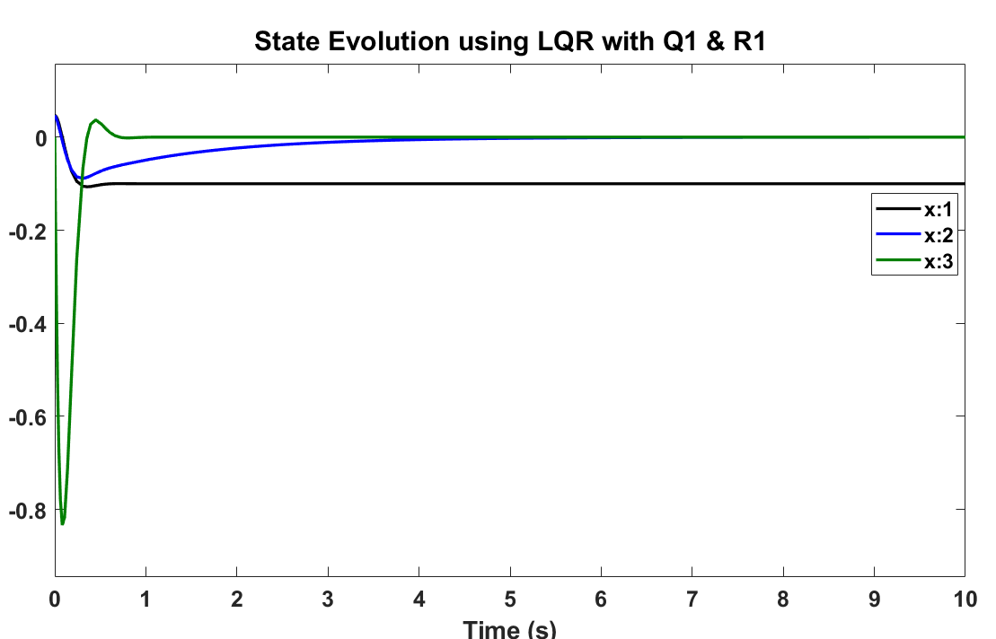

Figure 14 State Evolutions using LQR with Q1 and R1

where $X_{1}$, $X_{2}$, $X_{3}$, are the pitch angle, angle of attack and the pitch rate respectively.

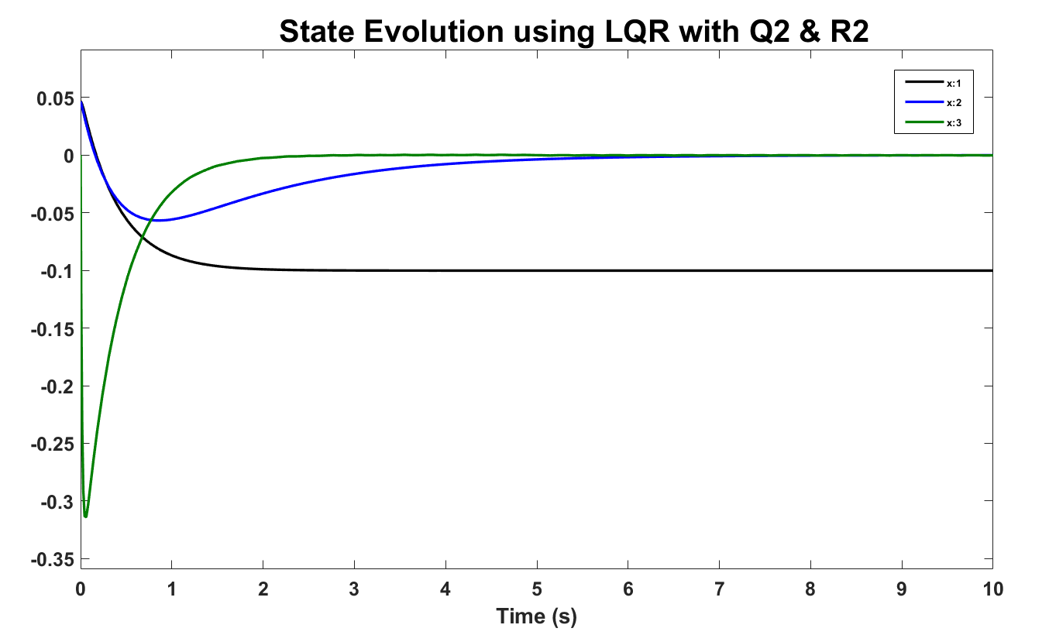

Figure 15 State Evolutions using LQR with Q2 and R2

From the last two plots is clear that the pitch rate has a smaller peak value in the second case.

We will now consider also the minimization of the control action, in order to reduce the elevator deflection needed to rotate the aircraft. This will lead to higher settling time, as expected.

1. *Minimizing the Control Action*

We will construct an LQR controller for the following values of R:

Table VII Values for R matrix in the examples

|  |  |  |
| --- | --- | --- |
| $$r_{1}$$ | $$r_{2}$$ | $$r_{3}$$ |
| 5 | 10 | 15 |

The Q matrix will be the same of the first case.

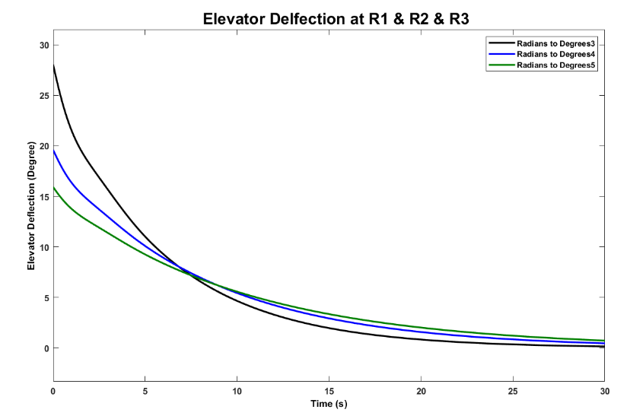We obtain the following plots for the control input and pitch angle:

Figure 16 Elevator Deflection

Figure 16 Elevator Deflection

Where the green line represents $r_{3}$,the blue line represents $r_{2}$ and the black line represents the $r_{1}$. From these values we obtain the following tracking for the pitch angle, paying the price of a higher settling time to stabilize.

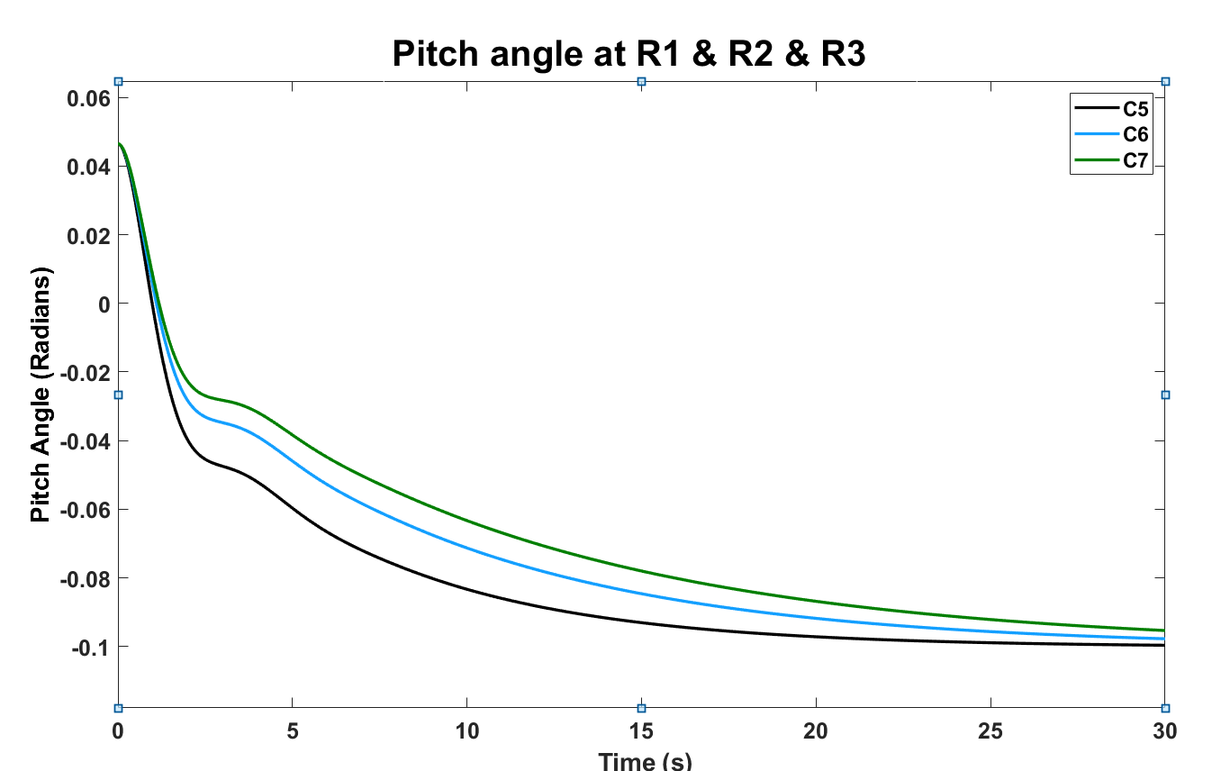

Figure 17 Pitch Angle

Where the green line represents $r_{3}$,the blue line represents $r_{2}$ and the black line represents the $r_{1}$

1. *Linear Quadratic Regulator with Bounded Control*

In the previous cases we were not considering the boundedness of the control action and state variables. Using elevator’s parameters from [4] we conclude that the elevator deflection range is $±25$ degrees with respect of the aircraft axis and, we have bounded pitch rate $p\left(t\right)$. We will consider this bound for the control and state variables:

$$\left|u\left(t\right)\right|≤25 deg (34)$$

$$p\left(t\right)≤60 \frac{deg}{s^{2}} (35)$$

And then, considering the following values for $Q_{3} \& R_{3}$:

$$Q_{3}=\left(\begin{matrix}900 & 0 & o \\ 0 & 0 & 0 \\ 0 & 0 & 9\end{matrix}\right)$$

$$R_{3}=0.1$$

We Obtain:

$$K_{4}^{'}=\left(\begin{aligned}-94.8683 \\ 12.0903 \\ -27.5126\end{aligned}\right)$$

$$G_{4}=-94.8683$$

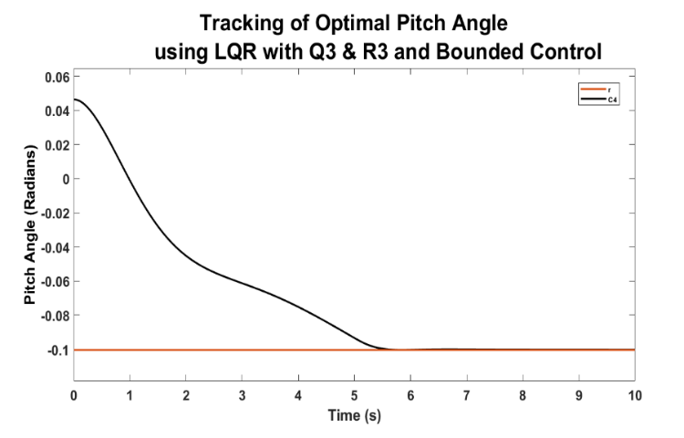

Below are shown, in degree, the elevator deflection and the pitch rate, that are in the range considered.

Figure 18 Tracking the optimal Pitch Angle LQR with Q3 and R3 and bounded control

Where the black line represents the evolution of pitch angle with time and the red line represents the optimal references of pitch angle obtained from the outer loop of Zermelo’s problem

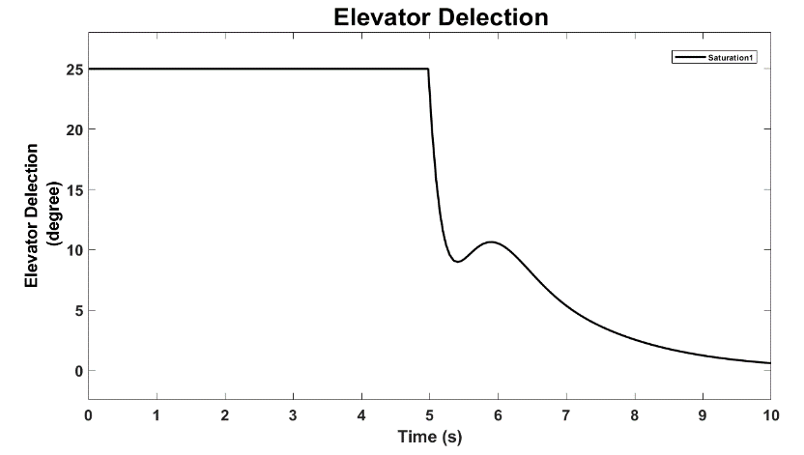

Figure 19 Elevator Deflection

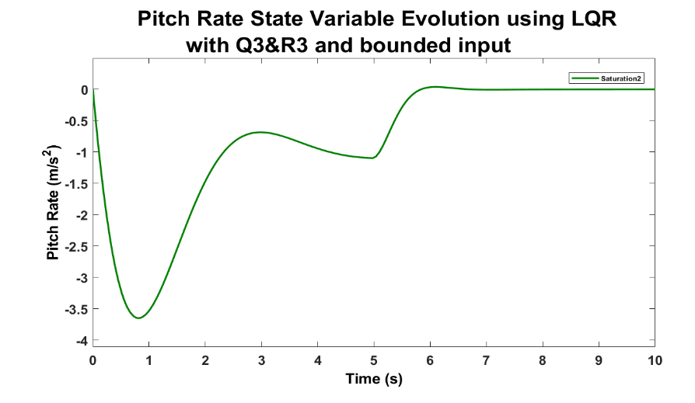

Figure 20 Pitch Rate State Variable Evolution

It is clear that form figure 18 that after 5 Seconds we can obtain our desired optimal value and that because we are using the full deflection of elevator available (+25 degree) in the first 5 seconds as shown in figure 19.

**FUTURE WORK**

It could also be interesting to consider other variations to our project. The way the model is constructed in our case of study could also be deepened. Instead of studying the flight of an aircraft in a constant wind situation, we could also consider a variable wind along multiple directions, that implies the resolution of Zermelo’s problem in more general case and the try to follow that optimal path in an inner loop as we did.

**REFERENCES**

[1] Aysha S. Hameed, Al Bilal. N., Mukund A. R., Ansha S., Comparison of Aircraft Pitch Control using Pole Placement and LQR, International Journal of Advanced Research in Electrical, Electronics and Instrumentation Engineering, available at: <http://www.ijareeie.com/upload/2019/june/4_Comparison.pdf>

[2] Kahina Louadj, Pierre Spiteri, Fethi Demim, Mohamed Aidene, Abdelkrim Nemra and Frédéric Messine, Application Optimal Control for a Problem Aircraft Flight, Journal of Engineering Science and Technology Review 11 (1)(2018) 156-164, available at:

<https://www.researchgate.net/publication/323887316_Application_Optimal_Control_for_a_Problem_Aircraft_Flight>

[3] Sivaram Wijenddra, Manuel Vergara and Gunneet Singh, Autopilot Design for an F16 Fighter Aircraft, available at: <https://users.encs.concordia.ca/~ymzhang/courses/MECH480-6091/CourseProjects&Labs/MECH6091/F2011/MECH6091_Presentation_Group2.pdf>.

*[4] Ying Huo, Model of F16 Fighter Aircraft, available at:*[*https://archive.siam.org/books/dc11/f16/Model.pdf*](https://archive.siam.org/books/dc11/f16/Model.pdf)

*[5] Michael Cook, Flight Dynamic* Principles, Butterworth-Heinemann.*

*[6] Daniel Liberzon, Calculus of Variations and Optimal Control Theory: A Concise Introduction,* *Princeton University Press*

**CONCLUSIONS**

To sum up, by solving two optimal control problems we found   
and tracked the best pitch angle for an aircraft flying in a constant  
 upwind condition. We decide to compare two different control  
 schemes which are Pole Placement and LQR. After having set  
 overshoot and settling time of the pitch angle as two different  
 performance objectives, we finally proved that LQR is the best   
controller since it satisfied the objectives that we set. Then we   
solved the same problem at first minimizing the control without constraints, then with constraints on control and on the third state variable to ensure the satisfaction of the physical limit constraints for maximum elevator deflection of $±25$ degree.