**Please cross the symbol that you think expresses a better response to the question.**

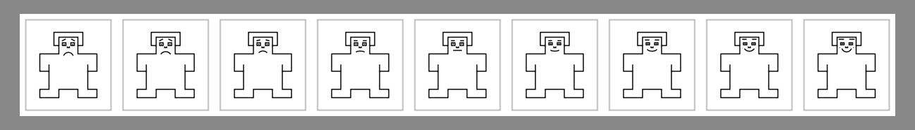How unpleasant/unhappy or pleasant/happy did you feel during the experience?

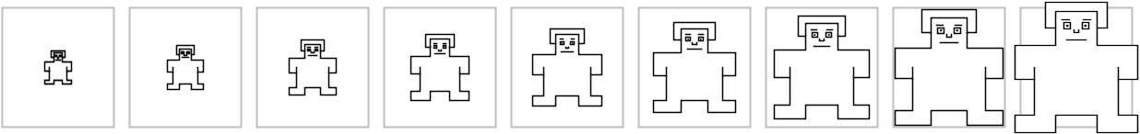How much did you feel you have had control of the situation?

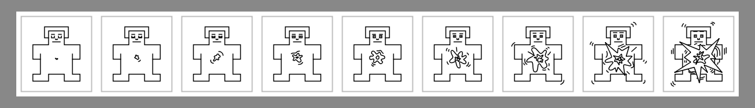How aroused did you feel during the experience?