Course Prerequisites: Installation of LM Studio

Prerequisites for Practical Sessions
For the hands-on activities in this course, it is essential that you have LM Studio installed on your computer. LM Studio provides an easy-to-use interface to run local large language models (LLMs) without requiring advanced technical skills.
Please follow these instructions carefully.

1. System Requirements
Before installing LM Studio, ensure your machine meets the following minimum requirements:
- Operating System: Windows 10/11 (64-bit), macOS 12+, or Linux (Ubuntu 20.04+).
- RAM: Minimum 16 GB (32 GB recommended).
- Disk Space: At least 20 GB free space.
- GPU (optional): A dedicated NVIDIA GPU will improve performance but is not mandatory.

2. Downloading LM Studio
1. Go to the official website: https://lmstudio.ai
2. Click on Download.
3. Select the appropriate version based on your operating system.
4. Save the installer file to your computer.
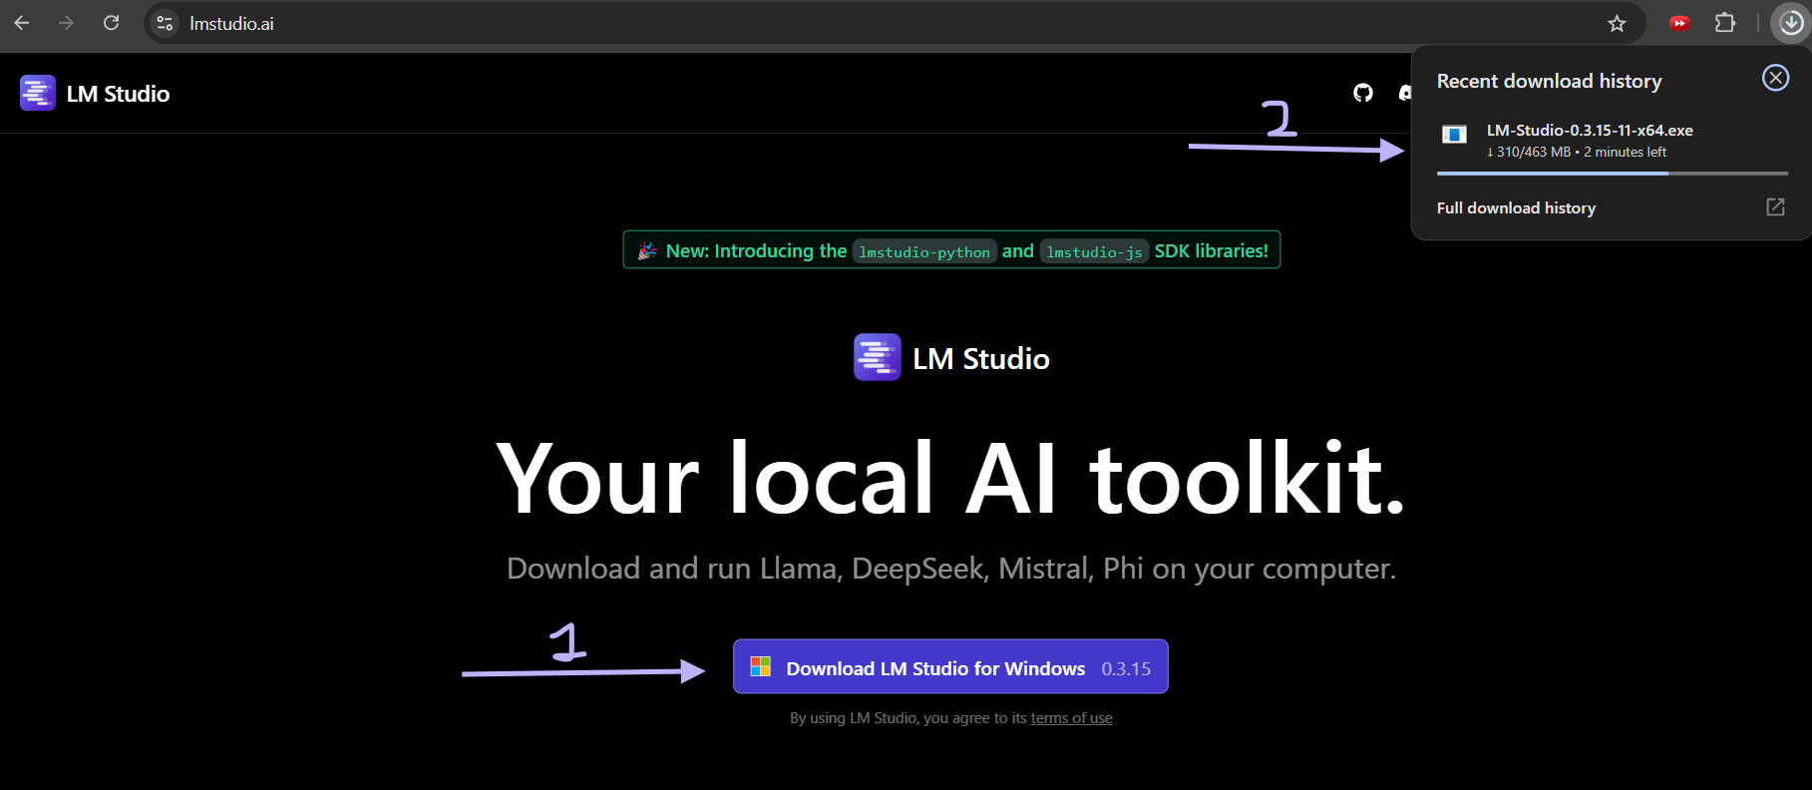

3. Installing LM Studio

On Windows:
1. Double-click the downloaded `.exe` file.
2. Approve any security prompts.
3. Follow the on-screen setup instructions.
4. Complete the installation.

On macOS:
1. Open the downloaded `.dmg` file.
2. Drag LM Studio into Applications.
3. Open from Applications, approve any security prompts.

On Linux:
1. Download the `.AppImage` or `.deb` file.
2. Use chmod +x and run, or dpkg -i for installation via terminal.

4. First Launch
Open LM Studio, accept terms, allow any initial downloads. No account needed.
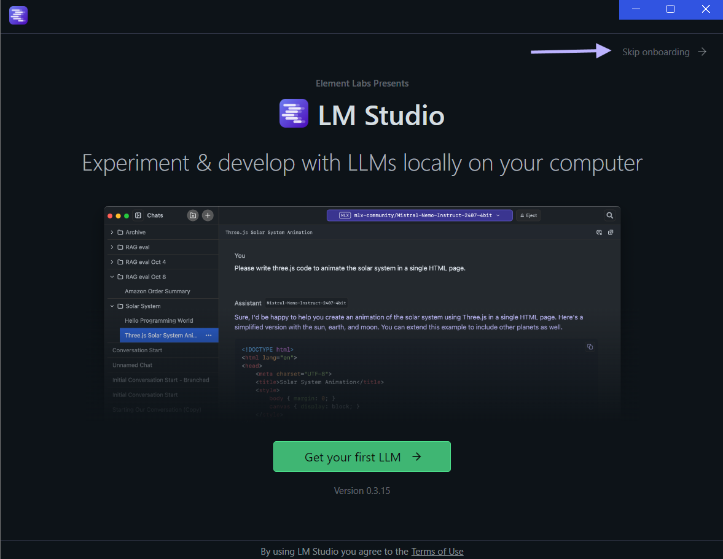

5. Downloading a Local Model
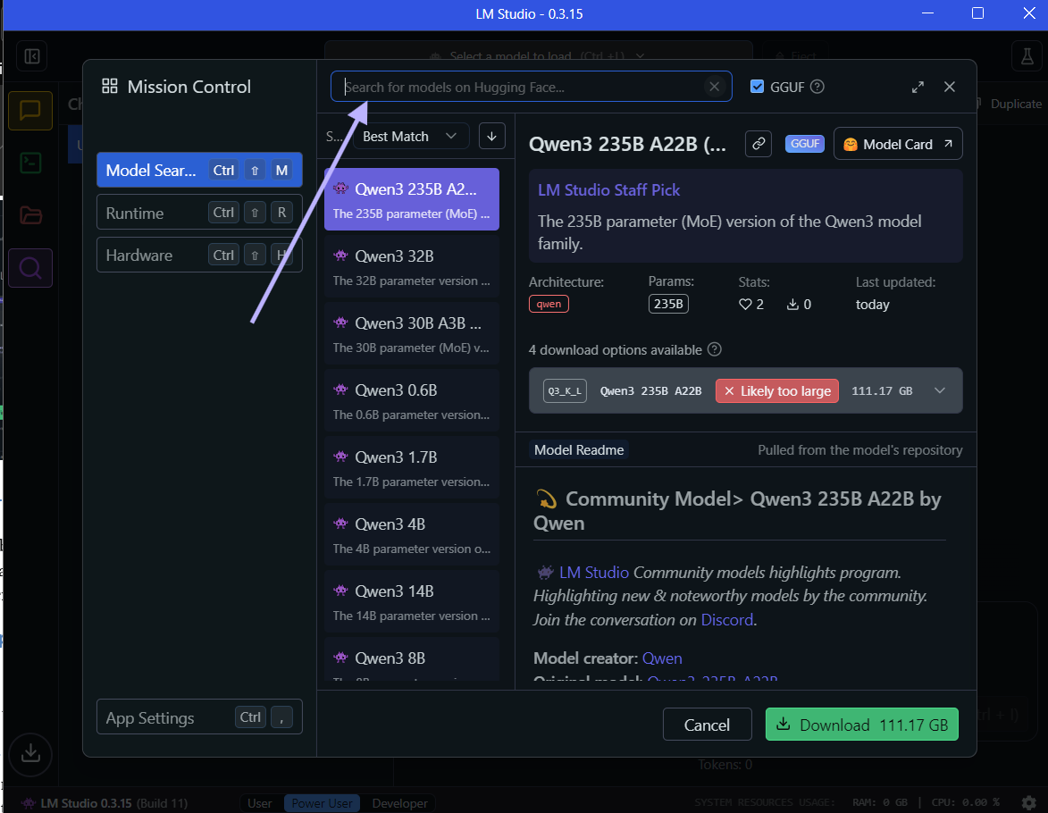
1. Open LM Studio.
2. Go to the Models tab.
3. Search and download a model according
4. Download small model first

Qwen3 is available in 8 sizes, you can start with the smallest one 0.6B that is ~1GB

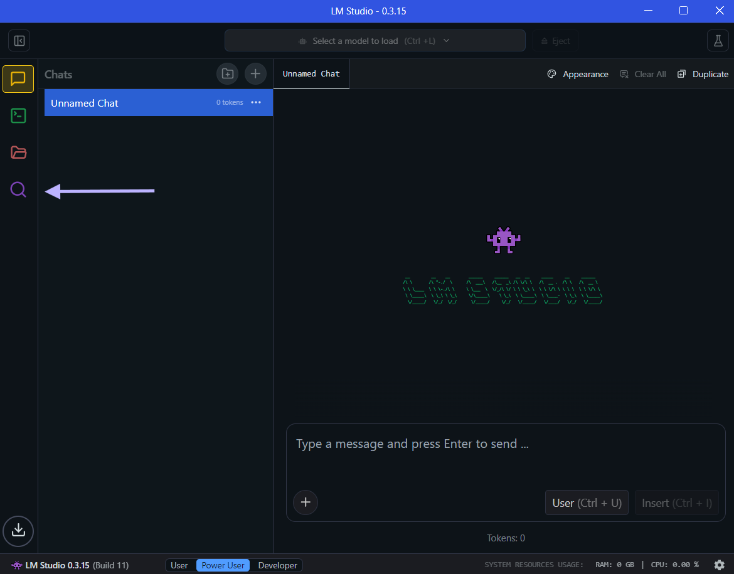
6. Testing the Setup
1. Open Chat tab.
2. Select your model.
3. Type a prompt and verify response.

7. Troubleshooting
- Ensure your system meets requirements.
- Restart after installation.
- Visit https://lmstudio.ai/docs for help.

Notes
- Please bring your laptop with LM Studio pre-installed to class.
Thank you and see you in class!

