Factor-Level Analysis of Two LLM-Evolved Alpha Books
GPT-5.6 Terra (L4 configuration) vs. Claude Opus 5, benchmarked against the 101 formulaic alphas — Nasdaq-100 point-in-time panel, 2010–2026.

1. What is measured
Each evolution run publishes a book of factors: small Python programs that map the market panel (prices, volumes, fundamentals, estimates) to one signal value per (day, stock). This analysis evaluates those signals directly — no strategy construction, no position sizing, no costs.
Two kinds of information coefficient (IC) are reported, both against 6-day forward returns (h = 6 bars, the horizon both runs searched at):
- Per-factor IC. For each factor and each stock, the Pearson correlation between the factor's signal series and that stock's own 6-day forward-return series; the observation-weighted average across stocks is the factor's pooled per-underlying IC. This is the statistic family the evolutionary harness itself optimises, so it is the honest yardstick for the search.
- Combined-book IC. All signals of a book are standardised per stock and fed to a LightGBM regressor (the same model class the runs used to score marginal value), fitted once on the DEV window only, predicting the 6-day forward return. The pooled per-underlying IC of that single combined prediction measures the book as a whole, including nonlinear interactions between factors.
Three evaluation windows, following the runs' own 60/20/20 split convention of the research panel (2010 → 2024-07):
Window | Period | Bars | Role
DEV (IS+VAL) | 2010-01-04 → 2021-08-25 | 2932 | Search window: the evolution selected factors on (parts of) this data; the combined model is fitted here. Combined ICs on DEV are in-sample.
TEST | 2021-08-26 → 2024-07-26 | 733 | Final 20% of the research panel, never revealed to any generation of the search.
FORWARD | 2024-07-29 → 2026-07-27 | 500 | Entirely outside the research panel (data downloaded after the runs finished). The cleanest out-of-sample evidence.

Comparability caveat: no Opus 5 run exists at the L4 configuration (the Opus ladder stopped after L2 when its budget was exhausted). The comparison is therefore L4_terra_s0 (GPT-5.6, GraphRAG retrieval, 8 mechanism groups, 44 published factors, $87) vs. L2_opus5_s0 (Claude Opus 5, no retrieval, 1 group × 4 demes, 18 factors, $452). Model and configuration are confounded; differences cannot be attributed to the model alone.
Four of the 44 Terra factors produce degenerate (variance-free) signals on the extended analysis panel and are excluded from per-factor and correlation statistics; they remain in the combined fits, where they contribute nothing.

2. Combined books: IC by window
Book | DEV (in-sample) | TEST | FORWARD
101 formulaic alphas alone | 0.210 | 0.026 | 0.024
Terra book (44) | 0.213 | 0.024 | 0.033
Opus book (18) | 0.158 | 0.045 | 0.026
Terra + Opus (62) | 0.221 | 0.041 | 0.039
Terra + 101 (145) | 0.236 | 0.031 | 0.041
Opus + 101 (119) | 0.215 | 0.039 | 0.027
Terra + Opus + 101 (163) | 0.244 | 0.039 | 0.040

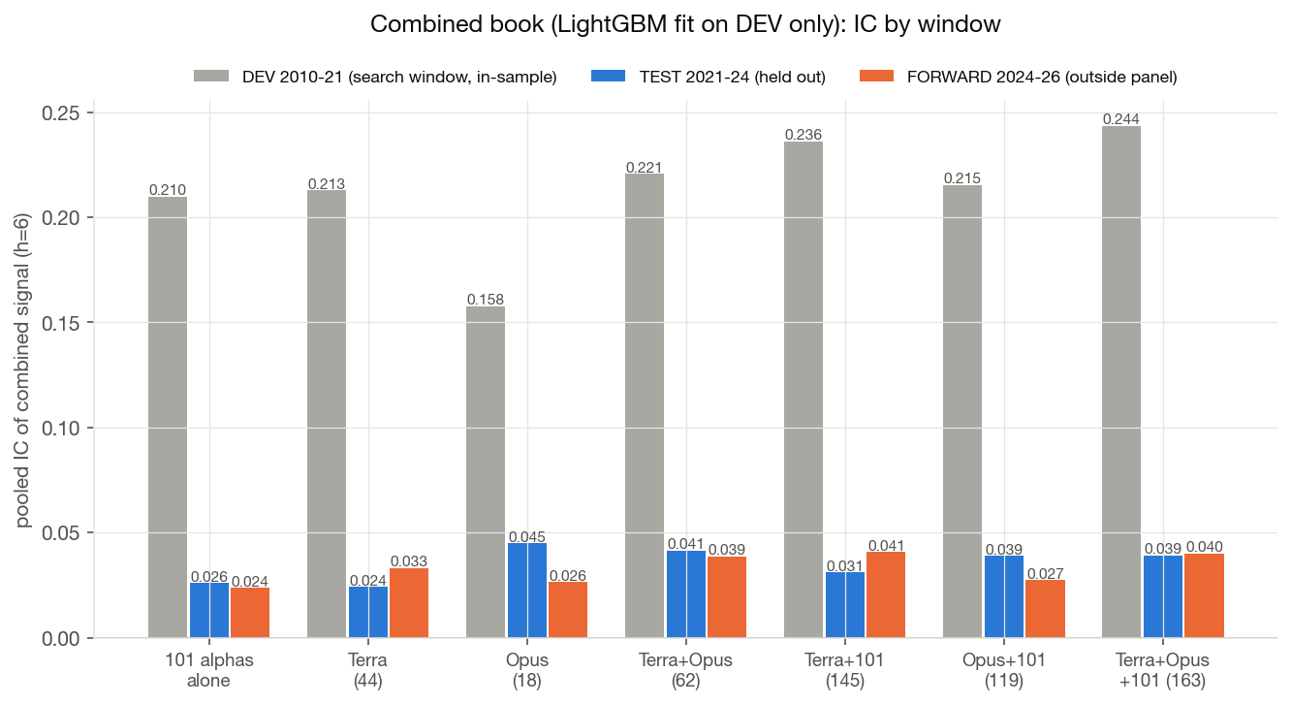
Figure 3 — Combined-book IC per window (LightGBM fitted on DEV only). DEV bars are in-sample fits and are shown only to gauge the generalisation gap.
- Opus generalises best on its own. TEST IC 0.045 from a DEV fit of 0.158 — a retention of 28%, vs. 11% for Terra and 12% for the formulaic library.
- Terra is a marginal-value book. Alone it sits at library level (TEST 0.024), but added to the 101 alphas it lifts the FORWARD IC from 0.024 to 0.041 — consistent with the L4 run's selection objective (leave-one-out marginal contribution against exactly this reference book).
- The two books combine well. Terra + Opus reaches TEST 0.041 / FORWARD 0.039 from only 62 factors; adding the 101 alphas on top gives TEST 0.039 / FORWARD 0.040.

3. Per-factor ICs: distribution and degradation
Book | n | mean |IC| DEV | mean |IC| TEST | mean |IC| FWD | sign retention DEV→TEST | corr(DEV, TEST)
Terra (L4) | 40 | 0.0082 | 0.0106 | 0.0133 | 80% | 0.55
Opus (L2-evolution) | 18 | 0.0135 | 0.0176 | 0.0152 | 83% | 0.65
101 alphas | 101 | 0.0143 | 0.0110 | 0.0126 | 75% | 0.66

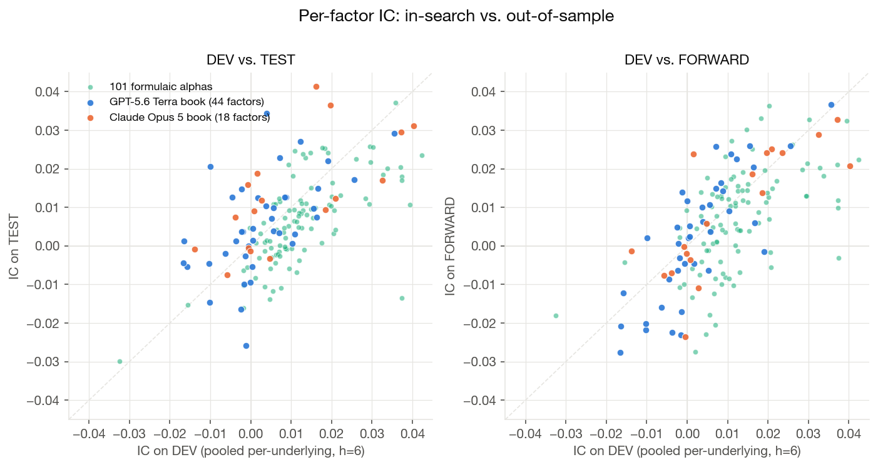
Figure 1 — Each point is one factor: DEV IC against TEST IC (left) and FORWARD IC (right). Points do not collapse below the diagonal: average per-factor ICs do not degrade out of sample, because the search never selected on standalone IC (it selected on marginal contribution to the book), so standalone IC was never over-optimised. Sign retention is 80–89% for the LLM books vs. 74–75% for the formulaic library.
Key finding: the apparent overfitting sits in the combining model, not in the factors. The combined-book IC drops by roughly an order of magnitude from DEV to TEST (e.g. Terra 0.213 → 0.024), which at first glance looks like heavy factor overfitting. The per-factor evidence contradicts that reading: individual factor ICs are as strong on TEST and FORWARD as on DEV (mean |IC| flat to rising, sign retention 80–89%). What collapses out of sample is the fitted LightGBM combination — its in-sample IC reflects the model memorising DEV-specific interaction patterns, an in-sample artefact that says little about the factors themselves. The honest generalisation gap of the books is the much smaller one visible per factor, plus the 2021 regime break documented in Section 7.

4. Strongest individual factors
Opus — top 8 by |TEST IC|:
Factor | Category | IC DEV | IC TEST | IC FWD
comparable_basket_repair_rate_activity_clock_h6 | statistical_arbitrage | 0.0235 | 0.0622 | 0.0242
rice_consistency_wedge_gated_crossing_clock_fade | mean_reversion | 0.0162 | 0.0414 | 0.0187
run_surprisal_vs_flip_baseline_exhaustion_h6 | mean_reversion | 0.0197 | 0.0365 | 0.0241
churn_resilience_gated_sweep_debt_snapback_h6 | microstructure | 0.0403 | 0.0312 | 0.0208
reignition_hazard_pending_spell_vs_paid_split_h6 | microstructure | 0.0372 | 0.0296 | 0.0328
program_gated_elasticity_factor_return_snapback | statistical_arbitrage | 0.0016 | 0.0189 | 0.0239
absorbed_wick_routed_unowed_transient_snapback | microstructure | 0.0326 | 0.0171 | 0.0288
volume_evenness_entropy_innovation_gated_path_ef | microstructure | -0.0008 | 0.0159 | -0.0002

Terra — top 8 by |TEST IC|:
Factor | Category | IC DEV | IC TEST | IC FWD
nonlinear_downside_coskew_compensation_h6 | volatility | 0.0039 | 0.0344 | 0.0063
peer_hawkes_contagion_underreaction | microstructure | 0.0356 | 0.0292 | 0.0366
consumption_tail_amplification_premium_h6 | other | 0.0123 | 0.0271 | 0.0226
news_synchrony_forcedflow_conversion_j_1 | microstructure | -0.0012 | -0.0258 | 0.0139
stale_surprise_fear_state_cascade_diffusion | sentiment | 0.0072 | 0.0229 | 0.0257
earnings_turnover_impedance_resolution | microstructure | 0.0191 | 0.0221 | -0.0015
coherent_surprise_response_gap_drift | sentiment | -0.0100 | 0.0206 | 0.0021
tail_cluster_resilient_liquidity_release | mean_reversion | 0.0256 | 0.0172 | 0.0260

Reference: the best formulaic alphas on TEST are alpha_024 (0.052) and alpha_035 (0.037). The single best factor of the whole analysis is Opus's comparable_basket_repair_rate_activity (TEST 0.062 from a DEV of only 0.024).
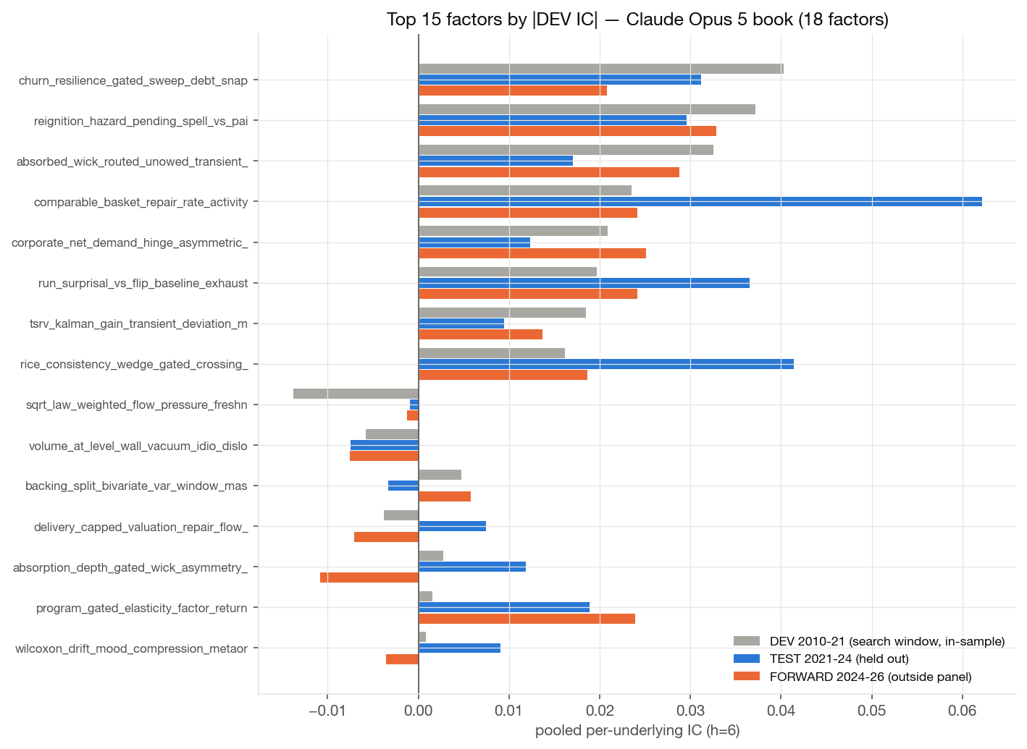
Figure 2a — Opus: top 15 factors by |DEV IC|, with TEST and FORWARD alongside.
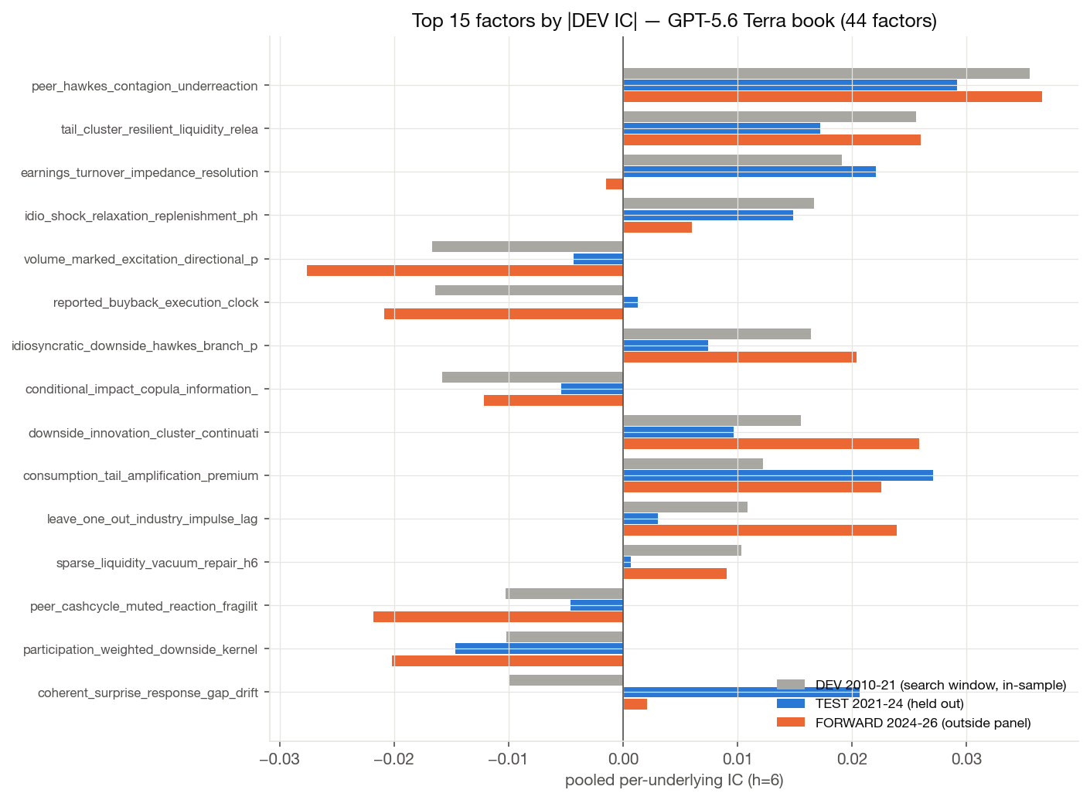
Figure 2b — Terra: top 15 factors by |DEV IC|.

5. Correlation structure and diversity
Signal correlations are computed on cross-sectionally standardised signals over the DEV window. Within-book redundancy is low for both LLM books (mean |ρ|: Terra 0.093, Opus 0.094, library 0.120), but efficiency differs: the participation ratio of the correlation spectrum gives Opus 12.7 effective factors out of 18 (71%), Terra 19.7 / 41 (48%), and the formulaic library only 25.8 / 101 (26%).
The cross-blocks are weak: mean |ρ| Terra×Opus 0.056 (max 0.62), Terra×library 0.076, Opus×library 0.093. The two models explored largely orthogonal factor spaces: Opus concentrated on microstructure (12 of 18 factors), Terra spread across sentiment, volatility, fundamentals and microstructure. Pooling everything yields 35.0 effective factors from 160.
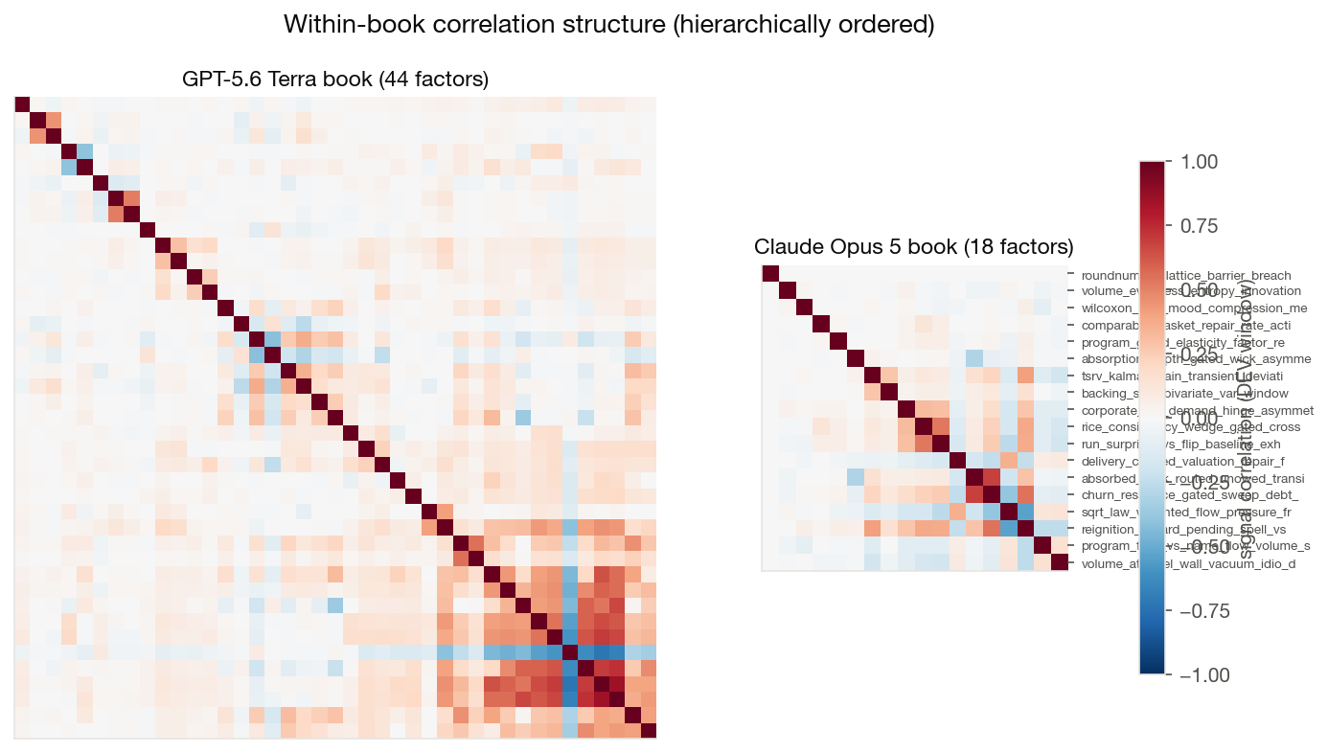
Figure 4 — Within-book correlations, hierarchically ordered. Terra carries one visible redundancy cluster (liquidity/downside family, pairs up to |ρ| ≈ 0.85); Opus a small four-factor wick/absorption block.
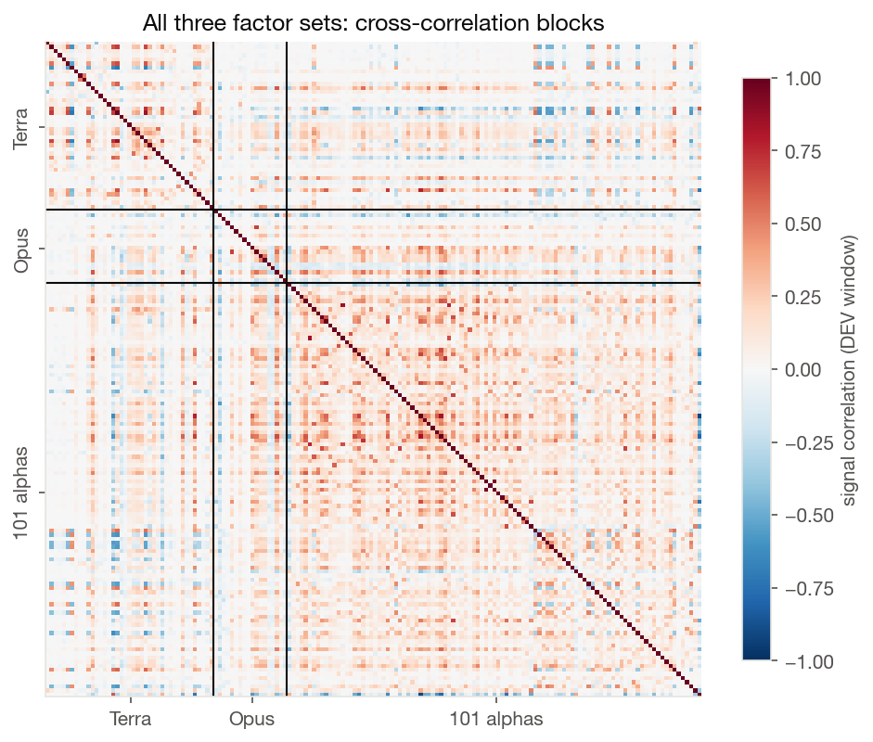
Figure 5 — Full correlation matrix with block boundaries. The library block (bottom right) is visibly denser; the off-diagonal blocks stay pale.
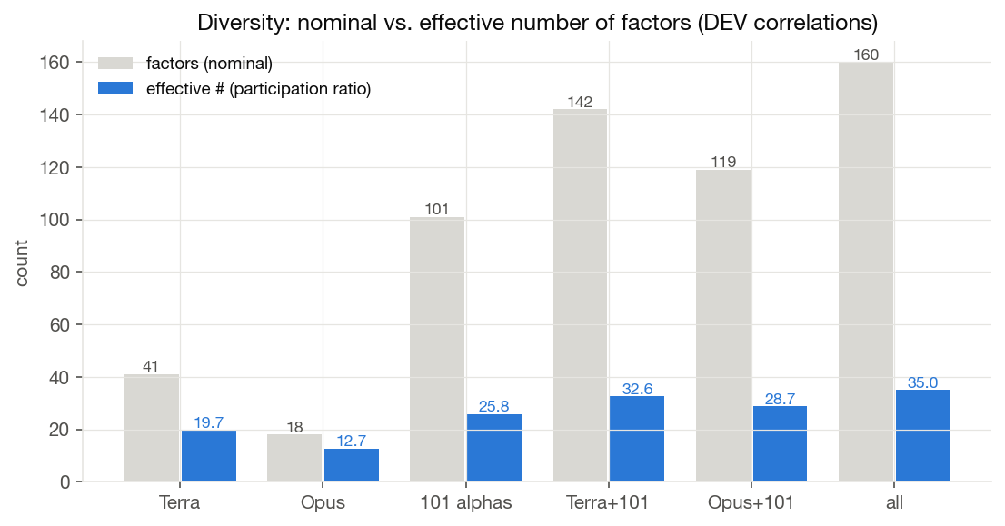
Figure 7 — Nominal vs. effective factor counts (participation ratio of the correlation eigenvalues).

6. Novelty relative to the formulaic library
For each evolved factor, the maximum |correlation| to any of the 101 formulaic alphas measures how much of it the library already spans. The median is 0.28 (Terra) and 0.29 (Opus): the typical evolved factor is not a disguised formulaic alpha. The most library-like factors of both books attach to the same two alphas (alpha_033, alpha_038), with a maximum of 0.78.
Book | Factor | Nearest alpha | max |ρ| library | max |ρ| own book
Terra | idiosyncratic_downside_hawkes_branch_pressure | alpha_033 | 0.78 | 0.63
Opus | reignition_hazard_pending_spell_vs_paid_split_h6 | alpha_038 | 0.65 | 0.55
Terra | conditional_impact_copula_information_residual | alpha_033 | 0.63 | 0.73
Opus | tsrv_kalman_gain_transient_deviation_memory_h6 | alpha_033 | 0.60 | 0.41
Terra | tail_cluster_resilient_liquidity_release | alpha_038 | 0.59 | 0.36
Terra | sparse_liquidity_vacuum_repair_h6 | alpha_062 | 0.59 | 0.85

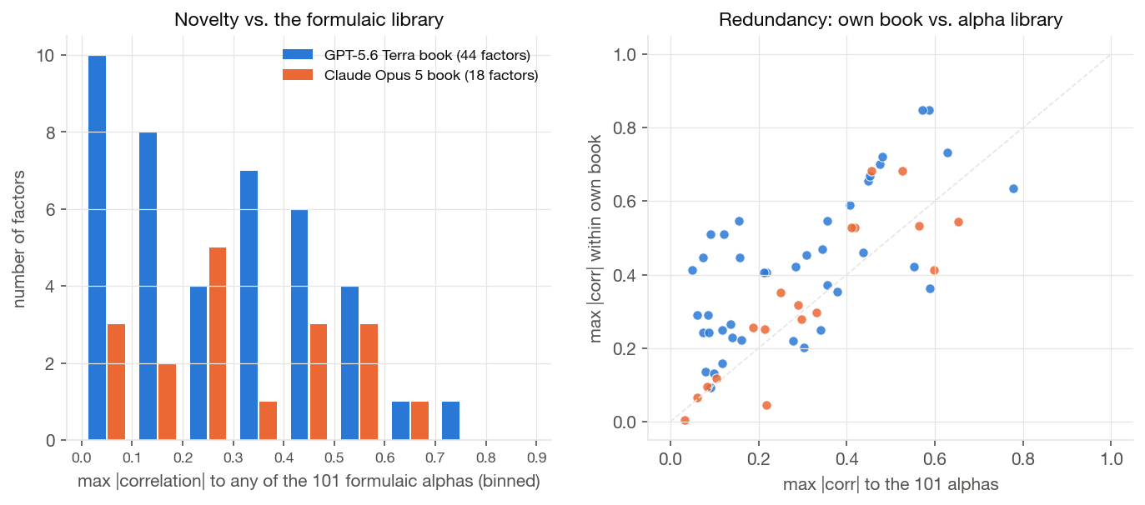
Figure 6 — Left: distribution of library-similarity (binned in 0.1-wide buckets); Terra has a solid block of genuinely novel factors below 0.15. Right: factors above the diagonal are more redundant within their own book than with the library — Terra's redundancy is home-grown (the cluster of Figure 4), not library imitation.

7. IC through time: the 2021 regime break
The pooled per-underlying IC is one number per window and has no daily analogue, so the time-resolved view uses the daily cross-sectional IC (each day, the correlation across stocks between signal and forward return) as a diagnostic; its level is not comparable to the pooled numbers above.
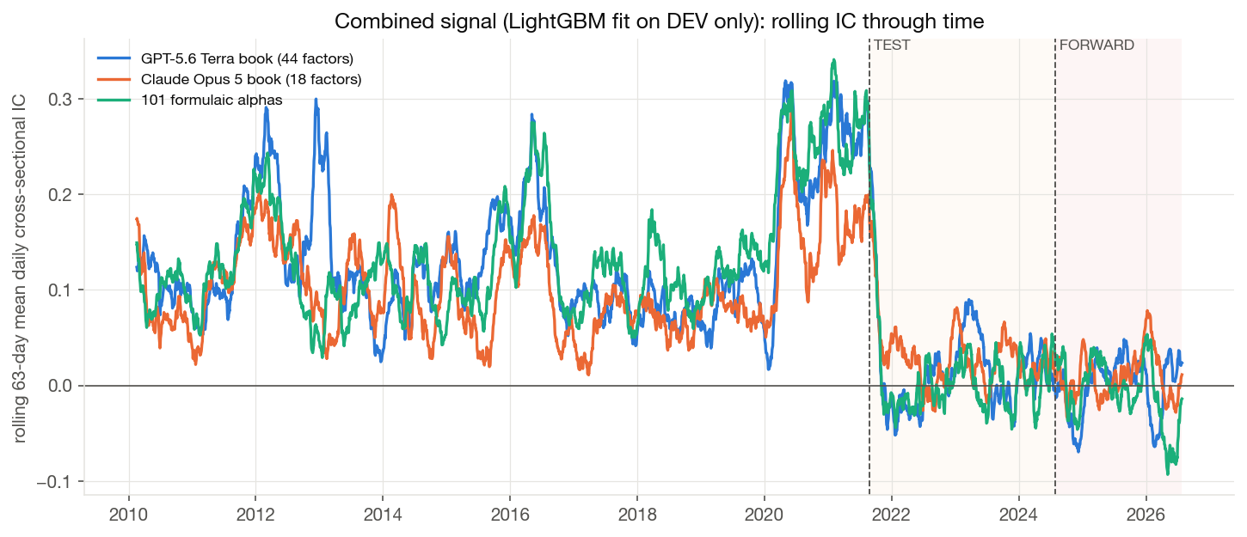
Figure 8 — 63-day rolling mean of the daily cross-sectional IC of the combined signals (fitted on DEV only). All three books — including the formulaic library, which was never fitted to this panel — collapse simultaneously at the 2021 TEST boundary: the cross-sectional factor regime in the Nasdaq-100 itself changed (mega-cap concentration), so the DEV→TEST drop is not pure overfitting. The Opus signal stays above zero most often out of sample; the library turns clearly negative in 2025–26.

8. Conclusions
- Per-factor quality: Opus. Individually stronger and more stable factors (mean |TEST IC| 0.018 vs. 0.011), the best standalone generalisation of the combined book (TEST 0.045), and the highest effective-dimension efficiency — at 5× the cost ($452 vs. $87) and with only 18 factors.
- Breadth and marginal value: Terra. More factors, more genuine novelty, the largest diversity gain to the pooled book, and the best FORWARD results appear only in combination (Terra + 101: 0.041) — exactly the selection objective of the L4 configuration.
- Near-orthogonal books. Mean cross-correlation of 0.056 between the two books; combining them (with or without the formulaic library) is the natural next step and already outperforms either book alone on TEST.
- The DEV→TEST gap is a model artefact, not factor overfitting. Per-factor ICs hold or improve out of sample while only the fitted combination collapses; in-sample combined ICs should never be quoted as evidence of book quality.
- Attribution caveat. Model (GPT-5.6 vs. Opus 5) and configuration (L4 GraphRAG / 8 groups vs. L2 no-retrieval / 1 group) are confounded; a clean model comparison would require the never-run L4 Opus arm.
Reproduction: scripts/analyze_l4_factor_books.py → data/comparisons/l4_factor_analysis/ (CSVs, summary.json), figures: scripts/plot_l4_factor_books_en.py.

