Super records User Manual

- Admin Login Panel -------------------------------------------------------------------- 2
- System Setup --------------------------------------------------------------------------- 3
- Workflow Activities ---------------------------------------------------------------------11
- Client Management -------------------------------------------------------------------14
- Staff Management -------------------------------------------------------------------- 27
- Timesheet ------------------------------------------------------------------------------- 30
- Worksheet ------------------------------------------------------------------------------- 31
- Worksheet Repeats ------------------------------------------------------------------- 38
- Tickets ------------------------------------------------------------------------------------ 39
- Email Options --------------------------------------------------------------------------- 42
- Reports ----------------------------------------------------------------------------------- 44
- CMS Admin ---------------------------------------------------------------------------- 53
- Client Side Process ------------------------------------------------------------------ 61

Admin Login Panel
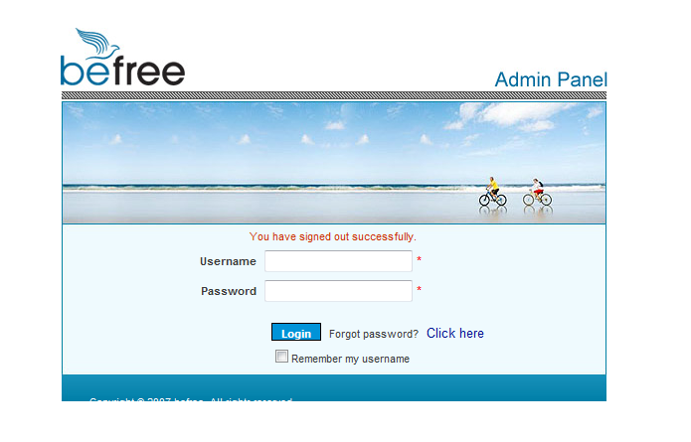
Once you entered the login credentials, you will be able to access throughout this application.
Note: If anyone access this application via new IP address, that IP should be added to our application by using “IP address module” under “System Setup”. ( See the section 2.15 below)

System Setup

Case Status

This is used to update the status dynamically which will be using under Case Module. We can add / update / delete Status whenever we want to do. Also it has custom filter options to search the details rapidly.
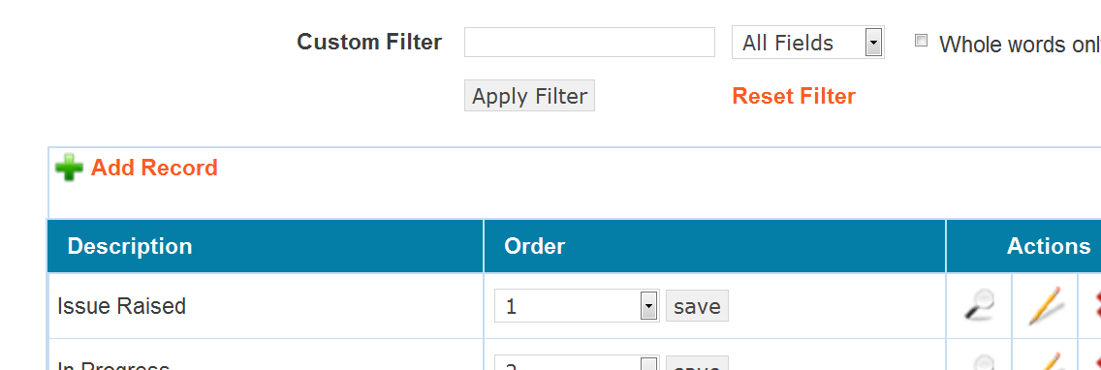

Designation

This is used to update the Designation dynamically which will be using under Client and Staff Module. We can add / update / delete Designation whenever we want to do. Also it has custom filter options to search the details rapidly.

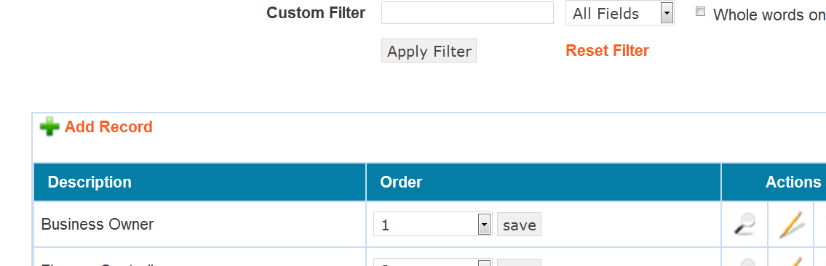

Entity Type

This is used to update the Entity types dynamically which will be using under Client and Staff Module. We can add / update / delete Designation whenever we want to do. Also it has custom filter options to search the details rapidly.
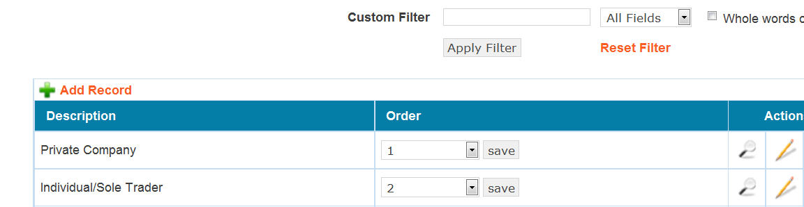

Leave Request Status

This is used to update the status of Leave Request forms dynamically which will be using Leave Request module. We can add / update / delete status of Leave Request forms whenever we want to do. Also it has custom filter options to search the details rapidly.

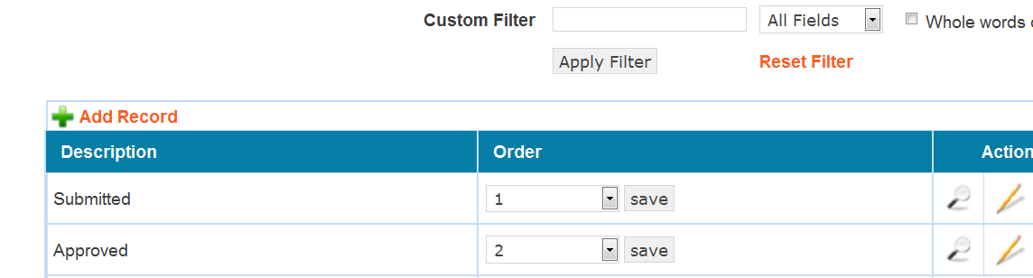

Process Cycle

This is used to update the Process cycle dynamically which will be using Worksheet module. We can add / update / delete Process cycle whenever we want to do. Also it has custom filter options to search the details rapidly.

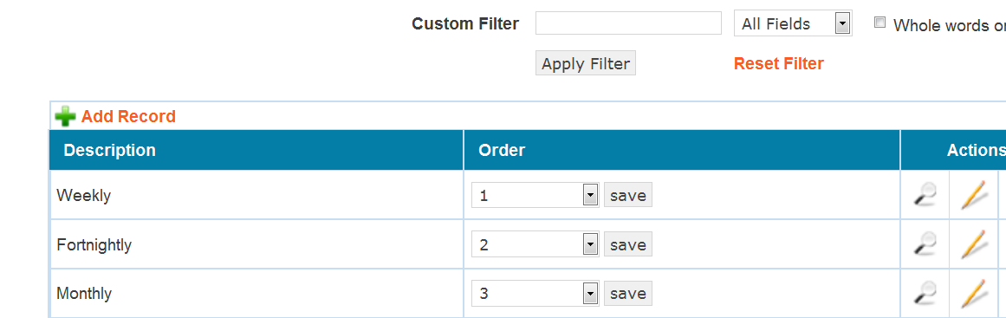

Priority

This is used to update the Priority dynamically which will be using Worksheet & Tickets module. We can add / update / delete Priority whenever we want to do. Also it has custom filter options to search the details rapidly.
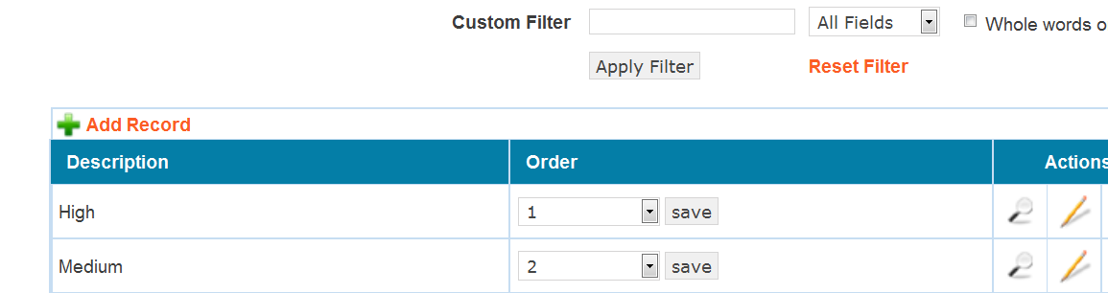

Timesheet Status

This is used to update the Status of Timesheet dynamically which will be using Timesheet module. We can add / update / delete Status of Timesheet whenever we want to do. Also it has custom filter options to search the details rapidly.

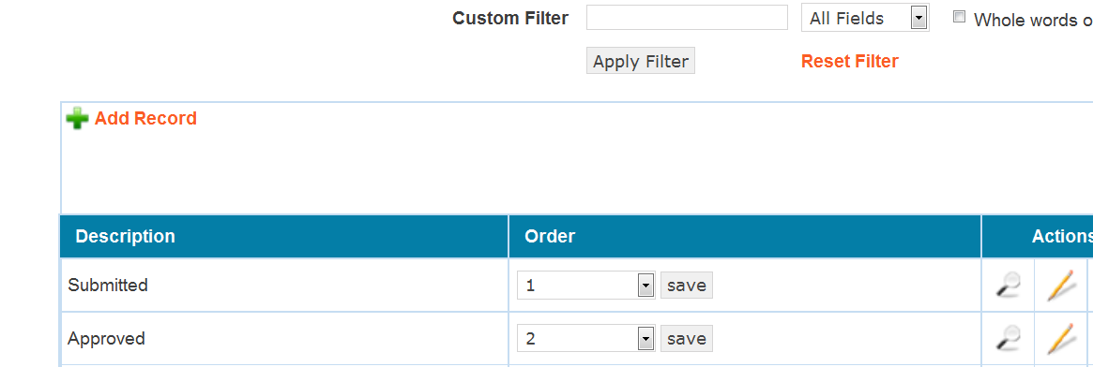

Worksheet Status

This is used to update the Status of Worksheet dynamically which will be using Timesheet module. We can add / update / delete Status of Worksheet whenever we want to do. Also it has custom filter options to search the details rapidly.
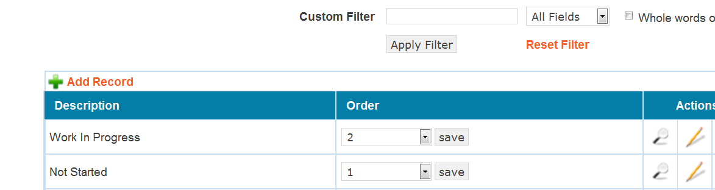

Lead Stage

This is used to update the Stages of Lead type client dynamically which will be using Lead type under Client module. We can add / update / delete Stages of Lead type whenever we want to do. Also it has custom filter options to search the details rapidly.
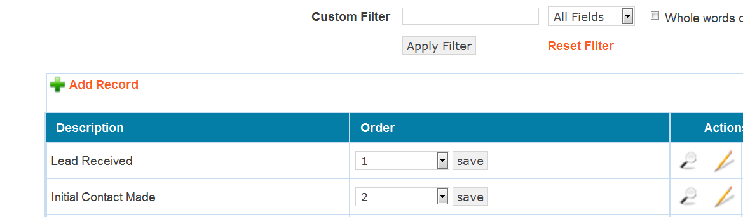

Lead Status

This is used to update the Status of Lead type client dynamically which will be using Lead type under Client module. We can add / update / delete Status of Lead type whenever we want to do. Also it has custom filter options to search the details rapidly.
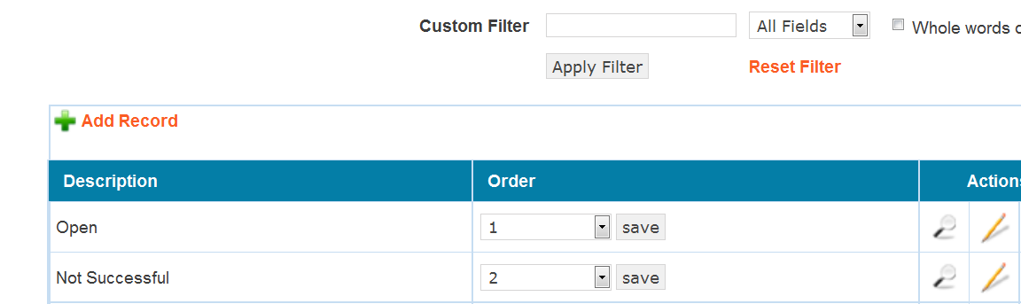

Source

This is used to update the Source type dynamically which will be using on Client module. We can add / update / delete Source type whenever we want to do. Also it has custom filter options to search the details rapidly.

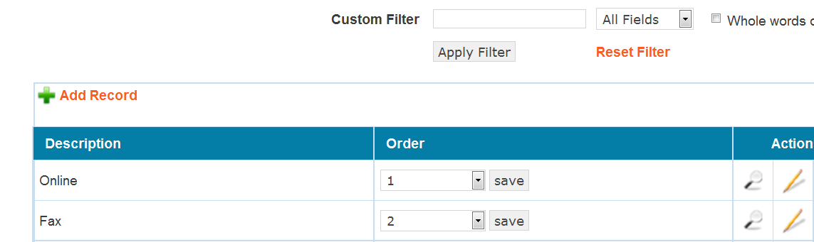

Method of Contact

This is used to update the Method of Contact dynamically which will be using on Client module. We can add / update / delete Method of Contact whenever we want to do. Also it has custom filter options to search the details rapidly.
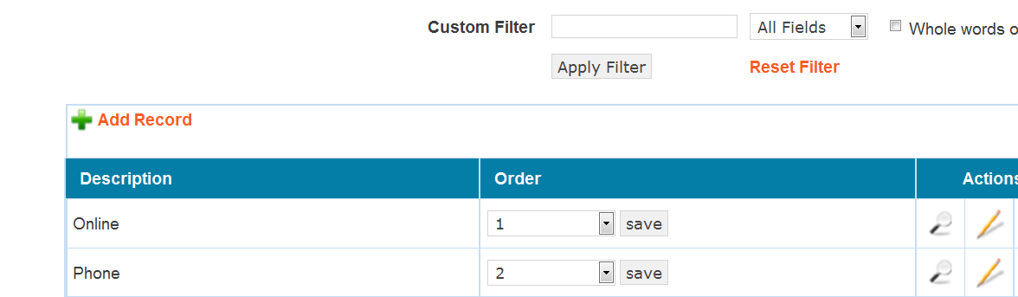

Industry

This is used to update Industry type dynamically which will be using on Client module. We can add / update / delete Industry type whenever we want to do. Also it has custom filter options to search the details rapidly.
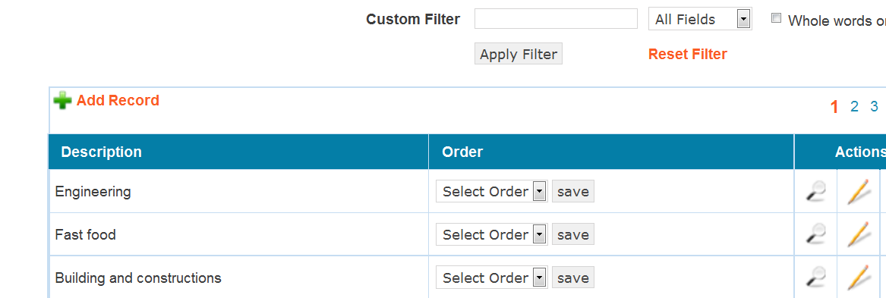

Service Required

This is used to update Service required details dynamically which will be using on Client module. We can add / update / delete Service required details whenever we want to do. Also it has custom filter options to search the details rapidly.

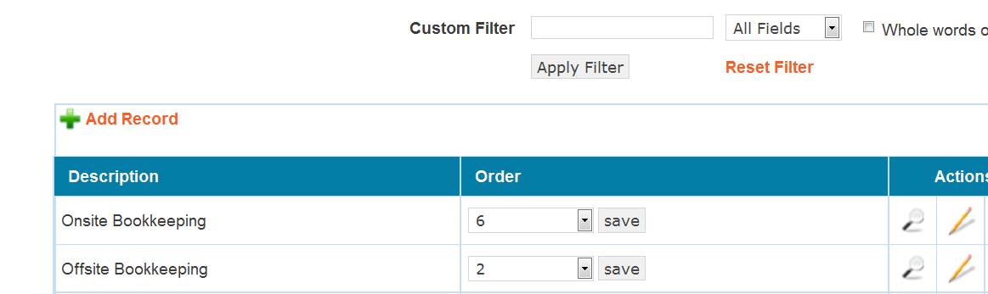

IP address

This is used to add / update IP address of staffs dynamically whenever they access this application from new IP address. It is too imperative that make sure new IP address of staff is added because the respective staff can’t access it without adding their IP address here. Also it has custom filter options to search the details rapidly.
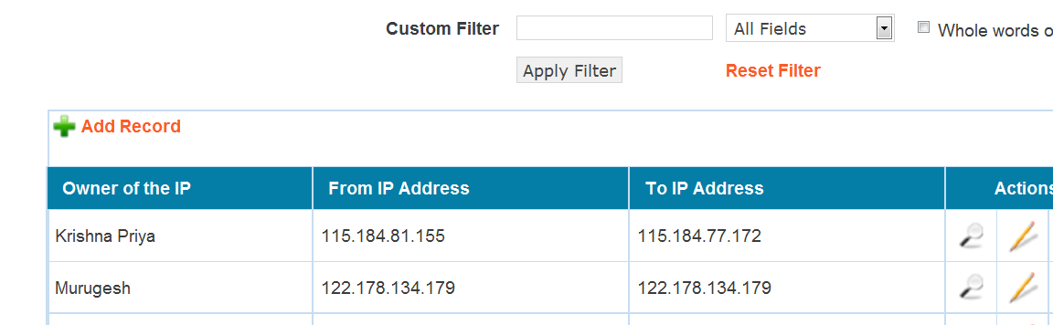

Workflow Activities

Master Activity

This is used to update Master activity details dynamically which will be using on Timesheet / Worksheet / Ticket modules. We can add / update / delete Master activity details whenever we want to do. Also it has custom filter options to search the details rapidly.
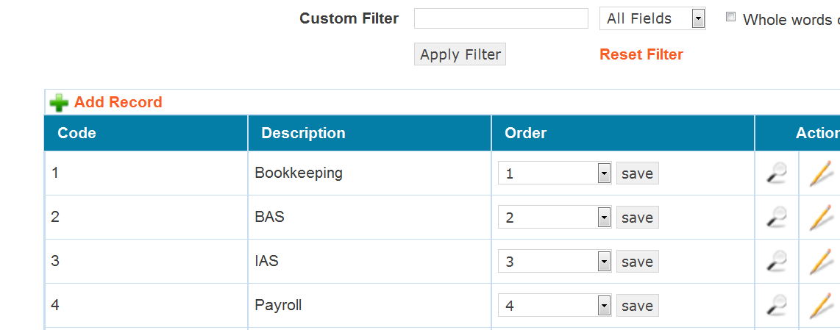

Sub Activity

This is used to update Sub activity details dynamically which will be using on Timesheet / Worksheet / Ticket modules. We can add / update / delete Sub activity details whenever we want to do. Also it has custom filter options to search the details rapidly.
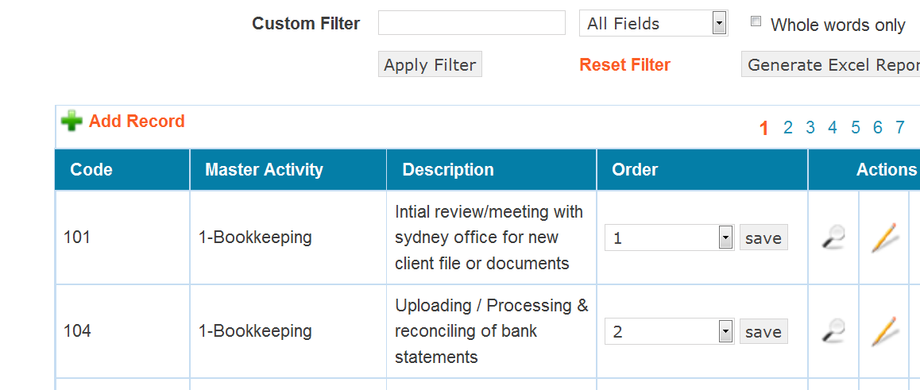

Tasks

This is used to update Tasks dynamically which will be using on Perm Info / Quotesheet / Hosting and so on under Client modules. We can add / update / delete Tasks whenever we want to do. Also it has custom filter options to search the details rapidly.
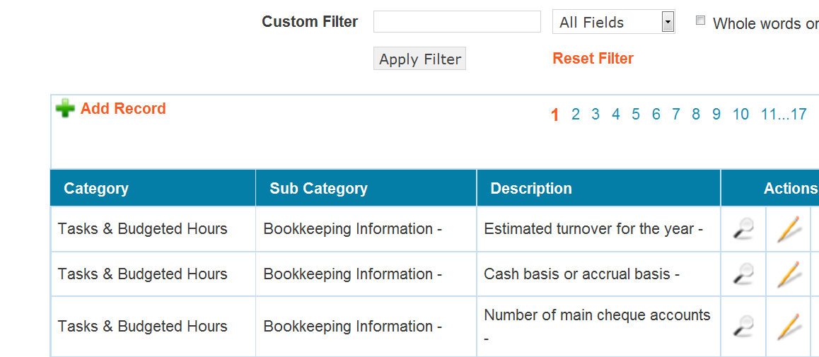

Timesheet Tasks Templates

This is used to update Template details dynamically which will be using on Timesheet module. We can add / update / delete Template details whenever we want to do. Also it has custom filter options to search the details rapidly.
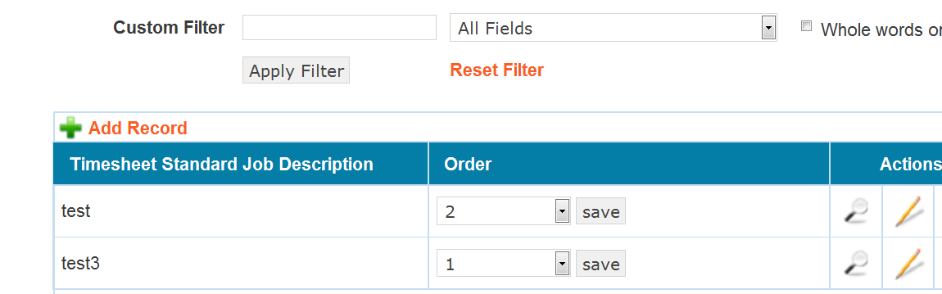

Client Management

Navigate the menu “Clients -> Manage Clients”, you will see the list of clients on grid format like below screen shots.

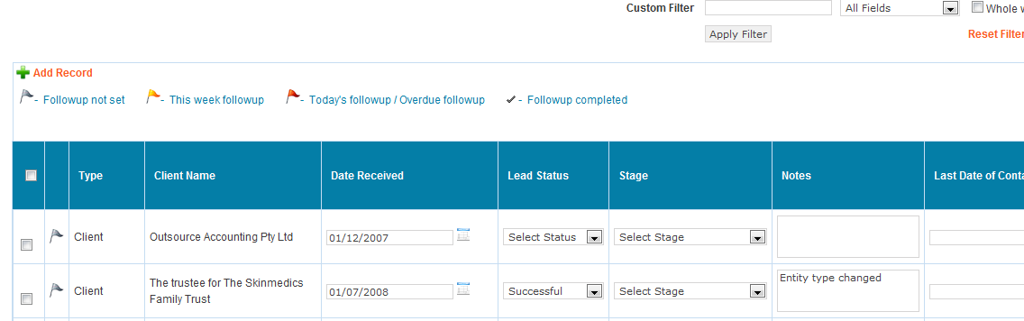

Note:
1). In grid view, the fields from “Date Received” to “Future Contact date” will be shown only to the user who has permission to view / edit “Lead”. Refer below screenshot.

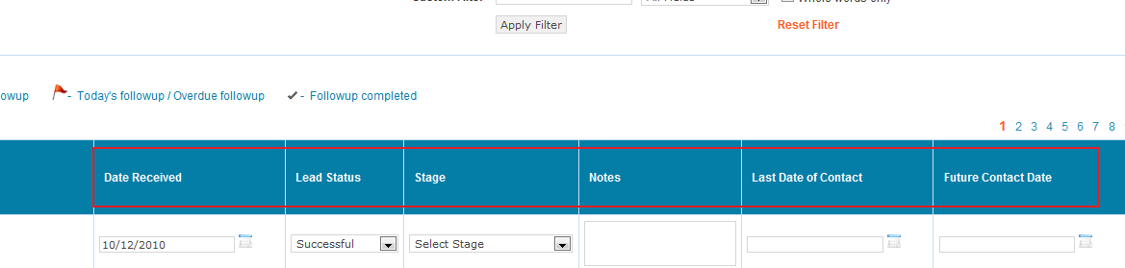

2). In grid view, “Document” field will be shown only to the user who has permission of “Upload Document” and the client who has the type of “Client / Contract Signed”. This will be disabled to “Lead / Discontinued” type of Clients. Refer below screenshot.

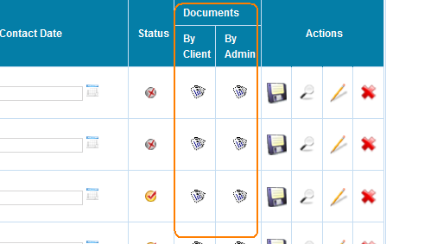

Documents By Client
If you click document icon under “By Client”, then you will be taken in to “View Client Uploaded Documents” page where the documents uploaded by Client will only be listed out.
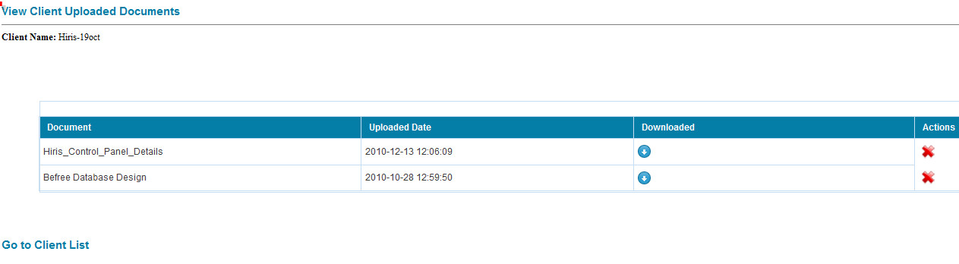

Documents By Admin
If you click document icon under “By Admin”, then you will be taken in to “View Admin Uploaded Documents” page where the documents uploaded by Admin will only be listed out.
- Click Here to Upload Admin Documents : It takes you to “CMS ADMIN” where you can upload new documents and see the existing lists.
- Go to Client List : It takes you to Manage Client home page.
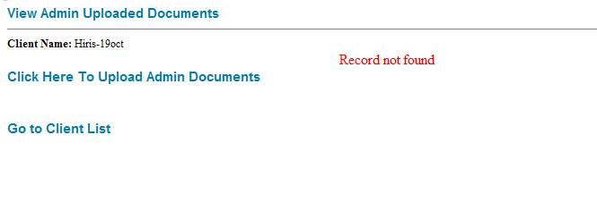

Add New Client

Add new client with providing required details of them. The required fields will be placed according to the selection of Client types. The basic details of Client will be shown like below screenshot while you add new Client:
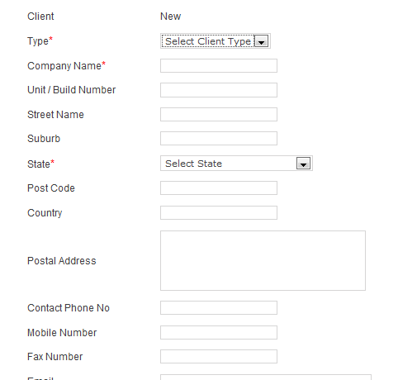
You will see the “contact details” under the base details of the client like below screenshot:
.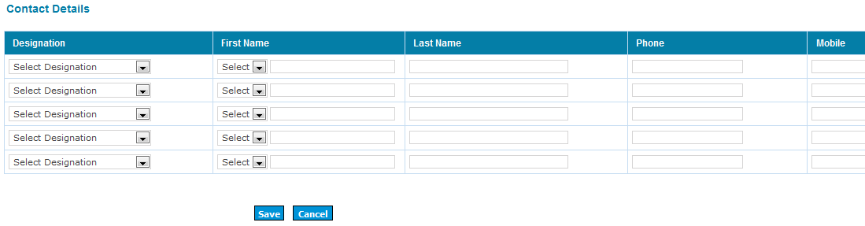
Client:
The following fields are required while we select / change the type to “client”:
- Australia Manager
- India Manager
- Billing Person
- Team In Charge
- Team Member
- Unit / Build Number
- Street Name
- State
- Post Code
- Email
- Password
Contract Signed:
The following fields are required while we select / change the type to “Contract Signed”:
- Australia Manager
- Unit / Build Number
- Street Name
- Contact Phone No
- Email
- Password
- Industry
- Source
- Contract Signed Date

Mail Process:
1). When the client types are changed to “Contract Signed”, 2 mails will trigger separately. One mail to “Sales person” of the client and Admin with subject as “E1 - Signed Contract Received”. Another one to “Australian Manager “ of the client with subject as “E1 - New Client Assigned - Please send welcome email”.
2) When the client types are changed to “Client” Email goes to India Manager of the Client with subject as “E4 – Assign new client to India Manager and Submit Permanent Info”.
3). When changed Team-in-charge of the “Client”, Email goes to Current Team-in-charge & India Manager of the client with subject as “E6 - New client ready to start/assigned to Team Incharge”.

Activate / Inactivate the Client

The admin user can Activate or Deactivate the clients from grid listing. By status column of grid listing, we can know whether the client is active or not. (Refer below screen)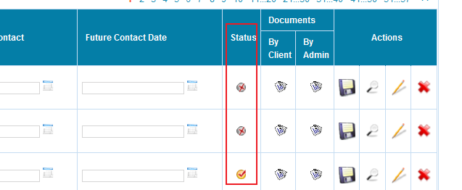

After selecting the checkboxes which are against the client on the rows, click the buttons which prompting the process what we want (Activate / Deactivate). Refer below screenshot.

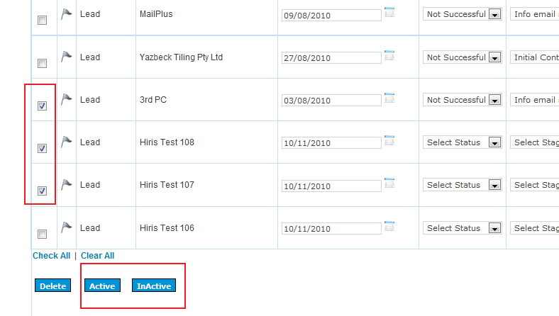
Mail Process: When the clients are activated, Email goes to the corresponding users with their login details.

Flag setting

This is used to setting follow up date to the client. There are 4 types shown to your reference with different colors. They are :
1). Not set,
2). This week,
3). Today / overdue,
4). Completed.

We can set the follow up date from grid listing, click Flag icon which against the client’s row then pop-up will show. In which, we can set the flag whatever we want. Refer below screenshots.
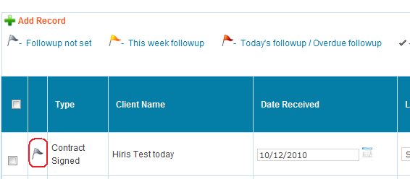

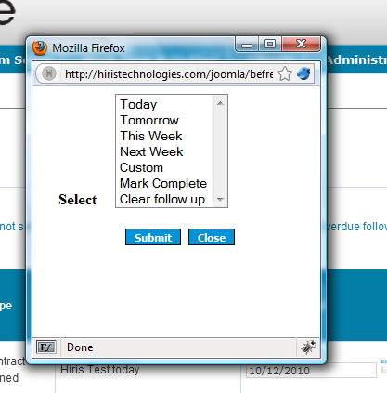

Task Panels (display on left side)

Task Panels will be different according to types of client. The client, who belongs to “Lead” type has only below base panels:
    - Details
    - Contact
For “Client / Contract signed” type clients have below panels as well as the above base panels:
    - Quote Sheet
    - Sales Notes
    - Permanent Information
    - Tax & Accounting
    - Hosting
    - Notification

- Details

It contains the details of the client. We can view / edit the details of the client from here. Also we can download PDF / Excel format which contains the details of the client.

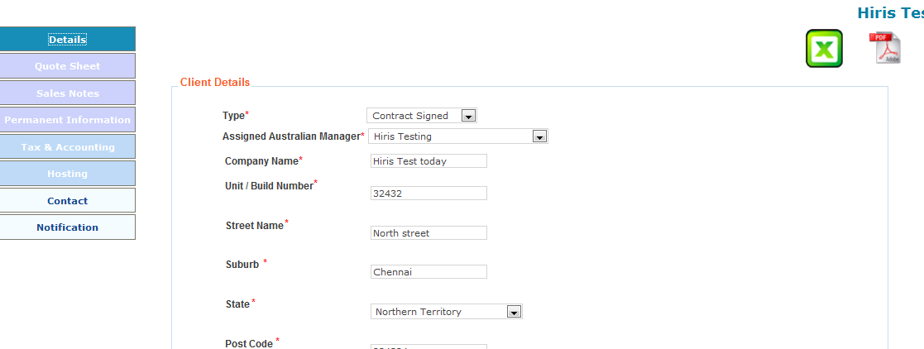

- Contact
We can add / edit/ delete the contact person’s details under the respective client. . Also it has custom filter options to search the details rapidly.

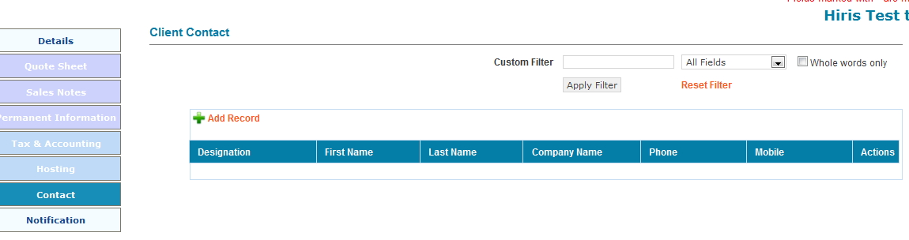

- Quote sheet
There are 2 tabs available under Quote sheet panel. They are: 1). Card File Info, 2). Invoice. Also PDF / Excel download option is there to view entire details of quote sheet.
Note : Indian Notes will be enabled only for admin users who is Indian manager of current client.
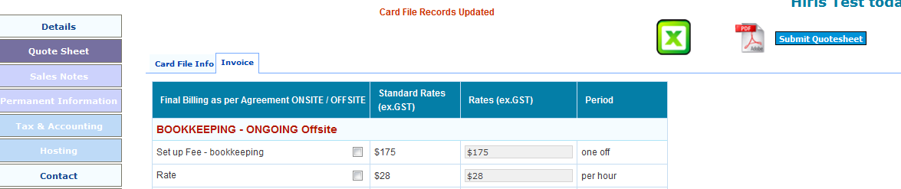

Dependence : If you select Entity type as anyone of these (Private Company, Individual / Sole Trader, Partnership) under “Card File Info” tab, it will enable “Entity Details” under “Permanent Information -> Perm Info” tab.

Email Option:
When Quote sheet information submits, Email goes to info@super records.com.au, billing@super records.com.au and “Sales Person” who assigned to that respective client with subject as “E2 – quotesheet submitted”.

- Sales Notes
There are 4 tabs available under Sales Notes panel. They are: 1). Details, 2). Status, 3). Tasks, 4). Notes. Also MS word download option is there to view entire details of Sales Notes.
Email Options:
When Sales Notes submitted, Email goes to Australia Manager who assigned to that respective client with subject as “E3 – Sales Notes”. Also Sales Notes/Tasks section - when we select "Yes" to super records doing tax returns, and when sales people submits the sales notes it goes to Vaishali’s email address.

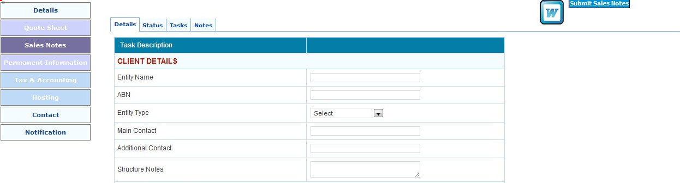

Note : Indian Notes will be enabled only for admin users who is Indian manager of current client.

- Permanent Information
There are 13 tabs available under Permanent Information panel. They are: 1). Set Up Syd, 2). Perm Info, 3). Current Status, 4). Back log Jobsheet, 5). General Info, 6). Bank, 7). AR, 8). AP, 9).Payroll, 10). BAS, 11). Tax Returns, 12). Special Tasks, 13). Due Dates & Reports. Also PDF / Excel download option is there to view entire details of quote sheet.
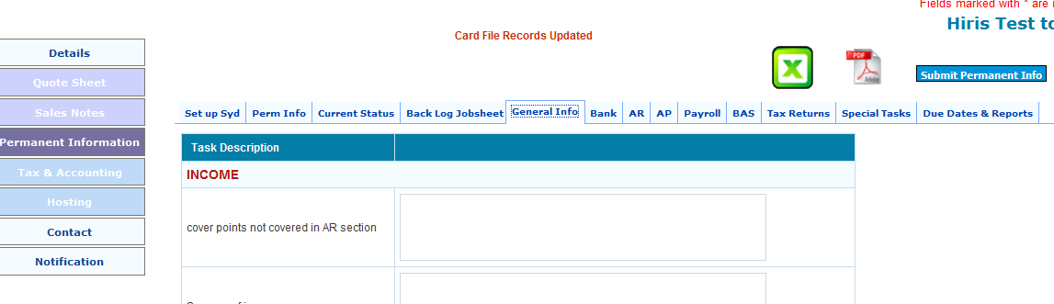
Note :
1). Indian Notes will be enabled only for admin users who is Indian manager of current client.
2). “Permanent information” should be submitted before changing the client type from anyone to “Client”.

- Tax & Accounting

There is only one tab available under Tax & Accounting panel that is Tax & Accounting. Also PDF / Excel download option is there to view entire details of Tax & Accounting.

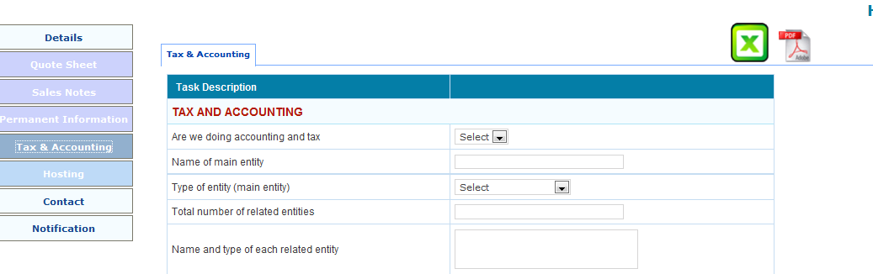
Note :
1). Indian Notes will be enabled only for admin users who is Indian manager of current client.

Email Option:
When Tax & Accounting details submits, Email goes to “India Manager” and “ Sales person” of that respective client with subject as “E7”.

- Hosting

There is only one tab available under Hosting panel that is Hosting. Also PDF / Excel download option is there to view entire details of Hosting.

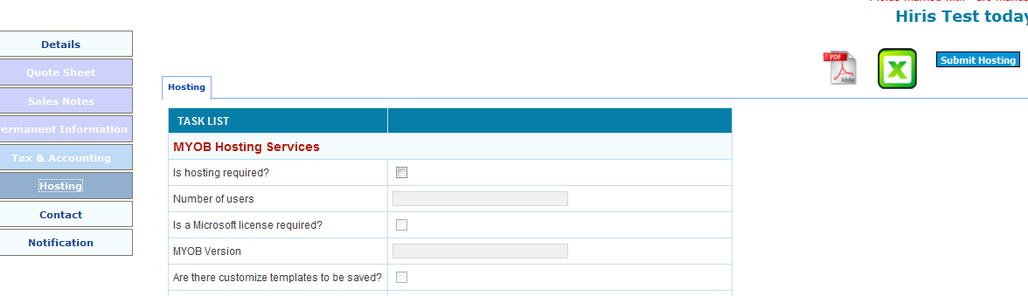

Note :
1). Indian Notes will be enabled only for admin users who is Indian manager of current client.
2). “Is hosting required” field should be checked before submitting Hosting.

Email Option:
When Hosting information submits, Email goes to info@super records.com.au with subject as “E5 - Hosting”.

- Notification
This is used to send Email notification to the staffs whoever we want to send it.
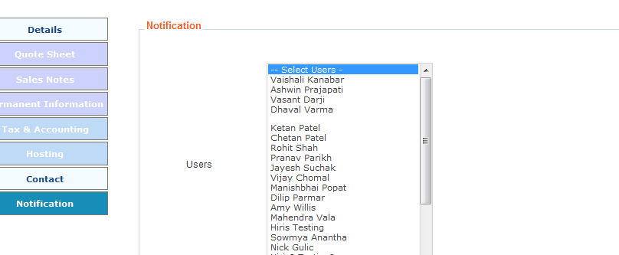

Email Option:
Mail goes to One or More than One Selected the users.

Staff Management

Employees

This is used to update the details of employees like Email, name, contact and so on. We can add / update / delete details of employees whenever we want to do. Also it has custom filter options to search the details rapidly.

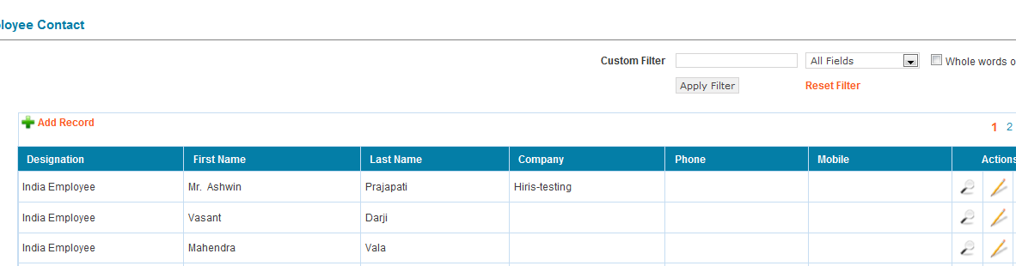

Users

This is used to set Login credentials and permission to access modules. We can add / update / delete details of employees whenever we want to do. Also it has custom filter options to search the details rapidly.

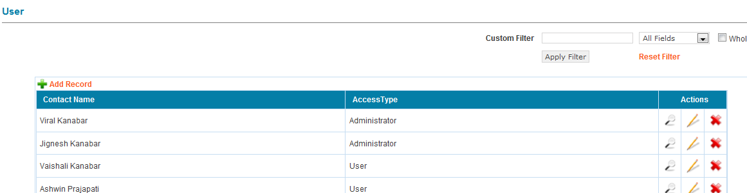

Setting Permissions
There are 4 options available such as View, Add, Edit and Delete. We can set these options by checking checkbox against on every modules / forms which listed there. Refer below screenshot.

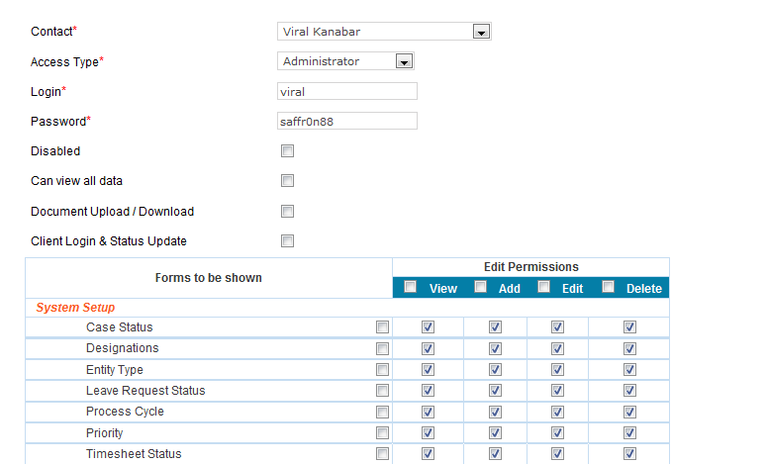

Disabled : If we checked this option, it will keep the staff as inactive. So they can do nothing.
Can View All data : This is used to enable the staff to view all records which belonged to each and every clients and staffs similar to Admin privilege. But these conditions will only apply to their enabled modules.
Document Upload / Download : This is used to enable the staff to upload the documents to their corresponding clients via CMS admin as well as to view the documents in client’s grid list (Clients -> Manage Clients).
Client login & Status update: This is used to enable the staff to Active / In-Active clients from grid listing. See section 4.2

Leave Request Form

This is used to send “Leave request details” to Admin. We can add / update / delete “Leave request details” whenever we want to do. But Admin can only approve / decline. Also it has custom filter options to search the details rapidly.
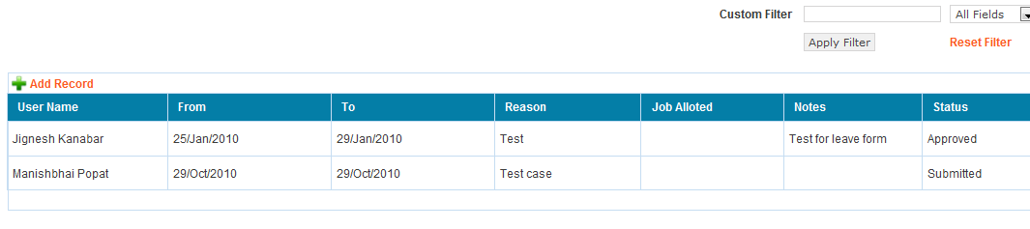

Email Option:
When Add or Edit Leave Request mail goes to Admin.

Timesheet

This is used to update Timesheet details dynamically. We can add / update / delete Timesheet details whenever we want to do. Also it has custom filter options to search the details rapidly.
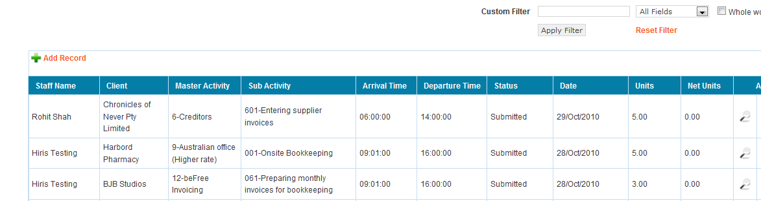
Refer below screenshot. This is the form to enter the staff’s details and their timings on that day.
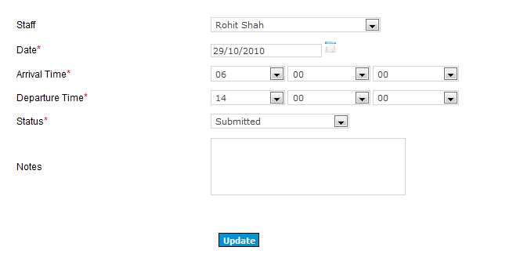
Once you submitted the above said form, you will be enabled to enter project / client details that you worked on that timesheet.
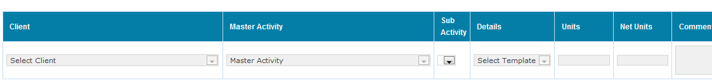

Worksheet

After you selecting Worksheet, you will see the grid list which shows the clients whoever have worksheet. If you click “+” symbol located left against the client name, It will show the worksheets under corresponding client.
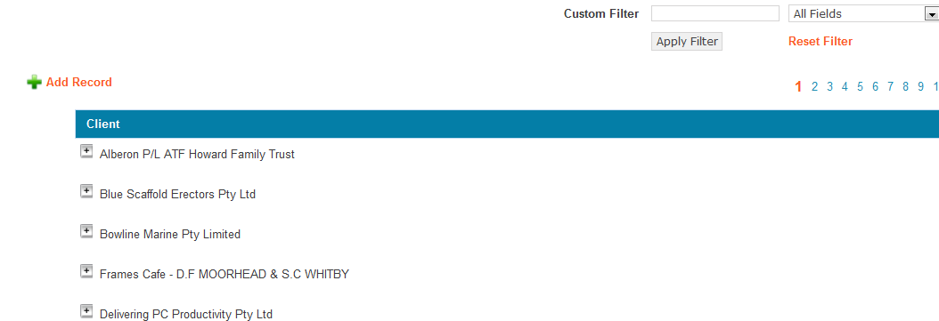

There are 2 new options except edit , view, etc such as Inline save and Copy option. Inline save is used to update some particular fields that displayed in grid. Refer below screenshot:

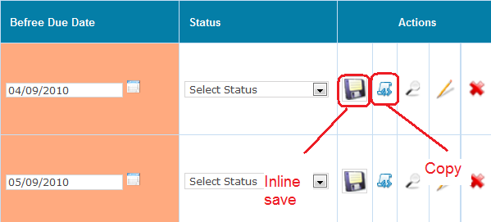

Copy option is used to clone new worksheet from current worksheet , in which you can enter new “External Due date” & “Super records Due date” but other details come from existing record. Go through below screenshot for your reference.

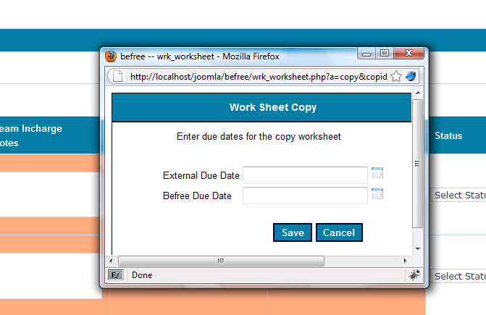

Add Worksheet
When you add new worksheet, you will fill required details and submit. You can create worksheet repeats as well while you add new one. We explained briefly about worksheet repeats on next section.

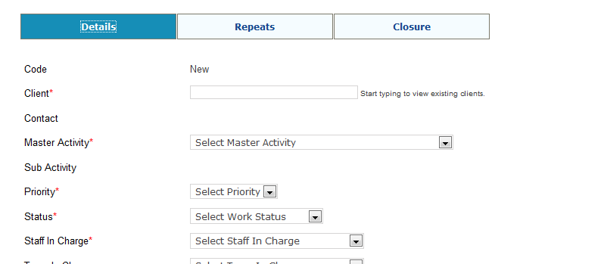

Repeats / Closure
When you edit worksheet record, you will find 3 tabs such details , Repeats & Closure like below screenshot:
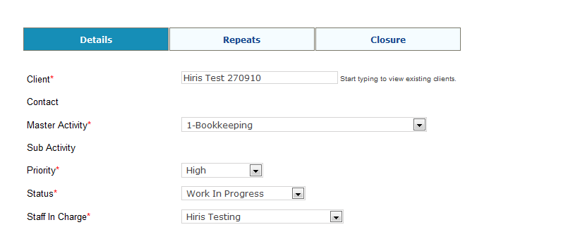
In repeats, you can repeats according to different aspects like daily, weekly, monthly and so on. We will see briefly one by one, refer below screenshot:
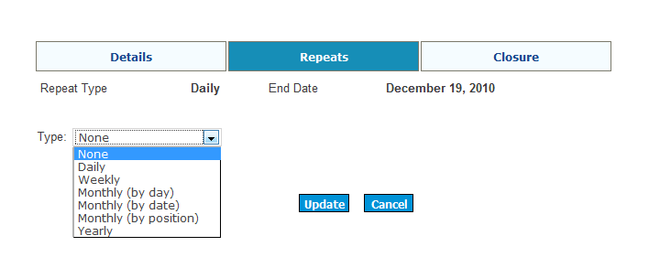

In closure tab, once you give “completion date” and submit the form, It will be closed the corresponding worksheet that wouldn’t be visible in future. Refer below screenshot:
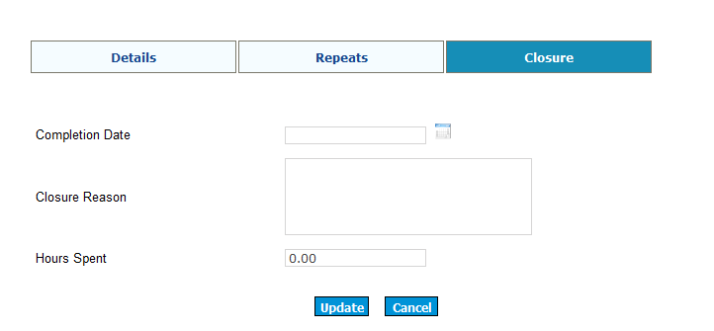

Daily basis: If you select “Start Date” & “End Date / Number of Times” , number of worksheets will be created according to the selection on the basis of Frequency. If set Frequency is 1, create worksheet every day, If frequency is 2, create worksheet two days once and so on.
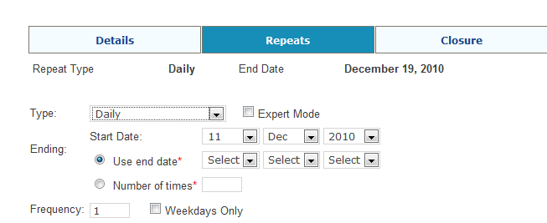

Weekly basis: If you select “Start Date” & “End Date / Number of Times”, number of worksheets will be created according to the selection on the basis of Frequency and ByDay. If set Frequency is 1, create worksheet every week on that particular days (It will take checked days under “ByDay” option, if they are checked otherwise it will take the day of Start date ), If frequency is 2, create worksheet two weeks once on that particular days and so on. (Refer below screenshot):

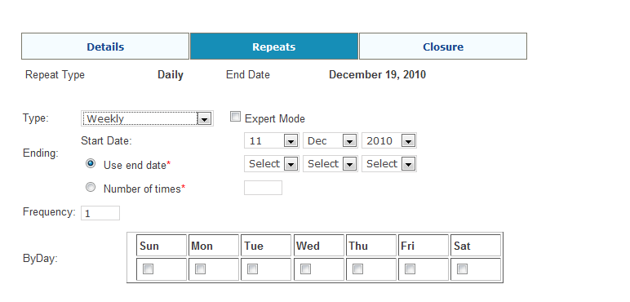
Monthly (by day) basis: If you select “Start Date” & “End Date / Number of Times”, number of worksheets will be created according to the selection of the Dates and Frequency. If set Frequency is 1, create worksheet every month on that particular day which taken from “Super records Due date” from “Details” Tab, If frequency is 2, create worksheet two months once on that particular day and so on. (Refer below screenshot):
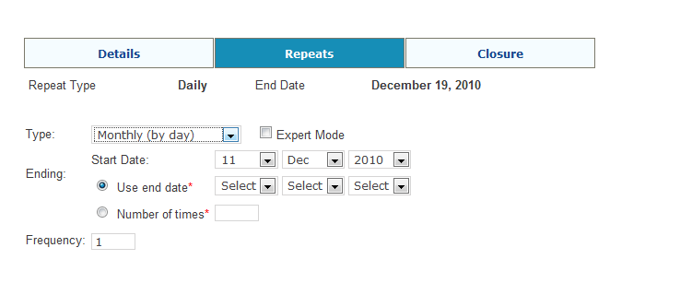

Monthly (by date) basis: If you select “Start Date” & “End Date / Number of Times”, number of worksheets will be created according to the selection of the Dates and Frequency. If set Frequency is 1, create worksheet every month on that particular date which taken from “Super records Due date” from “Details” Tab, If frequency is 2, create worksheet two months once on that particular date and so on. (Refer below screenshot):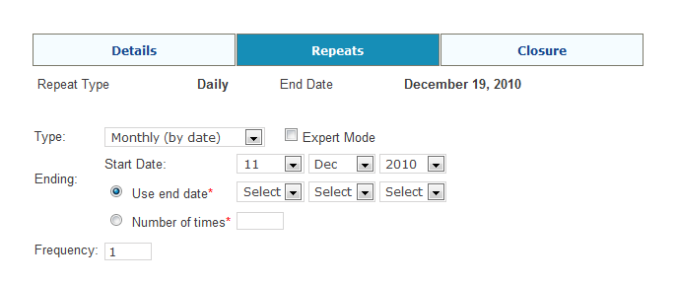
Yearly basis: If you select “Start Date” & “End Date / Number of Times”, number of worksheets will be created according to the selection of the Dates and Frequency. If set Frequency is 1, create worksheet every year on that particular date which taken from “Super records Due date” from “Details” Tab that would apply within the date limits, If frequency is 2, create worksheet two years once on that particular date and so on. (Refer below screenshot):
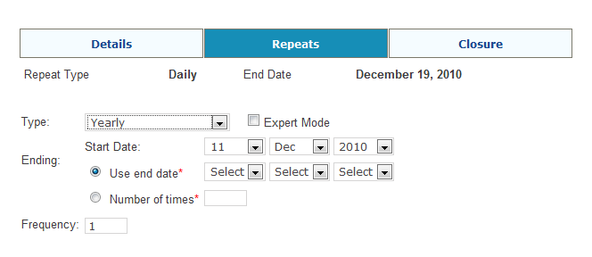
Note:
If you changed Status to “Completed” while Master Activity selected as “B101-Bookkeeping” by grid listing “save option”, it will alert with message of “Do you want to copy this worksheet”.
If click “OK” then the particular worksheet will be copied and updated.
If click “Cancel” then the particular worksheet will only be updated.
Email Option:
When Status changed to “For Team Leader Review” by grid listing “Save option”, Email goes to Team In Charge of corresponding client.

Worksheet Repeats

This is used to Copy / Delete Worksheet Repeats dynamically which are being created on worksheet module. We can copy / delete Worksheet Repeats whenever we want to do. Also it has custom filter options to search the details rapidly.
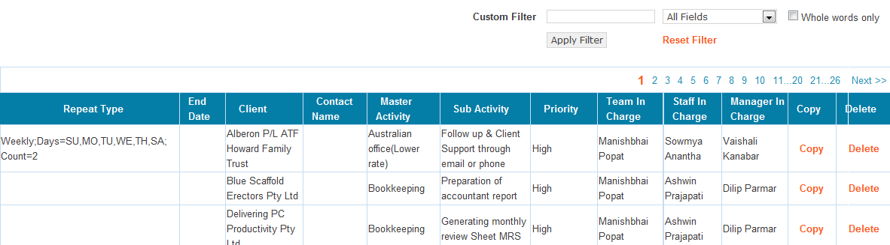

Copy: When you click “Click” option which against Repeats on the rows, it will redirect to Worksheet Add page where we can update worksheet details / create (copy) current worksheet by Repeat option.
Delete: When you click “Delete” option which against Repeats on the rows, it will open POP-UP window where worksheet under the Repeats will be listing. In which, we can delete worksheets whatever we want to. See below the screen shot.
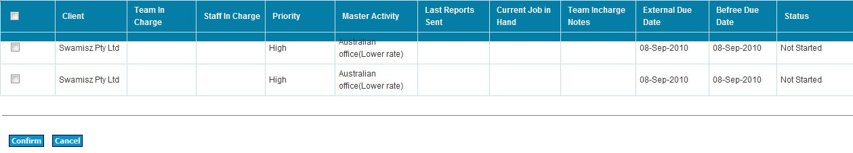

Tickets

This is used to Update Tickets (Customer Care) dynamically. We can add / update / delete Worksheet Repeats whenever we want to do. Also it has custom filter options to search the details rapidly.
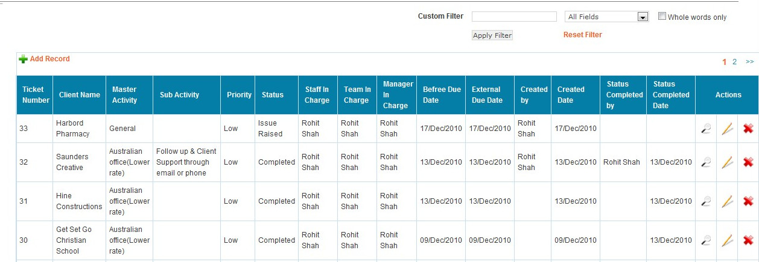

Add Ticket:
Submit the form after filling required fields, It trigger mails to “Team in Charge, Australia Manager and info@super records.com.au”. We can change the Email Ids thru “Email option” modules.

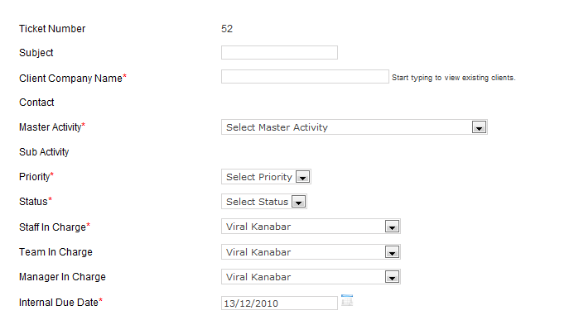

Update Ticket:
This is used to update the tickets where we can see clients comments (Read only) and History of Tickets which contains very recent updated records of who currently logged in as well as others. When you update the tickets, It trigger mails to “Team in Charge, Australia Manager and info@super records.com.au”. We can change the Email Ids thru “Email option” modules.

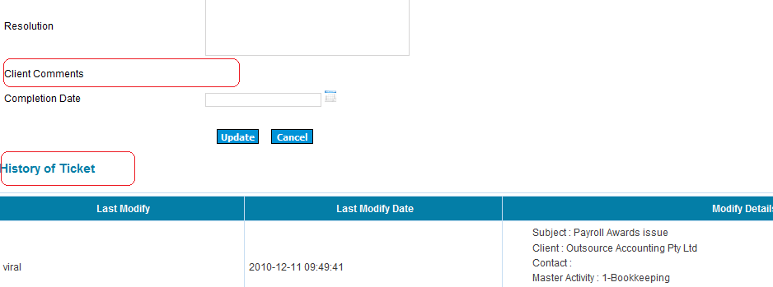

Complete Ticket:
In edit form of the Tickets where you can close the tickets by selecting the status as “Completed” then “Completion date” will be required one at the moment. When you update the tickets after providing those details, The Email will be triggering to “Team in Charge, Australia Manager , Ticket creator (who creates the ticket), Ticket closer (who close the tickets) and info@super records.com.au”. We can change the Email Ids thru “Email option” modules.
Refer below screenshot:
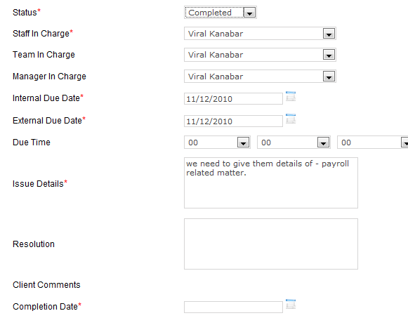

Email Options

This is used to Update Email options for different processes dynamically. We can add / update / delete Email details whenever we want to do. Also it has custom filter options to search the details rapidly.

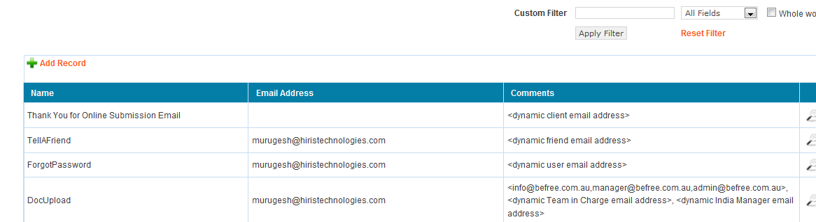

This is add /edit form of Email options where we can enter Name (Process name for identification), Email Addresses (Additional Email Ids whatever we want other than including in Template), Template (Role / Designation name for identification with Quick tags <>, these are entirely controlled by scripts). Refer below screenshot:
Note: Don’t edit Template field which is being built for developer purpose.
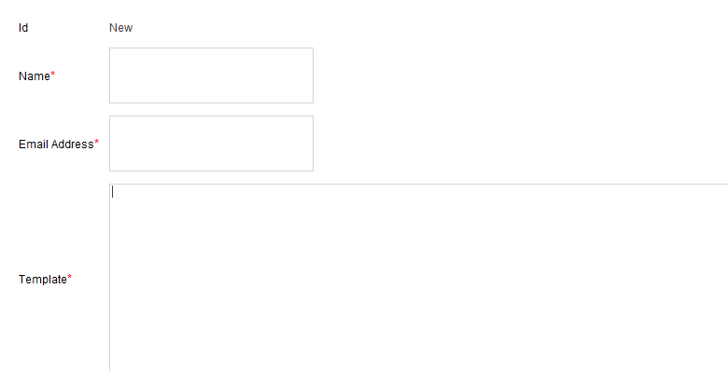

Reports

Timesheet Report

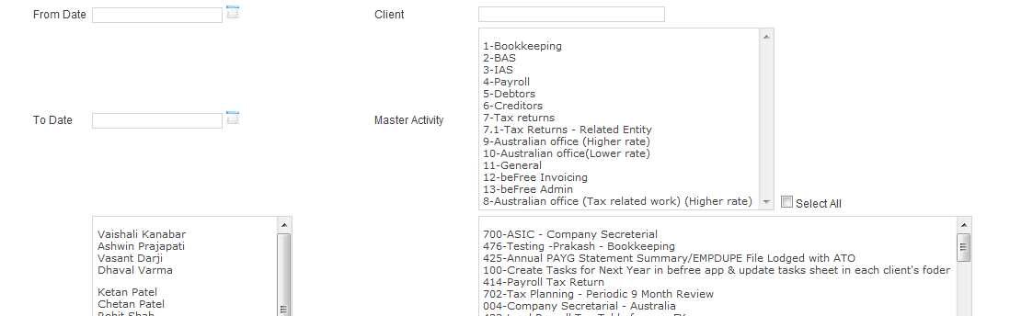

Generate Report: You will see this button under the selection process. At least one condition fields should be selected before click this options .
Generate Excel Report: This is used to export the report as MS Excel after generating the reports.
Reset Filter: Reset all conditions and reload the report page.

Worksheet Report

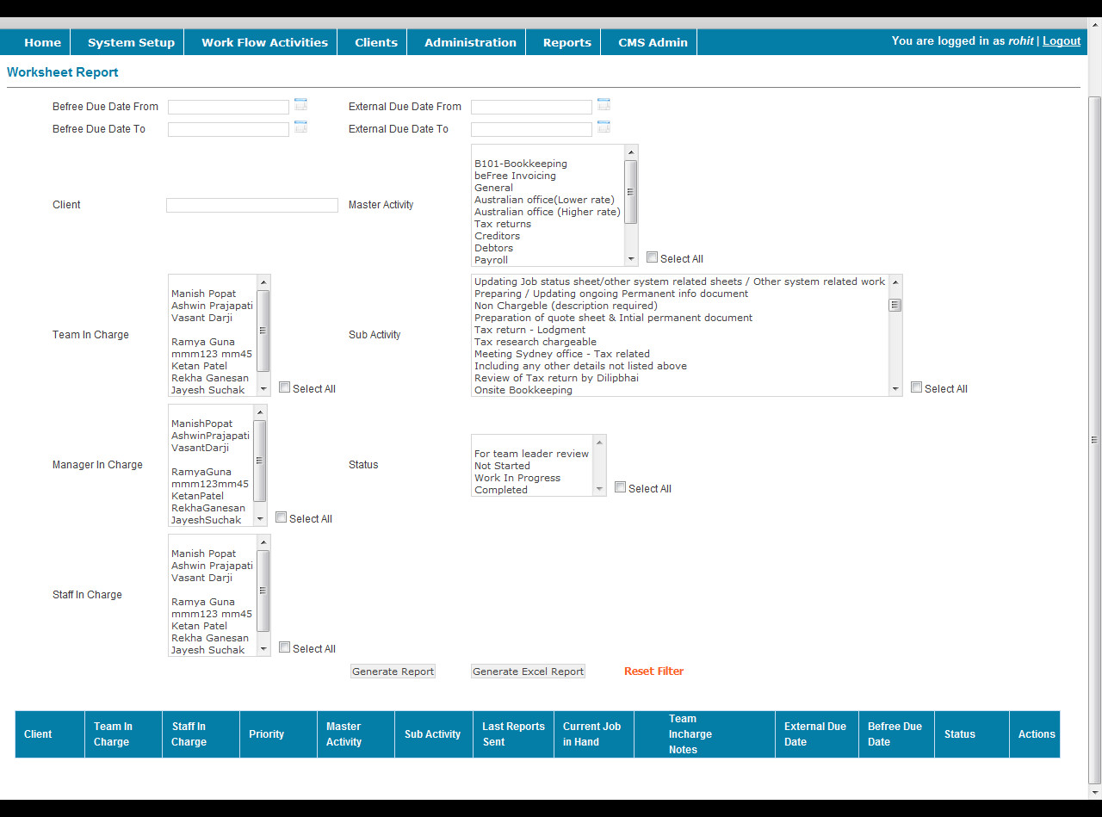

Generate Report: You will see this button under the selection process. At least one condition fields should be selected before click this options .
Generate Excel Report: This is used to export the report as MS Excel after generating the reports.
Reset Filter: Reset all conditions and reload the report page.

Sales Report

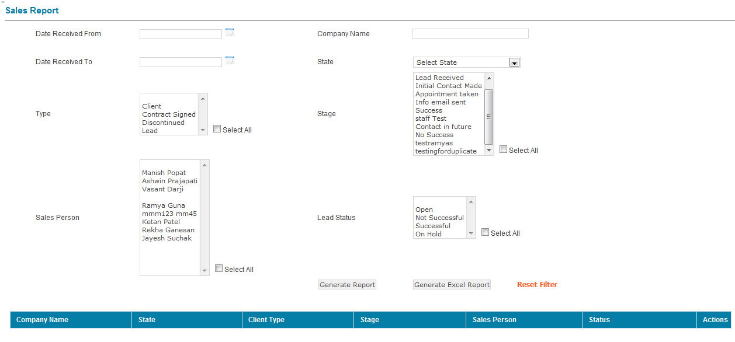

Generate Report: You will see this button under the selection process. At least one condition fields should be selected before click this options .
Generate Excel Report: This is used to export the report as MS Excel after generating the reports.
Reset Filter: Reset all conditions and reload the report page.

Custom Sales Report

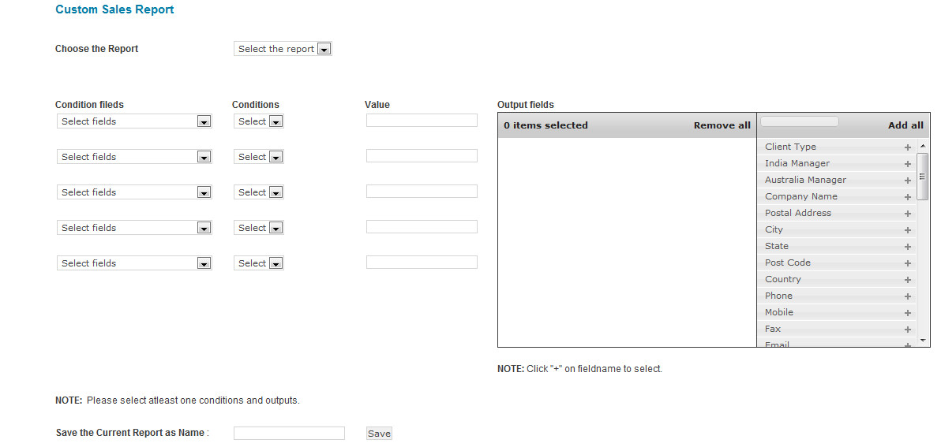

Report: It will list out all existing reports as a Dropdown related to the staff who currently logged in. IF you Select the report form dropdown then it will fill Conditions fields, Conditions, Values and Output fields automatically what they saved before.
Conditional fields: It shows all available conditional fields by dropdown. When you select this field, it will be changed condition and value fields according to selection of this.
Conditions: Condition will be different based on the selection of conditional field. Also it will change the fields and values of “Value” field.
Value: It will be different based on the selection of conditional fields and conditions.
Output fields: It shows all available output fields by interactive list box. When click “+” against fieldname, it would be selected. . If click ‘-‘ symbol, it would be vice versa.
Report save option : Once you select all required fields the you will be able to save the report as well as generate report. If you want to save this report, you should enter name for this report and click “Save” button. Then the report will be saved and generated. You can generate report only if you don’t want to save this report.
If select the Report from dropdown list, then it will enable two button such as “save as New” & “Update”.
Save As New : This is used to save current report as new one.
Update : This is used to update current report.

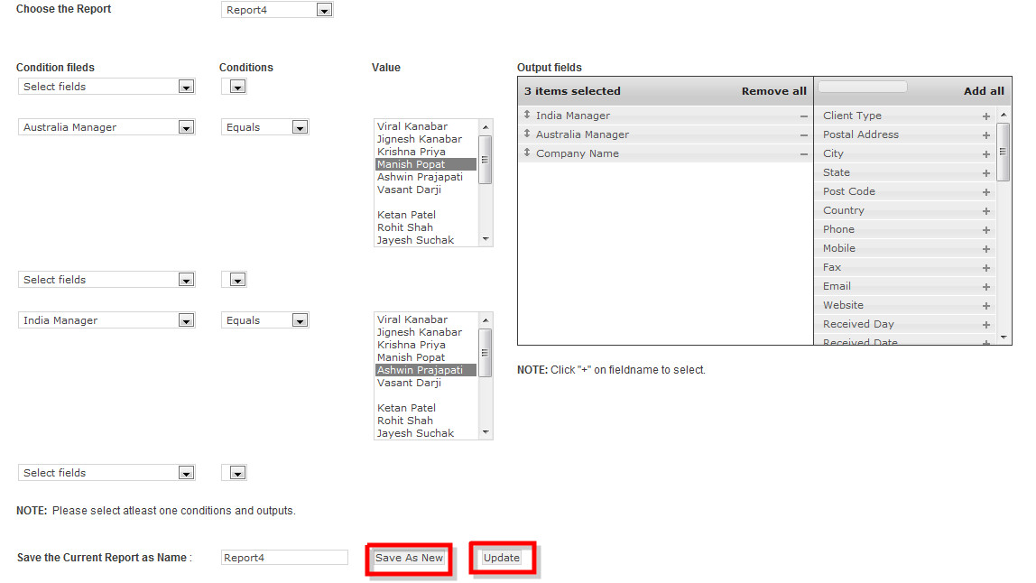

Generate Report: You will see this button under the selection process. At least one condition field, condition, value, Output fields should be selected before click this options .
Reset Filter: Reset all conditions and reload the report page.
After generating report, you will be able to download excel report to see all the details of current report. Pagination and details of total records and every record able edit and save options are there.

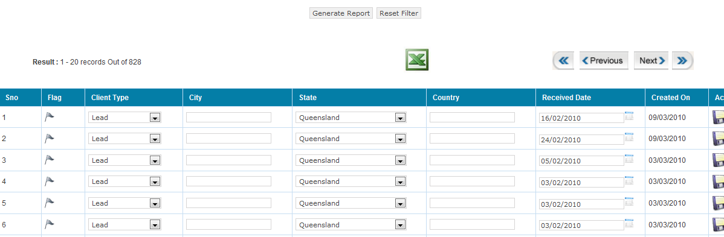

Custom Worksheet Report

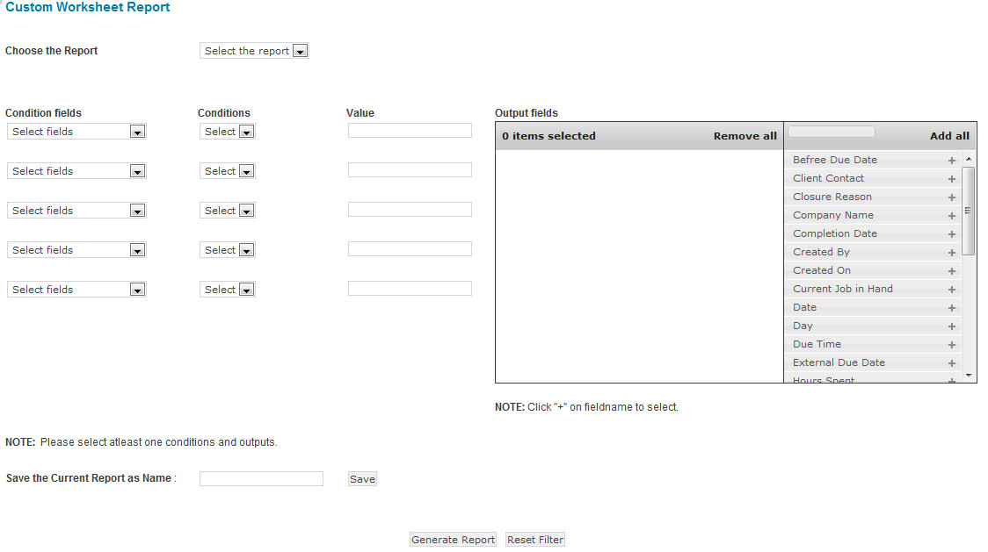
Report: It will list out all existing reports as a Dropdown related to the staff who currently logged in. IF you Select the report form dropdown then it will fill Conditions fields, Conditions, Values and Output fields automatically what they saved before.

Conditional fields: It shows all available conditional fields by dropdown. When you select this field, it will be changed condition and value fields according to selection of this.
Conditions: Condition will be different based on the selection of conditional field. Also it will change the fields and values of “Value” field.
Value: It will be different based on the selection of conditional fields and conditions.
Output fields: It shows all available output fields by interactive list box. When click “+” against fieldname, it would be selected. If click ‘-‘ symbol, it would be vice versa.
Report save option : Once you select all required fields the you will be able to save the report as well as generate report. If you want to save this report, you should enter name for this report and click “Save” button. Then the report will be saved and generated. You can generate report only if you don’t want to save this report.
If select the Report from dropdown list, then it will enable two button such as “save as New” & “Update”.
Save As New : This is used to save current report as new one.
Update : This is used to update current report.

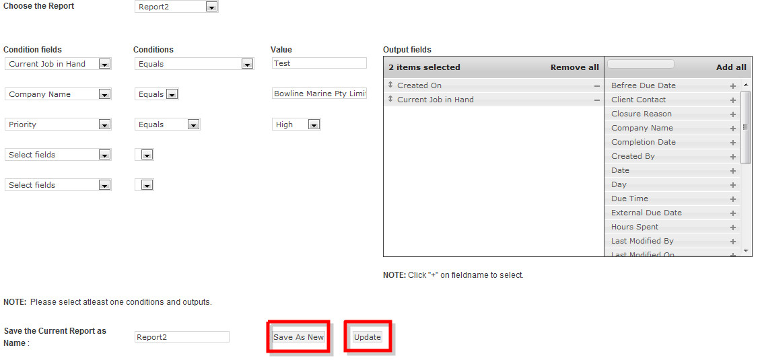

Generate Report: You will see this button under the selection process. At least one condition field, condition, value, Output fields should be selected before click this options .
Reset Filter: Reset all conditions and reload the report page.

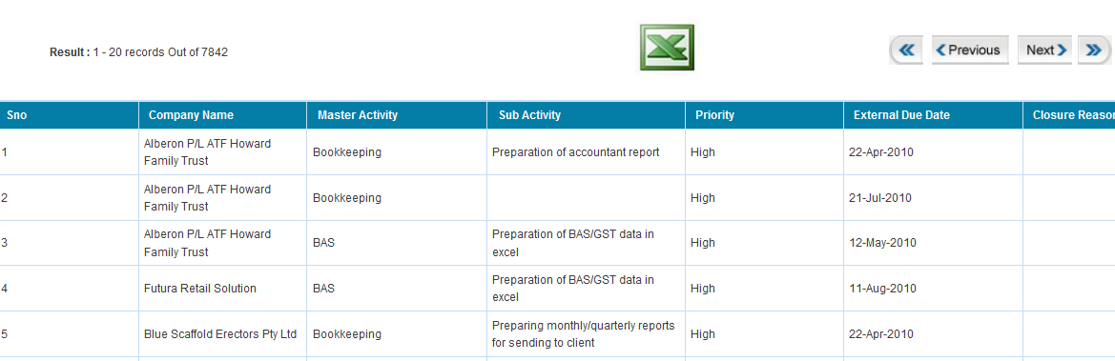

After generating report, you will be able to download excel report to see all the details of current report. Pagination and details of total and current records are there. Please refer above screenshot.

Custom Tickets Report

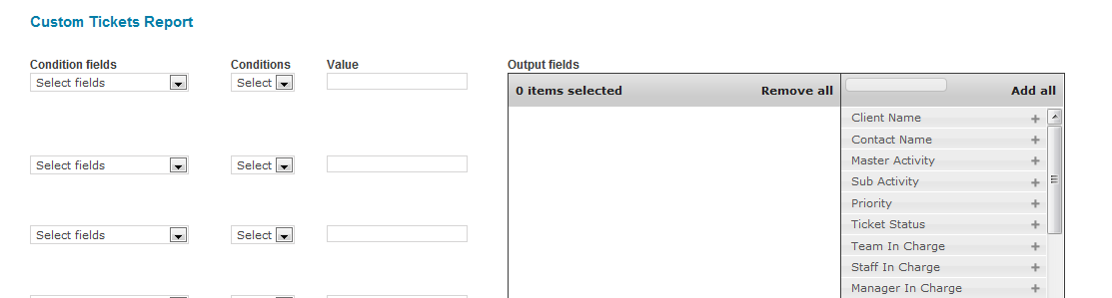

Conditional fields: It shows all available conditional fields by dropdown. When you select this field, it will be changed condition and value fields according to selection of this.
Conditions: Condition will be different based on the selection of conditional field. Also it will change the fields and values of “Value” field.
Value: It will be different based on the selection of conditional fields and conditions.
Output fields: It shows all available output fields by interactive list box. When click “+” against fieldname, it would be selected. If click ‘-‘ symbol, it would be vice versa.
Generate Report: You will see this button under the selection process. At least one condition field, condition, value, Output fields should be selected before click this options .
Reset Filter: Reset all conditions and reload the report page.
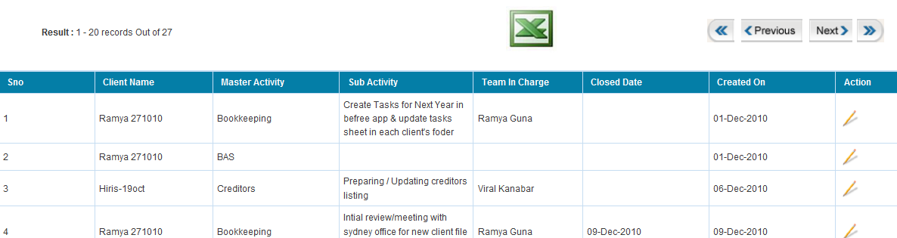

After generating report, you will be able to download excel report to see all the details of current report. Pagination and details of total and current records are there. Please refer above screenshot.

CMS Admin

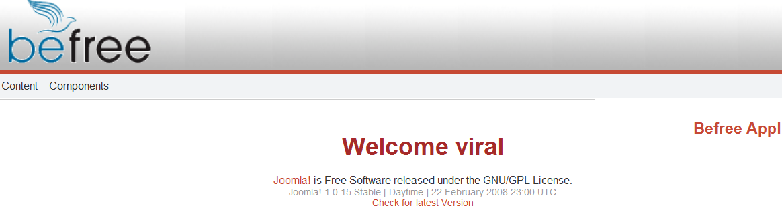

When you click “CMS Admin” menu, you will be taken into CMS admin interface (see above screenshot) where the components installed for Document handling and Newsletter. See the below screenshot which shows menu in interface.

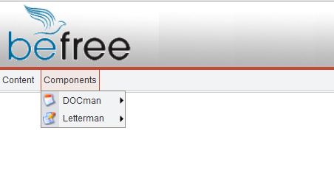

Document Handling

Click menu “ Component -> DOCman -> Categories”. 3 types of categories already added such as Standard Docs, Client Uploaded and Reports. If you want to add / edit more, you can do this.

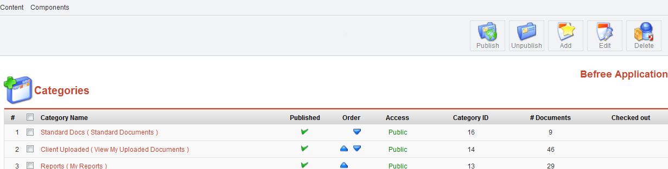

Click menu “ Component -> DOCman -> Documents” where you will see more menu at top right corner as below mentioned screenshots. In which, you can edit / delete existing documents from grid listing.

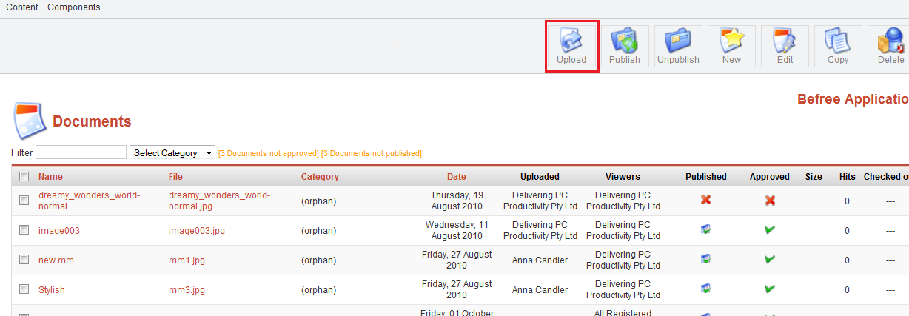
After you click “Upload” menu on top right corner as red marked of above screenshot, you will be taken into new interface where you can choose the files which need to be uploaded. Refer below screenshot:
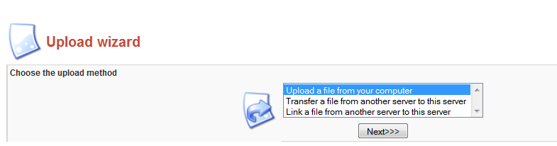
After you selected the files where they are, you will be taken into next interface where you can browse the files from wherever you chosen.

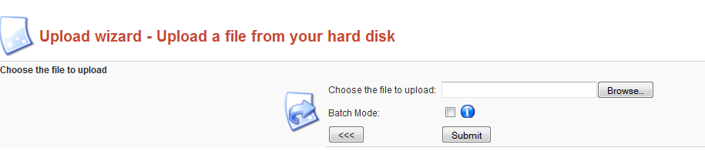
After you selected the files, it will be uploaded and moved to next form where you can enter Document name, Category, status of approving / publishing and contents. Also there will be “File” field which displays all uploaded files on bottom of the form.
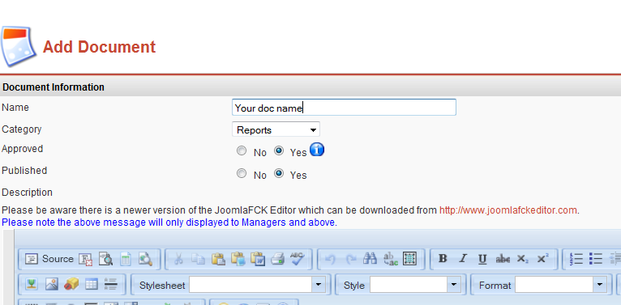

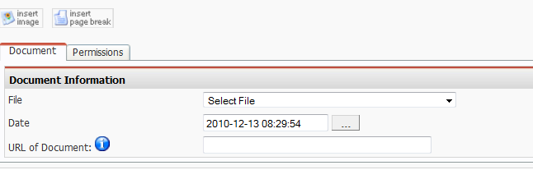

After filling required fields, click “Save” button then form will be submitted and saved.

Newsletter
Click menu “ Component -> Letterman -> Newsletter Management”, then you will see the list of Newsletter content from grid listing. Refer below screenshots:
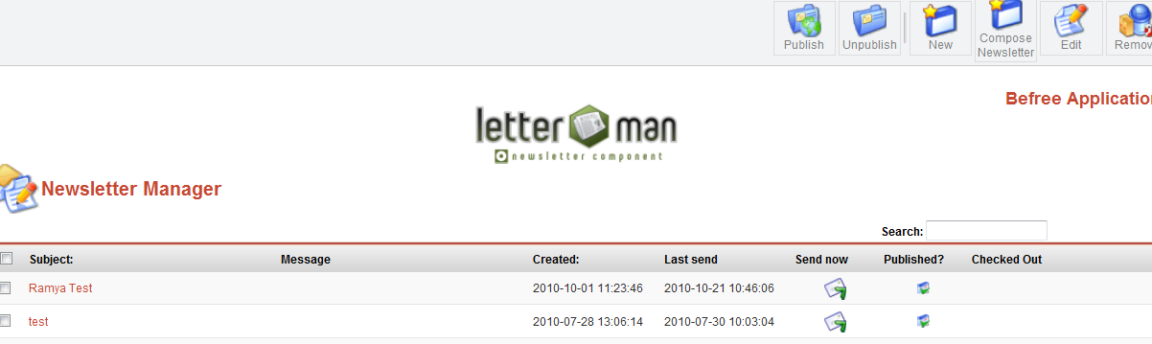
There are many menus are available on top right corner like below mentioned screenshots.
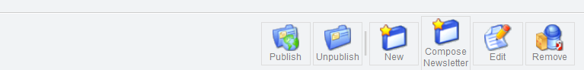

If you want to add new Newsletter content, click “New” icon on top then it will be taken to you new interface where you can populate new content of Newsletter with Subject, HTML message and some required fields. Refer below screenshots.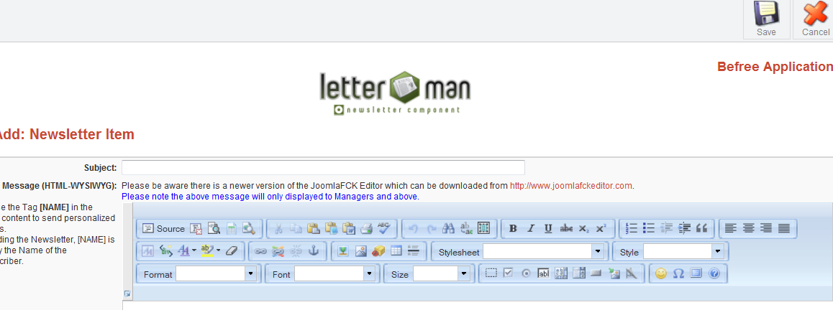
Send Newsletter
Click “Sends Now” icon which against the Subject of newsletter what you want on the row (See below screenshot).
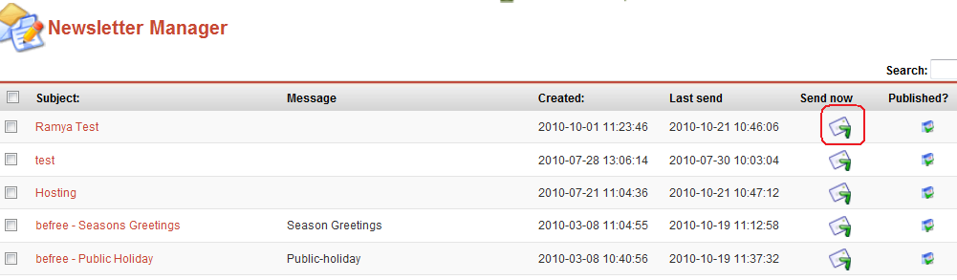

Then you will be taken into new interface where you can check Subject & Content then change Email IDs (From, Reply to) what you want. Also one more option named “Select Email list” as red marked in below screenshot. When click on this link, it will open POPUP window where you can get Client’s mail ID whoever you want from reporting.

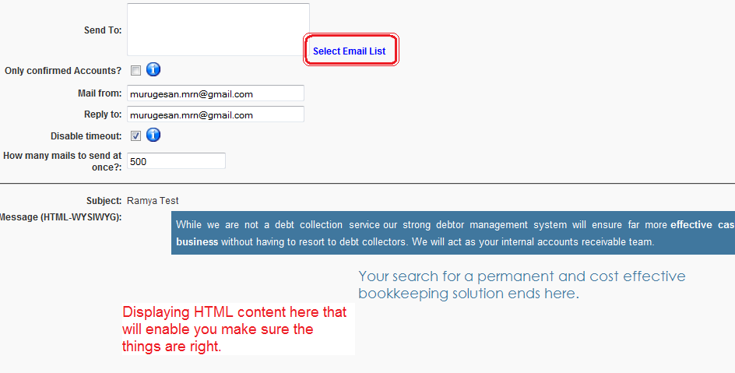

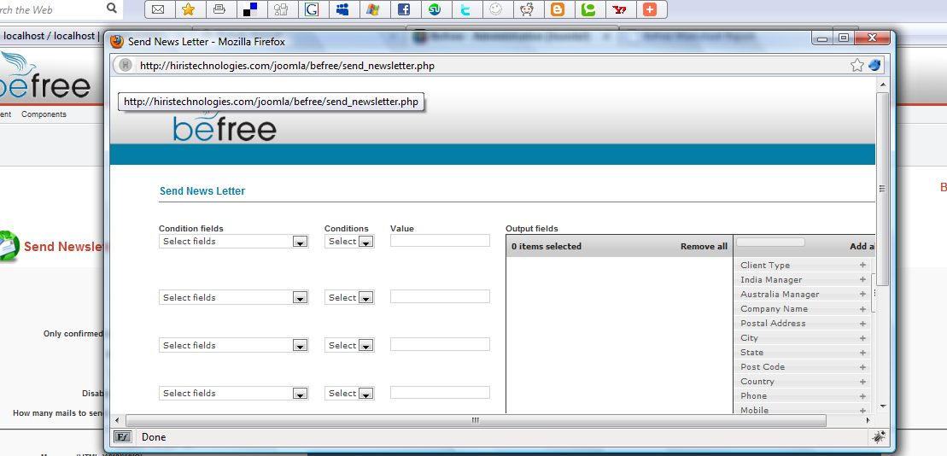

After generating report with specific conditions, you will see the list of clients in the grid listing where you can check the checkboxes placed on left against the clients on the same row and click “Select” button. Otherwise you can choose “Send to all” if you want to select all clients.
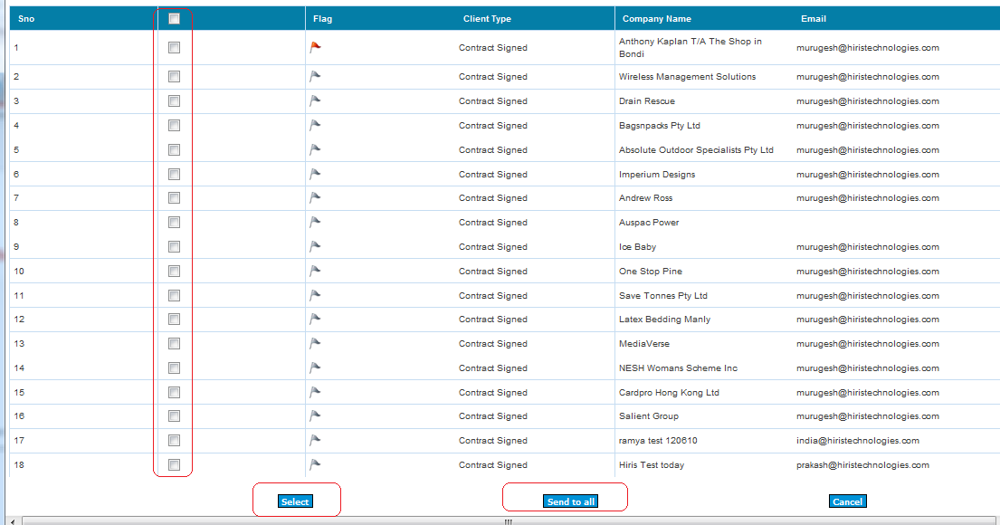
After that you will finally see that Email IDs of selected clients added with separation of comma then you would publish the newsletter by clicking “Publish” icon which displayed on top right corner. Refer below screenshot:
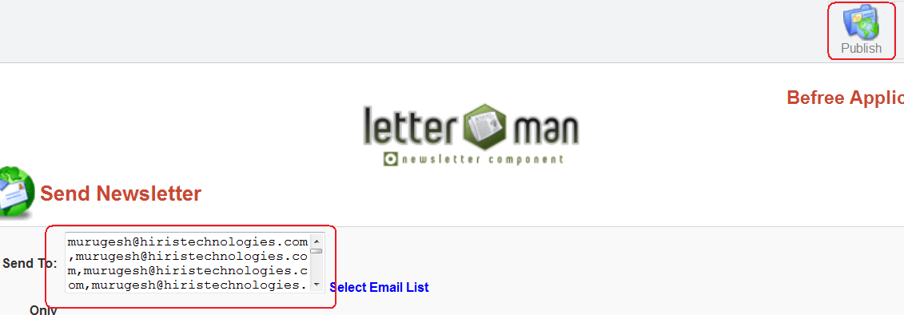

Client Side Process

After logged in as a Client by using credentials, you will see the home page as figured out in below screenshot:

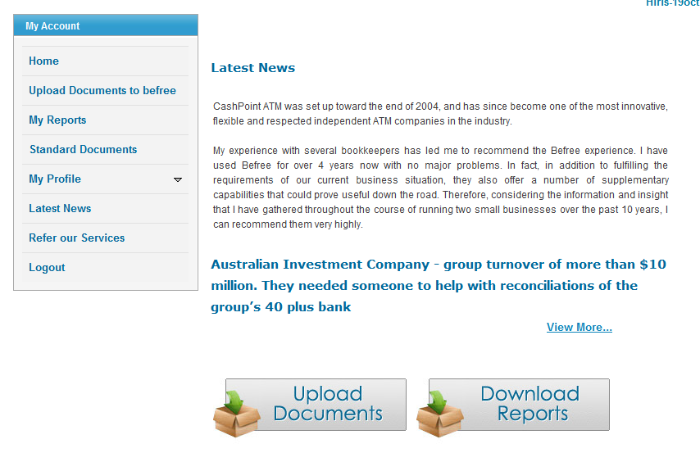

Upload document
When you click “Upload documents to super records” menu placed on left side, you will be taken into document interface where you will see the grid listing that displayed the documents uploaded by the Client / Admin users. Refer below screenshots
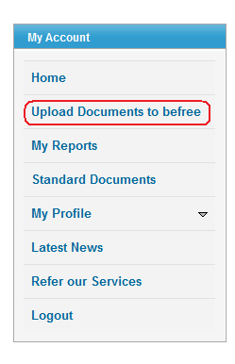
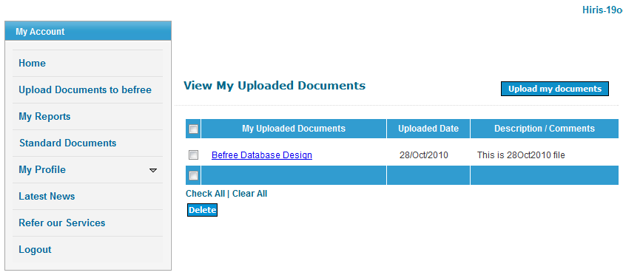

Upload the files what you want through this interface and add your description to that document.
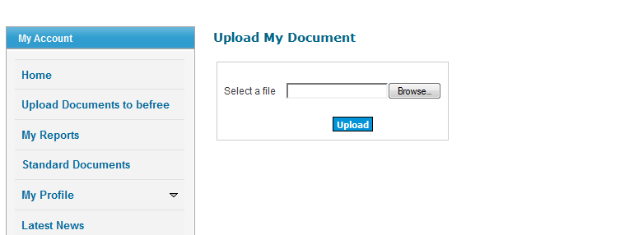

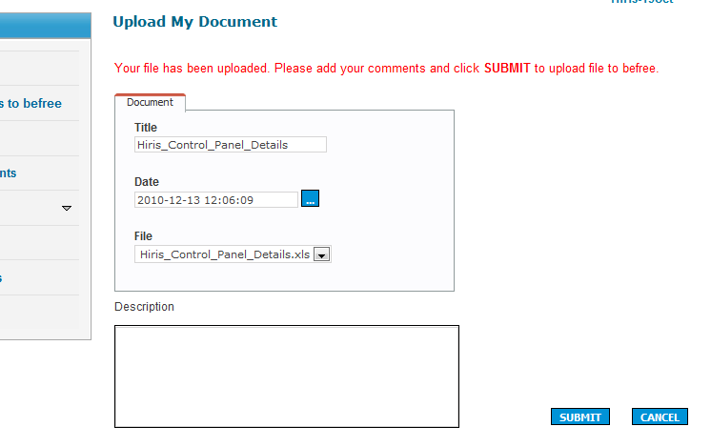
Email Options:
When documents uploaded, Email goes to info@super records.com.au, manager@super records.com.au, admin@super records.com.au, Team-in-charge & Indian Manager of that respective client.

Finally you will see that the uploaded file has been added in grid listing like below screenshot.
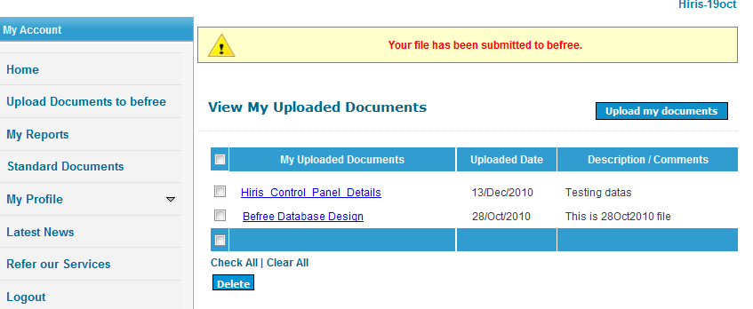

My Reports – This is category of documents controlled by CMS admin, here you can see that what are all the documents available under this category then view / delete the documents.

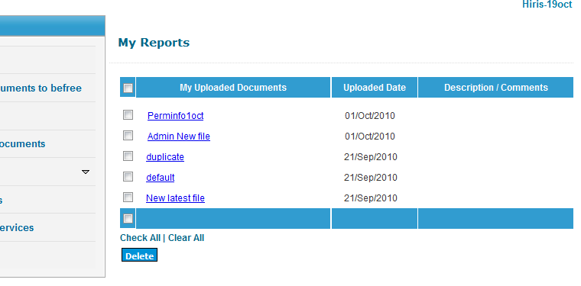

Standard Documents – This is category of documents controlled by CMS admin, here you can see that what are all the documents available under this category then view / delete the documents.
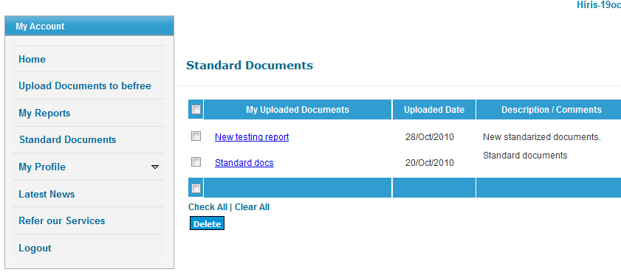

Change Password – This is used to change the password details, here you can update the password what you want.
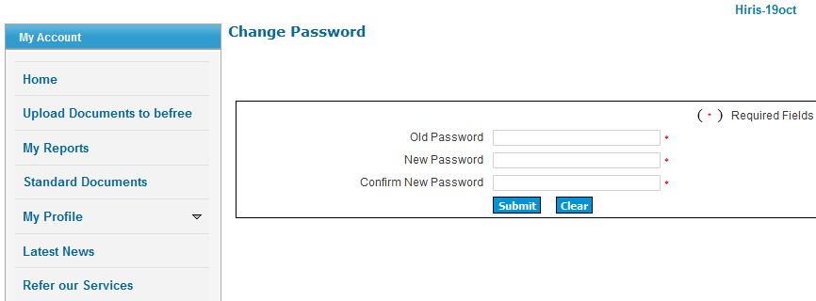

Edit your Profile – This is used to change the user’s profile who logged in here, he can update the details like Business name, email, city and so on.
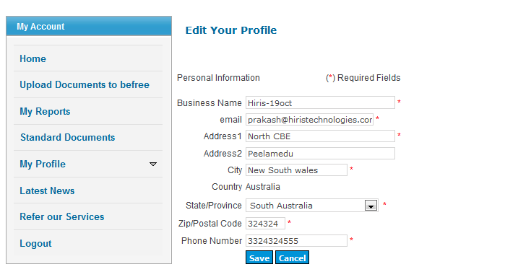

Refer Our Services – This is the interface where you can refer / tell your friends about Super records services, here you will have “Receive Copy” option which means once the receiver (your friend) received Email regarding this, you will get notification about that.
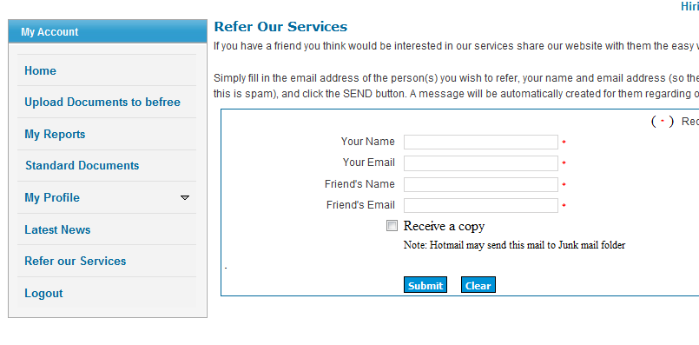

Anonymous users
This is free request form for anonymous users who can submit the form to Admin regarding their quotes. Once they submits this form with filling required fields, Thanks Email goes to that user.
Note:
When submit this form, the details of this form will be saved as a Client with “Lead” type.
