MODELING THE MAGNETIC FIELD SURROUNDING A PERMANENT MAGNET

INTRODUCTION
This model also computes the force with which it acts on a nearby iron rod. Due to the symmetry of the geometry and the antisymmetry of the magnetic field, only one fourth of the geometry needs to be modeled.

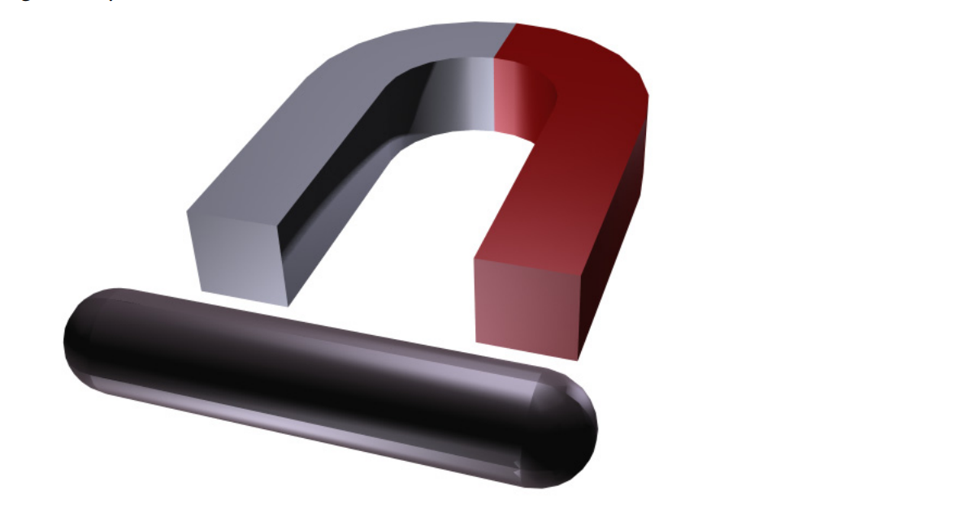
Illustration 1: A full 3D view of the geometry. Left-right and top-down symmetry is used to minimize the problem size.

MODEL DEFINITION
In a current free region, where , it is possible to define the scalar magnetic potential, from the relation
This is analogous to the definition of the electric potential for static electric fields.
Using the constructive relation between the magnet flux density and magnetic field
together with the equation you can derive an equation for ,

BOUNDARY CONDITIONS

On the symmetry plane, the magnetic field is tangential to the boundary. This is described by the Magnetic Insulation condition: .
On the antisymmetry plane, the magnetic field is perpendicular to the boundary. This condition is represented by a constant magnetic scalar potential. The model uses the Zero Magnetic Scalar Potential condition.

RESULTS AND DISCUSSION

The force on the rod is calculated internally as an integral of the surface stress tensor over all boundaries of the rod. The expression for the stress tensor reads where n1 is the boundary normal pointing out from the rod and T2 the stress tensor of air. The integration gives 1.53 N, which corresponds to one quarter of the rod. The actual force on the rod is therefore four times this value, or 6.11 N.

Below are some screenshots of the results that got. The captions of each picture, are on top of them.
