VISION TECHNOLOGIES COMPANY LTD
Customer Relationship Management System
Final Exam Project — Phases 1 to 4

MUNEZERO IRAKOZE Luccin · Student ID 25815
SENG 8240 — Best Programming Practices and Design Patterns
Instructor: Rutarindwa Jean Pierre
Faculty of IT — Department of Software Engineering, AUCA
Academic Year 2025 / 2026 — Semester II

Abstract
This document is the complete written submission of the Vision Technologies CRM final-exam project for SENG 8240. It bundles all four phases — analysis & design, software prototype with applied design pattern and coding standards, Dockerisation and version-control setup, and the software test plan — into a single deliverable. The accompanying source code lives in the vision-tech-crm/ folder and runs end-to-end with one command: docker compose up --build.

Project at a glance
Aspect | Detail
Domain | Customer Relationship Management for Vision Technologies Company Ltd (VTC) — an East-African Security/IT/Telecom integrator.
Frontend | Vue.js 3 (Composition API) + Vite + Vue Router 4 + Pinia + Tailwind CSS + Chart.js.
Backend | Spring Boot 3 + Spring Security (JWT) + Spring Data JPA + Lombok.
Database | MySQL 8 with InnoDB; named volume mysql_data persists data across restarts.
Runtime | Docker + Docker Compose (three containers on private bridge network vtc-net).
Architecture | Model-View-Controller end-to-end, with cross-cutting Mapper/DTO, JWT filter chain, and global exception handler.
Test stack | JUnit 5 + Mockito (unit) · Spring Boot Test + MockMvc + H2 (integration) · manual + Cypress (E2E) · JMeter (perf).
Single command to run | docker compose up --build

Phase 1 — System Analysis & Design

1.1 Case Study — Vision Technologies Company Ltd
Vision Technologies Company Ltd (VTC) is an East-African technology and infrastructure integrator that delivers turnkey Security Systems, IT & Telecommunications, ICT and Low-Voltage Systems to corporate, government and mission-critical clients. The company also provides end-to-end data-centre design, build and support services, covering structured cabling, CCTV and access-control, fire-detection systems, networking, server rooms, and managed support contracts. Its customer base is highly heterogeneous — banks, telecom operators, ministries, hospitals, hotels and SMEs — and engagements run from short break-fix jobs to multi-year managed-service contracts.
Today, VTC's customer-facing operations are managed through scattered tools: e-mail threads, Excel sheets, WhatsApp groups, paper visit-reports, and a few isolated spreadsheets per sales executive. As the company grows across Rwanda, Kenya, Uganda and Burundi, this approach has begun to break down. Sales leads from trade fairs and the website are lost between people; nobody can say with certainty how many open opportunities exist, what their pipeline value is, or which engineer last visited which client. Support tickets raised by phone are sometimes never logged, SLAs are missed, and managers have no consolidated view of revenue forecasts, customer health, or technician utilisation. Audit and ISO-compliance reviews are painful because activity history is not centralised.
A purpose-built CRM is therefore required to (a) consolidate all customers, contacts and contracts in a single source of truth, (b) track the full sales pipeline from raw lead to closed deal, (c) capture every customer interaction (calls, e-mails, visits), (d) manage support tickets with priority and SLA tracking, and (e) produce real-time dashboards and reports for management. The proposed system — built with Vue.js 3, Spring Boot 3, MySQL 8 and Docker — will give VTC the operational visibility and customer intimacy it needs to scale profitably across East Africa.

1.2 Functional Diagram — VTC internal workflow
The diagram below shows how VTC operates internally today. Marketing, the website, and referrals feed raw leads into a five-stage sales pipeline; once a deal is won, the customer is onboarded and handed to delivery and then to support. Every interaction — call, e-mail, ticket — is captured in the interactions log, which feeds the reporting layer and the management dashboard.
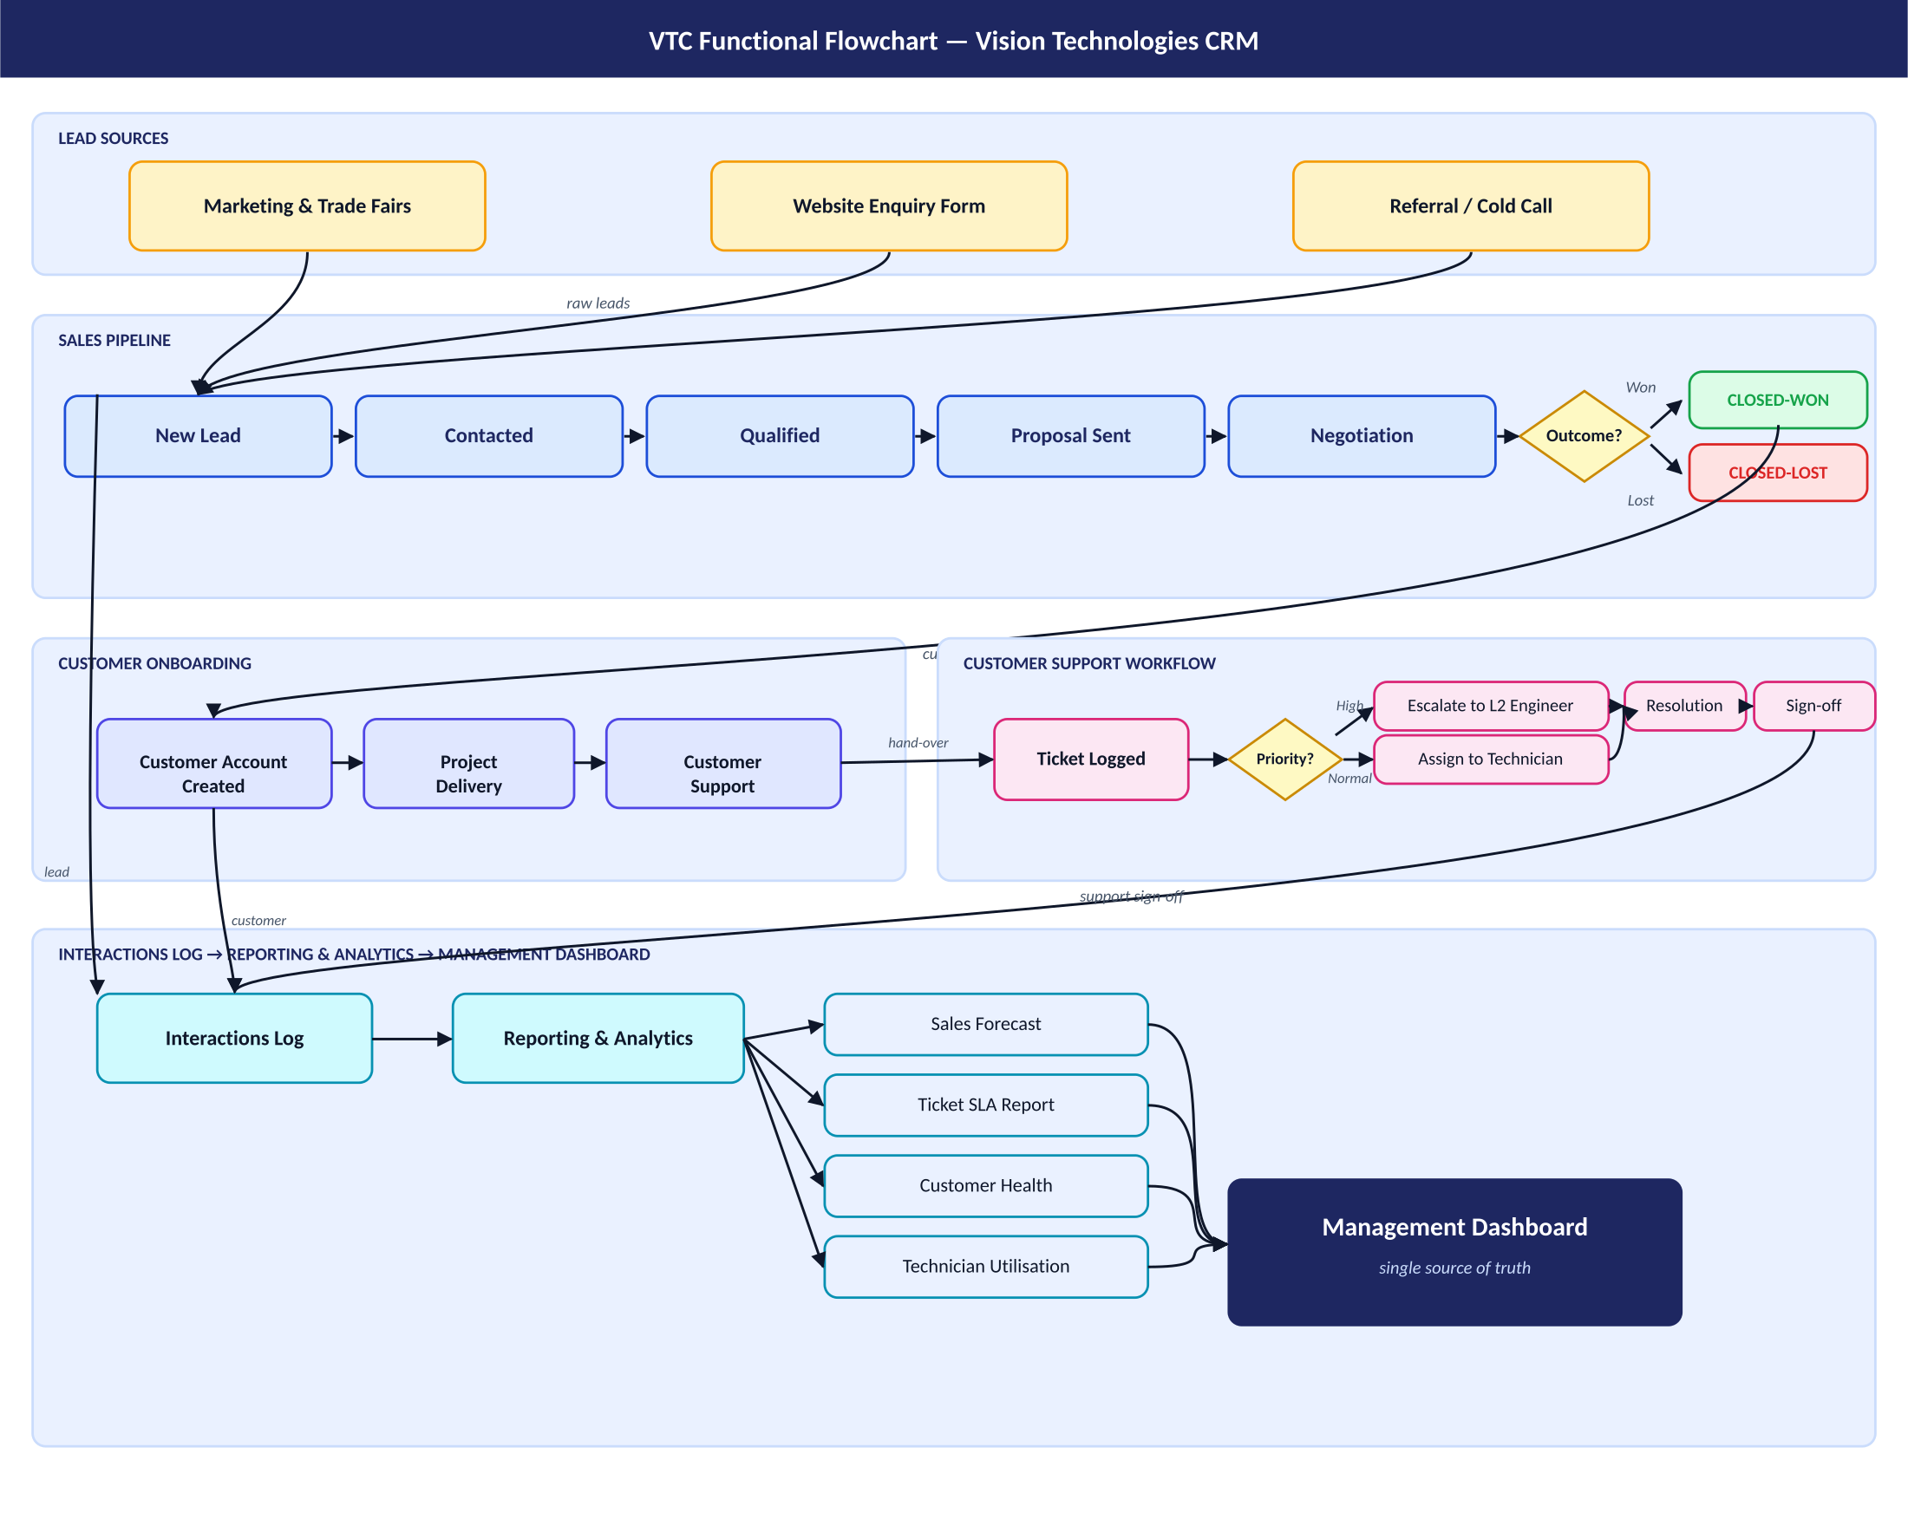
Figure: VTC functional flowchart — lead sources, sales pipeline, customer onboarding, support workflow, interactions log, reporting and management dashboard.

1.3 Problem Statement — five pain points
Without a CRM, Vision Technologies currently faces the following problems:
- Fragmented Customer Data — customer information is scattered across e-mail, spreadsheets, paper site-survey forms and individual sales reps' phones. There is no single, reliable source of truth for who the customer is, what they bought, and who owns the relationship.
- Lost Sales Leads & No Pipeline Visibility — leads from trade-fairs, the website and referrals are not consistently captured. Management cannot answer basic questions such as "how many qualified opportunities are open?" or "what is the expected revenue this quarter?", so forecasting is guesswork.
- Unstructured Support Workflow & SLA Breaches — support requests arrive by phone, WhatsApp and e-mail and are not logged in one place. Tickets are forgotten, priority is not enforced, and SLA breaches on mission-critical contracts (data centres, banks) damage VTC's reputation.
- No Interaction History per Customer — when an engineer visits or a sales rep calls, the activity is rarely recorded against the customer record. New staff have no context; account managers repeat questions; cross-sell and up-sell opportunities are missed.
- Manual, Late and Inconsistent Reporting — monthly sales, ticket and revenue reports are stitched together by hand from many Excel files. Reports arrive late, numbers do not reconcile across departments, and ISO / audit reviews are painful because activity history cannot be reconstructed.

1.4 Object-Oriented Analysis & Design diagrams
The five diagrams in this section translate the case study and pain points into a buildable system. Each diagram is a contract that the rest of the project — the entities, REST endpoints, Vue pages and tests — has to honour.

1.4.1 Use Case Diagram
The system identifies four internal roles and one external actor — the customer who raises tickets. Sales reps mostly use the Customers, Leads and Interactions screens; support engineers live in the Tickets screen; managers focus on the Dashboard and Reports; the Admin manages users. The four internal roles map directly to the four seeded demo accounts in the running application.
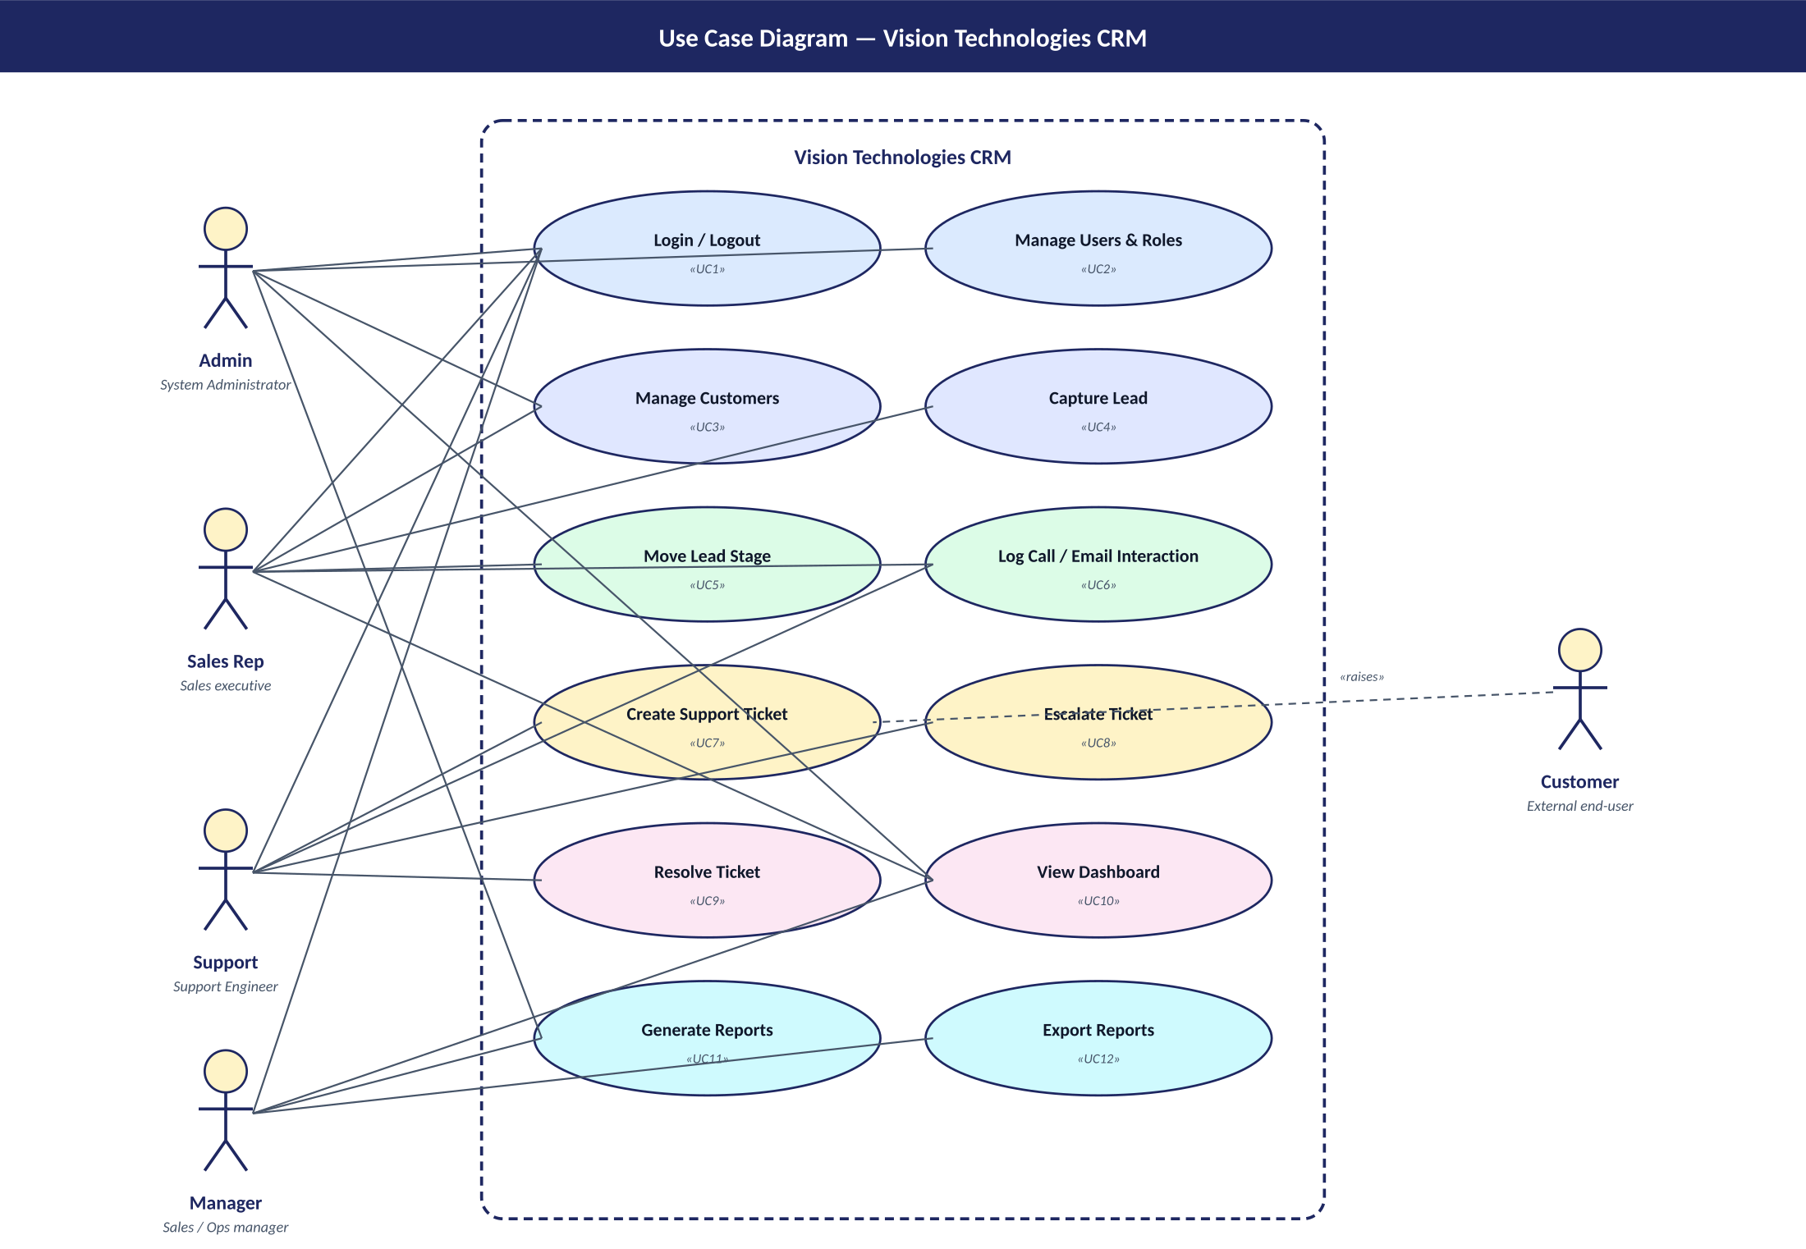
Figure: Use case diagram — five actors (Admin, Sales Rep, Support, Manager, Customer) and twelve use cases inside the CRM system boundary.

1.4.2 Class Diagram
The class diagram is the contract between the business and the database. Every Lead, Interaction, Ticket and Opportunity belongs to exactly one Customer, which is therefore the aggregate root. Enumerations such as LeadStage, Priority and TicketStatus make illegal states unrepresentable — there is no way to have, for example, a Lead whose stage is "blah". This same shape appears in the JPA entities under com.visiontechcrm.model and in the Pinia stores on the frontend.
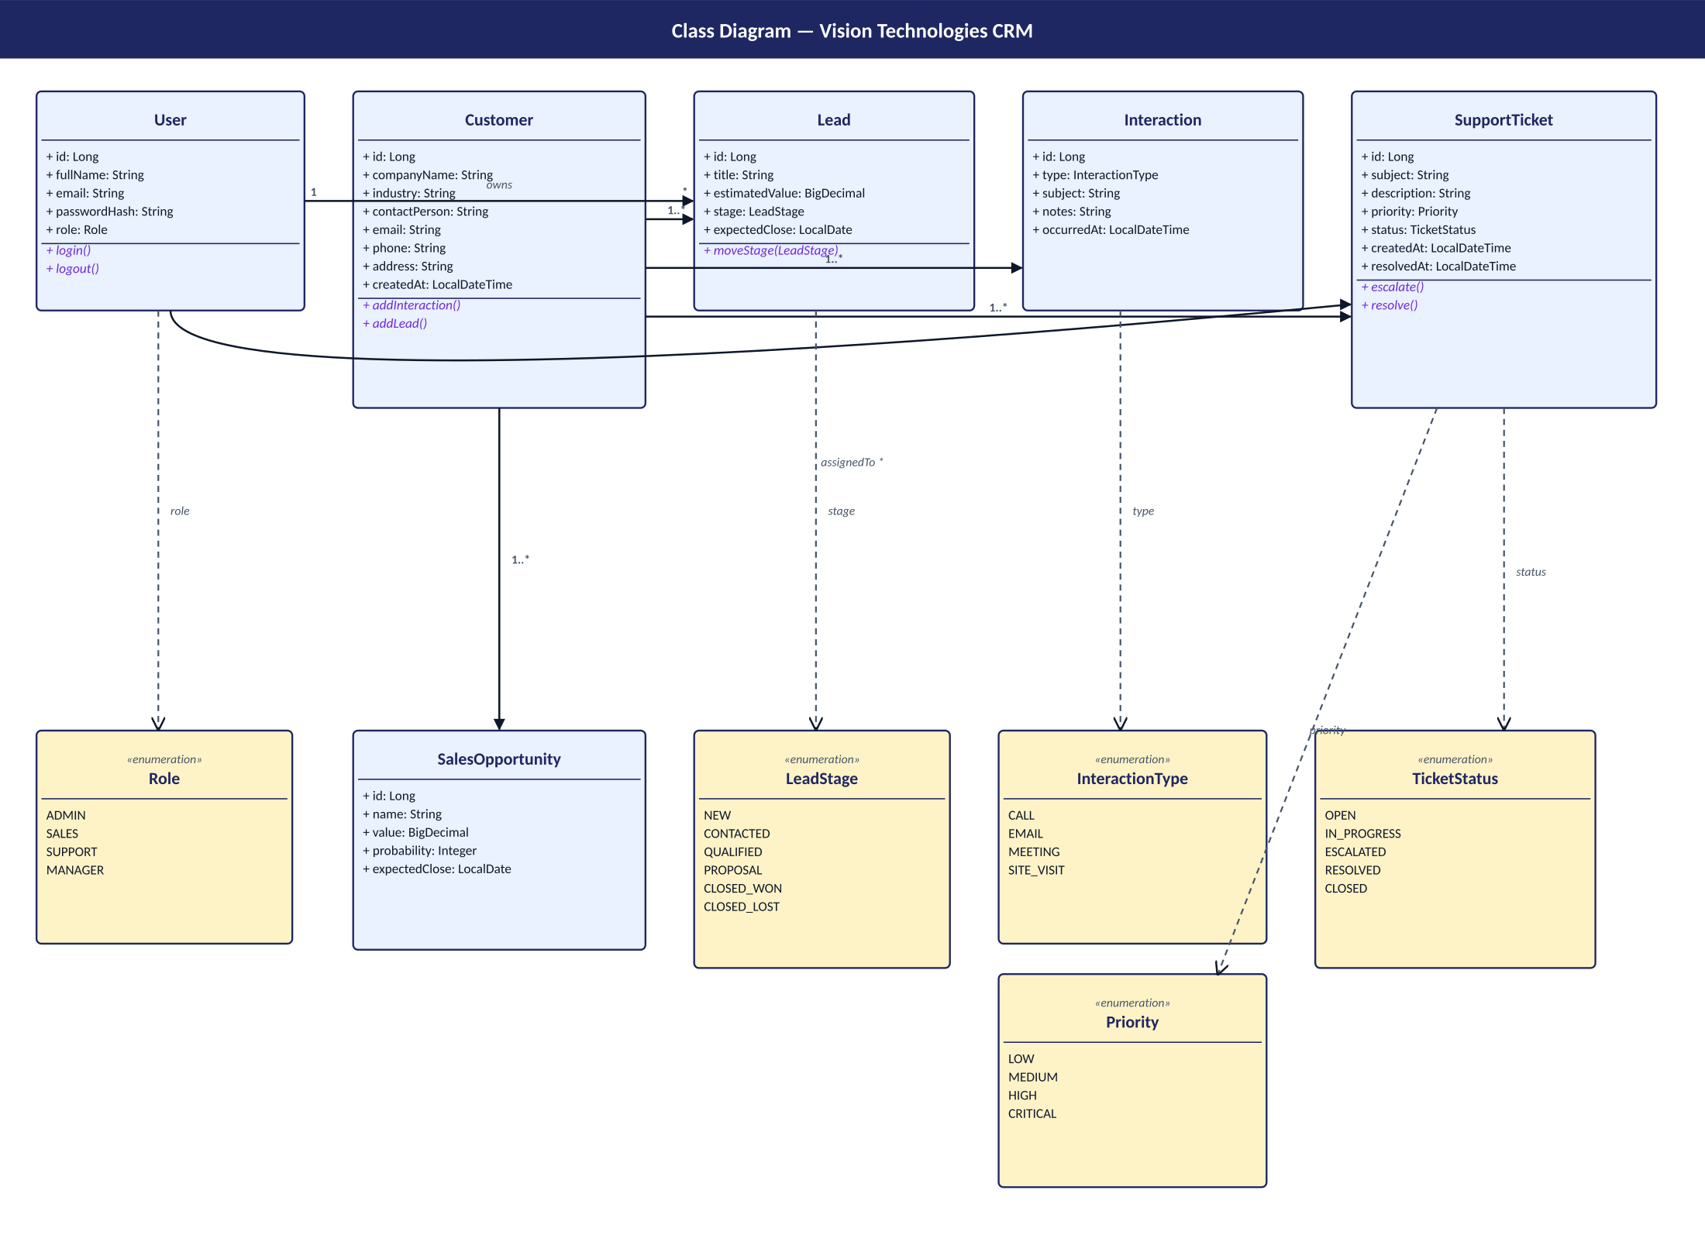
Figure: Class diagram — six entities (User, Customer, Lead, Interaction, SupportTicket, SalesOpportunity) and five enumerations.

1.4.3 Activity Diagram — Lead capture to customer conversion
This is the happy path from a raw enquiry to a paying customer. The diamond decision points correspond to actions in the live app: a sales rep moves a Kanban card from one column to the next. When the card reaches CLOSED_WON, the customer record gets a tag and ownership moves to the delivery team. The activity diagram is therefore not decorative — it is the actual workflow encoded in the code.
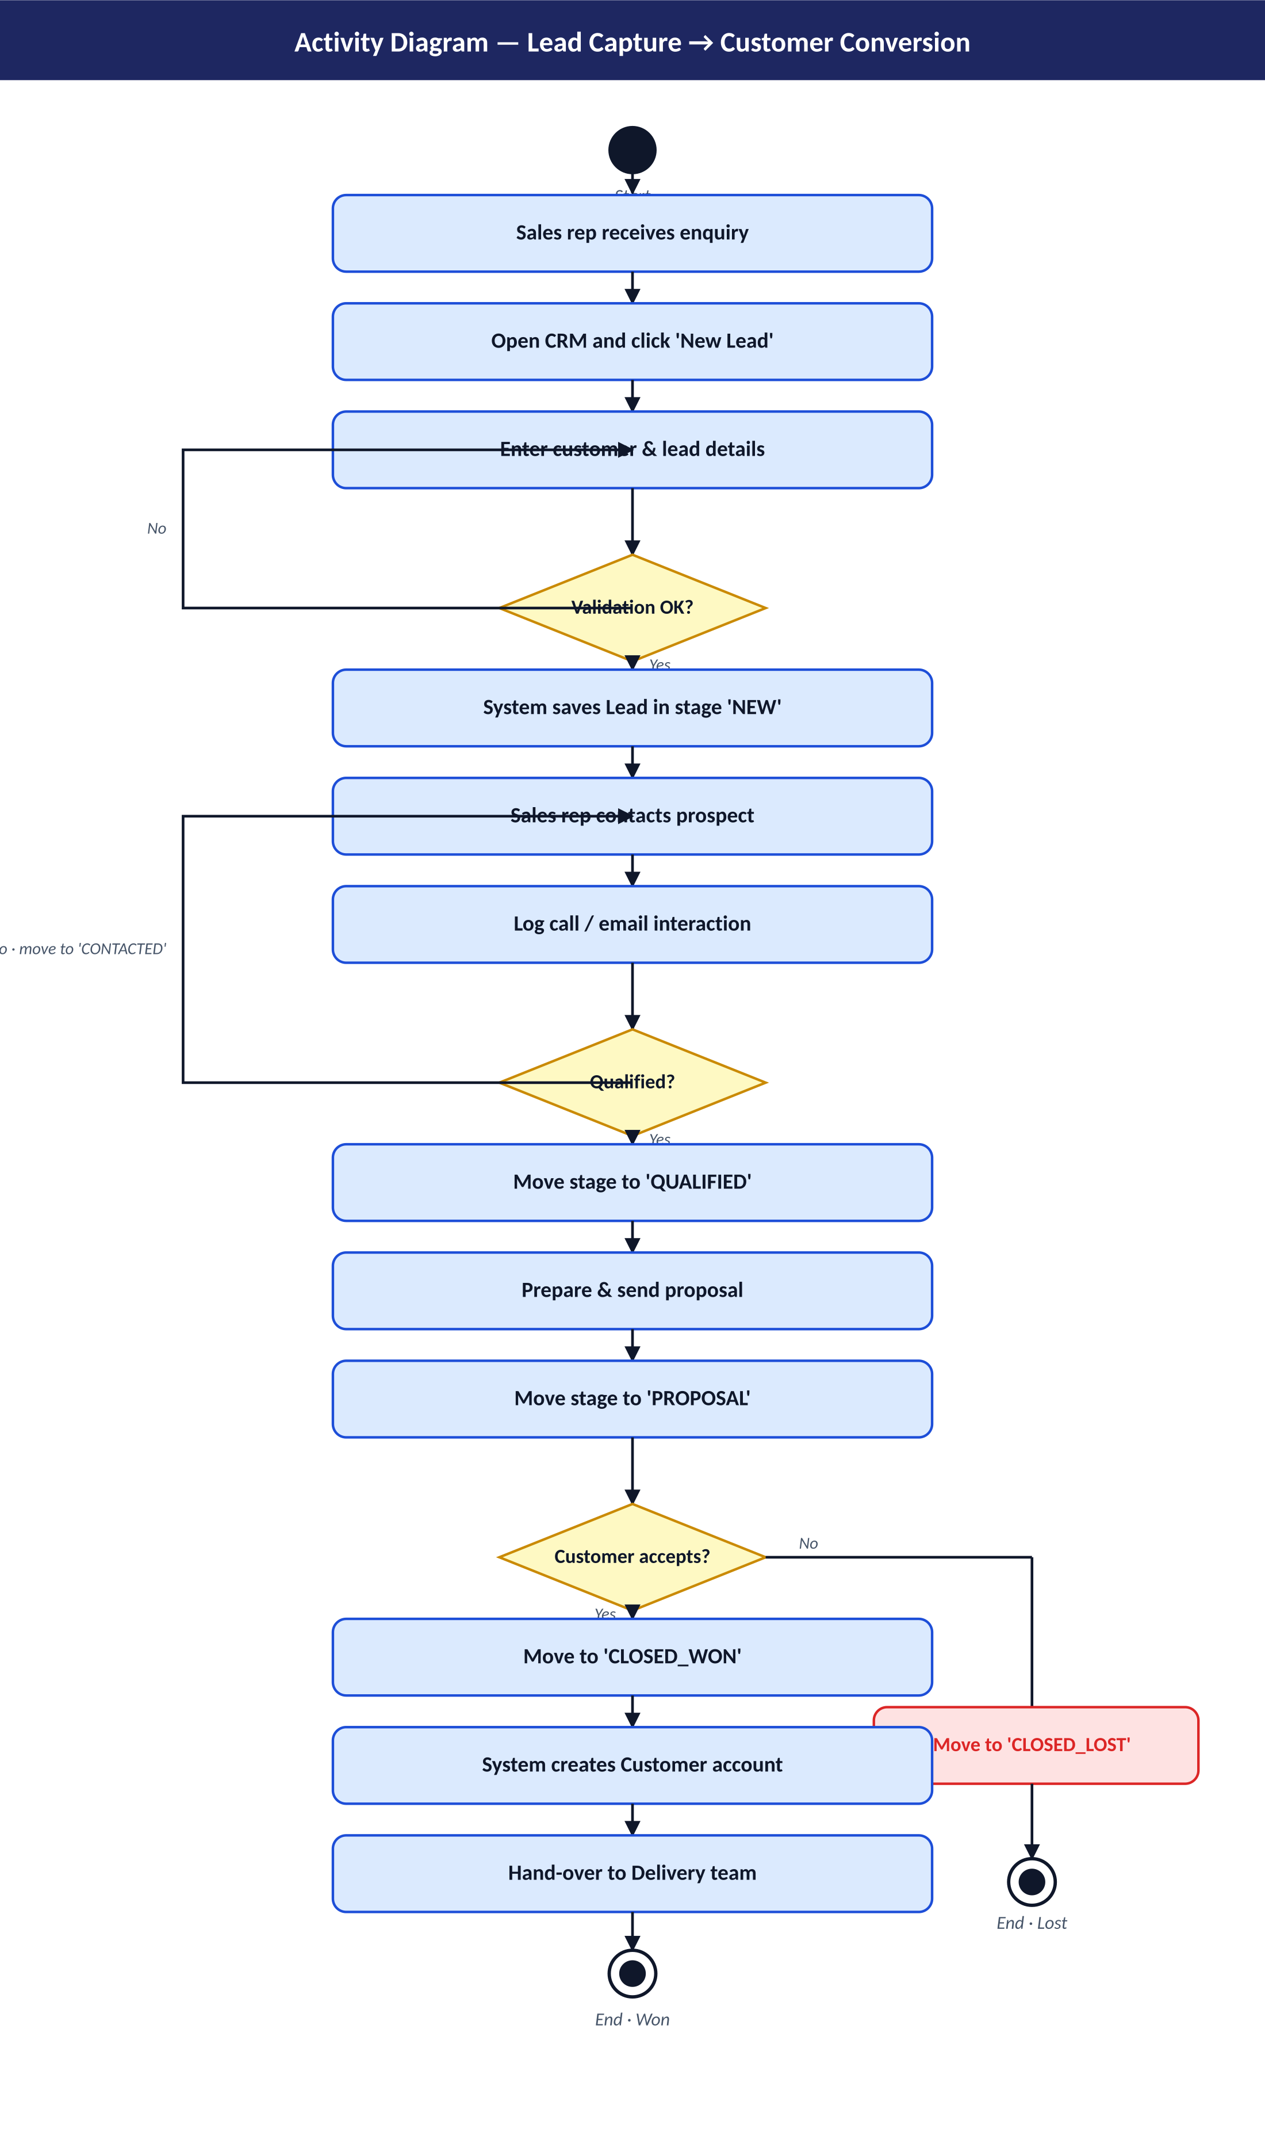
Figure: Activity diagram — three decision points (Validation OK?, Qualified?, Customer accepts?) and two end states (Closed-Won, Closed-Lost).

1.4.4 Sequence Diagram — Log call & update lead stage
This shows exactly what happens when a sales rep logs a call and drags a lead from Qualified to Proposal. The Vue page sends two REST calls with the JWT in the Authorization header. The Spring Boot controller delegates to the service, which uses Spring Data JPA to update MySQL. Every step is verified by the unit and integration tests described in Phase 4.
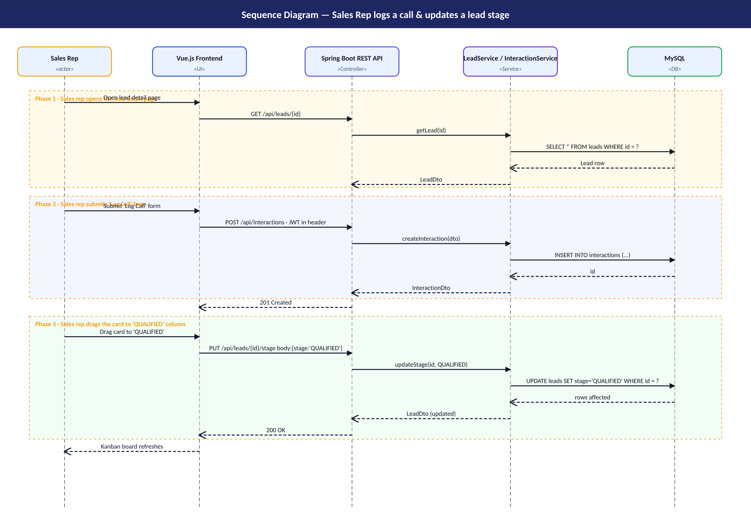
Figure: Sequence diagram — three phases: open lead detail (read), submit Log Call form, drag to QUALIFIED column.

1.4.5 Component Diagram
The deployment view is intentionally simple. The frontend container is NGINX serving a static Vue bundle and proxying /api to the backend container. The backend container is a fat JAR built from Java 17. The database is MySQL 8 with a named volume mysql_data so data survives restarts. The examiner only needs Docker and Git installed to run this — docker compose up --build does everything else.
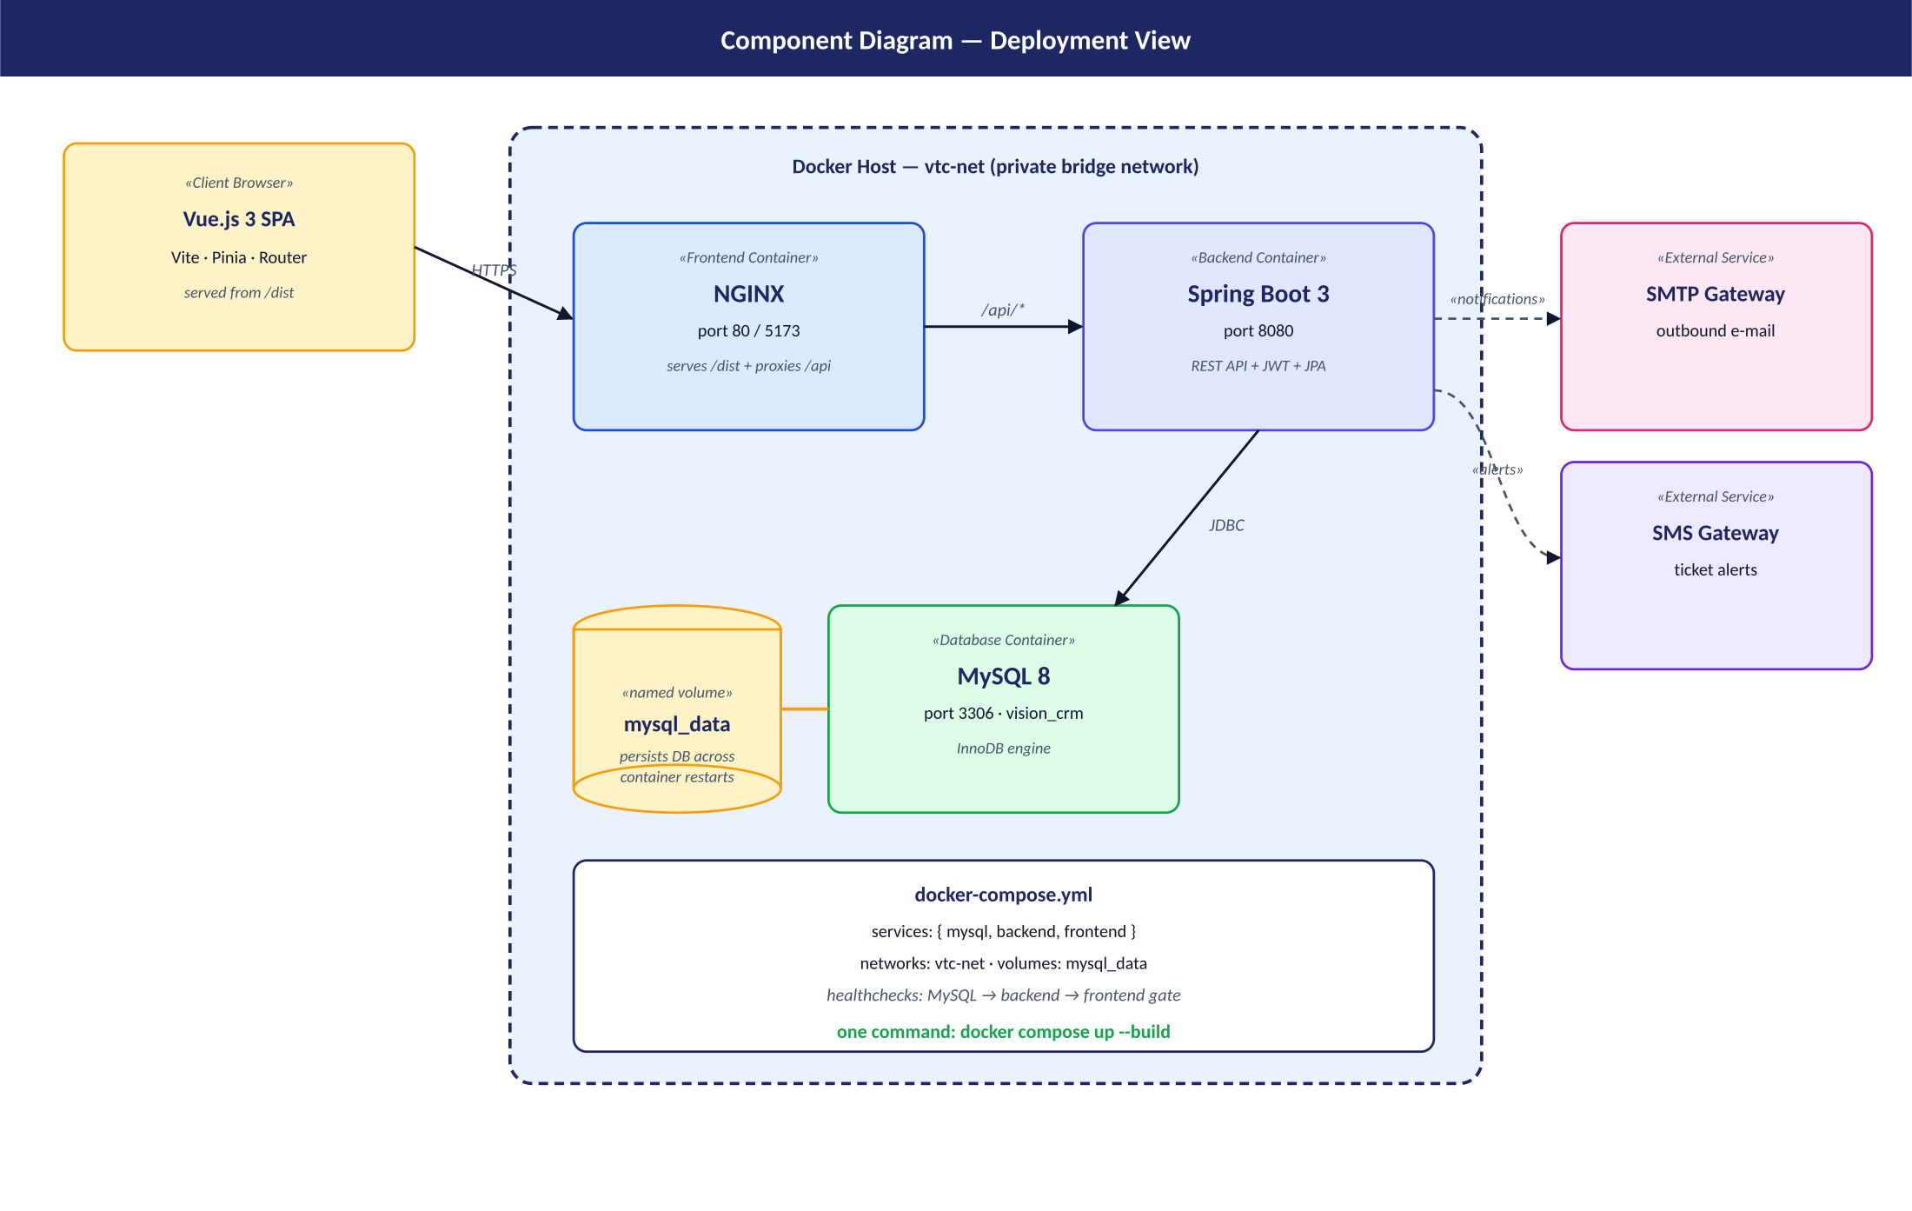
Figure: Component diagram — three Docker containers (Vue/NGINX, Spring Boot, MySQL), named volume, and external SMTP/SMS gateways.

Phase 2 — Software Prototype, Coding Standards & Design Pattern

2.1 Tech stack
The prototype is the full-stack CRM whose source code lives under vision-tech-crm/. It pairs a Vue 3 SPA with a Spring Boot REST API and a MySQL 8 database, all orchestrated with Docker Compose.
Layer | Choices
Frontend | Vue 3 (Composition API) · Vite · Vue Router 4 · Pinia · Tailwind CSS · Chart.js · Axios.
Backend | Spring Boot 3 · Spring Security (JWT) · Spring Data JPA · Lombok · Bean Validation · MapStruct-style mappers.
Database | MySQL 8 with InnoDB; schema in backend/src/main/resources/schema.sql; seeded by DataLoader.java.
Build | Maven (backend) · npm (frontend) · multi-stage Dockerfiles.
Runtime | docker compose up --build — three containers on vtc-net network with health checks.

2.2 Folder structure
The source tree follows a strict separation of concerns. Top-level folders:
- backend/ — Spring Boot service (controllers, services, repositories, models, DTOs, mappers, security, exception handling, config).
- frontend/ — Vue 3 SPA (views, components, stores, router, services, assets).
- docs/ — design documentation (Phase 1 diagrams, design pattern, coding standards, test plan, git guide, presentation deck).
- docker-compose.yml — declares the three services, the private network and the named volume.

2.2.1 Backend packages
Inside backend/src/main/java/com/visiontechcrm/ the code is organised by responsibility:
Package | What lives here
controller/ | AuthController, CustomerController, LeadController, InteractionController, TicketController, ReportController — thin HTTP adapters.
service/ | AuthService, CustomerService, LeadService, InteractionService, TicketService, ReportService — business logic, @Transactional.
repository/ | Spring Data JPA interfaces: UserRepository, CustomerRepository, LeadRepository, InteractionRepository, SupportTicketRepository, SalesOpportunityRepository.
model/ | JPA entities: User, Customer, Lead, Interaction, SupportTicket, SalesOpportunity + enums (Role, LeadStage, InteractionType, Priority, TicketStatus).
dto/ | API contract: LoginRequest, LoginResponse, CustomerDto, LeadDto, InteractionDto, TicketDto, StageUpdateRequest, ReportSummaryDto.
mapper/ | CustomerMapper, LeadMapper, InteractionMapper, TicketMapper — convert entities ↔ DTOs.
security/ | JwtUtil (sign/parse), JwtAuthFilter (per-request validation), CustomUserDetailsService.
config/ | SecurityConfig, CorsConfig, DataLoader (seeds the four demo users + sample data).
exception/ | ResourceNotFoundException, ErrorResponse, GlobalExceptionHandler (uniform JSON 400/404/500 bodies).

2.2.2 Frontend folders
Folder | What lives here
views/ | LoginPage, DashboardPage, CustomersPage, CustomerDetailPage, LeadsPage, InteractionsPage, TicketsPage, ReportsPage.
components/ | AppShell, AppNavbar, AppSidebar, CustomerCard, LeadCard, TicketBadge, ConfirmModal, LoadingSpinner, ErrorBanner.
stores/ | Pinia stores: auth.js (token + user), customer.js, lead.js.
router/ | Vue Router config + auth guard.
services/ | api.js — axios instance with global JWT interceptor.
assets/ | main.css with Tailwind base + project-wide @layer components (.btn-primary, .input, .card, .badge).

2.3 Coding standards

2.3.1 Backend — Google Java Style Guide
Java code follows the Google Java Style Guide (https://google.github.io/styleguide/javaguide.html). Source files are UTF-8, one top-level class per file, ordered package → imports → class. Imports are fully qualified with no wildcards. Indentation is 4 spaces (no tabs). Lines stay under 100 characters. Braces are always present, even for single-statement if/for/while.
Element | Convention | Example in code
Package | lower-case, no underscores | com.visiontechcrm.service
Class / Interface / Enum | UpperCamelCase | CustomerService, LeadStage
Method / Variable | lowerCamelCase | findById, estimatedValue
Constant | UPPER_SNAKE_CASE | MONTH_FMT in ReportService
Type parameter | single capital letter | T, R
Lombok generates getters, builders and constructors so the entities and DTOs stay readable. Every public class has a short Javadoc explaining what it does; only non-obvious logic gets an inline comment — Javadoc never narrates the syntax. Each class addresses a single concern (controller, service, repository, mapper); domain errors throw ResourceNotFoundException and everything else is caught by GlobalExceptionHandler and converted to a uniform JSON payload.

2.3.2 Frontend — Vue.js Style Guide
Vue code follows the Vue.js Style Guide (https://vuejs.org/style-guide/). All component names are multi-word (CustomerCard, LeadCard, AppNavbar, AppShell …). Files are PascalCase.vue. Each .vue file follows the standard order: <template> → <script setup> → <style>. Composition API with <script setup> is used consistently.
- Props are always defined as objects with type, required and (when applicable) default — never as bare arrays.
- Every v-for has a unique :key bound to a stable id.
- v-if and v-for are never combined on the same element; we pre-filter in the Pinia store or a computed.
- Components with no children are self-closing, e.g. <LoadingSpinner /> and <ErrorBanner :message="error" />.
- All cross-page state lives in Pinia stores. Components never reach into localStorage directly except through auth.js.
- UI styling is Tailwind utility classes plus project-wide @layer components rules in src/assets/main.css.

2.3.3 Project-wide rules
- Meaningful names everywhere — estimatedValue not v, customerId not cid.
- No dead code, no over-commenting — comments explain why, not what.
- One responsibility per class / component / store.
- All forms validate inputs before submitting and show inline error messages (LoginPage, CustomersPage, LeadsPage, TicketsPage, InteractionsPage).
- All pages handle three states — loading (LoadingSpinner), error (ErrorBanner), and success.

2.4 Design Pattern — Model-View-Controller
Why MVC? Separation of concerns. Persistence rules live in the Model; the presentation layer (HTML / Vue templates) lives in the View; the Controller is the glue — it accepts requests, calls business logic, and produces a response. This makes the code testable, replaceable and easy to understand for new team members.

2.4.1 Model layer
The Model is the domain — what the business cares about. Backend models are JPA entities under backend/src/main/java/com/visiontechcrm/model/: User, Customer, Lead, Interaction, SupportTicket, SalesOpportunity and the five enumerations Role, LeadStage, InteractionType, Priority, TicketStatus.
Persistence is delegated to Spring Data JPA repositories — CustomerRepository, LeadRepository, etc. The repository interfaces declare the data-access contract; the framework generates the implementation at runtime, keeping the Model layer free of SQL.
On the frontend, Pinia stores are the Model's mirror: auth.js (token + logged-in user), customer.js (list, search, create, edit, delete) and lead.js (sales pipeline, exposes byStage(stage) for the Kanban board). Stores never touch the DOM; they contain pure state and async actions, which makes them trivially unit-testable.

2.4.2 View layer
The View renders the model to the user. Vue Single-File Components take that role; the backend has no server-rendered views — its "view" is the JSON returned by the REST controllers. Pages live in frontend/src/views/ (LoginPage, DashboardPage, CustomersPage, CustomerDetailPage, LeadsPage, InteractionsPage, TicketsPage, ReportsPage) and reusable bits in frontend/src/components/ (AppShell, AppNavbar, AppSidebar, CustomerCard, LeadCard, TicketBadge, ConfirmModal, LoadingSpinner, ErrorBanner).

2.4.3 Controller layer
The Controller is the traffic director. It accepts user input, invokes services and chooses the response. Backend REST controllers live in com.visiontechcrm.controller and are deliberately thin — they parse the request, hand off to a service, and return a ResponseEntity. They contain no business rules.
Controller | Endpoints
AuthController | POST /api/auth/login
CustomerController | GET, POST, PUT, DELETE /api/customers[/{id}]
LeadController | GET, POST, PUT, DELETE /api/leads[/{id}], PUT /api/leads/{id}/stage
InteractionController | GET, POST, DELETE /api/interactions[/{id}]
TicketController | GET, POST, PUT, DELETE /api/tickets[/{id}], PUT /api/tickets/{id}/escalate, PUT /api/tickets/{id}/resolve
ReportController | GET /api/reports/summary
The actual business logic — the "controller" role from a pattern-purity point of view — sits in service classes: AuthService (authenticates credentials and signs a JWT), CustomerService (CRUD + search), LeadService (only legal stage transitions, default stage NEW), InteractionService (records and retrieves recent activity), TicketService (escalate/resolve lifecycle, timestamps), ReportService (aggregates counts for the dashboard). Each service has a single responsibility, depends on its repositories through constructor injection, and is annotated @Transactional so JPA changes commit or roll back atomically.
On the frontend the Controller role is split between the Vue Router (frontend/src/router/index.js — maps URLs to views and enforces auth guards) and Pinia actions in auth.js, customer.js, lead.js — these dispatch HTTP requests, mutate store state, and surface errors to the view.

2.4.4 Cross-cutting building blocks
File | Pattern | Role
mapper/CustomerMapper.java + siblings | Mapper / Adapter | Convert entities ↔ DTOs so the model is not leaked to clients.
dto/*.java | DTO | Stable wire contract for the REST API.
security/JwtUtil + JwtAuthFilter | Chain of Responsibility | Authenticate every request with one JWT pass.
exception/GlobalExceptionHandler.java | Front Controller + Strategy | Translates any exception into a uniform ErrorResponse.
frontend/src/services/api.js | Singleton + Interceptor | One configured axios instance, JWT auto-attached.
components/AppShell.vue | Composite View | Wraps every page in a consistent navbar + sidebar layout.

2.4.5 How a request flows through MVC
Browser --HTTP--> Vue View (LeadsPage.vue)
│ user drops a card on "QUALIFIED"
▼
Pinia action leads.moveStage(id, 'QUALIFIED')
│ axios PUT /api/leads/{id}/stage
▼
LeadController.updateStage(id, req)
│
▼
LeadService.updateStage(id, stage)
│
▼
LeadRepository (Spring Data JPA)
│ UPDATE leads SET stage='QUALIFIED' WHERE id=?
▼
MySQL
The View only knows about a Pinia action. The action only knows axios. The controller only knows the service. The service only knows the repository. The repository only knows JPA. Each layer can be replaced without rewriting the others — the hallmark of a well-applied MVC pattern.

Phase 3 — Dockerisation & Version Control

3.1 Containers — what and why
A container is a lightweight, isolated process that packages an application together with all its dependencies — the runtime, libraries, OS packages, configuration — into a single, portable unit. Unlike a virtual machine, a container shares the host OS kernel, so it starts in milliseconds and uses a fraction of the resources.
Without Docker | With Docker
"It runs on my laptop" — env mismatches between machines. | Same image runs identically everywhere.
Manual install of Java 17, Node 18, MySQL 8, configuration… | docker compose up --build and it just works.
Hard to reset state. | docker compose down -v and start fresh.
Hard to deploy. | Push the image, pull it anywhere — same artefact.

3.2 The general steps to dockerise an application
- Choose a base image. A small, well-maintained image with the right runtime — eclipse-temurin:17-jdk-alpine for Java, node:18-alpine for building the frontend, nginx:alpine for serving it, mysql:8.0 for the database.
- Write a Dockerfile that lists, step-by-step, what should go inside the image: copy source, install dependencies, run the build, expose the port, declare the start command. Order steps from least to most frequently changing to maximise layer caching.
- Use multi-stage builds for compiled languages: a heavy "builder" stage compiles the code, then a slim "runtime" stage receives only the resulting artefact (JAR or /dist). The final image is small and contains no build tools.
- Build the image locally: docker build -t vtc-backend ./backend.
- Compose multiple containers with docker-compose.yml, declaring the services, networks, named volumes, environment variables, port mappings and health checks.
- Run with docker compose up --build. Compose builds images, creates the network and the volume, starts the containers in dependency order, and streams their logs to the console.
- Iterate. Edit code → rebuild only the affected service: docker compose up --build backend.

3.3 How the Vision Technologies CRM is dockerised
Container | Image base | Job
vtc-mysql | mysql:8.0 | Persists data in named volume mysql_data; runs schema.sql on first start.
vtc-backend | multi-stage: maven:3.9.6-eclipse-temurin-17 → eclipse-temurin:17-jdk-alpine | Builds the Spring Boot fat-jar, then runs it on port 8080. HEALTHCHECK calls /actuator/health every 20s.
vtc-frontend | multi-stage: node:18-alpine → nginx:alpine | Runs npm run build, then NGINX serves /dist on port 80 and proxies /api/* to the backend.
All three services share the bridge network vtc-net; ports 5173, 8080 and 3306 are mapped to the host so the examiner can poke at each one directly. Health-checks on MySQL and the backend prevent the frontend from receiving traffic before the API is ready. The full compose file lives at the project root: docker-compose.yml. To run:
docker compose up --build

3.4 Version Control — Git setup
We use Git as the VCS because it is the de-facto standard, ships with GitHub / GitLab / Bitbucket integration, and supports the simplified Git Flow branching workflow described below.

3.4.1 Install and configure
OS | Install
Windows | https://git-scm.com/download/win (includes Git Bash)
macOS | brew install git or xcode-select --install
Linux | sudo apt install git (Debian/Ubuntu) or sudo dnf install git (Fedora)
Configure once per machine:
git config --global user.name "Your Full Name"
git config --global user.email "you@example.com"
git config --global init.defaultBranch main
git config --global core.autocrlf input # Windows users: 'true'

3.4.2 Initialise the repository
From the project root (vision-tech-crm/):
git init
git branch -m main # ensure default branch is 'main'

3.4.3 .gitignore
A combined .gitignore for Java + Maven + Node + Vue + Docker + IDE/OS noise is shipped at the project root. It is intentionally narrow — it ignores only build output, node_modules, IDE cruft, secrets and OS noise. Everything else (source code, configuration templates, docker-compose.yml, Dockerfiles, schema, documentation, Mermaid diagrams, the test plan) is tracked by Git. A fresh clone is sufficient to reproduce the entire system from scratch with docker compose up --build.
# Java / Maven
target/
*.class
.idea/

# Node / Vue / Vite
node_modules/
dist/
.vite/

# Env / Secrets
.env
backend/.env
frontend/.env

# OS
.DS_Store
Thumbs.db

3.4.4 First commit
git add .
git commit -m "chore: initial commit — scaffolding and documentation"

3.4.5 Branching strategy — simplified Git Flow
main ← stable, deployable
└── develop ← integration branch for the next release
├── feature/auth
├── feature/customers
├── feature/leads
├── feature/interactions
├── feature/tickets
└── feature/reports
Create the long-lived branches and a feature branch:
git checkout -b develop
git push -u origin develop

git checkout develop
git checkout -b feature/auth
# … work …
git add .
git commit -m "feat(auth): add JWT login endpoint and front-end login page"
git push -u origin feature/auth
Merge a finished feature into develop via a Pull Request, then merge develop into main at release time.

3.4.6 Conventional Commits
Every commit message begins with a type, optionally a scope, then a short imperative description:
Type | Use for | Example
feat | A new user-facing feature | feat(leads): add drag-and-drop Kanban board
fix | A bug fix | fix(auth): expire JWT after 24 h, not 24 s
docs | Documentation only | docs(readme): add docker compose instructions
style | Formatting / whitespace / no logic change | style(controller): reformat per Google Java Style
refactor | Code change that neither fixes nor adds a feature | refactor(service): extract LeadMapper
test | Adding or fixing tests | test(customer): add JUnit 5 CustomerServiceTest
chore | Build, tooling, CI | chore: bump spring-boot to 3.2.5
perf | Performance improvement | perf(reports): cache monthly aggregation
Examples actually used in this project:
feat(auth): implement JWT login and Spring Security filter
feat(customers): CRUD endpoints + Vue table with search/add/edit/delete
feat(leads): Kanban board with drag-and-drop and stage transitions
feat(tickets): escalate and resolve endpoints
fix(cors): allow Authorization header from http://localhost:5173
docs(phase1): add 5 Mermaid diagrams and problem statement
docs(phase4): write test plan with 20 cases
test(auth): add AuthServiceTest with Mockito
chore(docker): multi-stage Dockerfiles for backend and frontend

3.4.7 Pushing to GitHub
- Create an empty repo on GitHub (vision-tech-crm) — do not tick "Add README" or it will conflict.
- Add the remote and push:
git remote add origin https://github.com/<your-username>/vision-tech-crm.git
git push -u origin main
git push -u origin develop

Phase 4 — Software Test Plan
Project: Vision Technologies CRM Version: 1.0 Date: Semester II 2025 / 2026

4.1 Test Objectives
The objectives of testing are derived directly from the functional and non-functional requirements of the CRM:
# | Objective | Aligned requirement
O1 | Verify that authentication issues a valid JWT and rejects bad credentials. | Login screen, JWT security.
O2 | Verify that customer CRUD operations succeed and persist to MySQL. | Customer Management.
O3 | Verify that the sales pipeline correctly transitions leads between stages. | Lead Management.
O4 | Verify that interactions are recorded against the correct customer and timestamped. | Interactions log.
O5 | Verify the support-ticket lifecycle: create → escalate → resolve. | Support Tickets.
O6 | Verify the dashboard and reports produce the correct aggregates. | Reporting.
O7 | Verify the application behaves correctly under invalid input, missing resources and expired tokens. | Robustness, error handling.
O8 | Verify the dockerised stack starts and is healthy. | Phase 3 — containerisation.

4.2 Scope

4.2.1 In scope
- Backend REST API — /api/auth, /api/customers, /api/leads, /api/interactions, /api/tickets, /api/reports.
- Frontend Vue.js SPA pages: Login, Dashboard, Customers, Leads (Kanban), Interactions, Tickets, Reports.
- JWT authentication, role-based access, CORS configuration.
- Database persistence (MySQL) and seed data (DataLoader.java).
- Docker Compose stack health.

4.2.2 Out of scope
- E-mail / SMS gateway integration (mocked).
- Multi-tenancy / multi-currency.
- Internationalisation.
- Load testing beyond a basic smoke under JMeter.
- Penetration testing.

4.3 Test Types
Type | Tooling | What it covers
Unit tests | JUnit 5 + Mockito | Pure logic in services (CustomerService, AuthService, LeadService, TicketService, ReportService).
Integration tests | Spring Boot Test + @SpringBootTest + MockMvc | REST endpoints with an in-memory H2 database.
End-to-end (manual) | Browser at localhost:5173 + checklist | The 20 test cases below executed against the live, dockerised stack.
End-to-end (automated) | Cypress (optional) | Smoke flows: login → dashboard → CRUD customer → drag lead → log interaction → escalate ticket.
Performance | JMeter | 50 concurrent users hitting /api/customers and /api/auth/login; track p95 latency and error rate.
Security | Postman + manual | JWT expiry, CORS, 401 on missing token, 403 on wrong role.

4.4 Test Tools — justification
Tool | Why
JUnit 5 | Modern testing standard for Java, parameterised tests, lifecycle annotations, ships with Spring Boot.
Mockito | Best-in-class mocking library, perfect for isolating service-layer logic from repositories.
Spring Boot Test | Brings up a real ApplicationContext for integration tests with one annotation.
MockMvc | Calls controllers without an actual HTTP server — fast feedback.
Cypress | Real-browser E2E with great DX; tests run on the same dockerised app the examiner uses.
JMeter | Industry-standard load-testing tool; produces clear HTML reports for performance bottlenecks.
Postman | Manual / exploratory API testing during development.
GitHub Issues | Used to track bugs; each test failure becomes an issue with reproduction steps and the failing test ID.

4.5 Entry & Exit criteria

4.5.1 Entry criteria
- All Phase 2 code compiles (mvn -B verify, npm run build).
- docker compose up --build runs to completion with all services healthy.
- Seed data is loaded (admin user, 4 customers, 4 leads, 3 tickets).
- Test data is available for negative cases.

4.5.2 Exit criteria
- 100% of the 20 test cases in §4.8 are executed.
- All Critical / High severity defects are fixed.
- Unit-test pass rate ≥ 95%; integration-test pass rate = 100%.
- Performance: p95 latency < 500 ms for read endpoints under 50 concurrent users.
- Sign-off from the instructor.

4.6 Roles & Responsibilities
Role | Person | Responsibility
Developer / Tester | MUNEZERO IRAKOZE Luccin (ID 25815) | Writes code, unit tests, integration tests, runs the manual checklist.
Examiner | Rutarindwa Jean Pierre | Independent verification of all 20 test cases on the live system.
Tool | GitHub Issues | Defect tracker, severity & priority labels.

4.7 Test Schedule
Day | Activity
Day 1 | Write JUnit unit tests for all services.
Day 2 | Add Spring Boot integration tests for /api/customers and /api/leads.
Day 3 | Manual E2E walk-through of all 20 test cases on dockerised stack.
Day 4 | Fix discovered defects, re-run failing cases.
Day 5 | Performance smoke with JMeter, security checks, final report.

4.8 Test Cases
All twenty cases below are executed during Phase 4 manual E2E. Pass/Fail and Actual columns are filled in during execution.
ID | Feature | Description | Expected Result
TC-01 | Login (valid) | Login with the seeded admin should succeed. | JWT stored in localStorage; user redirected to /dashboard; navbar shows full name and role.
TC-02 | Login (wrong password) | Login with a wrong password must fail and stay on the login page. | Inline error "Invalid email or password"; no JWT stored; user stays on /login.
TC-03 | Create customer | Sales rep can create a new customer (Acme Ltd, IT, a@b.rw). | New row visible in the table; record persisted in customers; created_at populated.
TC-04 | Edit customer | Editing a customer updates the persisted record (industry → Banking). | Table row reflects Banking; backend returns 200 OK; DB shows updated industry.
TC-05 | Delete customer | Deleting a customer removes it from list and DB. | Customer disappears from table; backend returns 204 No Content; DB row gone.
TC-06 | Search customer | Searching by partial company name filters the table ("bank"). | Only customers whose company name or e-mail contains "bank" are shown.
TC-07 | Create lead | Creating a lead persists it in stage NEW. | New card appears in the New column; backend returns 201 Created.
TC-08 | Move lead stage | Dragging a card from New to Qualified updates its stage. | Card now sits in Qualified; DB stage = QUALIFIED; PUT /api/leads/{id}/stage returns 200.
TC-09 | Log call interaction | Logging a call attaches it to the correct customer. | Entry at top of Recent activity; persisted in interactions with type='CALL'.
TC-10 | Send email interaction | Same as TC-09 but type=EMAIL; visible on customer detail page too. | Email interaction visible both on the global list and on the customer detail history.
TC-11 | Create support ticket | Support engineer can create a ticket with priority HIGH. | Ticket appears in the table with priority badge High and status Open.
TC-12 | Escalate ticket | Escalating a ticket sets status to ESCALATED and bumps priority if low/med. | Status badge changes to Escalated; if priority was Medium it is now High.
TC-13 | Resolve ticket | Resolving a ticket sets status RESOLVED and stamps resolved_at. | Status badge Resolved; resolved_at is set in the DB.
TC-14 | Generate monthly report | Reports page shows a bar chart of monthly leads. | Bar chart renders one bar per year-month; numbers match the DB.
TC-15 | Export report | Reports can be exported as CSV. | CSV downloaded with rows: Metric, Value; opens cleanly in Excel / Numbers.
TC-16 | Dashboard data loads | Dashboard cards show non-zero counts after login. | All four stat cards show numbers matching GET /api/reports/summary.
TC-17 | JWT token expiry | An expired token forces re-login. | Axios interceptor receives 401, clears state, redirects to /login with ?redirect=….
TC-18 | CORS validation | OPTIONS preflight from localhost:5173 allowed; from another origin blocked. | Browser blocks request because the response lacks the right Access-Control-Allow-Origin.
TC-19 | 404 on missing resource | API returns a clean 404 JSON body for unknown IDs. | HTTP 404 with ErrorResponse JSON {status:404, error:"Not Found", message:"Customer not found with id: 99999"}.
TC-20 | Docker health check | Dockerised stack reports healthy. | All three containers show Up and healthy; logs contain "Started VisionTechCrmApplication".

4.9 Implemented test classes
Two unit-test classes (Mockito) and two integration-test classes (Spring Boot Test + MockMvc + H2) ship with the project:
Test class | Type | Coverage
CustomerServiceTest | Unit | 9 tests: findAll, findById (found / not found), create, update (success / missing), delete (success / missing), search.
AuthServiceTest | Unit | 3 tests: login OK, bad password, missing user.
CustomerControllerIT | Integration | Logs in as admin to obtain a JWT, then drives the full CRUD lifecycle through MockMvc — covers TC-03, TC-04, TC-05, TC-06 and TC-19.
AuthControllerIT | Integration | POST /api/auth/login with valid admin (TC-01), wrong password (TC-02), and unknown-user — verifies JWT body and 401 responses.

Closing

Lessons Learned
- MVC keeps each layer small and replaceable — the same pattern, applied identically on backend and frontend.
- Docker eliminated environment friction; the examiner needs only Docker + Git installed.
- DTOs + mappers protect the domain model from API consumers and make the wire contract explicit.
- Conventional Commits turn `git log --oneline` into a project timeline that reads like a changelog.

Live demo checklist
- Log in as alice@visiontech.rw / Sales@123.
- Land on Dashboard — see counts of customers, open leads, open tickets.
- Customers → add New Bank Ltd → save → edit → delete.
- Leads → drag the MTN CCTV card from Qualified to Proposal.
- Interactions → log a call against Bank of Kigali.
- Tickets → escalate the highest-priority open ticket.
- Reports → inspect the bar chart of monthly leads and the pie chart of tickets by status; click Export CSV.
End of submission.

