

**Requirement & Design Specification**

**Quiz Practice System (QPS)**

**Version: 2.0**

– Hanoi, May 5 2024 –

# Record of Changes

|  |  |  |  |  |
| --- | --- | --- | --- | --- |
| Version | Date | A* M, D | In charge | Change Description |
| V1.0 | 10/5 | A | Dungnmhe173094 | create project folder and login page |
| V1.1 | 11/5-14/5 | A | LucNTHE173098 | create home ; database and initial functions: semester,coursea;class |
| V1.2 | 14/5 | A | Dungnmhe173094 | Do document v1.0 |
| V1.3 | 15/5-16/5 | A | DuongLMHE186043 | Do document v1.0 |
|  | 16/5 – 19/5 | A | DuongLMHE186043 | Do document v1.0 |
|  | 22/5 | A | DuongLMHE186043 | Fix database |
|  | 23/5-24/5 | M | DuongLMHE186043 | Fix use case, add feature, and add code packages. |
|  |  |  |  |  |
|  |  |  |  |  |
|  |  |  |  |  |
|  |  |  |  |  |
|  |  |  |  |  |

*A - Added M - Modified D - Deleted

Contents

Record of Changes 2

I. Overview 4

1. User Requirements 4

1.1 Actors 4

1.2 Use Cases 4

2. Overall Functionalities 5

2.1 Screens Flow 5

2.2 Screen Descriptions 5

2.3 Screen Authorization 5

2.4 Non-UI Functions 6

3. System High Level Design 6

3.1 Database Design 6

3.2 Code Packages 7

II. Requirement Specifications 8

1. <<Feature Name>> 8

1.1 <<UseCaseCode_UC Name>> 8

2. Common Functions 11

2.1 UC-2_Login System 11

3. Patron Feature 12

3.1 UC-5_Order a Meal 12

3.2 UC-6_Register for Payroll Deduction 13

III. Design Specifications 14

1. <<Feature Name>> 14

1.1 <<SubFeature Name>> 14

1.2 System Access 15

IV. Appendix 19

1. Assumptions & Dependencies 19

2. Limitations & Exclusions 19

3. Business Rules 19

4. .. 19

# I. Overview

## 1. User Requirements

### 1.1 Actors

|  |  |  |
| --- | --- | --- |
| **#** | **Actor** | **Description** |
| 1 | Admin | Manage Manager account + decentralize Manager rights |
| 2 | Manager | view personal profile; manage Teacher account ;manage Student account ;create semester ;create course ;create class and add teacher to class |
| 3 | Teacher | Change profile; import student class; create quiz including test date and subject (eg PT1, PT2, etc.), set up: essay or multiple choice test, set time and number of students; Instructors can view all student scores; create questions including: mult choice, true false, essay and are automatically added to question bank;view scores |
| 4 | Student | change profile ;do quiz ; view score; Can see questions and incorrect answers (cannot see correct answers) |

### 1.2 Use Cases

#### a. Diagram(s)

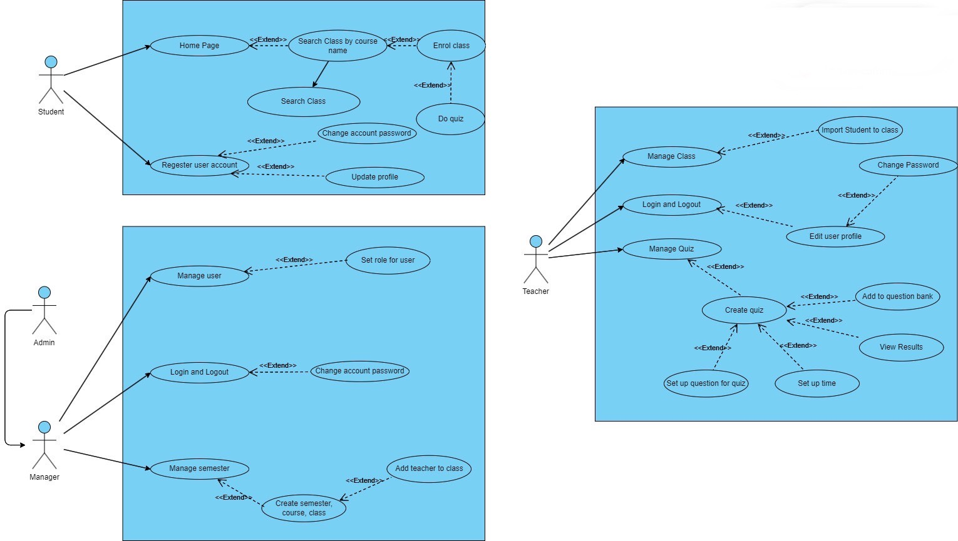

#### b. Descriptions

|  |  |  |  |
| --- | --- | --- | --- |
| **ID** | **Feature** | **Use Case** | **Use Case Description** |
| 01 | User Registration | Register User Account | A user (student or teacher) can register a new account on the platform by providing their personal information. |
| 02 | User Registration | Update Profile | A user (student or teacher) can update their profile information, such as name, email, or password. |
| 03 | User Management | Set Role for User | The admin can set the role (student or teacher) for a registered user. |
| 04 | Course Management | Manage Semester | The manager can manage semesters, including creating new semester courses and classes. |
| 05 | Course Management | Add Teacher to Class | The manager can assign a teacher to a specific class. |
| 06 | Student Features | Search Class | A student can search for and find classes based on various criteria, such as course name. |
| 07 | Student Features | Enroll in Class | A student can enroll in a class they have found. |
| 08 | Student Features | Do Quiz | A student can take a quiz associated with a class they are enrolled in. |
| 09 | Teacher Features | Manage Class | A teacher can manage the classes they are assigned to, including importing student lists. |
| 10 | Teacher Features | Manage Quiz | A teacher can manage quizzes for their classes, including creating new quizzes, setting questions, and viewing results. |
| 11 | Teacher Features | Add to Question Bank | A teacher can add questions to their personal question bank for use in future quizzes. |
| 12 | Teacher Features | Set Up Question for Quiz | A teacher can set up questions for a specific quiz. |
| 13 | Teacher Features | Set Up Time | A teacher can set a time limit for a quiz. |
| 14 | Manager Features | Login and Logout | The manager can log in and out of the platform. |
| 15 | Manager Features | Change Account Password | The manager can change their account password. |
| 16 | Admin Features | Manage Users | The admin can give permission to which user is manager |

## 2. Overall Functionalities

### 2.1 Screens Flow

\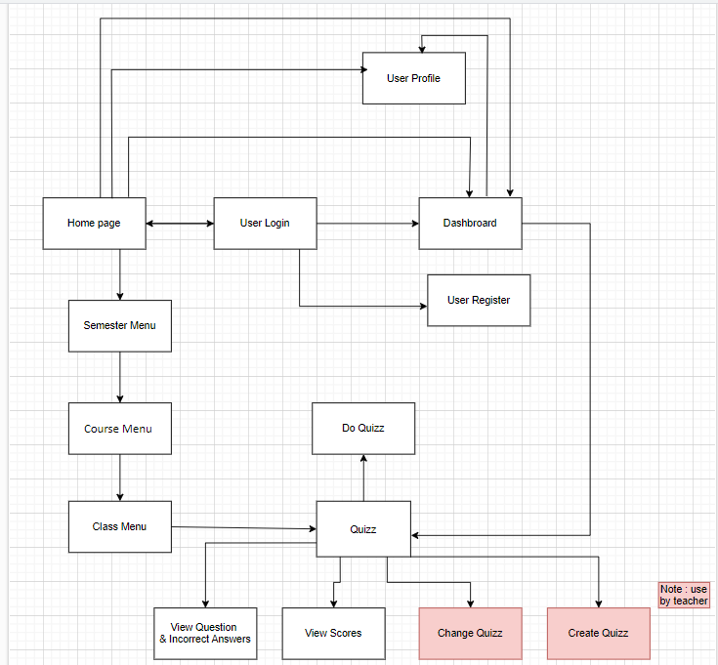

### 2.2 Screen Descriptions

|  |  |  |  |
| --- | --- | --- | --- |
| **ID** | **Feature** | **Screen** | **Description** |
| 1 | User Management | Home page | The initial landing page of the application where users can access login or registration functionality. |
| 2 | User Management | User Login | A screen where existing users can enter their credentials (username/email and password) to log in to the application. |
| 3 | User Management | User Register | A screen where new users can sign up for an account by providing their personal information and creating login credentials. |
| 4 | User Management | User Profile | A screen where users can view and update their profile information, such as name, contact details, and profile picture. |
| 5 | User Management | Password Change | A screen where users can change their current password to a new password. |
| 6 | User Management | Password Reset | A screen where users can initiate the process of resetting their forgotten password. |
| 7 | Course Management | Dashboard | The main screen after logging in, providing an overview of the user's courses, assignments, and other relevant information. |
| 8 | Course Management | Semester Menu | A screen displaying a list of available semesters and the option to navigate to specific semester details. |
| 9 | Course Management | Course Menu | A screen showing the courses offered in a selected semester and the ability to navigate to individual course details. |
| 10 | Course Management | Class Menu | A screen listing the classes associated with a selected course, allowing users to access class-specific information and activities. |
| 11 | Quiz Management | Quiz | A screen where users can access and attempt quizzes associated with their enrolled classes. |
| 12 | Quiz Management | Create Quiz | A screen where teachers can create new quizzes by adding questions, setting time limits, and configuring other quiz parameters. |
| 13 | Quiz Management | Change Quiz | A screen where teachers can modify existing quizzes by editing questions, adjusting settings, or updating other quiz details. |
| 14 | Quiz Management | Do Quiz | A screen where students can take a quiz, view questions, and submit their answers. |
| 15 | Quiz Management | View Question & Incorrect Answers | A screen where teachers can view the questions and incorrect answers provided by students for a specific quiz. |
| 16 | Quiz Management | View Scores | A screen where teachers can view the scores and performance of students for a particular quiz. |

### 2.3 Screen Authorization

|  |  |  |  |  |
| --- | --- | --- | --- | --- |
| **Screen** | **Admin** | **Manager** | **Teacher** | **Student** |
| Home page |  |  | X | X |
| User Login | X | X | X | X |
| User Profile | X | X | X | X |
| Password Change |  | X | X | X |
| Password Reset |  | X | X | X |
| Semester Menu |  | X | X | X |
| Course Menu |  | X | X | X |
| Class Menu |  | X | X | X |
| Quiz |  |  | X | X |
| Do Quiz |  |  |  | X |
| Create Quiz |  |  | X |  |
| Change Quiz |  |  | X |  |
| View Question |  |  | X | X |
| View Scores |  |  | X | X |
| Course Management |  | X |  |  |
| Add New Course |  | X |  |  |
| Update Course |  | X |  |  |
| Delete Course |  | X |  |  |

### 2.4 Non-UI Functions

|  |  |  |  |
| --- | --- | --- | --- |
| **ID** | **Feature** | **System Function** | **Description** |
| 1 | Quiz Management | Quiz Time Enforcement | A background service or scheduled job that enforces the time limit for quizzes. It monitors the quiz duration and automatically submits the quiz on behalf of the student when the time limit is reached. |
| 2 | Course Management | Course Enrollment Synchronization | A batch process or API that synchronizes course enrollment data from the institution's student information system (SIS) to the learning management system (LMS). This ensures that students are properly enrolled in the correct courses based on their registration records. |
| 3 | Notification Management | Notification Delivery | A service or API that handles the delivery of various notifications to users, such as upcoming quiz reminders, grade updates, or course announcements. It may integrate with email, push notification, or messaging services. |

## 3. System High Level Design

### 3.1 Database Design

#### a. Database Schema

#### b. Table Descriptions

|  |  |  |
| --- | --- | --- |
| **No** | **Table** | **Description** |
| 01 | Course | This table stores information about courses offered in the system.   * Primary keys: course_code * Foreign keys: semester_name, teacher_username |
| 02 | Semester | This table stores information about semesters, including their start and end dates.   * Primary keys: semester_name * Foreign keys: None |
| 03 | Teaching Assignments | This table stores information about teaching assignments, which associate teachers with courses and semesters.   * Primary keys: username, course_code, semester_name * Foreign keys: username, course_code, semester_name |
| 04 | Teacher | This table stores information about teachers, including their personal and contact details, and the manager who manages them.   * Primary keys: username * Foreign keys: managed_by_manager |
| 05 | Student | This table stores information about students, including their personal and contact details, date of birth, and the manager who manages them.   * Primary keys: username * Foreign keys: managed_by_manager |
| 06 | Enrollment | This table stores information about student enrollments in classes.   * Primary keys: username, class_id * Foreign keys: username, class_id |
| 07 | Class | This table stores information about classes, which are instances of a course offered in a specific semester and room.   * Primary keys: class_id * Foreign keys: course_code, semester_name |
| 08 | Quiz | This table stores information about quizzes associated with classes.   * Primary keys: quiz_id * Foreign keys: class_id |
| 09 | Score | This table stores the scores obtained by students in quizzes.   * Primary keys: username, quiz_id * Foreign keys: username, quiz_id |
| 10 | Admin | This table stores information about system administrators, including their personal and contact details.   * Primary keys: username * Foreign keys: None |
| 11 | Manager | This table stores information about managers who manage teachers and students, including their personal and contact details, and the admin who manages them.   * Primary keys: username * Foreign keys: managed_by_admin |

### 3.2 Code Packages

*[Provide the package diagram for each sub-system. The content of this section including the overall package diagram, the explanation, package and class naming conventions in each package. Please see the sample & description table format below]*

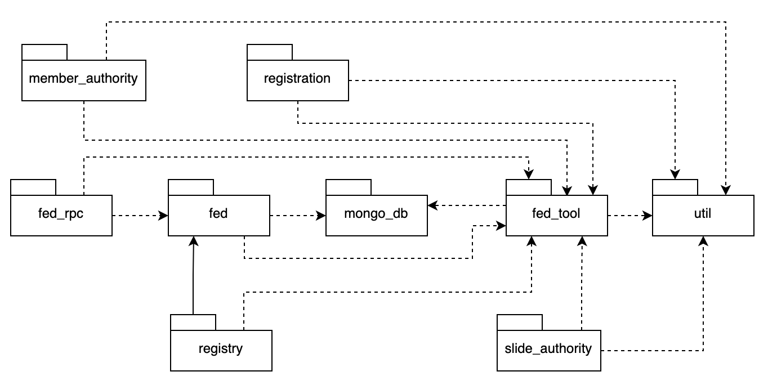

***Package descriptions***

|  |  |  |
| --- | --- | --- |
| **No** | **Package** | **Description** |
| *01* | *Member_authority* | *<Description of the package>* |
| *02* | *registration* | *<Description of the package>* |
| *03* | *…* |  |

# II. Requirement Specifications

## 1. Main Functions

### 1.1 UC-01_Create Quiz

#### a. Functionalities

|  |  |  |  |
| --- | --- | --- | --- |
| UC ID and Name: | Create Quiz | | |
| Created By: | DungNMHE173094 | Created By: | DungNMHE173094 |
| Primary Actor: | Teacher | Primary Actor: | Teacher |
| Trigger: | User clicks Create Quiz button from the page header, or  User accesses an authenticated feature (from a link or type the page URL directly into the address bar) | | |
| Description: | As a teacher, I can create a Quiz through the system's features to help students do their homework and check their scores. | | |
| Preconditions: | User account has been created & authorized | | |
| Postconditions: | User logs into the system successfully  The system has confirmed that the user is a teacher | | |
| Normal Flow: | **1.0 Create quiz**  1. User accesses the home screen  2. Access the class that needs to create Quiz  3. User chooses to create Quiz  4.Users set the questions and time of the Quiz  5. User submits the quiz to the system | | |
| Alternative Flows: | None | | |
| Exceptions: | None | | |
| Priority: | **High** | | |
| Frequency of Use: | Must Have | | |
| Business Rules: |  | | |
| Other Information: |  | | |
| Assumptions: |  | | |

### 1.2 UC-02_Do Quiz

|  |  |  |  |
| --- | --- | --- | --- |
| UC ID and Name: | Do Quiz | | |
| Created By: | DungNMHE173094 | Created By: | DungNMHE173094 |
| Primary Actor: | Student | Primary Actor: | Teacher |
| Trigger: | User initiates the action to start the quiz (clicks on "Start Quiz" button). | | |
| Description: | This use case describes the process a user follows to take a quiz on the platform. The user will access the quiz, answer the questions, and submit their responses. | | |
| Preconditions: | 1. The user must be logged into the platform. 2. The quiz must be available and accessible to the user. 3. The user must have the necessary permissions to take the quiz. | | |
| Postconditions: | 1. The user's responses are recorded and saved. 2. The user receives feedback or results of the quiz (if applicable). 3. The user's progress is updated in their profile or course record. | | |
| Normal Flow: | **1.0 Do quiz**   1. User Logs In: The user logs into the platform using their credentials. 2. Navigate to Quiz: The user navigates to the quiz section or page. 3. Start Quiz: The user clicks on the "Start Quiz" button. 4. Display Questions: The system displays the first question of the quiz. 5. Answer Question: The user selects or inputs their answer. 6. Next Question: The user clicks "Next" to proceed to the following question. 7. Repeat Steps 5-6: Steps 5 and 6 are repeated until all questions are answered. 8. Submit Quiz: The user clicks on the "Submit Quiz" button. 9. Save Responses: The system saves the user's responses. 10. Provide Feedback: The system provides feedback or results (e.g., score, correct answers) to the user. 11. Update Progress: The system updates the user's progress in their profile or course record. | | |
| Alternative Flows: | Alternative Flow 1: User Cancels Quiz  5a. User Cancels Quiz: At any point, the user decides to cancel the quiz and clicks the "Cancel" button.  6a. Confirm Cancellation: The system prompts the user to confirm the cancellation.  7a. Return to Main Page: Upon confirmation, the system discards any unsaved responses and returns the user to the main quiz page or dashboard.  Alternative Flow 2: Timeout During Quiz  5b. Quiz Timeout: The quiz has a time limit, and the time runs out before the user submits.  6b. Auto-Submit: The system automatically submits the user's answers collected so far.  7b. Save and Feedback: The system saves the responses and provides feedback or results based on the submitted answers. | | |
| Exceptions: | User Not Logged In: If the user is not logged in, they are redirected to the login page. | | |
| Priority: | **High** | | |
| Frequency of Use: | Users will use this feature regularly, especially if quizzes are a core part of the platform's educational offerings. | | |
| Business Rules: | 1. Save Progress: The system should save user progress at regular intervals to prevent data loss. 2. Authentication Required: Users must be authenticated to access and take quizzes. | | |
| Other Information: | User Interface: The quiz interface should be user-friendly, with clear navigation and instructions. | | |
| Assumptions: | Stable Internet Connection: Users have a stable internet connection to complete the quiz without interruptions. | | |

**Functional Description Contents**

***Use Case ID and Name***

Give each use case a unique integer sequence number identifier. State a concise name for the use case that indicates the value the use case would provide to some user. Begin with an action verb, followed by an object.

***Author and Date Created***

Enter the name of the person who initially wrote this use case and the date it was written.

***Primary and Secondary Actors***

An actor is a person or other entity external to the software system being specified who interacts with the system and performs use cases to accomplish tasks. Different actors often correspond to different user classes, or roles, identified from the customer community that will use the product. Name the primary actor that will be initiating this use case and any other secondary actors who will participate in completing execution of the use case.

***Trigger***

Identify the business event, system event, or user action that initiates the use case. This trigger alerts the system that it should begin testing the preconditions for the use case so it can judge whether to proceed with execution.

***Description***

Provide a brief description of the reason for and outcome of this use case, or a high-level description of the sequence of actions and the outcome of executing the use case.

***Preconditions***

List any activities that must take place, or any conditions that must be true, before the use case can be started. The system must be able to test each precondition. Number each precondition. Example: PRE-1: User’s identity has been authenticated.

***Postconditions***

Describe the state of the system at the successful conclusion of the use case execution. Label each postcondition in the form POST-X, where X is a sequence number. Example: POST-1: Price of item in the database has been updated with the new value.

***Normal Flow***

Provide a description of the user actions and corresponding system responses that will take place during execution of the use case under normal, expected conditions. This dialog sequence will ultimately lead to accomplishing the goal stated in the use case name and description. Show a numbered list of actions performed by the actor, alternating with responses provided by the system. The normal flow is numbered “X.0”, where “X” is the Use Case ID.

***Alternative Flows***

Document other successful usage scenarios that can take place within this use case. State the alternative flow, and describe any differences in the sequence of steps that take place. Number each alternative flow in the form “X.Y”, where “X” is the Use Case ID and Y is a sequence number for the alternative flow. For example, “5.3” would indicate the third alternative flow for use case number 5. Indicate where each alternative flow would branch off from the normal flow, and if pertinent, where it would rejoin the normal flow.

***Exceptions***

Describe any anticipated error conditions that could occur during execution of the use case and how the system is to respond to those conditions. Number each alternative flow in the form “X.Y.EZ”, where “X” is the Use Case ID, Y indicates the normal (0) or alternative (>0) flow during which this exception could take place, “E” indicates an exception, and “Z” is a sequence number for the exceptions. For example “5.0.E2” would indicate the second exception for the normal flow for use case number 5. Indicate where in the normal (or an alternative) flow each exception could occur.

***Priority***

Indicate the relative priority of implementing the functionality required to allow this use case to be executed. Use the same priority scheme as that used for the functional requirements.

***Frequency of Use***

Estimate the number of times this use case will be performed per some appropriate unit of time. This gives an early indicator of throughput, concurrent usage loads, and transaction capacity.

***Business Rules***

List any business rules that influence this use case. Don’t include the business rule text here, just its identifier so the reader can find it in another repository when needed.

***Other Information***

Identify any additional requirements, such as quality attributes, for the use case that may need to be addressed during design or implementation. Also list any associated functional requirements that aren’t a direct part of the use case flows but which a developer needs to know about. Describe what should happen if the use case execution fails for some unanticipated or systemic reason (e.g., loss of network connectivity, timeout). If the use case results in a durable state change in a database or the outside world, state whether the change is rolled back, completed correctly, partially completed with a known state, or left in an undetermined state as a result of the exception.

***Assumptions***

List any assumptions that were made regarding this use case or how it might execute.

#### b. Business Rules

Provide the business rules those are applied only to the use case

|  |  |  |
| --- | --- | --- |
| **ID** | **Business Rule** | **Business Rule Description** |
| FR1 | Password Encoding | User’s password must be encoded with MD5 hashing |

## 2. Common Functions

### 2.1 UC-2_Login System

#### a. Functional Description

|  |  |  |  |
| --- | --- | --- | --- |
| UC ID and Name: | **UC-2_Login System** | | |
| Created By: | DungNM | Date Created: | 10/May/2024 |
| Primary Actor: | Student | Secondary Actors: | Teacher |
| Trigger: | User clicks Login button from the page header, or  User clicks on Google Login button. It only allow FPT Gmail | | |
| Description: | As a user, I want to be able to log into the system so that I can use the system’s authenticated features and access my personalized account. | | |
| Preconditions: | User account has been created & authorized | | |
| Postconditions: | * User logs in the system successfully * The system tracked successful login into the Activity Log | | |
| Normal Flow | **2.0 Login System**  1. User accesses the User Login screen  2. User types in the login details or choose other login options  3. User clicks the Login button  4. System validates the login details  5. System allows user to access  6. System tracks user’s success login to the Activity Log  7. System accesses the Home Page | | |
| Alternative Flows: | ***2.1 Google Login***  1. User chooses to login system using Google account  2. System redirects the user to the Google’s Login screen  3. User types in the Google account details and chooses to login  4. Google validates user’s login information successfully and redirect him/her back to the system  5. Return to step 5 of normal flow. | | |
| Exceptions: | ***None*** | | |
| Priority: | Must Have | | |
| Frequency of Use: |  | | |
| Business Rules: |  | | |
| Other Information: |  | | |
| Assumptions: |  | | |

#### b. Business Rules

|  |  |  |
| --- | --- | --- |
| **ID** | **Business Rule** | **Business Rule Description** |
| FR1 | Password Encoding | User’s password must be encoded with MD5 hashing |
| FR2 | Invalid Logging In | User can’t be authenticated to login the system if below cases   * His/her logging-in details are incorrect * His/her account has not been verified * His/her account has been locked or blocked |
| FR3 | Account Locking | If user inputs wrong logging-in details 6 times continuously, his/her account would be locked in 30 minutes |

## 3. Patron Feature

### 3.1 UC-5_Order a Meal

#### a. Functional Description

|  |  |  |  |
| --- | --- | --- | --- |
| ID and Name: | **UC-5 Order a Meal** | | |
| Created By: | Prithvi Raj | Date Created: | 10/4/13 |
| Primary Actor: | Patron | Secondary Actors: | Cafeteria Inventory System |
| Description: | A Patron accesses the Cafeteria Ordering System from the corporate intranet or from home, views the menu for a specific date if desired, selects food items, and places an order for a meal to be delivered to a specified location within a specified 15-minute time window. | | |
| Trigger: | A Patron indicates that he wants to order a meal | | |
| Preconditions: | PRE-1. Patron is logged into COS.  PRE-2. Patron is registered for meal payments by payroll deduction. | | |
| Postconditions: | POST-1. Meal order is stored in COS with a status of “Accepted”.  POST-2. Inventory of available food items is updated to reflect items in this order.  POST-3. Remaining delivery capacity for the requested time window is updated. | | |
| Normal Flow: | **5.0 Order a Single Meal**   1. Patron asks to view menu for a specific date. (see 5.0.E1, 5.0.E2) 2. COS displays menu of available food items and the daily special. 3. Patron selects one or more food items from menu. (see 5.1) 4. Patron indicates that meal order is complete. (see 5.2) 5. COS displays ordered menu items, individual prices, and total price, including taxes and delivery charge. 6. Patron either confirms meal order (continue normal flow) or requests to modify meal order (return to step 2). 7. COS displays available delivery times for the delivery date. 8. Patron selects a delivery time and specifies the delivery location. 9. Patron specifies payment method. 10. COS confirms acceptance of the order. 11. COS sends Patron an email message confirming order details, price, and delivery instructions. 12. COS stores order, sends food item information to Cafeteria Inventory System, and updates available delivery times. | | |
| Alternative Flows: | **5.1 Order multiple identical meals**   1. Patron requests a specified number of identical meals. (see 5.1.E1) 2. Return to step 4 of normal flow.   **5.2 Order multiple meals**   1. Patron asks to order another meal. 2. Return to step 1 of normal flow. | | |
| Exceptions: | **5.0.E1 Requested date is today and current time is after today’s order cutoff time**  1. COS informs Patron that it’s too late to place an order for today.  2a. If Patron cancels the meal ordering process, then COS terminates use case.  2b. Else if Patron requests another date, then COS restarts use case.  **5.0.E2 No delivery times left**  1. COS informs Patron that no delivery times are available for the meal date.  2a. If Patron cancels the meal ordering process, then COS terminates use case.  2b. Else if Patron requests to pick the order up at the cafeteria, then continue with normal flow, but skip steps 7 and 8.  **5.1.E1 Insufficient inventory to fulfill multiple meal order**  1. COS informs Patron of the maximum number of identical meals he can order, based on current available inventory.  2a. If Patron modifies number of meals ordered, then Return to step 4 of normal flow.  2b. Else if Patron cancels the meal ordering process, then COS terminates use case. | | |
| Priority: | High | | |
| Frequency of Use: | Approximately 300 users, average of one usage per day. Peak usage load for this use case is between 9:00 A.M. and 10:00 A.M. local time. | | |
| Business Rules: | BR-1, BR-2, BR-3, BR-4, BR-11, BR-12, BR-33 | | |
| Other Information: | 1. Patron shall be able to cancel the meal ordering process at any time prior to confirming it. 2. Patron shall be able to view all meals he ordered within the previous six months and repeat one of those meals as the new order, provided that all food items are available on the menu for the requested delivery date. (Priority = M) 3. The default date is the current date if the Patron is using the system before today’s order cutoff time. Otherwise, the default date is the next day that the cafeteria is open. | | |
| Assumptions: | Assume that 15 percent of Patrons will order the daily special (source: previous 6 months of cafeteria data). | | |

#### b. Business Rules

None

### 3.2 UC-6_Register for Payroll Deduction

#### a. Functional Description

|  |  |  |  |
| --- | --- | --- | --- |
| ID and Name: | **UC-6 Register for Payroll Deduction** | | |
| Created By: | Nancy Anderson | Date Created: | 9/15/13 |
| Primary Actor: | Patron | Secondary Actors: | Payroll System |
| Description: | Cafeteria patrons who use the COS and have meals delivered must be registered for payroll deduction. For noncash purchases made through the COS, the cafeteria will issue a payment request to the Payroll System, which will deduct the meal costs from the next scheduled employee payday direct deposit. | | |
| Trigger: | Patron requests to register for payroll deduction, or Patron says yes when COS asks if he wants to register | | |
| Preconditions: | PRE-1. Patron is logged into COS. | | |
| Postconditions: | POST-2. Patron is registered for payroll deduction. | | |
| Normal Flow: | **6.0 Register for Payroll Deduction**   1. COS asks Payroll System if Patron is eligible to register for payroll deduction. 2. Payroll System confirms that Patron is eligible to register for payroll deduction. 3. COS asks Patron to confirm his desire to register for payroll deduction. 4. If so, COS asks Payroll System to establish payroll deduction for Patron. 5. Payroll System confirms that payroll deduction is established. 6. COS informs Patron that payroll deduction is established. | | |
| Alternative Flows: | None | | |
| Exceptions: | 6.0.E1 Patron is not eligible for payroll deduction  6.0.E2 Patron is already enrolled for payroll deduction | | |
| Priority: | High | | |
| Business Rules: | BR-86 and BR-88 govern an employee’s eligibility to enroll for payroll deduction. | | |
| Other Information: | Expect high frequency of executing this use case within first 2 weeks after system is released. | | |

#### b. Business Rules

None

# III. Design Specifications

## 1. <<Feature Name>>

### 1.1 <<SubFeature Name>>

#### a. <<Screen/Function Name>>

*[Provide brief description of the screen/function + related UC here and other details as in the sub-sections]*

##### UI Design

*[This is to describe the UI layout (Mockup prototype) & descriptions for screen fields/components]*

<<Mockup prototype>>

|  |  |  |
| --- | --- | --- |
| **Field Name** | **Field Type** | **Description** |
| ***Field Group Name*** | | |
| <<Field-Name>> | <<Field type>> | <<Field description & data initializing design>> |

##### Database Access

*[Provide the design description for the screen/function to access the database here: what table the screen/function would access, which transactions does it make (C-Create, R-Read, U-Update, or D-Delete), and how/purpose of the access (by providing Description and SQL commands)]*

|  |  |  |
| --- | --- | --- |
| **Table** | **CRUD** | **Description** |
| <<Table Name>> | <<transaction(s)>> | <<Table access description: purpose, how,…>> |
| .. |  |  |

***SQL Commands***

*[Provide the detailed SQL (select, insert, update...) which are used in implementing the screen/function]*

### 1.2 System Access

#### a. User Login

This screen allows user to be authenticated to the system screens/functionalities.

Related use cases:

* UC02_Login System

##### UI Design

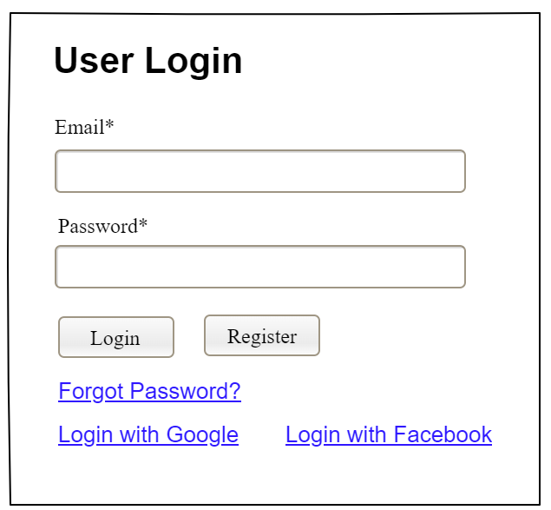

|  |  |  |
| --- | --- | --- |
| **Field Name** | **Field Type** | **Description** |
| Email* | Text Box | This is for user to input valid email address for logging in |
| Password* | Password Box | This is for user to input password for logging in |
| Login | Button | User clicks to authenticate him/herself into the system with provided email & password |
| Register | Button | User clicks to redirect to the User Register page for registering new user account to access the system |
| Forgot Password? | Hyperlink | User clicks to redirect to the Password Reset page for resetting his/her forgot password |
| Login with Google | Hyperlink | Allow user to login with his/her Google account |
| Login with Facebook | Hyperlink | Allow user to login with his/her Facebook account |

##### Database Access

|  |  |  |
| --- | --- | --- |
| **Table** | **CRUD** | **Description** |
| User | R | Verify UserName & Password information |
| Setting, User | R | Specify the authorizations of the logged-in user |

***SQL Commands:***

1/ Verify UserName & Password information

SELECT user_id, full_name, email, image_url, status

FROM user WHERE user_name = ? AND password = ?

2/ Specify the authorizations of the logged-in user

SELECT mapped_values FROM setting WHERE setting_id = ?

SELECT setting_name, mapped_values FROM setting WHERE setting_id IN (?)

#### b. Setting List

##### UI Design

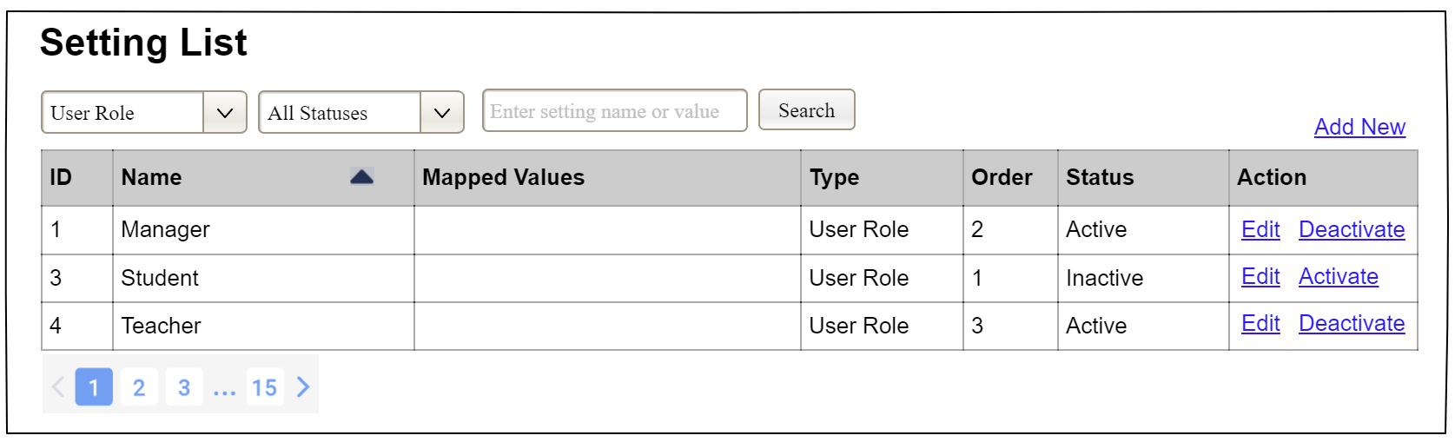

|  |  |  |
| --- | --- | --- |
| **Field Name** | **Field Type** | **Description** |
| ***Search Fields*** | | |
| Setting Type | Combo Box  Single-Choice | Filled with the list of current active setting types  Allow to filter the list by setting type;  Default value is “All Types” |
| Setting Status | Combo Box  Single-Choice | Values: All Statuses (default), Active, and Inactive  Allow to filter the list by status  Default value: “All Statuses” |
| Search Phase | Text Box  String (30) | Allow to search using the name or map values  Default value: blank |
| Search | Button | Click to refresh the list with the defined filter(s) and search phrase. |
| Add New | Hyperlink | Click to open the Setting Details page for adding new setting (master data) |
| ***Data Table*** | | |
| ID | Integer | Auto-increased identifier of the setting |
| Name | Text | Name of the setting |
| Mapped Values | Text | Supplementary information for the setting |
| Type | Text | Type of the setting |
| Order | Integer | Display order of the setting: the order of the setting type, displayed among the list of settings with the same type |
| ***Data Actions*** | | |
| Edit | icon | Click to open the Setting Details page for updating the relevant setting (master data) |
| Activate | icon | Shown when the data status is inactive. This is to activate the relevant setting (master data) |
| Deactivate | Ion | Shown when the data status is active. This is to deactivate the relevant setting (master data) |

##### Database Access

|  |  |  |
| --- | --- | --- |
| **Table** | **CRUD** | **Description** |
| Setting | RU | Query the list of current settings from the database  Update status of a specific setting |

***SQL Commands:***

1/ Query the list of current settings from the database

SELECT setting_id, setting_name, mapped_values, type_id, display_order, status

FROM setting WHERE (setting_type = ?) AND (status = ?) AND (setting_name LIKE ?)

2/ Update status of a specific setting

UPDATE setting SET status = ? WHERE setting_id = ?

#### c. Setting Details

##### UI Design

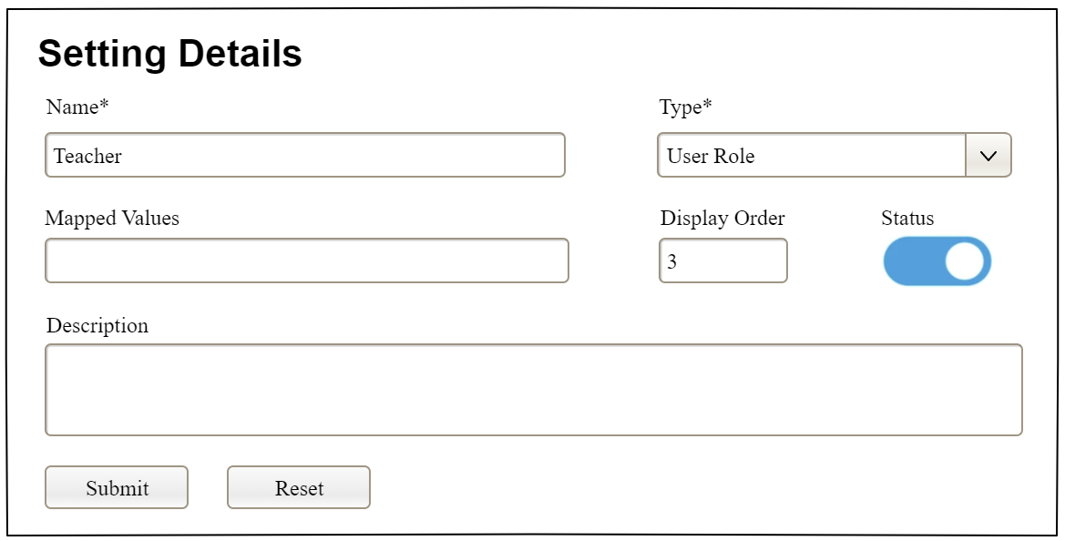

|  |  |  |
| --- | --- | --- |
| **Field Name** | **Field Type** | **Description** |
| Name* | Text Box  String (20) | Name of the setting |
| Type* | Combo Box  (Single Choice) | Type of the setting, filled with the list of setting types  Default value: the first type in the list |
| Mapped Values | Text Box  String (50) | Supplementary information for the setting (if any) |
| Order | Text Box  Integer (>=0) | Display order of the setting: the order of the setting type, displayed among the list of settings with the same type |
| Status | On/Off button | Status of the setting: Active or Inactive  Default value: Active |
| Description | Text Area  String (200) | Description of the setting |
| Submit | Button | Click to store new or updated setting details |
| Reset | Button | Click to reset the changes use has made on the screen fields back to the initial values when the screen is loaded |

##### Database Access

…

# IV. Appendix



## 1. Assumptions & Dependencies

*[Record any assumptions that were made when conceiving the project and writing this vision and scope document. Note any major dependencies the project must rely upon for success, such as specific technologies, third-party vendors, development partners, or other business relationships.]*

<<Sample:

AS-1: Systems with appropriate user interfaces will be available for cafeteria employees to process the expected volume of meals ordered.

AS-2: Cafeteria staff and vehicles will be available to deliver all meals for specified delivery time slots within 15 minutes of the requested delivery time.

DE-1: If a restaurant has its own on-line ordering system, the Cafeteria Ordering System must be able to communicate with it bi-directionally.

>>

## 2. Limitations & Exclusions

*[Identify any product features or characteristics that a stakeholder might anticipate, but which are not planned to be included in the new product]*

## 3. Business Rules

*[Provide common business rules that you must follow. The information can be provided in the table format as the sample below]*

<<Sample

|  |  |  |
| --- | --- | --- |
| **ID** | **Category** | **Rule Definition** |
| BR-01 | Constraints | Delivery time windows are 15 minutes, beginning on each quarter hour. |
| BR-02 | Constraints | Deliveries must be completed between 10:00 A.M. and 2:00 P.M. local time, inclusive. |
| BR-03 | Facts | All meals in a single order must be delivered to the same location. |
| BR-04 | Facts | All meals in a single order must be paid for by using the same payment method. |
| BR-11 | Constraints | If an order is to be delivered, the patron must pay by payroll deduction. |
| BR-12 | Computations | Order price is calculated as the sum of each food item price times the quantity of that food item ordered, plus applicable sales tax, plus a delivery charge if a meal is delivered outside the free delivery zone. |
|  |  |  |

>>

## 4. ..