Assumption
database (mysql or mariadb)
webserver already installed (apache or ngix)

Task
- define mantisbt version
- download tarball and it’s fingerprint
- verify that donwloaded tarball and fingerprint match
- extract the downloaded tarball renaming the directory or creating a symbolic link
- Execution of installation script

Download url

https://sourceforge.net/projects/mantisbt/files/mantis-stable/2.27.0/mantisbt-2.27.0.tar.gz/download

xxx
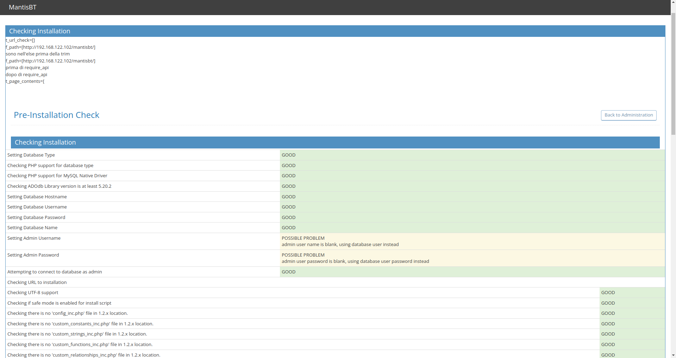
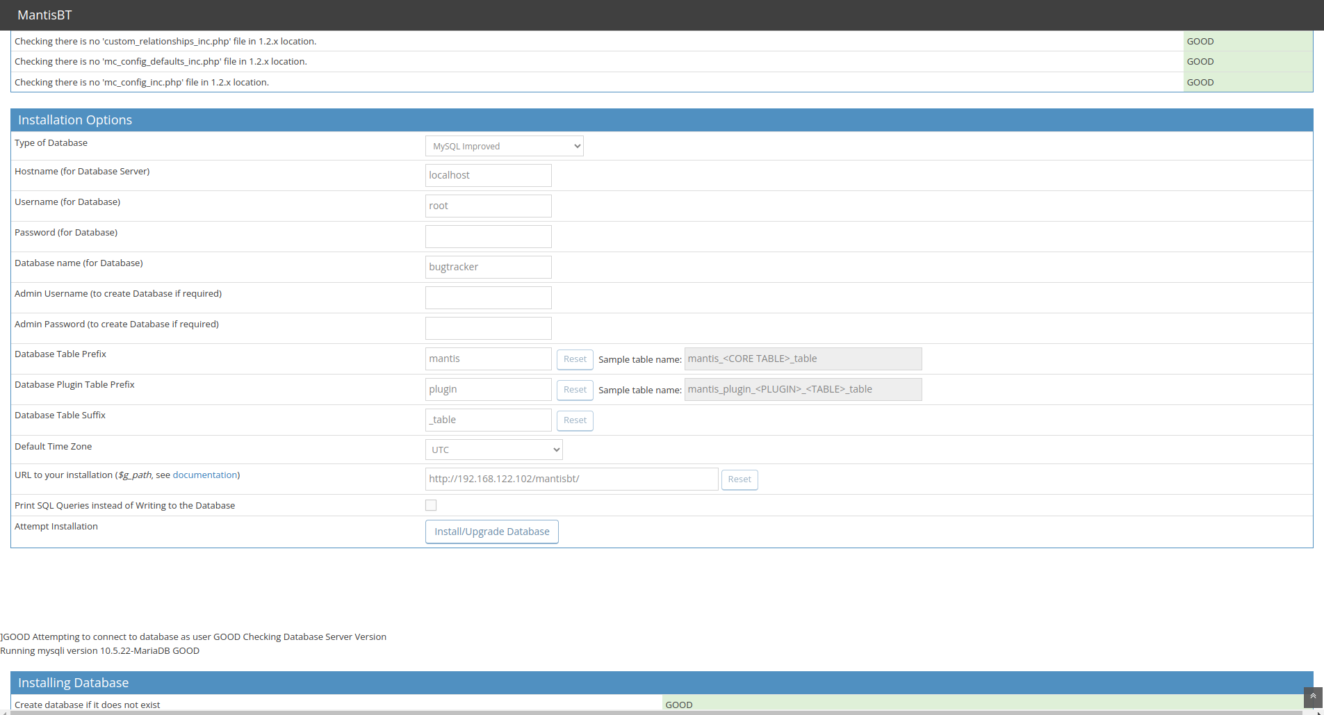
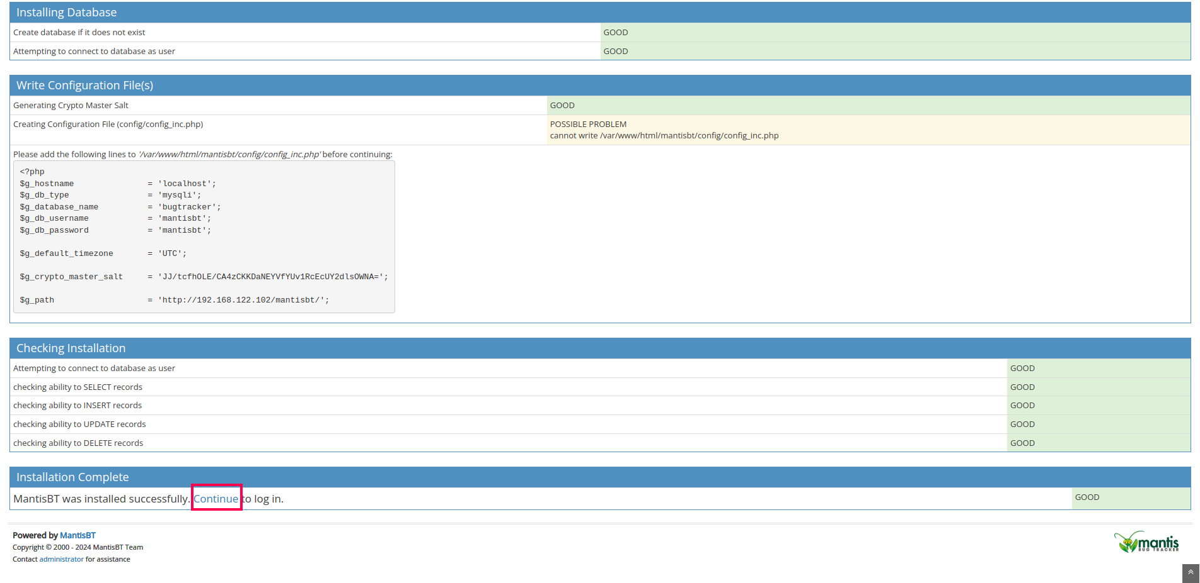
http://192.168.122.102/mantisbt/login_page.php
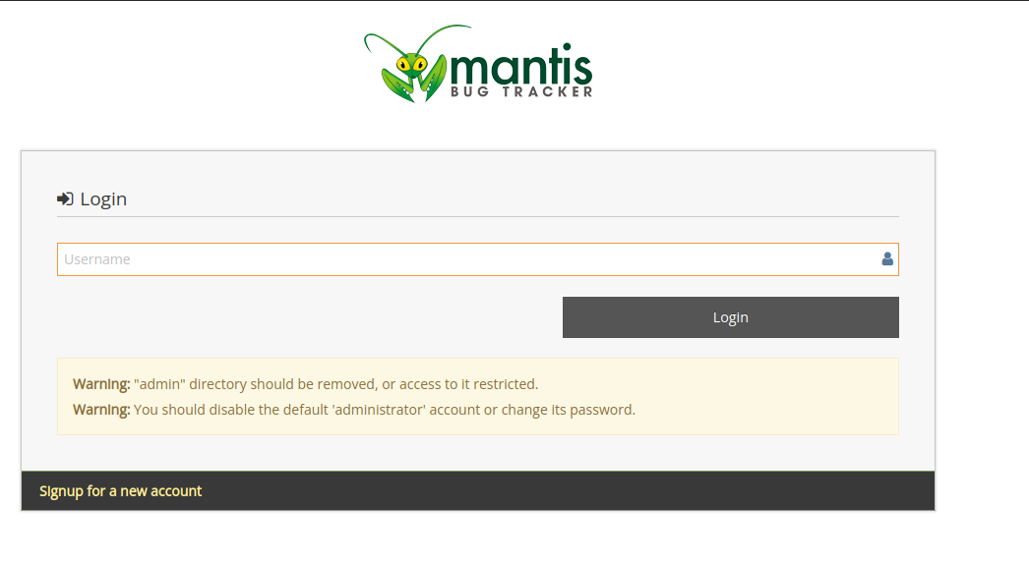
La logica per proceder o meno all’installazione può essere messa nella presenza o meno della pagina di login

